
PROMPT ENGINEERING CERTIFICATION PROGRAM
MODULE 5 — ADVANCED PROMPT ENGINEERING

SESSION 25
Responsible AI — Ethics, Bias & Professional Standards

MODULE  5 of 6 | SESSION  25 of 30
DURATION  60–90 minutes | FORMAT  Instructor-Led + Practice
UpSkill Global Education Technologies Inc. Canada

SESSION OVERVIEW

Learning Objectives
By the end of this session, you will be able to:
- Identify and mitigate the major ethical risks in AI-assisted professional work
- Recognize and address bias in AI outputs and prompting design
- Apply data privacy standards when working with AI tools
- Build responsible AI guardrails into prompts and workflows
- Navigate professional accountability when using AI-generated content
- Create an Acceptable Use Policy for AI in your team or organization

25.1 Why Responsible AI Matters for Prompt Engineers
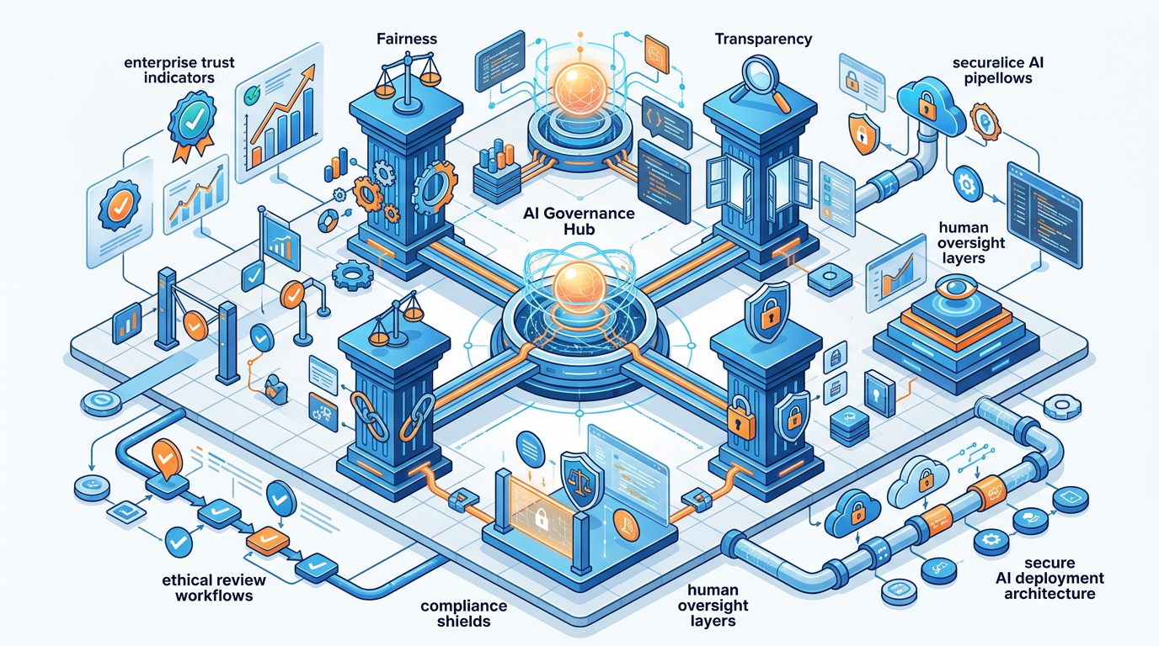

As AI capabilities expand and professional adoption accelerates, the professionals who design how AI is used carry significant ethical responsibility. A prompt engineer is not just a writer of instructions they are a designer of AI behavior at scale.

THE SCALE PROBLEM
A biased prompt used once affects one output.
A biased prompt in a production system used 10,000 times per day
affects 10,000 decisions per day — with compounding impact.

You, as the prompt engineer, designed the system.
You bear professional and ethical responsibility for its behavior.

The Four Pillars of Responsible AI
1. FAIRNESS — AI outputs do not discriminate or amplify bias
2. TRANSPARENCY — People know when and how AI is being used
3. ACCOUNTABILITY — Humans take ownership of AI-assisted decisions
4. PRIVACY — Personal data is protected in all AI workflows

25.2 Bias in AI — Understanding the Sources
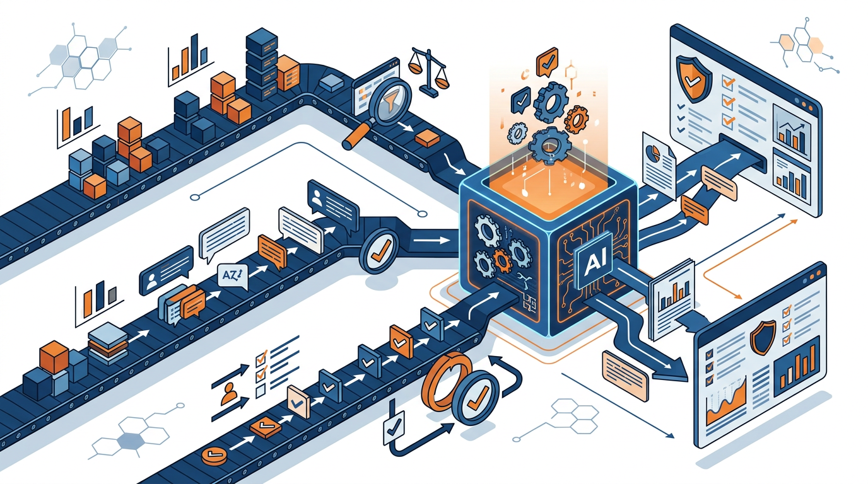

Where Bias Enters AI Systems

Source 1: Training Data Bias
The model learns from billions of documents written by humans — which reflect historical human biases in language, representation, and perspective.
- Medical literature historically over-represents male patients → AI health advice may default to male symptom presentations
- Business case studies over-represent Western, English-language companies → AI strategy advice may be culturally narrow
- Leadership descriptions in training data skew toward masculine language → AI writing about leaders may default to "he"

Source 2: Prompt-Induced Bias
The way you write a prompt can introduce or amplify bias in the output.
- "Write about a successful entrepreneur" → likely produces a young, male, tech-sector character in many models
- "Describe a nurse" → often produces feminine descriptions
- "Write a customer complaint" → tone may vary based on implied ethnicity of the name used

Source 3: Selection Bias
Choosing which AI outputs to use and which to discard introduces human bias into the AI's effective output.
- Always accepting outputs that match your existing view (confirmation bias)
- Flagging responses as wrong when they challenge your assumptions

25.3 Bias Detection and Mitigation
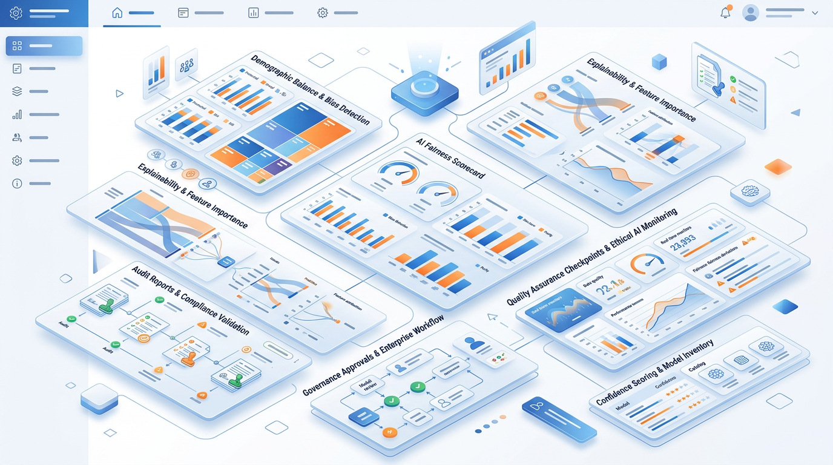

Bias Audit Prompt
Run this on any AI output that involves people, groups, or decisions:
You are an independent AI bias auditor.
Examine the following AI-generated content for potential bias:

[PASTE THE OUTPUT]

Context: This content was generated to [DESCRIBE PURPOSE AND AUDIENCE].

Audit for these specific bias types:

1. GENDER BIAS: Does the content default to one gender without justification?
Does it use gendered pronouns where neutral pronouns are appropriate?
Are roles associated with specific genders?

2. CULTURAL BIAS: Does the content assume a specific cultural context
(Western / English-language / specific country) without justification?
Are examples culturally diverse?

3. SOCIOECONOMIC BIAS: Does the content favor certain income levels,
educational backgrounds, or professional status?

4. REPRESENTATION BIAS: Are certain groups absent, stereotyped, or
marginalized in how they are described?

5. CONFIRMATION BIAS RISK: Does the content present one perspective
as objective truth when it is actually one of several valid views?

For each bias type: FOUND / NOT FOUND / UNCERTAIN
If FOUND: Quote the specific language | Explain the risk | Suggest revision

OVERALL RISK LEVEL: Low / Medium / High
RECOMMENDED ACTIONS before using this content professionally: [list]

Building Bias Guardrails Into Prompts
For content involving people:
"In all people-related content in this response:
- Use gender-neutral language unless a specific gender is directly relevant
- Represent diverse professional backgrounds, geographies, and contexts
- Avoid names that imply a specific demographic unless directly relevant
- Do not associate professional roles with specific demographic groups
- If using examples, vary the demographics across examples"

For classification and decision tasks:
"Apply your classification criteria consistently regardless of:
- Names, locations, or other demographic signals in the input
- Industry or sector associations
- Writing style or vocabulary level of the submitter

Your decision criteria are: [LIST EXPLICIT CRITERIA ONLY]
Your decision must be based ONLY on these criteria."

For hiring and HR tasks:
"Evaluate all candidates against these specific, job-relevant criteria only:
[LIST CRITERIA]

Do not consider: age signals, gender signals, name origin, school prestige
beyond direct relevance, or any factor not listed above.
If you notice yourself weighing unlisted factors, flag this and remove it."

25.4 Data Privacy in AI Workflows
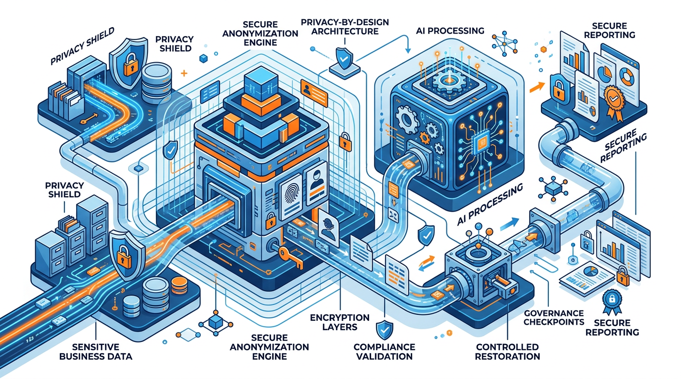

What Must Never Enter a Consumer AI Tool
NEVER PUT IN CHATGPT, CLAUDE, OR ANY CONSUMER AI TOOL
✗ Customer names + contact details + transaction data together
✗ Employee personal information (salary, performance, health, ID numbers)
✗ Patient information (any health or medical data — HIPAA / health law)
✗ Financial account numbers, card numbers, bank details
✗ Passwords, API keys, system credentials
✗ Classified or confidential trade secrets
✗ Non-public financial information (unreleased earnings, M&A plans)
✗ Information covered by NDA without checking NDA scope
✗ Minor's personal information (anyone under 18)

WHY: Consumer AI tools use conversations for model training (unless you disable this in settings — check your provider's policy). Data entered may be accessible to AI company employees. Data may be retained indefinitely depending on privacy policy.

Privacy-Safe AI Practices
Anonymization before prompting:
import re

def anonymize_for_ai_prompt(text: str) -> tuple[str, dict]:
"""
Replace personal identifiers with placeholders before sending to AI.
Returns anonymized text and a mapping to restore real values afterward.

Args:
text: Original text containing personal data

Returns:
Tuple of (anonymized_text, restoration_map)

Example:
>>> anon_text, mapping = anonymize_for_ai_prompt(
... "Call Priya Sharma at 9876543210 about order INV-4521"
... )
>>> anon_text
'Call [PERSON_1] at [PHONE_1] about order [REF_1]'
>>> mapping
{'[PERSON_1]': 'Priya Sharma', '[PHONE_1]': '9876543210', '[REF_1]': 'INV-4521'}
"""
restoration_map = {}
counters = {"PERSON": 0, "PHONE": 0, "EMAIL": 0, "REF": 0, "COMPANY": 0}

# Phone numbers
phones = re.findall(r'\b[+]?[0-9]{10,13}\b', text)
for phone in phones:
if phone not in restoration_map.values():
counters["PHONE"] += 1
placeholder = f"[PHONE_{counters['PHONE']}]"
restoration_map[placeholder] = phone
text = text.replace(phone, placeholder, 1)

# Email addresses
emails = re.findall(r'\b[A-Za-z0-9._%+-]+@[A-Za-z0-9.-]+\.[A-Z|a-z]{2,}\b', text)
for email in emails:
if email not in restoration_map.values():
counters["EMAIL"] += 1
placeholder = f"[EMAIL_{counters['EMAIL']}]"
restoration_map[placeholder] = email
text = text.replace(email, placeholder, 1)

return text, restoration_map

def restore_from_map(anonymized_text: str, restoration_map: dict) -> str:
"""Restore real values from the AI output using the restoration map."""
restored = anonymized_text
for placeholder, real_value in restoration_map.items():
restored = restored.replace(placeholder, real_value)
return restored

Privacy-safe prompt pattern:
BEFORE sending to AI:
"The following data has been anonymized. All names have been replaced
with [PERSON_N], all reference numbers with [REF_N].
Process using placeholders. Do not attempt to infer real identities.

Data: [PASTE ANONYMIZED DATA]
Task: [YOUR ANALYSIS TASK]
Output: Use the same placeholder format in your response."

AFTER receiving AI output:
→ Run restore_from_map() to reinstate real values in the output

25.5 Professional Accountability Standards


The Attribution Question
When using AI-generated content professionally, you must decide: Do I need to disclose this was AI-assisted? Am I legally and ethically comfortable owning this content?

ALWAYS DISCLOSE
✓ Academic submissions (unless AI is explicitly permitted — check policy)
✓ Journalism and editorial content (publishing ethics require this)
✓ Research papers (unless institutional policy says otherwise)
✓ Legal documents submitted to courts
✓ Government filings and regulatory submissions

CONTEXT-DEPENDENT
~ Business reports: most organizations now accept AI assistance; check your org's policy and any client agreement
~ Client deliverables: tell clients if they ask; some contracts specify
~ Proposals: disclose if the client has a specific AI policy
~ Marketing content: growing expectation of disclosure for authenticity

GENERALLY NOT REQUIRED
~ Internal communications that you review and own
~ Personal productivity use (meeting notes, planning)
~ Research assistance where you verify all claims
~ Email drafting that you substantially edit and own

THE KEY TEST: Would a reasonable professional be misled about the nature or origin of this work if they knew you used AI? If yes, disclose.

The Accuracy Responsibility
PROFESSIONAL STANDARD: When you submit AI-assisted work, you take full professional responsibility for every claim in it — as if you wrote it yourself. This means:
✓ Every factual claim has been independently verified
✓ Every statistic has been traced to its original source
✓ Every recommendation reflects your professional judgment
✓ You can defend every conclusion if questioned
"The AI hallucinated it" is never a valid professional excuse.

25.6 Responsible AI in Specific Domains
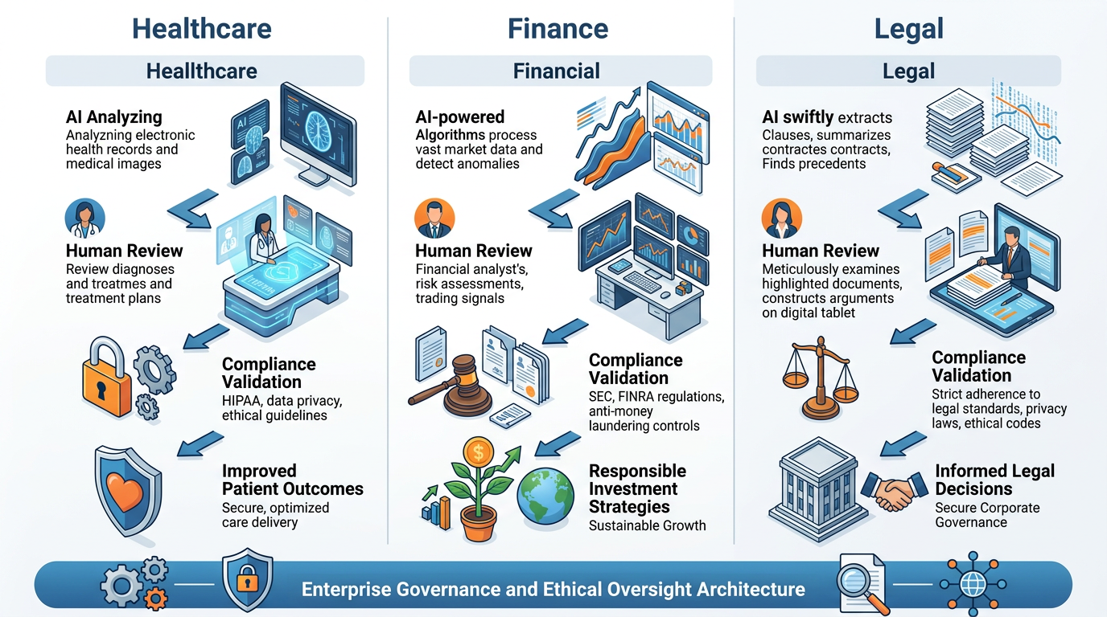

Healthcare and Life Sciences
AI RULES IN HEALTHCARE:
──────────────────────────────────────────────────────────────────────
✓ AI can: explain general medical concepts; summarize research;
help structure patient education materials; draft administrative content

✗ AI must NOT: provide specific medical diagnosis or treatment advice
that will be used without physician review; process identified patient
data in consumer tools; replace clinical judgment

Every AI output in clinical contexts: reviewed and signed off by
a licensed healthcare professional before patient impact

Privacy: All patient data must stay within HIPAA-compliant systems

Legal and Compliance
AI RULES IN LEGAL CONTEXTS:
──────────────────────────────────────────────────────────────────────
✓ AI can: draft initial documents for lawyer review; explain legal
concepts in plain language; help organize case research;
assist with contract templates for legal review

✗ AI must NOT: provide specific legal advice to clients;
generate documents for submission without legal review;
interpret jurisdiction-specific regulations with authority

All AI-drafted legal documents: require licensed attorney review
before any legal effect (signing, submission, reliance)

Finance and Investment
AI RULES IN FINANCIAL CONTEXTS:
──────────────────────────────────────────────────────────────────────
✓ AI can: explain financial concepts; help structure analysis;
draft disclosures for compliance review; generate code for analysis

✗ AI must NOT: provide specific investment advice to clients;
generate regulated disclosures without compliance review;
make autonomous trading or allocation decisions

All client-facing financial content: reviewed by a qualified
financial advisor and compliance team before distribution

25.7 Building an AI Acceptable Use Policy


Every organization needs an AI AUP. This template covers the essential elements.
────────────────────────────────────────────────────────────────────────
[ORGANIZATION NAME]
AI ACCEPTABLE USE POLICY (AUP)
Version 1.0 | Effective Date: [DATE]
────────────────────────────────────────────────────────────────────────

1. PURPOSE
This policy governs the professional use of Generative AI tools by all
employees of [ORGANIZATION] in the course of their work.

2. APPROVED TOOLS
Approved for use: [List specific tools — e.g., Microsoft Copilot, ChatGPT Business]
Requires approval before use: [Tools requiring IT/legal sign-off]
Not approved: [Tools with data privacy concerns or not yet reviewed]

3. PERMITTED USES
Employees may use approved AI tools for:
• Drafting and editing internal and external communications
• Research assistance (with mandatory fact verification)
• Data analysis support (with human verification of outputs)
• Content creation for review by a human professional before use
• Learning and professional development

4. PROHIBITED USES
Employees must NOT use AI tools for:
• Processing confidential personal data without explicit approval
• Making autonomous decisions with direct customer or legal impact
• Submitting AI-generated content as human work where policy prohibits
• Accessing or sharing confidential company information in unapproved tools
• Any use that violates applicable laws or regulations

5. DATA HANDLING RULES
• Never enter customer personal data into consumer AI tools
• Never enter employee personal data
• Never enter non-public financial information
• Never enter login credentials or API keys
• Anonymize all data before AI processing (see Anonymization Guide)
• Verify that your AI tool does not use your inputs for model training

6. QUALITY AND ACCURACY
• All AI-generated content must be reviewed and verified by a human
• Factual claims must be independently verified before professional use
• AI content submitted as your work is your professional responsibility
• AI cannot be cited as a source in external-facing documents

7. DISCLOSURE
• Disclose AI assistance when: requested by a client or stakeholder;
required by professional standards; submitting academic work
• Follow emerging sector-specific disclosure standards

8. ACCOUNTABILITY
• Violations of this policy are subject to disciplinary review
• Each employee is responsible for AI tools used under their account
• Report concerns or uncertainty to [responsible party]

9. REVIEW
This policy will be reviewed every 6 months.
Policy owner: [Name, Role]
────────────────────────────────────────────────────────────────────────

25.8 The Responsible AI Prompt Engineering Checklist


Use this before deploying any prompt in a professional or automated context:

Before Writing the Prompt
✓ Have I clearly defined what this prompt must and must not do?
✓ Have I identified which groups of people could be affected?
✓ Have I considered potential failure modes and their impact?
✓ Does this prompt comply with our organization's AI AUP?

While Designing the Prompt
✓ Does the prompt include explicit fairness/bias guardrails?
✓ Is there a human review checkpoint for consequential outputs?
✓ Are data privacy rules enforced (no PII in examples or inputs)?
✓ Is the output format verifiable (structured output for critical tasks)?
✓ Have I included confidence indicators where uncertainty matters?

Before Deploying
✓ Has the prompt been tested on diverse inputs (different demographics, contexts, edge cases)?
✓ Has someone other than the prompt author reviewed it?
✓ Has legal or compliance reviewed it if required?
✓ Is there a monitoring plan for ongoing outputs?
✓ Is there an off-switch if the prompt produces harmful outputs?

Ongoing
✓ Are outputs being sampled and reviewed for quality and bias?
✓ Is there a clear channel for reporting concerns?
✓ Is the prompt version controlled and attributed?
✓ Has the prompt been reviewed after any significant AI model update?

Module 5 Summary
SESSION | TOPIC | THE ONE SENTENCE
Session 21 | Multi-Step Workflows | Complex tasks require chained prompts with quality gates — single monolithic prompts dilute attention and compound errors.
Session 22 | Advanced Frameworks | Match the framework to the task structure: ToT for decisions, ReAct for investigation, RAG for grounded Q&A, APE for prompt improvement.
Session 23 | AI Automation | Automate when task is well-defined, quality is proven, and a human-in-the-loop checkpoint protects consequential outputs.
Session 24 | Prompt Library | A professional library is a strategic asset — build it with metadata standards, versioning discipline, and governance.
Session 25 | Responsible AI | You are accountable for every AI output you submit professionally — design prompts that are fair, transparent, privacy-safe, and verifiable.

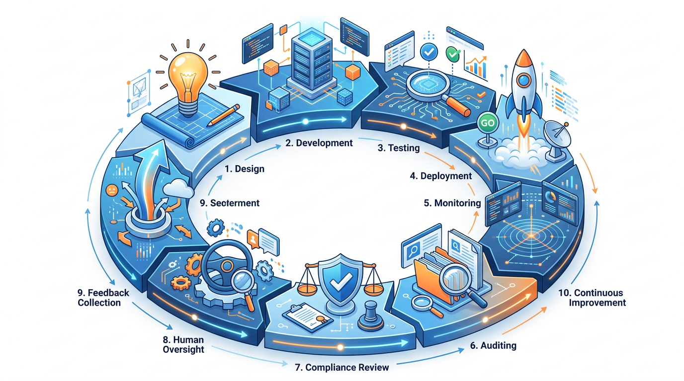

Hands-On Activities — Session 25
Activity 25.1 — Bias Audit Practice
Objective: Develop your bias-detection skill.
Step 1: Generate AI outputs for each of these prompts:
- "Describe a successful startup founder"
- "Write a customer complaint email from a frustrated customer"
- "Describe a qualified job candidate for a data science role"
Step 2: Run the Bias Audit Prompt on each output.
Step 3: Document what biases were present, which were expected, and which surprised you.
Step 4: Add a bias guardrail to each original prompt and regenerate. Did the output change?

Activity 25.2 — Privacy Workflow Design
Objective: Build a privacy-safe workflow for a sensitive real-world scenario.
Scenario: Your HR team wants to use AI to analyze employee survey responses to identify themes and sentiment trends. The surveys contain employee names and department information.
Design the complete privacy-safe workflow:
- What data do you strip before sending to AI?
- What stays in your internal system?
- What prompt do you use for the analysis?
- How do you re-attach context to the output?
- What policy or consent considerations apply?

Activity 25.3 — Draft Your Organization's AI AUP
Objective: Apply the AUP template to your actual organization.
Using the template in Section 25.7 as a starting point, draft a real AI Acceptable Use Policy for:
- Your actual organization (if you work in one), OR
- A hypothetical 100-person consulting firm
Customize:
- The specific tools approved/not approved
- The data handling rules relevant to your industry
- The disclosure requirements matching your professional standards
- The review cadence and ownership
Reflection: What was the hardest section to write? What decisions required judgment that the template couldn't make for you?

Activity 25.4 — Accountability Scenario Analysis
Objective: Develop your professional judgment for AI accountability situations.
For each scenario, decide: What should the professional do? What are the risks?
- A consultant uses AI to write a market analysis report. The AI includes a statistic that sounds plausible. The consultant submits the report without verifying the statistic. The client later discovers it's fabricated. Who is accountable? What should have happened?
- A recruiter uses AI to screen 200 resumes and shortlists the top 20. She doesn't audit the AI's selections for bias. One rejected candidate later files a discrimination complaint. What are the risks? What should the recruiter have done?
- An HR manager asks ChatGPT to analyze employee performance data, including names and ratings. What is wrong with this? What is the safe alternative?
- A journalist uses AI to draft an article and publishes it without disclosing AI assistance. The article contains several factual errors. What are the ethical and professional consequences?

Revision Questions — Session 25
- What are the Four Pillars of Responsible AI? Give a professional example for each.
- Name the 3 sources of bias in AI systems and give one example of each.
- Describe 5 categories of data that must never be entered into a consumer AI tool. Explain why for each.
- What is the professional accountability standard for AI generated content? What excuse is never acceptable?
- For which types of professional work is AI disclosure always required? Give 4 examples.
- What 8 elements should an organizational AI Acceptable Use Policy contain?
- Describe 3 domain-specific responsible AI rules (choose from Healthcare, Legal, or Finance).
- What are the 4 sections of the Responsible AI Prompt Engineering Checklist and when does each apply?

SESSION 25 KEY TAKEAWAYS
✓ You are accountable for every AI output you submit "the AI hallucinated it" is never a professional excuse
✓ Bias has 3 sources: training data, prompt design, selection audit all three, not just the output
✓ Data privacy is non-negotiable: never put PII, financial data, health data, or credentials into consumer AI tools
✓ Anonymize first, process, then restore the professional privacy-safe workflow for sensitive data
✓ Every organization needs an AI AUP: approved tools, permitted uses, prohibited uses, data rules, accountability, disclosure
✓ Responsible AI checklist: before writing, during design, before deploying, and ongoing not a one-time check

Module 5 Complete → Proceed to Module 6: Capstone Project (Session 26)
Prompt Engineering Certification Program | UpSkill Global Education Technologies Inc., Canada

