
PROMPT ENGINEERING CERTIFICATION PROGRAM
MODULE 6 — CAPSTONE PROJECT & CERTIFICATION

SESSION 26
Capstone Project Kickoff — Problem Definition & Planning

MODULE  6 of 6 | SESSION  26 of 30
DURATION  60–90 minutes | FORMAT  Self-Paced + Capstone
UpSkill Global Education Technologies Inc.
Canada

SESSION OVERVIEW

Learning Objectives
By the end of this session, you will be able to:
- Define a meaningful, scoped capstone project that demonstrates your learning
- Complete a Problem Definition Document for your chosen capstone
- Map your project to the full range of techniques learned across Modules 1 to 5
- Build a realistic project plan with milestones for Sessions 26 to 30
- Identify the deliverables required for certification assessment
- Use AI to assist in planning and scoping your own capstone project

26.1 What is the Capstone Project?

The capstone project is your opportunity to synthesize everything learned across 25 sessions into a coherent, real-world AI productivity solution. It is the evidence that you have moved from understanding concepts to applying them professionally.
What a Strong Capstone Looks Like
STRONG CAPSTONE CHARACTERISTICS
✓ Solves a REAL problem from your actual professional context
✓ Demonstrates MULTIPLE techniques (not just one prompt)
✓ Includes a PROMPT LIBRARY with at least 8 documented entries
✓ Shows ITERATION — version history, what changed, why
✓ Applies RESPONSIBLE AI principles (bias audit, privacy considerations)
✓ Produces MEASURABLE IMPACT — time saved, quality improved, task enabled
✓ Is PRESENTABLE — a working system someone else could use

WEAK CAPSTONE CHARACTERISTICS
✗ A collection of one-off prompts with no coherent use case
✗ Demonstrates only the simplest techniques (only zero shot)
✗ No iteration documented — first draft submitted as final
✗ Generic — could apply to "any company" with no real context
✗ No measurement of impact
✗ Only the student can use it — no documentation for reuse

26.2 Capstone Project Options
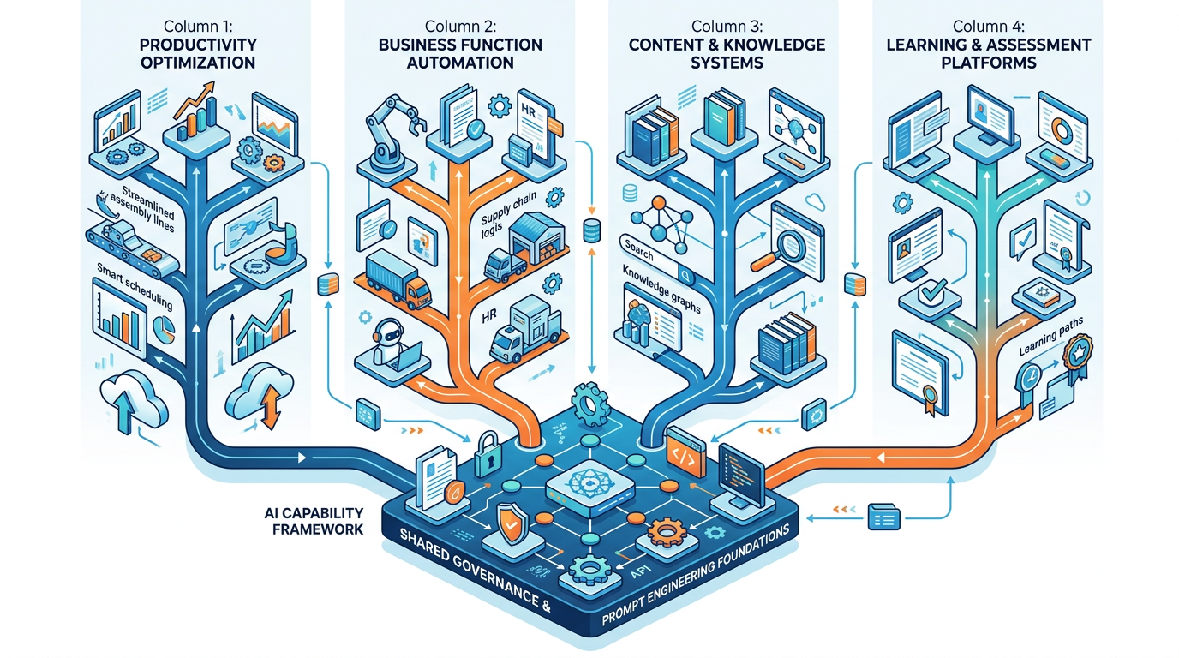
Choose one of the following tracks based on your professional context:

Track A: AI Productivity System for Your Role
What it is: A complete, documented AI productivity system for your specific professional role — covering your most time-intensive repeating tasks.
Minimum requirements:
- Workday audit identifying top 8+ AI opportunities
- 10+ prompt library entries (full documentation standard)
- 3+ workflow designs (morning routine, core task type, end-of-day)
- Automation design for at least 1 recurring task
- Measurable impact: before/after time comparison for 5 tasks
- Responsible AI compliance checklist for your context
Best for: Professionals focused on personal productivity transformation

Track B: AI Solution for a Business Function
What it is: A purpose-built AI solution addressing a specific business function (marketing, HR, finance, customer support, strategy).
Minimum requirements:
- Problem statement and business case
- 10+ prompt library entries specific to the function
- At least 1 multi-step pipeline (minimum 4 steps)
- Sample outputs with quality evaluation (rubric scoring)
- Automation design for the highest-volume task
- Responsible AI assessment (bias audit + privacy review)
- ROI calculation
Best for: Professionals building team or organizational AI capabilities

Track C: AI-Powered Content or Knowledge System
What it is: A comprehensive content production or knowledge management system powered by AI prompting.
Minimum requirements:
- Content strategy with 4-week calendar
- Complete content production pipeline (brief to published)
- 10+ prompt library entries covering all content formats needed
- Brand voice documentation and few-shot examples
- Repurposing pipeline (1 cornerstone → 5+ formats)
- Quality rubric for content evaluation
- Responsible AI: bias audit on representative outputs
Best for: Content creators, marketers, communications professionals

Track D: AI Learning and Assessment System
What it is: An AI-assisted learning content and assessment system for a topic you are an expert in.
Minimum requirements:
- Learning objectives and curriculum design (5+ modules)
- AI-assisted content generation pipeline for 3 lesson types
- Assessment bank: 20+ questions (MCQ, scenario, practical)
- Student feedback response templates
- Personalization prompts (adapting content for different learner levels)
- Quality standards for educational AI content
- Responsible AI: accessibility and bias considerations
Best for: Trainers, educators, L&D professionals, subject matter experts

26.3 Problem Definition Document
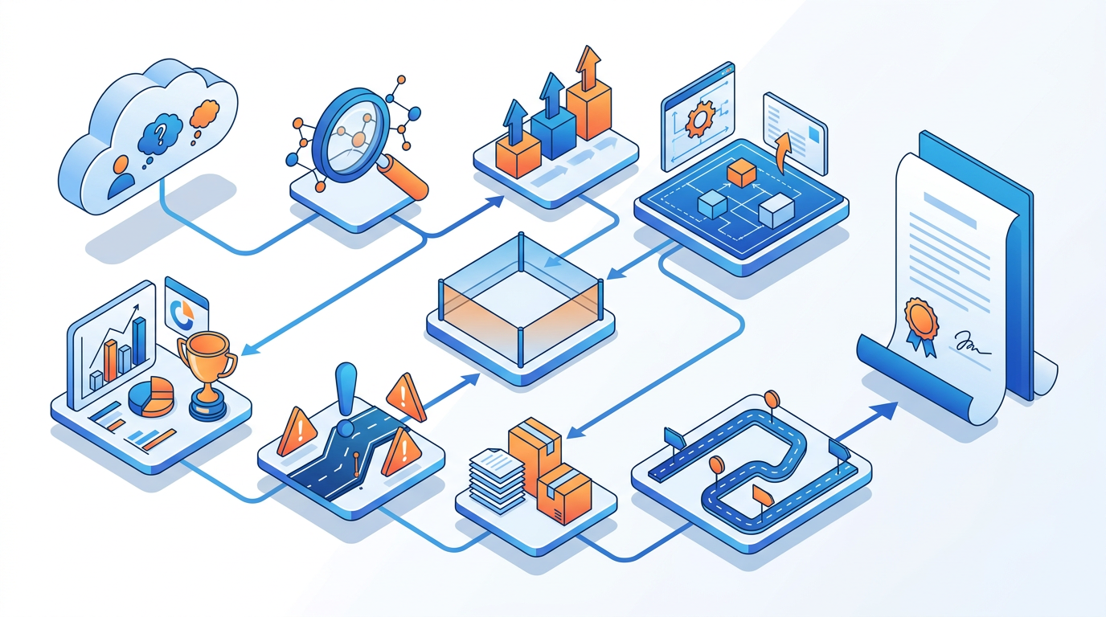
Every capstone begins with a structured Problem Definition Document. This is your project charter.
══════════════════════════════════════════════════════════════════════════
CAPSTONE PROJECT — PROBLEM DEFINITION DOCUMENT
══════════════════════════════════════════════════════════════════════════

## STUDENT PROFILE
Name: ______________________________
Role/Title: ______________________________
Industry: ______________________________
Organization type: ______________________________
Capstone Track: [A / B / C / D]

## PROBLEM STATEMENT
────────────────────────────────────────────────────────────────────────
The problem I am solving:
[2–3 sentences. Be specific — what breaks down, who is affected, what is
the cost in time, quality, or opportunity?]

Why this problem matters:
[1–2 sentences. What is the business or professional case for solving it?]

Who benefits from this solution:
[Describe the primary beneficiary — you, your team, your organization?]

## SOLUTION OVERVIEW
────────────────────────────────────────────────────────────────────────
My proposed AI solution (2 sentences):
[What will you build? What will it enable?]

Key capabilities this solution will have:
• [Capability 1]
• [Capability 2]
• [Capability 3]
• [Capability 4]

Techniques from the course I will apply:
☐ CRAFT Framework ☐ Zero-Shot Prompting
☐ Few-Shot Prompting ☐ Chain-of-Thought
☐ Persona Prompting ☐ Prompt Optimization
☐ Multi-Step Pipelines ☐ Advanced Frameworks (specify: ________)
☐ AI Automation ☐ Prompt Library (documented)
☐ Responsible AI Practices

## SCOPE
────────────────────────────────────────────────────────────────────────
IN SCOPE (what I will build in Sessions 26–30):
• [Item 1]
• [Item 2]
• [Item 3]

OUT OF SCOPE (what I am explicitly NOT building):
• [Item 1]
• [Item 2]

## SUCCESS METRICS
────────────────────────────────────────────────────────────────────────
How will I know this project succeeded?
Metric 1: [Measurable — time, quality score, task count, etc.]
Metric 2: [Measurable]
Metric 3: [Measurable]

Baseline (before): [Current state for each metric]
Target (after): [Goal state for each metric]

## RISKS AND MITIGATIONS
────────────────────────────────────────────────────────────────────────
Risk 1: [What could prevent success?] → Mitigation: [What I'll do about it]
Risk 2: [Risk] → Mitigation: [Mitigation]
Risk 3: [Risk] → Mitigation: [Mitigation]

## DELIVERABLES CHECKLIST
────────────────────────────────────────────────────────────────────────
By Session 30, I will submit:
☐ Problem Definition Document (this document — Session 26)
☐ Prompt Library (minimum 10 entries, full documentation standard)
☐ At least 1 multi-step pipeline (documented)
☐ Sample outputs with quality evaluation
☐ Responsible AI assessment
☐ Impact measurement (before/after comparison)
☐ 10-minute presentation (slides + speaker notes)
☐ Reflection essay (500 words)
══════════════════════════════════════════════════════════════════════════

26.4 Project Planning — Sessions 26 to 30
CAPSTONE PROJECT TIMELINE
SESSION 26 — KICKOFF: Problem Definition Document
• Complete Problem Definition Document
• Select track; define scope; identify techniques
• Create project plan with milestones
• Begin research and problem context gathering

SESSION 27 — BUILD PHASE 1: Foundation Prompts
• Build first 5 prompt library entries
• Design and test your core pipeline
• Gather baseline measurements (before data)
• First quality gate: are core prompts working?

SESSION 28 — BUILD PHASE 2: Complete System + QA
• Build remaining 5+ prompt library entries
• Complete automation design
• Responsible AI assessment
• Full quality evaluation of all outputs

SESSION 29 — PRESENTATION PREPARATION
• Build 10-minute presentation using Session 13 methods
• Compile all deliverables
• Write reflection essay
• Peer review and Q&A preparation

SESSION 30 — FINAL PRESENTATION & CERTIFICATION
• Deliver 10-minute presentation
• Answer Q&A panel (10 minutes)
• Submit complete deliverables package
• Receive certification assessment feedback

26.5 Using AI to Plan Your Capstone
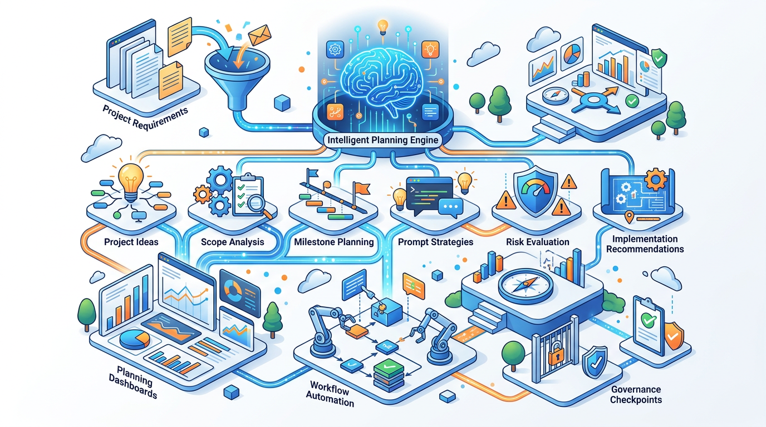
Apply your prompt engineering skills to help design the capstone itself.
Capstone Problem Ideation Prompt
You are a curriculum designer and professional coach helping a student
select and define a meaningful capstone project for their AI certification.

Student profile:
- Role: [YOUR ROLE]
- Industry: [YOUR INDUSTRY]
- Organization: [DESCRIBE YOUR ORGANIZATION]
- Key responsibilities: [LIST 5]
- Biggest time consumers at work: [LIST 3–5]
- Most frustrating repeating tasks: [LIST 2–3]

Help me define a strong capstone project:

1. PROBLEM IDENTIFICATION: Based on my profile, what are the 3 most
compelling problems I could solve with AI? Rate each for:
- Impact potential (High/Medium/Low)
- Feasibility in 5 sessions (High/Medium/Low)
- Learning demonstration value (High/Medium/Low)

2. RECOMMENDED TRACK: Which of the 4 capstone tracks (A/B/C/D) best fits
my role and what will have most impact?

3. PROBLEM STATEMENT: Draft a Problem Definition for the top recommendation
using the Problem Definition Document structure.

4. SUCCESS METRICS: Suggest 3 specific, measurable success metrics for
this project that I can establish a baseline for immediately.

5. QUICK WINS: What can I implement in the FIRST session (Session 26)
to get immediate value even before the full project is complete?

Capstone Scope Validation Prompt
Review my capstone project scope and tell me if it's too big, too small,
or appropriately scoped for 5 sessions of work (approximately 25–30 hours total).

My Problem Definition Document: [PASTE YOUR DRAFT PDD]

Evaluate:

1. SCOPE SIZE: Is this achievable in 5 sessions? Too ambitious? Too narrow?
If too big: what should I cut to maintain quality?
If too small: what additional dimension would strengthen the project?

2. TECHNIQUE COVERAGE: Does this project allow me to demonstrate the
full range of techniques from the course? Which techniques are underrepresented?

3. MEASURABILITY: Are my success metrics truly measurable? Can I realistically
gather before/after data?

4. DIFFERENTIATION: What would make this project genuinely impressive vs.
adequate? What single addition would most strengthen it?

5. RISK ASSESSMENT: What is the biggest risk that could derail this project?
Provide a specific mitigation strategy.

26.6 Capstone Assessment Rubric — Full Criteria
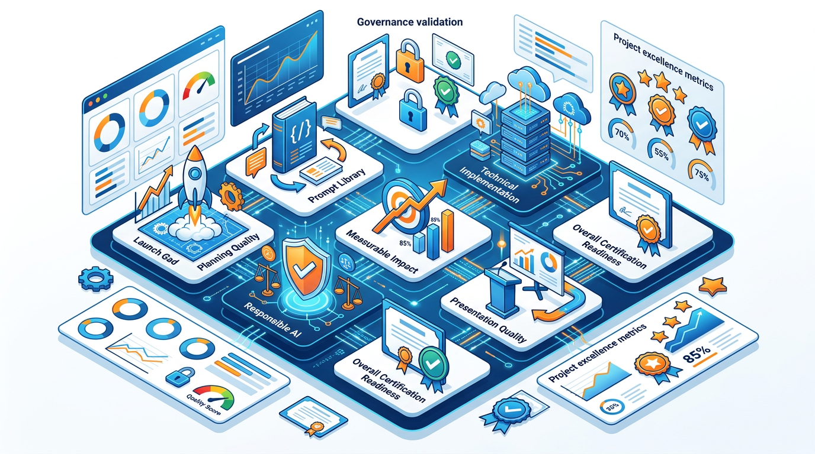
Understanding how your project will be assessed allows you to build toward the highest quality from day one.
══════════════════════════════════════════════════════════════════════════
CAPSTONE ASSESSMENT RUBRIC
Total: 100 points | Pass mark: 70 points | Distinction: 85+ points
══════════════════════════════════════════════════════════════════════════

SECTION 1: PROBLEM DEFINITION & PLANNING (15 points)
────────────────────────────────────────────────────────
- Problem statement is specific, real, and professionally meaningful (5)
- Scope is appropriate — not too broad, not too narrow (5)
- Success metrics are measurable with realistic baseline and target (5)

SECTION 2: PROMPT LIBRARY QUALITY (25 points)
────────────────────────────────────────────────────────
- Minimum 10 complete entries (full documentation standard) (10)
- Demonstrates variety of techniques across entries (5)
- All entries have tested examples with quality ratings (5)
- Iteration history shows real improvement journey (5)

SECTION 3: TECHNICAL DEPTH (20 points)
────────────────────────────────────────────────────────
- At least one multi-step pipeline with quality gates (8)
- Advanced techniques applied correctly (CoT, Persona, RAG, etc.) (7)
- Automation design is realistic and implementable (5)

SECTION 4: QUALITY AND IMPACT (20 points)
────────────────────────────────────────────────────────
- Outputs demonstrate clear quality improvement over baseline (10)
- Measurable impact documented (time saved, quality improvement) (5)
- Quality evaluation rubric applied to representative outputs (5)

SECTION 5: RESPONSIBLE AI (10 points)
────────────────────────────────────────────────────────
- Bias audit conducted and findings documented (5)
- Privacy considerations addressed appropriately (3)
- Professional accountability standards applied (2)

SECTION 6: PRESENTATION & COMMUNICATION (10 points)
────────────────────────────────────────────────────────
- 10-minute presentation is structured and compelling (5)
- Message headlines (not topic labels) used throughout (2)
- Q&A handled professionally with specific, honest answers (3)

BONUS (up to 5 additional points):
- Exceptionally novel or creative application of AI techniques (+3)
- Team implementation documented (built for others to use) (+2)
══════════════════════════════════════════════════════════════════════════

26.7 Session 26 Deliverable
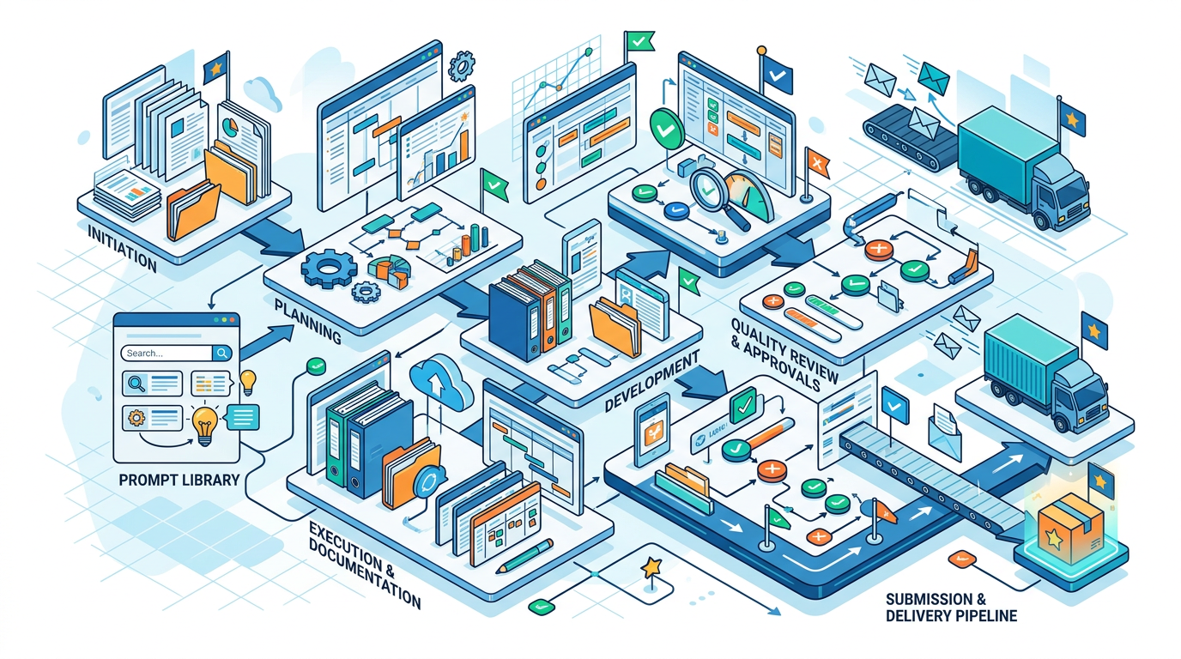
By the end of Session 26, complete and submit:
Deliverable 1: Problem Definition Document (complete all sections)

Deliverable 2: Prompt Library Skeleton Create the folder structure and index file for your library. Add at least 2 complete entries (the first 2 prompts you will actually build).

Deliverable 3: Session 27 Preparation List the 5 prompts you will build in Session 27, with a one-sentence description of each and the technique you will use.

Hands-On Activities — Session 26
Activity 26.1 — Capstone Ideation
Run the Capstone Problem Ideation Prompt (Section 26.5) with your real professional profile. Generate 3 candidate problems and score them.
Select your capstone problem. Write your first draft of the Problem Statement section.

Activity 26.2 — Complete the Problem Definition Document
Work through every section of the Problem Definition Document (Section 26.3).
Don't skip the Risks section it is where projects most often fail due to scope creep, lack of measurement baseline, or overambitious timelines.

Activity 26.3 — Scope Validation
Run the Capstone Scope Validation Prompt on your completed Problem Definition Document.
Apply the feedback: what will you add, cut, or adjust before Session 27?

Activity 26.4 — Library Foundation
Set up your prompt library folder structure. Create:
- LIBRARY INDEX.md with the Quick Find table (headings only fill as you build)
- GOVERNANCE.md (personal or team version)
- Your first 2 complete prompt entries using the full documentation standard

Revision Questions — Session 26
- What are the 6 characteristics of a strong capstone project?
- Describe the 4 capstone tracks. What type of professional is each best suited for?
- What are the 8 required deliverables for capstone submission?
- Why is the Problem Definition Document completed before any prompts are written?
- Describe the Session 26–30 milestone plan. What is the primary focus of each session?
- The capstone assessment rubric has 6 sections. Which section carries the most weight and what does it evaluate?
- What makes a success metric "measurable" in the context of the capstone? Give an example of a weak metric and its stronger version.
- How can you use AI to help plan and scope your own capstone project?
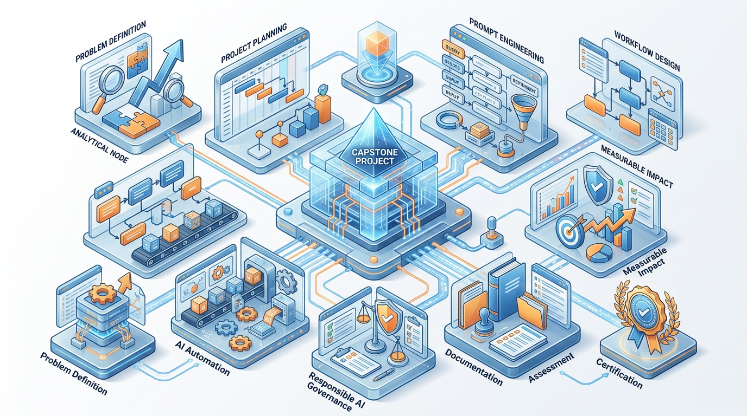

SESSION 26 KEY TAKEAWAYS
✓ Choose a REAL problem — capstone quality comes from authentic professional context, not invented scenarios
✓ Problem Definition Document first — scope, metrics, and risks defined before a single prompt is written
✓ 4 tracks available: Productivity System / Business Function / Content System / Learning System — pick the one that fits you
✓ Assessment rubric is your build guide — 6 sections, 100 points, know what you're targeting from the first session
✓ Use AI to plan the capstone itself — ideation, scope validation, milestone planning are all prompt-engineerable tasks
✓ Session 26 exit criteria: Problem Definition Document complete + Library foundation set up + 2 entries built

Session 26 Complete → Proceed to Session 27: Capstone Build Phase 1
Prompt Engineering Certification Program | UpSkill Global Education Technologies Inc., Canada

