
PROMPT ENGINEERING CERTIFICATION PROGRAM
MODULE 6 — CAPSTONE PROJECT & CERTIFICATION

SESSION 27
Capstone Build Phase 1 — Foundation Prompts & Core Pipeline

MODULE  6 of 6 | SESSION  27 of 30
DURATION  90–120 minutes | FORMAT  Self-Paced + Capstone
UpSkill Global Education Technologies Inc.
Canada

SESSION OVERVIEW

Learning Objectives
By the end of this session, you will be able to:
- Build the first 5 prompt library entries for your capstone project
- Design and test your core multi-step pipeline
- Establish baseline measurements for your chosen metrics
- Apply quality gate evaluation to your first outputs
- Use iteration discipline to move from v1.0 to v1.1+ on your core prompts
- Identify and resolve the first round of prompt failures

27.1 The Build Phase Mindset
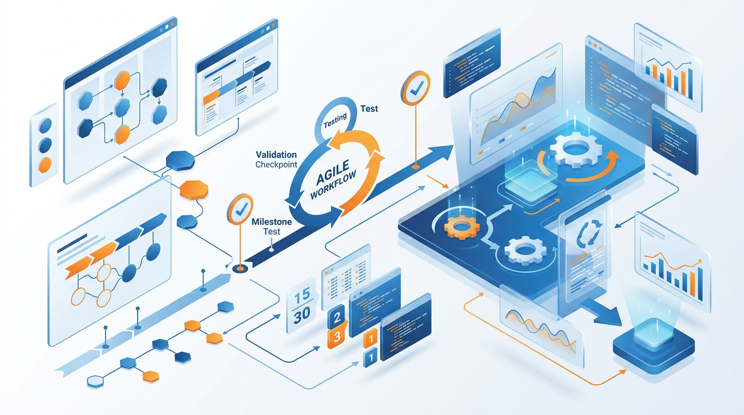
Session 27 is where the capstone moves from planning to production. The mindset shift required:
FROM PLANNING MODE | TO BUILD MODE
Thinking about what to build | Actually building
Designing the ideal solution | Shipping a working v1.0
Avoiding the first failure | Expecting the first failure — and learning
Waiting for clarity | Starting with the best available information
Optimizing before testing | Testing before optimizing
Build Mantra
✓ "Make it work, then make it better." A tested v1.0 that works 70% of the time is more valuable than a perfect design that hasn't been tested at all.

27.2 Baseline Measurement — Before You Build
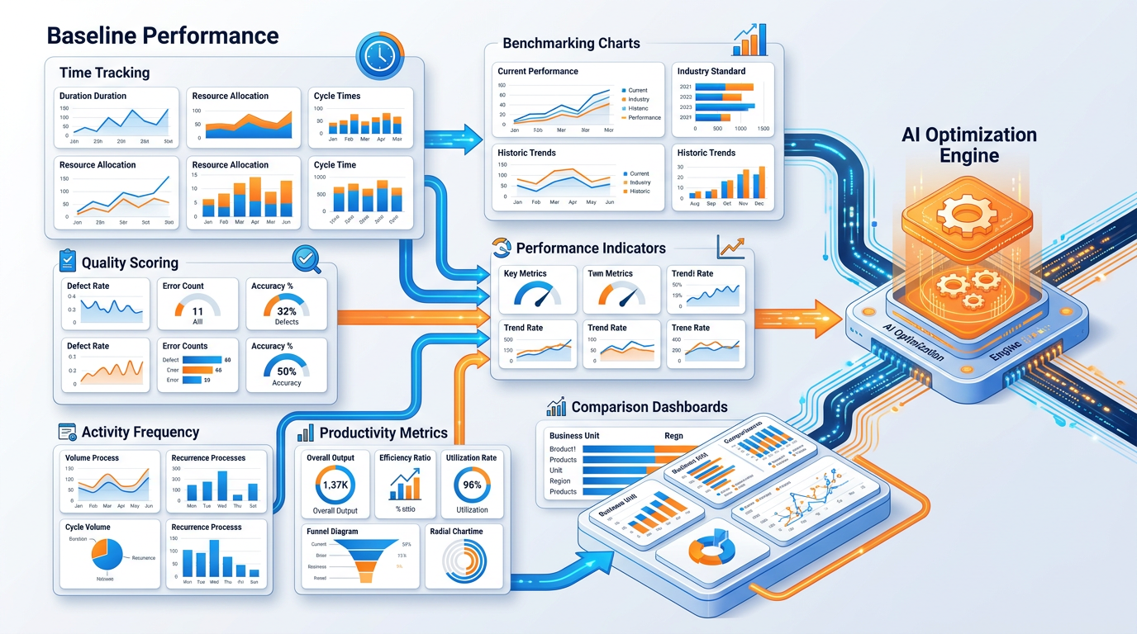
Before writing a single prompt, establish your baseline measurements. You cannot prove impact without a "before" state.

Baseline Data Collection Prompt
Help me establish measurable baseline metrics for my capstone project.

My project: [DESCRIBE YOUR CAPSTONE — what problem, what solution]

Tasks I will be improving with AI:
[LIST EACH TASK YOU PLAN TO IMPROVE]

For each task, help me design a baseline measurement:

1. TASK NAME: [Specific task]
Current approach: How do I do this now? (manually, with what tools?)
Time measurement: How long does it currently take? (per instance)
Quality measurement: How do I currently rate the quality? (1–5 scale or %)
Frequency: How often do I do this? (per day/week/month)
Total current time cost: [time per instance × frequency = weekly hours]

2. TASK NAME: [...]
[Repeat for each task]

BASELINE SUMMARY TABLE:
| Task | Time Per Run (now) | Quality (now) | Frequency | Weekly Hours |
[Generate this table from the task data above]

TOTAL BASELINE: [Sum of weekly hours spent on all tasks identified]

For each task, also identify:
- What would a "high quality" output look like? (Define the standard)
- What would a "low quality" output look like? (Define the floor)

This will be used for the After comparison in Session 28.

27.3 The First 5 Prompts — Build Standards
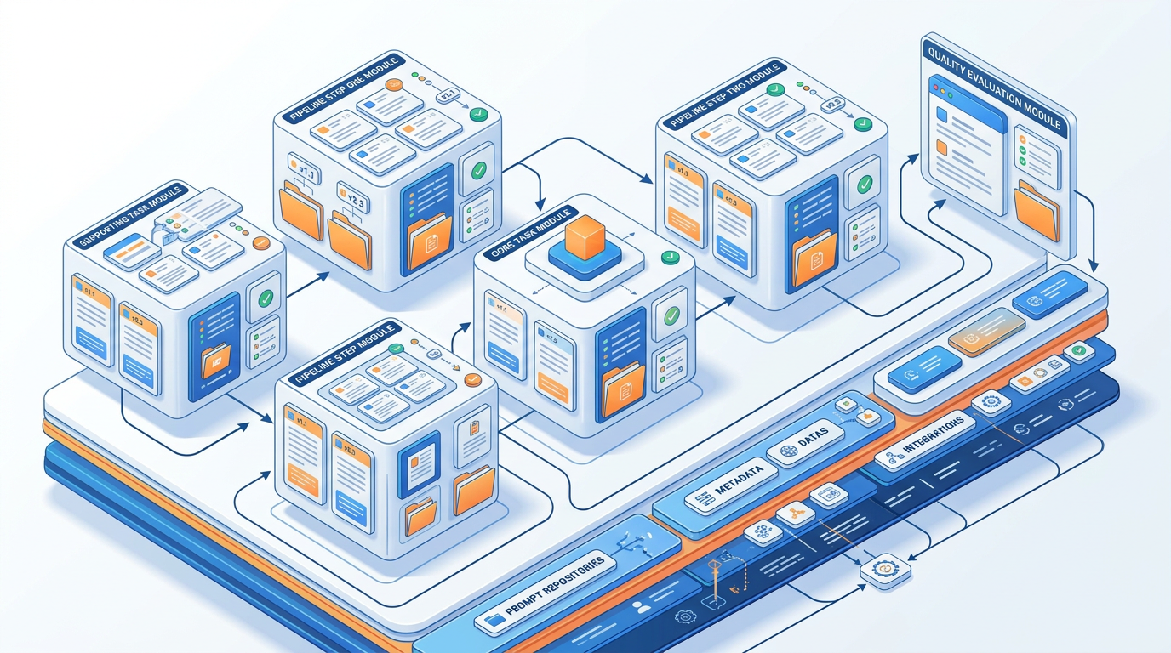
Prompt Build Sequence
For a systematic capstone, build prompts in this priority sequence:
PRIORITY ORDER FOR FIRST 5 PROMPTS:

1. CORE TASK PROMPT — The single most important, highest-frequency task
(This prompt alone should deliver most of your time savings)

2. PIPELINE STEP 1 — The first step of your core multi-step pipeline
(Build incrementally — get step 1 working before building step 2)

3. PIPELINE STEP 2 — The second step of your core pipeline

4. SUPPORTING TASK PROMPT — Second most important task prompt

5. QUALITY EVALUATION PROMPT — The rubric/critique prompt for your domain
(You need this to evaluate everything else you build)

Build Protocol for Each Prompt

For every prompt you build in the capstone, follow this 5-step protocol:
STEP 1 — DESIGN (5 minutes)
Answer these questions BEFORE writing:
- What technique am I using? (Zero-shot / Few-shot / CoT / Persona / Chain)
- What framework? (CRAFT / ReAct / ToT / RAG / Skeleton)
- What is the exact output format I need?
- What are the top 3 failure modes to guard against?

STEP 2 — WRITE v1.0 (10 minutes)
Write the complete prompt using the full template.
Include all CRAFT elements: Role, Context, Task, Format, Tone, Constraints.

STEP 3 — TEST v1.0 (10 minutes)
Run the prompt on 3 different inputs:
- A typical/expected input
- A complex or edge-case input
- A minimal/sparse input (least information)
Score each output: 1–5 on your quality rubric.

STEP 4 — DIAGNOSE AND ITERATE (10 minutes)
Identify the single most important failure mode from your 3 tests.
Make ONE change to address it. Document what changed and why.
This is v1.1.

STEP 5 — DOCUMENT (10 minutes)
Complete the full library entry standard.
Include the best output example from your tests.
Record your iteration history: v1.0 → v1.1 with the specific change.

27.4 Core Pipeline Design and Testing
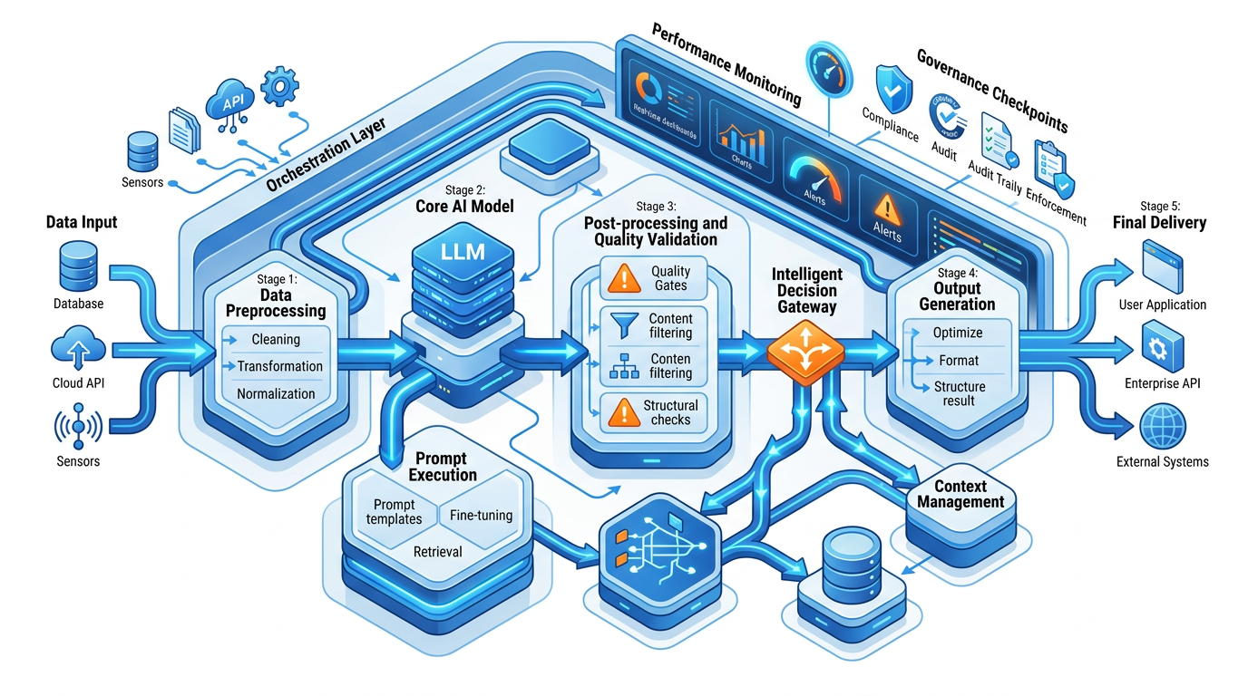
The Pipeline Design Document
Before coding or prompting the pipeline, write this design document:
PIPELINE DESIGN DOCUMENT

PIPELINE NAME: [Descriptive name]
PIPELINE PURPOSE: [What problem does this pipeline solve end-to-end?]
INPUT: [What does the user/system provide at the start?]
OUTPUT: [What is the final deliverable?]

STEP MAP:
──────────────────────────────────────────────────────────────────────
Step # | Name | Input | Prompt Technique | Output | Quality Gate?
──────────────────────────────────────────────────────────────────────
1 | [Name] | [What enters this step] | [Technique] | [Output type] | YES/NO
2 | [Name] | [Step 1 output + ?] | [Technique] | [Output type] | YES/NO
3 | [Name] | [Step 2 output + ?] | [Technique] | [Output type] | YES/NO
4 | [Name] | [Step 3 output + ?] | [Technique] | [Output type] | YES/NO

QUALITY GATES:
After Step [N]: Check for [specific criteria — binary pass/fail]
If FAIL: [specific corrective action]

CONTEXT BRIEF (carried at every step):
[What information will you include at the top of every step prompt?]

FAILURE MODES TO DESIGN AGAINST:
[List 3 things that most commonly break this type of pipeline]

ESTIMATED TIME SAVINGS vs. MANUAL:
[Time per run manually] → [Time per run with pipeline] = [Savings per run]
At [frequency], this saves [X hours per week/month]

27.5 Pipeline Step Templates by Capstone Track
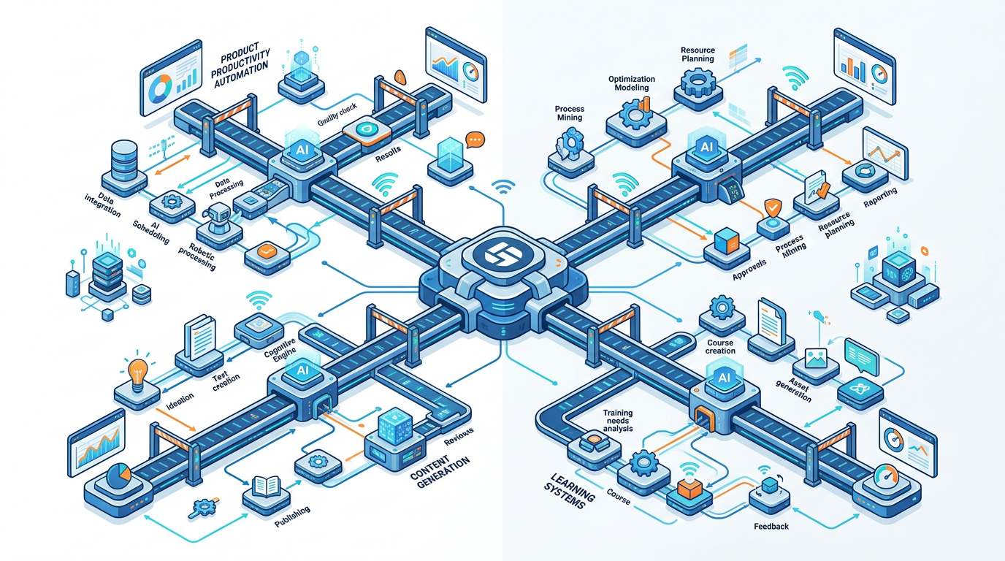

Track A — AI Productivity System Pipeline Example
Pipeline: Weekly Review and Forward Planning
STEP 1 — WEEKLY CAPTURE
Prompt: "Process my raw week-end notes into structured categories.
Input: [paste notes]
Output: COMPLETED | CREATED ACTIONS | DECISIONS MADE | WAITING FOR | INSIGHTS"

STEP 2 — ACCOMPLISHMENT SYNTHESIS
Input: [Step 1 COMPLETED section]
Prompt: "Convert these completed items into 3–5 professional achievement
bullets suitable for a weekly status report. Focus on outcomes, not activities."

STEP 3 — NEXT WEEK PLANNING
Input: [Step 1 CREATED ACTIONS + any carry-forward]
Prompt: "Prioritize this action list for next week using these criteria:
[your specific criteria]. Output a ranked daily plan with time estimates."

STEP 4 — STAKEHOLDER UPDATE
Input: [Step 2 achievements + Step 3 top priorities]
Prompt: "Draft my weekly stakeholder update email:
- 3 achievements this week
- 3 priorities for next week
- 1 item needing stakeholder input or decision
Under 200 words. Professional but conversational tone."

Track B — Business Function Pipeline Example
Pipeline: Customer Insight to Action Report
STEP 1 — RAW FEEDBACK PROCESSING
Input: [Customer feedback, NPS comments, support tickets]
Prompt: "Categorize and quantify themes in this customer feedback.
Output: Theme | Frequency | Sentiment | Representative Quote | Urgency"

STEP 2 — INSIGHT EXTRACTION
Input: [Step 1 theme table]
Prompt: "Identify the 3 most actionable insights from this feedback analysis.
For each: insight | evidence | business impact | root cause hypothesis"

STEP 3 — RECOMMENDATION GENERATION
Input: [Step 2 insights]
Prompt: "Generate specific, implementable recommendations for each insight.
Format: Recommendation | Owner (function) | Effort | Impact | Timeline"

STEP 4 — EXECUTIVE BRIEF
Input: [Step 1–3 outputs]
Prompt: "Write an executive customer insight brief:
HEADLINE: Most important finding in 1 sentence
INSIGHTS: 3 findings with evidence
RECOMMENDATIONS: Top 3 actions
METRICS TO WATCH: 2 leading indicators
Under 300 words. Board-ready language."

Track C — Content System Pipeline Example
Pipeline: Idea to Multi-Platform Content
STEP 1 — IDEA VALIDATION AND ANGLE
Input: [Content idea / topic]
Prompt: "Evaluate this content idea for my audience [DESCRIBE].
Output: Best angle | Hook options (3) | Platform fit | GO/REFINE/DISCARD"

STEP 2 — CORNERSTONE CONTENT DRAFT
Input: [Validated angle + best hook]
Prompt: "Write a 1,000-word blog post with SEO structure.
Keyword: [keyword]. Audience: [describe]. [Full blog post prompt]"

STEP 3 — REPURPOSING PACKAGE
Input: [Step 2 blog post]
Prompt: "Repurpose this into:
- LinkedIn post (250 words)
- Twitter thread (8 tweets)
- Email newsletter section (150 words)
- Instagram carousel (10 slides — title + 2 lines each)"

STEP 4 — PERFORMANCE PREDICTION AND CTA OPTIMIZATION
Input: [All Step 3 content]
Prompt: "For each platform version:
- Suggest the A/B variant for the opening hook
- Recommend optimal CTA
- Identify the highest-risk quality issue in this piece"

Track D — Learning System Pipeline Example
Pipeline: Topic to Complete Lesson
STEP 1 — LEARNING OBJECTIVE DESIGN
Input: [Topic / concept to teach]
Prompt: "Design learning objectives for a 60-minute lesson on [topic].
Audience: [describe]. Format: 3–5 objectives using Bloom's taxonomy verbs."

STEP 2 — LESSON CONTENT GENERATION
Input: [Step 1 objectives]
Prompt: "Generate lesson content outline with:
- Concept explanation (plain language)
- 2 concrete examples (real-world application)
- Common misconception and correction
- Summary framework (mnemonic or visual concept)"

STEP 3 — ASSESSMENT CREATION
Input: [Step 2 content]
Prompt: "Create 5 assessment questions from this lesson:
2 MCQ (knowledge check), 2 scenario questions (application),
1 reflection question. Include model answers."

STEP 4 — FACILITATION GUIDE
Input: [Step 1 objectives + Step 2 content + Step 3 assessments]
Prompt: "Write a facilitator guide for this lesson:
- Suggested timing for each section
- Engagement activity for the 30-minute mark
- Common learner questions and suggested responses
- How to adapt if the group is ahead / behind schedule"

27.6 Quality Gate — End of Session 27
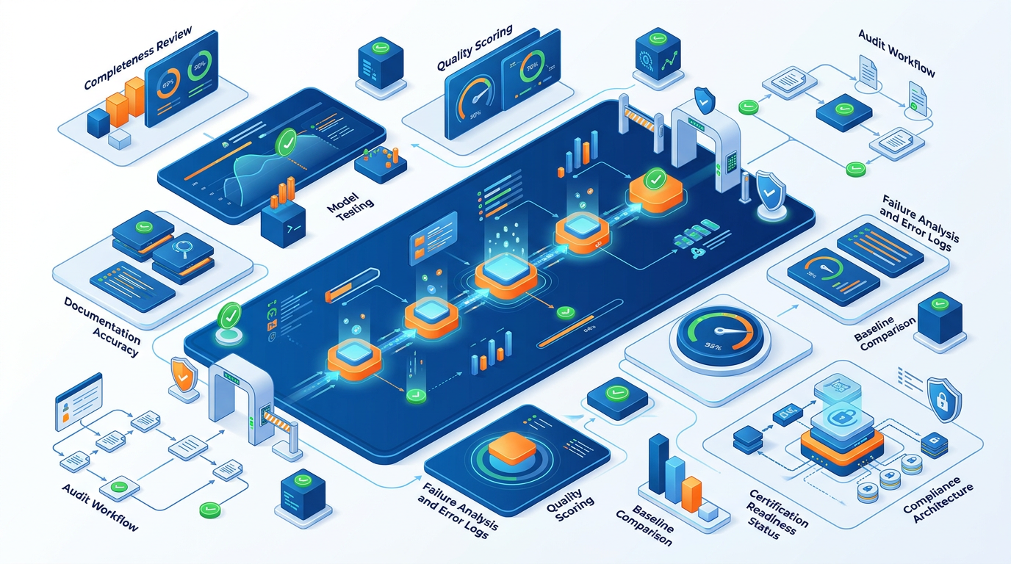

Before ending Session 27, run this quality gate on everything built:
For each of my 5 completed prompts, answer:

Completeness
✓ Full documentation standard completed? (all metadata fields)
✓ Example input and output documented?
✓ Iteration history shows at least v1.0 → v1.1?
✓ "Do Not Use When" section completed?

Quality
✓ Prompt tested on 3+ different inputs?
✓ Average quality score across tests recorded (minimum: 3/5 to proceed)?
✓ Failure modes identified and addressed?

Pipeline
✓ Pipeline Design Document completed?
✓ All steps tested end-to-end at least once?
✓ At least one quality gate defined and tested?
✓ Context brief defined and consistently applied?

Baseline
✓ Baseline measurements documented for all target tasks?
✓ Before-state quality scores recorded?
If ANY answer is NO: Address before starting Session 28. Session 28 builds ON this foundation — weak foundations compound.

Hands-On Activities — Session 27
Activity 27.1 — Baseline Data Collection
Run the Baseline Data Collection Prompt on your chosen capstone tasks. Spend time on this — it is your evidence base for the impact claim in your final presentation.
Time yourself doing each task manually (or estimate carefully from past experience). Record everything in your baseline table.

Activity 27.2 — Build Prompt 1: Your Core Task
Follow the 5-step Build Protocol (Section 27.3) for your most important prompt.
Do not move to Prompt 2 until Prompt 1 has been tested on 3 inputs and iterated at least once.

Activity 27.3 — Build Prompts 2 & 3: Pipeline Steps 1 and 2
Build the first two steps of your core pipeline following the Pipeline Design Document.
Test steps 1 and 2 in sequence — does the output of step 1 work as input for step 2? If not, what context is missing?

Activity 27.4 — Build Prompts 4 & 5
Build your supporting task prompt and your quality evaluation prompt.
Test the quality evaluation prompt on outputs from Prompts 1–3. Does the rubric catch the right quality issues?

Activity 27.5 — Run the Session 27 Quality Gate
Complete the quality gate checklist before closing this session. Address every NO before moving to Session 28.

Session 27 Deliverable Checklist
BY END OF SESSION 27:
✓ Baseline measurements documented (table format)
✓ 5 prompt library entries — complete documentation standard
✓ Pipeline Design Document completed
✓ All 5 prompts tested on 3+ inputs each
✓ Iteration history showing at least v1.0 → v1.1 for each prompt
✓ Session 27 Quality Gate passed (all checkboxes YES)
✓ Clear plan for Session 28 (which 5 prompts to build next)

SESSION 27 KEY TAKEAWAYS
✓ Baseline before building — without a "before" measurement, impact cannot be proven; collect it first
✓ Build protocol: Design → Write v1.0 → Test 3 inputs → Diagnose one failure → Iterate to v1.1 → Document
✓ Priority sequence: Core task → Pipeline steps → Supporting → Quality evaluation prompt (you need this to evaluate everything)
✓ Pipeline Design Document before pipeline prompts — architecture decisions made in writing, not discovered mid-build
✓ Session 27 Quality Gate is mandatory — weak foundations in Session 27 become compounding problems in Session 28
✓ "Make it work, then make it better" — a tested 70% solution beats an untested perfect design every time

Session 27 Complete → Proceed to Session 28: Capstone Build Phase 2 & Quality Assurance
Prompt Engineering Certification Program | UpSkill Global Education Technologies Inc., Canada

