
PROMPT ENGINEERING CERTIFICATION PROGRAM
MODULE 1 — FOUNDATIONS OF PROMPT ENGINEERING

SESSION 3
Prompt Anatomy — The Structure of an Effective Prompt

MODULE  1 of 6 | SESSION  3 of 30
DURATION  60–90 minutes | FORMAT  Self-paced + Activities
UpSkill Global Education Technologies Inc.
Canada

SESSION OVERVIEW

Learning Objectives
By the end of this session, you will be able to:
- Define the five structural components of an effective prompt
- Distinguish between weak (unstructured) and strong (structured) prompts
- Identify which component is missing when an AI response falls short
- Construct complete, structured prompts for a variety of real-world scenarios
- Classify prompts by type (instructional, analytical, creative, transformational)
- Diagnose prompt failures and apply targeted fixes

3.1 What is a Prompt?

A prompt is any input you provide to an AI model to elicit a response. It can be as simple as a single question or as complex as a multi-paragraph document with instructions, examples, context, and constraints.
The most important principle in prompt engineering:
Core Principle
✓ The quality of your prompt is the primary determinant of the quality of the AI's response.
Two people using identical AI tools can get vastly different results — not because of the tool, but because of how they communicate with it.

3.2 The Five Components of Prompt Anatomy

A well-constructed prompt contains up to five components. You don't always need all five — but knowing each one allows you to identify what's missing when a response falls short.
THE FIVE COMPONENTS OF A PROMPT
1. ROLE / PERSONA — Who should the AI be?
2. CONTEXT — What's the situation/background?
3. TASK — What should the AI do?
4. FORMAT — How should the output look?
5. CONSTRAINTS — What are the rules and limits?

Component 1: Role / Persona
What it is: Instructions telling the AI what identity, expertise, or perspective to adopt.
Why it matters: Assigning a role activates the model's training associated with that identity — shaping vocabulary, depth, priorities, and communication style.
Examples by Profession
Role Instruction | Effect on Response
"You are a cardiologist..." | Uses medical terminology, references clinical guidelines
"You are a kindergarten teacher..." | Uses simple language, analogies, encouraging tone
"You are a management consultant at McKinsey..." | Structured frameworks, business language, data-driven
"You are a skeptical editor..." | Critical eye, identifies weaknesses, questions assumptions
"You are a startup founder with 3 failed ventures..." | Practical, risk-aware, experience-grounded

Without a role:
Prompt: "What should I do about my low sales figures?"
Response: Generic advice — could apply to any business
With a role:
Prompt: "You are a B2B sales director with 15 years of experience in
SaaS companies. What should I do about my low sales figures?"
Response: Specific to B2B SaaS context — CRM hygiene, pipeline review, ICP refinement, sales cycle analysis
Role Template
You are a [JOB TITLE] with [YEARS/TYPE] of experience in [FIELD/SPECIALTY].
You work with [TYPE OF CLIENTS/ORGANIZATION].
You prioritize [KEY VALUES/APPROACH].

Component 2: Context


What it is: Background information, situation details, or relevant facts that the AI needs to give a relevant, tailored response.
Why it matters: Without context, the AI gives general answers. With context, it gives answers specific to YOUR situation.

Levels of Context
Level 0 — No context:
"How do I increase employee engagement?"
→ Generic HR advice applicable to any company
Level 1 — Basic context:
"I am an HR manager at a 200-person tech startup. How do I increase employee
engagement?"
→ More relevant — considers startup culture and tech worker expectations
Level 2 — Rich context:
"I am an HR manager at a 200-person B2B SaaS startup in Bengaluru.
Our team is 80% engineers, ages 24–35. We shifted to fully remote in 2022.
Our latest engagement survey showed: work-life balance (3.2/5) and
recognition (2.8/5) as the lowest-scoring areas. Budget for initiatives: ₹5
lakh.
How do I increase employee engagement?"
→ Highly specific, actionable advice targeting the exact problem areas
Types of Context to Provide
Context Type | Examples
Who you are | Role, industry, experience level
Who the audience is | Age, expertise level, relationship to you
What the situation is | Problem, current state, history
What constraints exist | Budget, timeline, resources, approvals needed
What has been tried | Previous attempts and outcomes
What you have access to | Tools, data, people, systems

Component 3: Task / Instruction
What it is: The specific action you want the AI to perform. This is the most critical component — without it, nothing else matters.
Why it matters: The more precisely you define the task, the more precisely the AI executes it.
The Power of Action Verbs
Weak tasks use vague verbs. Strong tasks use specific action verbs:
Weak Verb | Strong Alternative | Difference in Output
Help me with... | Write / Analyze / Summarize / Evaluate | Clear direction
Talk about... | Explain / Compare / Argue / Critique | Defines the angle
Do something about... | Rewrite / Fix / Improve / Optimize | Defines the action
Give me info on... | List / Research / Outline / Extract | Defines structure

Master List of Task Action Verbs
Category | Verbs
GENERATION | Write, Draft, Create, Generate, Compose, Produce
ANALYSIS | Analyze, Evaluate, Assess, Critique, Review, Audit
TRANSFORMATION | Rewrite, Translate, Convert, Simplify, Expand, Condense
EXTRACTION | Summarize, Extract, Identify, List, Find, Locate
COMPARISON | Compare, Contrast, Differentiate, Benchmark, Rank
EXPLANATION | Explain, Describe, Define, Illustrate, Clarify, Teach
REASONING | Argue, Defend, Debate, Challenge, Hypothesize, Predict
ORGANIZATION | Outline, Structure, Categorize, Prioritize, Plan, Map

Single Task vs. Multi-Task (Common Mistake)
❌ Multi-task in one prompt (reduces quality):
"Analyze my business idea, write a business plan, create financial projections,
and suggest marketing strategies."

✅ Sequential single tasks (much better):
Prompt 1: "Analyze this business idea for market fit and competitive advantage."
Prompt 2: "Based on that analysis, create a business plan outline."
Prompt 3: "Now develop the Financial Projections section."
Prompt 4: "Develop a marketing strategy based on the plan."

Component 4: Format

What it is: Instructions specifying how you want the output structured, organized, and presented.
Why it matters: Without format instructions, the AI defaults to prose paragraphs — which may not be useful for your actual purpose.
Complete Format Vocabulary
TEXT STRUCTURE
- Bullet points (unordered list)
- Numbered list (ordered/sequential)
- Paragraph form (specify: 2 paragraphs / short paragraphs / long-form)
- Headers and subheadings (specify: H2 / H3 levels)
- Outline format (I. A. 1. style)

DATA PRESENTATION
- Table (specify: columns and rows)
- Comparison matrix
- Timeline format
- Pros and cons table
- Decision matrix
DOCUMENT FORMATS
- Email (subject line + greeting + body + closing)
- Report (executive summary + sections + conclusion)
- Slide outline (slide number + title + 3 bullets + speaker note)
- Script (speaker + dialogue format)
- FAQ (Q: ... A: ...)
TECHNICAL FORMATS
- JSON structure
- XML
- CSV (comma-separated values)
- Markdown
- Code (specify language: Python, SQL, JavaScript, etc.)
LENGTH SPECIFICATIONS
- Word count: "in exactly 250 words"
- Sentence count: "in 3 sentences"
- Paragraph count: "in 2 short paragraphs"
- Section count: "covering 5 main points"
- Time-based: "for a 2-minute read"

Powerful Format Example
Task: "Compare three cloud providers for a small business."
Without format:
→ 3 paragraphs of text about each, mixed together, hard to compare
With format:
"Present as a comparison table with these columns:
Provider | Cost (monthly for 100GB) | Key Strength | Key Weakness |
Best For | Ease of Use (1-5)"
→ Immediately scannable, directly useful
JSON Format for Technical Use
Prompt: "Extract the following information from this job posting and
return it as JSON:
- job_title (string)
- company_name (string)
- required_experience_years (integer)
- required_skills (array of strings)
- salary_range (string, null if not mentioned)
- location (string)
- remote_status (enum: 'on-site', 'hybrid', 'remote', 'unspecified')

Job posting: [paste job posting here]"

Expected output:
{
"job_title": "Senior Data Analyst",
"company_name": "FinTech Solutions Pvt Ltd",
"required_experience_years": 5,
"required_skills": ["Python", "SQL", "Tableau", "Power BI"],
"salary_range": "₹18-25 LPA",
"location": "Bengaluru",
"remote_status": "hybrid"
}

Component 5: Constraints
What it is: Boundaries, rules, limitations, inclusions, and exclusions that govern the response.
Why it matters: Constraints paradoxically improve quality by narrowing the AI's creative space to the most useful range.
Types of Constraints
Length constraints:
- "Under 100 words"
- "Exactly 5 bullet points"
- "No more than 3 paragraphs"
- "Between 400 and 500 words"
Scope constraints:
- "Focus only on the financial implications, not operational"
- "Only consider options available in India"
- "Limit advice to what can be done with a team of 3"
Exclusion constraints (negative instructions):
- "Do not use technical jargon"
- "Avoid mentioning competitor brands by name"
- "Do not include implementation steps — only strategy"
- "Do not use clichés like 'think outside the box'"
Inclusion requirements:
- "Must include at least one real-world example"
- "Include a specific statistic for each point"
- "Each point must have an action step"

Audience constraints:
- "Write for someone with no finance background"
- "Assume the reader is a CEO with limited time"
- "The audience is skeptical — address objections proactively"
Style constraints:
- "Use active voice throughout"
- "Write in second person ('you' language)"
- "Match the tone of this example: [sample]"
- "No emojis"

3.3 Putting All Five Components Together
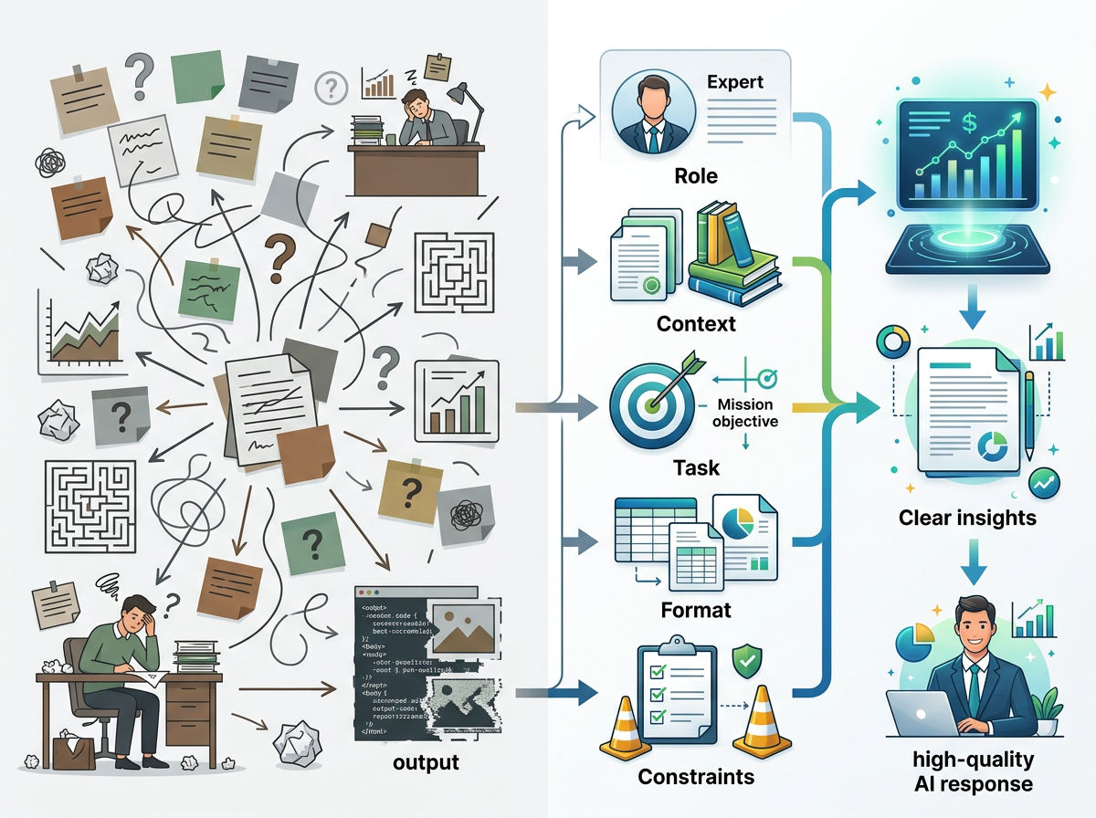
Anatomy Dissection — Before and After
Weak prompt:
"Help me with a presentation about sustainability."
Analysis of what's missing:
- ❌ Role: Who is giving this advice? Generic output.
- ❌ Context: What kind of presentation? For whom? How long?
- ⚠ Task: Present (create a presentation) — but vague
- ❌ Format: No structure specified
- ❌ Constraints: No length, no depth, no topic boundaries
Expected Output
⚠ A vague, generic presentation outline about sustainability that could fit anyone, anywhere, for any purpose.

Strong prompt:
You are an experienced sustainability consultant who has worked with Fortune 500
companies on ESG reporting.

Context: I am the Head of Corporate Affairs at a 3,000-employee manufacturing
company in Pune. I need to present our 2024 sustainability initiatives to the
Board of Directors (10 people, non-technical, focused on business outcomes).

Task: Create a complete 10-slide presentation outline for a 20-minute board
presentation on our sustainability progress and 2025 roadmap.

Format: For each slide provide:
Slide # | Slide Title | 3 key content points | Suggested visual | Speaker note
(2 sentences)

Constraints:
- Frame everything in terms of business value and risk reduction, not
environmental idealism
- Include specific metrics where possible (use placeholders like [X%] if actual
data needed)
- Slide 1 must be an executive summary with the single most important takeaway
- Last slide must be a clear call-to-action for the board
- No slide should be text-heavy — aim for visual-first design
Expected Output
✓ A board-ready, professionally structured 10-slide outline tailored to a manufacturing company's ESG context, framed for business-focused non-technical executives.

3.4 Types of Prompts
Different tasks call for different prompt types. Recognizing the type helps you structure the task component correctly.
Prompt Type | Definition | Task Verb Examples | Best For
Instructional | Direct command to produce output | Write, Draft, Create, Generate | Documents, emails, content
Analytical | Request evaluation or breakdown | Analyze, Evaluate, Assess, Critique | Data, decisions, plans
Question-based | Seek information or explanation | Explain, Describe, What is, How does | Learning, research
Transformational | Convert existing content | Rewrite, Translate, Summarize, Improve | Editing, localization
Generative-Creative | Open-ended creation | Invent, Imagine, Design, Brainstorm | Ideas, fiction, concepts
Conversational | Ongoing dialogue | Let's discuss, I think... do you agree? | Exploration, debate
Comparative | Contrast multiple options | Compare, Contrast, Which is better | Decisions, trade-offs
Procedural | Step-by-step guidance | How do I, Walk me through, Steps to | Tutorials, processes

3.5 Diagnosing Prompt Failures

When an AI response isn't what you wanted, use this diagnostic:
PROMPT FAILURE DIAGNOSTIC CHECKLIST
Response problem: "Too generic / could apply to anyone"
→ Missing: CONTEXT — add your specific situation

Response problem: "Wrong format (got paragraphs, wanted bullets)"
→ Missing: FORMAT — specify exact structure required

Response problem: "Doesn't sound expert enough / too basic"
→ Missing: ROLE — assign expert persona with credentials

Response problem: "Covered too much, not focused on what I needed"
→ Missing: CONSTRAINTS — add scope limitations and exclusions

Response problem: "I asked for X but got Y"
→ Weak: TASK — use more specific action verb and explicit task description

Response problem: "Too long / too short"
→ Missing: LENGTH CONSTRAINT — specify word count or bullet count

Response problem: "Doesn't account for my specific situation"
→ Missing: CONTEXT — add industry, role, organization details

Response problem: "Wrong tone (too formal / too casual)"
→ Add to CONSTRAINTS: tone descriptor + audience specification

3.6 Worked Examples — Full Prompt Anatomy
Example 1: Business Email
Scenario: You need to ask a client for a 2-week extension on a project deadline.
Anatomy:
- ROLE: You are a professional project manager who communicates with clarity and confidence.
- CONTEXT: I am the project lead at an IT consulting firm. Our client is a large bank (conservative, formal culture). We promised delivery of a data migration project by November 30th. Due to unexpected API changes on the client's own system, we need 2 more weeks (to December 14th). This is our 3rd project together.
- TASK: Write a professional email requesting a deadline extension.
- FORMAT: Standard business email format — Subject line, greeting, 3 paragraphs (reason, impact, solution), clear ask, professional closing.
CONSTRAINTS:
- Under 200 words
- Do not make excuses — present it as a quality decision
- Acknowledge the client's business impact briefly
- End with a specific proposed new deadline
- Professional but warm tone — we have an established relationship
Full Prompt:
You are a professional project manager who communicates with clarity and
confidence.

I am the project lead at an IT consulting firm. Our client is a large bank with a
conservative, formal culture. We promised delivery of a data migration project by
November 30th. Due to unexpected API changes on the client's own system (not our
fault, but ours to solve), we need 2 more weeks (new deadline: December 14th).
This is our 3rd successful project together — we have a good relationship.

Write a professional email requesting a 2-week deadline extension.

Format: Business email — Subject line, greeting, 3 short paragraphs (situation,
impact of rushing, proposed solution), clear ask, professional closing.

Constraints: Under 200 words. Do not frame it as an excuse — present it as ensuring
quality. Acknowledge their time briefly. End with the specific new proposed date.

Tone: Professional but warm, reflecting an established working relationship.

Example 2: Data Extraction in JSON
Scenario: You want to extract structured data from unstructured product descriptions.
You are a data extraction specialist who outputs clean, structured JSON.

Context: I am building a product database from raw web-scraped descriptions.
Each description is unstructured text containing product information.

Task: Extract product attributes from the description below and return
as a JSON object.

Format: JSON with these exact fields:
{
"product_name": string,
"brand": string,
"price_inr": number or null,
"category": string,
"key_features": array of strings (max 5),
"materials": array of strings,
"target_audience": string,
"warranty_months": number or null
}

Constraints:
- If a field is not mentioned, use null (never guess or infer)
- key_features must be actual product benefits, not marketing fluff
- All strings in English regardless of source language
- Return ONLY the JSON — no explanation, no markdown, no commentary

Product description to extract from:
"Introducing the UrbanGo Pro X Running Shoes by NovaTrek — priced at just
₹4,999! These lightweight trainers feature air-mesh upper construction and
dual-density EVA foam midsoles for maximum comfort. Perfect for daily runners
and fitness enthusiasts. Built with recycled polyester and natural rubber.
Our 6-month manufacturer warranty gives you peace of mind."
Expected output:
{
"product_name": "UrbanGo Pro X Running Shoes",
"brand": "NovaTrek",
"price_inr": 4999,
"category": "Running Shoes",
"key_features": [
"Lightweight design",
"Air-mesh upper construction",
"Dual-density EVA foam midsoles",
"Maximum comfort"
],
"materials": ["Recycled polyester", "Natural rubber", "EVA foam"],
"target_audience": "Daily runners and fitness enthusiasts",
"warranty_months": 6
}

Example 3: Educational Content
Scenario: Explaining a concept to a specific audience.
You are a high school chemistry teacher known for making abstract concepts
tangible through everyday examples.

Context: My students are 16-year-olds with no prior chemistry background.
We just finished a unit on states of matter. Next lesson introduces chemical
bonding. Many students struggle with abstract atomic concepts.

Task: Explain the concept of ionic bonding to my students.

Format:
1. Start with a relatable everyday analogy (2-3 sentences)
2. The scientific explanation using the analogy as a bridge (1 paragraph)
3. A real-world example of an ionic compound they know (table salt — NaCl)
4. A simple diagram using ASCII art to show electron transfer
5. A "Remember It" memory trick (1 sentence)
6. Two practice questions with answers

Constraints:
- No jargon without explanation
- Avoid equations — this is a conceptual introduction
- Maximum 400 words total
- Use an enthusiastic, encouraging tone

Hands-On Activities — Session 3
Activity 3.1 — Anatomy Dissection

For each of the following prompts, identify which of the 5 components are PRESENT and which are MISSING. Then rate the prompt's likely quality (1–5 stars).
Prompt A:
"Summarize this article."
Component | Present? | Missing?
Role
Context
Task
Format
Constraints
Predicted quality: ★☆☆☆☆ to ★★★★★ (circle one)

Prompt B:
You are a financial advisor. I am a 28-year-old software engineer earning
₹20 LPA with ₹3 lakh in savings and no investments yet. I want to start
investing for retirement and a home purchase in 7 years. Create a monthly
investment plan for me. Present it as a table with columns: Investment Type,
Monthly Amount, Expected Annual Return, Purpose. Limit to 5 investment types.
Avoid overly technical jargon — I am new to investing.
Component | Present? | Missing?
Role
Context
Task
Format
Constraints
Predicted quality: ★☆☆☆☆ to ★★★★★ (circle one)

Activity 3.2 — Prompt Reconstruction

Take this weak prompt and reconstruct it with all five components:
Weak prompt: "Write about remote work."
Fill in each component deliberately:
Component | Your Answer
ROLE
CONTEXT
TASK
FORMAT
CONSTRAINTS

Write your complete reconstructed prompt:
[Your full prompt here]

Reflection
💭 Run both the weak prompt and your reconstructed prompt in ChatGPT. Screenshot both responses and write a 3-sentence reflection on the difference.

Activity 3.3 — Real-World Prompt Build

Choose ONE real task you need to complete this week (at work, study, or life). Build a complete 5-component prompt for it.
My task: _______________________________________

Complete Prompt:
[Write your full prompt here]
Next Step
✓ Run it, evaluate the response, and identify which component you would strengthen for the next iteration.

Activity 3.4 — Format Exploration

Take this single task and run it 5 times with different format specifications:
Task: "Give me information about the benefits of regular exercise."

- No format specified (observe default)
- "Format as 5 bullet points"
- "Format as a table: Benefit | Explanation | Timeframe to see results"
- "Format as a Q&A — 5 questions and answers"
- "Format as a timeline: Week 1, Month 1, Month 3, Month 6, Year 1"
Reflection
💭 Which format was most useful for which purpose? What does this tell you about choosing formats based on end use?

Revision Questions — Session 3

- What are the five components of prompt anatomy? Define each in one sentence.
- Why does assigning a role to the AI improve the quality of the response?
- A colleague gives the prompt "Tell me about marketing strategies." Which components are missing and what should they add?
- What is the difference between an instructional prompt and an analytical prompt?
- Give an example of a format constraint and explain when you would use it.
- Give three examples of exclusion constraints (what NOT to do) and explain when each is useful.
- You run a prompt and get a response that is technically correct but uses advanced jargon your audience won't understand. Which component was missing or insufficient?
- Why is it better to break a complex task into multiple single-task prompts rather than putting everything in one prompt?

Key Takeaways — Session 3
✓ 5 components: Role | Context | Task | Format | Constraints
✓ Role activates domain-appropriate vocabulary and depth
✓ Context makes generic advice specific to YOUR situation
✓ Task precision: use strong action verbs — never "help me with"
✓ Format = the shape of the output — always specify it
✓ Constraints improve quality by narrowing the AI's scope. Negative instructions ("do not...") are highly effective
✓ Prompt failure diagnostic: if response is wrong, identify which component is weak and fix it specifically
✓ For complex tasks: one prompt per task, not everything at once

SESSION 3 COMPLETE
→ Proceed to Session 4: Prompt Best Practices

