
PROMPT ENGINEERING CERTIFICATION PROGRAM
MODULE 2 — PROMPTING TECHNIQUES

SESSION 8
Chain of Thought Prompting

MODULE  2 of 6 | SESSION  8 of 30
DURATION  60–90 minutes | FORMAT  Self-paced + Activities
UpSkill Global Education Technologies Inc.
Canada

SESSION OVERVIEW

Learning Objectives
By the end of this session, you will be able to:
- Explain what Chain of Thought prompting is and the research behind it
- Apply Zero Shot CoT using trigger phrases
- Build Few Shot CoT prompts with demonstrated reasoning chains
- Use Explicit Step Instruction to control the reasoning structure
- Apply Self Consistency to improve accuracy on critical decisions
- Identify which problem types benefit most from CoT and which don't
- Use CoT for business math, decision analysis, and strategic reasoning

8.1 What is Chain of Thought Prompting?
Chain of Thought (CoT) prompting is a technique that instructs the AI to reason through a problem step by step showing its work before arriving at a final answer rather than jumping immediately to a conclusion.
It was introduced and validated in the 2022 Google Research paper "Chain of Thought Prompting Elicits Reasoning in Large Language Models" by Wei et al. The paper demonstrated that simply adding "Let's think step by step" to prompts dramatically improved accuracy on complex reasoning tasks sometimes by 40% to 50%.


Why CoT Works
WITHOUT CoT (direct answer)
Problem → One-step prediction → Answer

(May be wrong because the model skips reasoning)

WITH CoT (step-by-step reasoning)
Problem → Step 1 → Step 2 → Step 3 → ... → Step N → Final Answer

Each step becomes context that guides the next step.
Errors in early steps can be caught.
The model "uses" its intermediate outputs as working memory.

The analogy: It is the difference between asking someone "What's the answer to this math problem?" versus "Show all your working." When someone shows their working:
- They are less likely to make careless errors
- You can see exactly where they went wrong if they do
- Complex multistep problems become manageable

8.2 Three Types of Chain of Thought Prompting
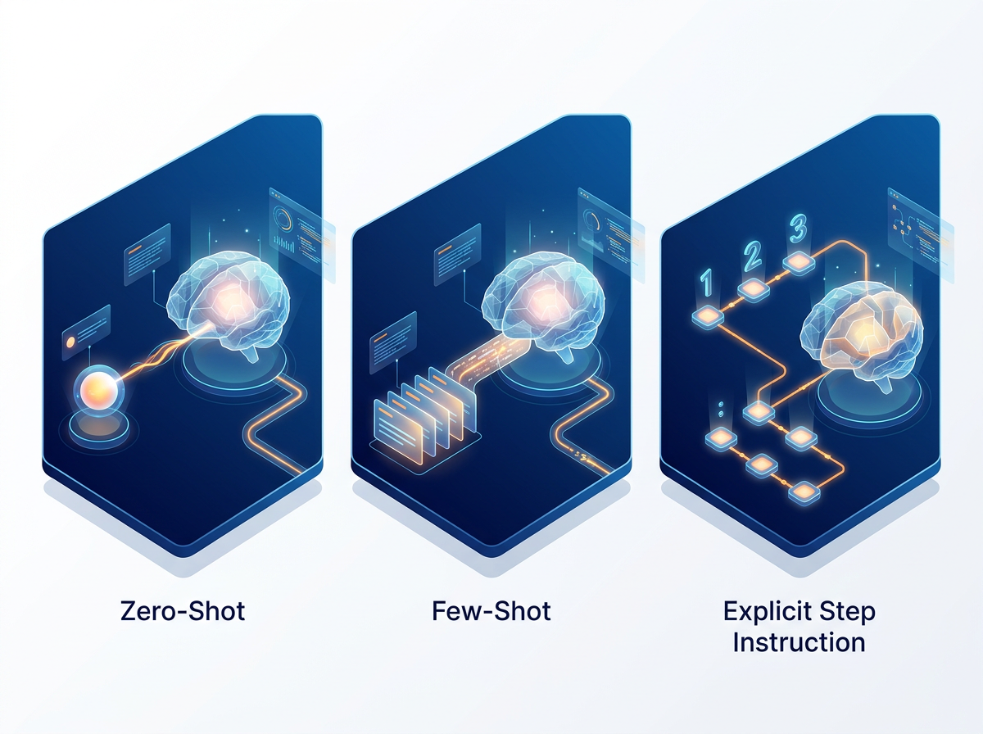

Type 1: Zero Shot CoT
The simplest form add a phrase that triggers the model to reason before answering. No examples needed.
Magic phrases that trigger CoT:
- "Let's think step by step."
- "Think through this carefully before answering."
- "Reason through this step by step."
- "Work through this systematically."
- "Show your reasoning before giving your final answer."
- "Think out loud, then conclude."

Demonstration — Without vs. With Zero Shot CoT
Without CoT:
Prompt: "A store sells apples for ₹15 each and mangoes for ₹25 each.
A customer buys 8 apples and 5 mangoes. They pay with ₹300. How much change do
they get?"

Response: "₹55"
(This could be right or wrong we can't tell how the model arrived at it)

With Zero-Shot CoT:
Prompt: "A store sells apples for ₹15 each and mangoes for ₹25 each.
A customer buys 8 apples and 5 mangoes. They pay with ₹300.
How much change do they get? Let's think step by step."

Response:
"Step 1: Calculate the cost of apples.
8 apples × ₹15 = ₹120
Step 2: Calculate the cost of mangoes.
5 mangoes × ₹25 = ₹125
Step 3: Calculate the total bill.
₹120 + ₹125 = ₹245
Step 4: Calculate the change. ₹300 − ₹245 = ₹55
The customer receives ₹55 in change."

Both give ₹55 here, but CoT makes the reasoning verifiable. On harder problems, CoT dramatically reduces errors.

Type 2: Few Shot CoT
Provide 1 or 2 examples where the reasoning chain is shown then present your actual problem. The model learns both the task and the reasoning pattern.
Example — Business Math with Few Shot CoT:
I'll demonstrate how to solve pricing and margin problems step by step.

EXAMPLE:
Q: A product costs ₹200 to manufacture. We want a 35% gross margin.
What should the selling price be?

A: Let me think through this.
Step 1: Understand what 35% gross margin means.
Gross margin = (Selling price − Cost) ÷ Selling price = 35%
This means cost = 65% of selling price.

Step 2: Set up the equation.
₹200 = 65% × Selling price
Selling price = ₹200 ÷ 0.65

Step 3: Calculate.
Selling price = ₹307.69 (rounded to ₹308)

Step 4: Verify.
Gross margin = (₹308 − ₹200) ÷ ₹308 = ₹108 ÷ ₹308 = 35.06% ✓

Answer: The selling price should be ₹308.

---
YOUR TURN:
Q: A SaaS company's monthly subscription costs ₹450/user to serve
(infrastructure + support + allocated overhead). They want a 60% gross
margin on their subscription revenue. Additionally, they must add 18% GST
on the final price charged to customers.
What should be the GST-inclusive monthly subscription price per user?
Think through this step by step, showing each calculation.
Type 3: Explicit Step Instruction
Tell the model exactly what steps to take. This gives you full control over the reasoning structure.
Template:
Analyze [problem] using the following steps:
Step 1: [What to do first]
Step 2: [What to do second]
Step 3: [What to do third]
Step 4: [Final synthesis / recommendation]

Problem: [Your problem]

Example — Root Cause Analysis:


Investigate the following business problem using exactly these steps:

Step 1: Restate the problem in your own words (2 sentences)
Step 2: Identify the 3 most likely root causes (not symptoms — causes)
Step 3: For each root cause, assess: likelihood (High/Medium/Low)
and evidence needed to confirm it
Step 4: Identify the single most likely root cause with justification
Step 5: Recommend the first 2 actions to investigate and begin resolving it

Problem: Our e-commerce website's conversion rate dropped from 3.2% to 1.8%
in the last 30 days. Traffic is up 15% (more visitors than before).
The product mix, pricing, and ad spend are unchanged. The drop happened
gradually over the 30-day period, not suddenly.

Expected structured output:
Step 1: Problem Restatement
Our website is getting more visitors than before but converting significantly
fewer of them to purchases — conversion has nearly halved while traffic rose 15%.
This suggests visitors are arriving but something is stopping them from buying.

Step 2: Three Most Likely Root Causes
1. Technical issue degrading user experience (slow load time, checkout errors)
2. Traffic quality change (new traffic source attracting less purchase-intent
visitors)
3. Competitive change (competitor launched lower price or better offer)

Step 3: Root Cause Assessment
1. Technical issue — Likelihood: HIGH
Evidence needed: Page load time data; checkout funnel drop-off data;
error log analysis; mobile vs desktop conversion split
2. Traffic quality — Likelihood: MEDIUM
Evidence needed: Traffic source breakdown before vs after;
bounce rate by traffic source; new visitor % change
3. Competitive change — Likelihood: LOW
Evidence needed: Competitor pricing audit; customer survey data

Step 4: Most Likely Root Cause
Technical issue — because the gradual decline (not sudden) with increased
traffic often points to performance degradation under load, and checkout
problems are the single biggest conversion killer in e-commerce.

Step 5: Recommended Actions
1. Immediate: Run GTmetrix and Google PageSpeed tests; analyze checkout
funnel in Google Analytics for step-specific drop-off points
2. Within 48 hours: Check server error logs; test checkout flow on
mobile and desktop; compare load times before vs. after the drop began

8.3 Self-Consistency — Advanced CoT Technique
Self-Consistency enhances CoT accuracy by:
- Running the same CoT prompt multiple times (or asking for multiple reasoning paths in one prompt)
- Comparing the reasoning chains and final answers
- Selecting the most consistent or most common answer
This is particularly powerful for high stakes decisions where accuracy is critical.



Self-Consistency in a Single Prompt
"Solve the following problem using 3 different reasoning approaches.
Show the full working for each approach. Then compare all three answers
and state which you are most confident in and why.

Problem: Our startup has ₹50 lakh in runway. Monthly burn rate is:
- Salaries: ₹18 lakh
- Infrastructure: ₹4 lakh
- Marketing: ₹8 lakh
- Operations: ₹3 lakh

We have two options:
Option A: Cut marketing to ₹2 lakh/month → extends runway
Option B: Double marketing to ₹16 lakh/month → aims to accelerate growth

Assuming Option B generates 30% more revenue (currently ₹10 lakh/month),
analyze both options for: runway duration, break-even timeline,
and which is strategically superior. Use 3 different analytical frameworks."

Verification-Through-CoT Pattern
After getting an AI answer, ask it to verify its own reasoning:
"Review your solution above. Check each step for:
1. Mathematical errors (recalculate each figure)
2. Logical errors (does each step follow from the previous?)
3. Assumption errors (what did you assume that may not be true?)

If you find any errors, correct them and provide the revised answer."

8.4 CoT for Business Applications
Business Math
Compound Growth / ROI:
"Calculate the 3-year ROI of implementing an AI-powered customer service
chatbot. Think through this step by step.

Given information:
- Current customer service team: 12 agents at ₹6 lakh/year each
- Chatbot implementation cost: ₹25 lakh (one-time)
- Annual maintenance: ₹5 lakh/year
- Chatbot can handle 70% of queries without human involvement
- Human agents needed after implementation: 4 (for complex cases)
- Assume agent costs stay flat (no raises for simplicity)

Calculate: Year 1, Year 2, Year 3 costs (before and after);
cumulative savings; total investment; 3-year ROI percentage."

Pricing and Margin Analysis:
"We are setting prices for a new consulting service package.
Think through this step by step.

Costs per engagement:
- Lead consultant time: 80 hours at ₹3,000/hour
- Junior consultant: 40 hours at ₹1,200/hour
- Travel and accommodation: ₹25,000 (flat)
- Administrative overhead allocation: 15% of direct labor costs
- Firm overhead allocation: 20% of total costs

We want a 40% profit margin on the project.
Calculate: total cost, target price, and price per day (assuming 15-day
project).
Then verify the margin is correct."

Decision Analysis
Multi-Factor Decision with CoT:
"Help me make a data-driven hiring decision. Think through this step by step.

We need to hire one Senior Data Scientist. We have 3 finalists.
Evaluate them against our criteria using a weighted scoring framework.

Criteria and weights:
- Technical skills (Python, ML, statistics): 30%
- Communication ability: 25%
- Domain experience (fintech): 20%
- Culture fit: 15%
- Salary expectation fit: 10%

Candidate scores (1–10):
Candidate A: Technical=9, Communication=6, Domain=8, Culture=7, Salary=6
Candidate B: Technical=7, Communication=9, Domain=7, Culture=9, Salary=9
Candidate C: Technical=8, Communication=7, Domain=9, Culture=6, Salary=7

Step 1: Calculate each candidate's weighted total score
Step 2: Identify the leading candidate by score
Step 3: Identify any 'veto-level' concern for the leading candidate
Step 4: Make a recommendation with reasoning"

Strategic Reasoning
Market Entry Analysis with CoT:
"Analyze whether our B2B HR software company should expand into the
Middle East market (UAE and Saudi Arabia). Think through this step by step.

Context:
- We are currently India-focused with ₹15 Cr ARR
- Product is cloud-based, configurable, English-language only
- Current team: 45 people, mostly in Bengaluru
- We have received 3 inbound inquiries from UAE companies in the last year
- No competitor of ours has a dedicated Middle East presence yet

Step 1: Assess market opportunity (size, growth, fit with our product)
Step 2: Assess our readiness (capability gaps, localization needs, investment
required)
Step 3: Assess competitive timing (first-mover advantage vs. risk of going too
early)
Step 4: Identify the 3 biggest risks of expanding now
Step 5: Identify the 3 biggest risks of NOT expanding now
Step 6: Make a clear recommendation: Expand now / Prepare for 12 months / Do not
expand
Support with a decision rationale of 3–4 sentences."



Debugging and Troubleshooting with CoT
CoT is invaluable for systematic debugging both technical and business process issues.
Code Debugging with CoT:
I have a bug in the following Python function. Walk me through the debugging
process step by step: first explain what the function is supposed to do,
then trace through the logic with the given inputs, identify where the
bug is, explain why it causes the wrong output, and provide the corrected code.

Input: items = [10, 20, 30, 40, 50], discount_rate = 0.1
Expected output: [9.0, 18.0, 27.0, 36.0, 45.0]
Actual output: [10, 20, 30, 40, 50] (no discount applied)

Buggy code:

def apply_discount(items: list, discount_rate: float) -> list:
discounted = []
for item in items:
if discount_rate > 0:
discounted_price = item * (1 - discount_rate)
discounted.append(item) # Bug is here — appending original, not
# discounted
return discounted

8.5 When to Use CoT — Decision Guide


Use CoT When:
Situation | Example
✓ MULTI-STEP MATH — Any calculation involving more than 2 operations. | "If revenue grows 15% each year for 3 years starting at ₹10 Cr..."
✓ CAUSAL REASONING — When you need to understand WHY, not just WHAT. | "Why did our churn rate increase?"
✓ COMPLEX DECISIONS — When multiple factors must be weighed and combined. | "Which vendor should we choose?"
✓ DEBUGGING / DIAGNOSIS — Finding the source of a problem systematically. | "Why isn't my SQL query returning the right results?"
✓ ARGUMENT CONSTRUCTION — Building a logical case with premises and conclusions. | "Make the case for a 4 day work week to our CFO."
✓ RISK ASSESSMENT — When multiple scenarios and their likelihood must be considered. | "What are the risks of launching in Q4?"
✓ ETHICAL ANALYSIS — When trade offs between values need to be explicitly worked through. | "Is it ethical to use customer data this way?"

Don't Need CoT for:
- ✗ Simple factual questions ("What is the capital of Japan?")
- ✗ Single step tasks ("Translate this to French")
- ✗ Simple summarization (no reasoning required)
- ✗ Format transformation (text to table, etc.)
- ✗ Creative writing (imagination, not logic)
- ✗ Standard classification (use few-shot instead)

8.6 CoT Trigger Phrase Reference
Not all CoT triggers are equal. Here are the most effective ones for different contexts:
Trigger Phrase | Best For
"Let's think step by step." | General reasoning, math, analysis
"Think through this carefully before answering." | Nuanced decisions
"Reason through all the factors systematically." | Multi-factor analysis
"Show your work for each calculation." | Math and financial problems
"Walk me through your diagnostic process." | Troubleshooting
"Reason from first principles." | Novel problems, strategy
"Consider all perspectives before concluding." | Ethical/stakeholder analysis
"Build the argument step by step, then state the conclusion." | Persuasive reasoning
"Identify assumptions, then reason from them." | Decision-making under uncertainty
"Think out loud, then give me your final answer." | Any complex task

Hands On Activities — Session 8
Activity 8.1 — Zero Shot CoT: Business Math

Part A — Without CoT:
"Our product costs ₹800 to manufacture. We sell it for ₹1,400.
Our monthly fixed costs are ₹2,50,000. How many units must we sell
per month to break even?"
Note the answer. Does the AI show its work?

Part B — With Zero-Shot CoT:
"Our product costs ₹800 to manufacture. We sell it for ₹1,400.
Our monthly fixed costs are ₹2,50,000. How many units must we sell
per month to break even? Let's think step by step, showing each
calculation clearly."

Then add complexity:
"Now also calculate: what happens to the break-even point if we:
(a) Increase selling price to ₹1,600
(b) Reduce manufacturing cost to ₹700 (different supplier)
(c) Both changes together
Think through each scenario step by step."

Document
💭 Did CoT improve accuracy? How did the reasoning help you verify the answer?

Activity 8.2 — Decision Analysis with Explicit Steps

Scenario: You need to decide whether to hire a full-time content writer or outsource to a freelancer.
Build a prompt using Explicit Step Instruction with these steps:
- Define the decision criteria relevant to this choice
- Estimate annual costs for each option (make reasonable assumptions)
- Assess non-financial factors (quality control, flexibility, IP, ramp-up time)
- Create a weighted decision matrix
- Make a clear recommendation
Evaluate
💭 Run it with ChatGPT. Does the reasoning feel logical? Where would you push back?

Activity 8.3 — Self Consistency for a Real Decision

Objective: Use self-consistency to validate a decision you're actually facing.
Think of a real decision you need to make (career, business, study, personal investment). Build a prompt that:
- States the decision clearly with all relevant facts
- Asks for 3 different reasoning approaches to the decision
- Asks for a final synthesized recommendation after comparing all 3
Reflection
💭 Did the three approaches agree? If they diverged, what does that tell you about the decision? What would you do next to resolve the divergence?

Activity 8.4 — CoT Code Debugging

Objective: Use CoT to debug code systematically.
Run this prompt:
"Walk me through debugging this Python function step by step.
First explain what it is supposed to do. Then trace through the logic
with the given test case. Identify the bug. Explain why it produces
the wrong output. Then provide the corrected version with a comment
explaining the fix.

Function purpose: Calculate the average of all numbers in a list,
excluding any values above a given threshold.

Expected behavior: average_below_threshold([10, 20, 30, 100, 50], 40)
should return 20.0 (average of 10, 20, 30 — excluding 50 and 100)

Buggy code:
def average_below_threshold(numbers, threshold):
filtered = [n for n in numbers if n < threshold]
if not filtered:
return 0
return sum(numbers) / len(filtered) # Bug: summing all numbers not filtered

Test case: average_below_threshold([10, 20, 30, 100, 50], 40)
Current output: 46.67 Expected output: 20.0"



Revision Questions — Session 8
- What is Chain-of-Thought prompting and what research validated its effectiveness?
- In your own words, explain WHY showing step-by-step reasoning improves AI accuracy on complex tasks.
- What is the difference between Zero-Shot CoT and Few-Shot CoT? Give an example scenario where each is preferable.
- What is Self-Consistency and when would a professional use it?
- Name 5 types of business tasks where CoT prompting is most valuable.
- Name 3 task types where CoT is unnecessary. Why don't these benefit from CoT?
- Write a CoT trigger phrase suitable for a risk assessment task.
- A financial analyst asks ChatGPT to calculate a complex multi-year financial projection and gets a wrong answer. How would they redesign the prompt using CoT to get a verifiable, accurate result?

Key Takeaways — Session 8
✓ CoT = instructing AI to show step by step reasoning before concluding proven to dramatically improve complex task accuracy
✓ Three types: Zero-Shot CoT (add "Let's think step by step"), Few-Shot CoT (show examples WITH reasoning chains), Explicit Step (define exact steps AI must follow)
✓ Self-Consistency: Run multiple reasoning paths, pick most common. Use for high stakes decisions where accuracy is critical
✓ Best for: math, multi-factor decisions, debugging, root cause, risk analysis, strategic reasoning, causal analysis
✓ Not needed for: simple facts, translation, creative writing, single-step format tasks
✓ Always verify: CoT makes reasoning visible = you can catch errors. Check each step before trusting the final answer

SESSION 8 COMPLETE
→ Proceed to Session 9: Persona Prompting

