10.REACTJS
THEORY
1Q.Define JSX
1A. JSX (JavaScript XML) is a syntax extension for JavaScript that allows developers to write HTML-like code inside JavaScript. It is mainly used in React to create and describe user interface (UI) elements in a simple and readable way.
JSX makes React code easier to understand because the UI structure looks similar to HTML. Although it looks like HTML, JSX is not directly understood by browsers. It is first converted into regular JavaScript using tools such as Babel, which transforms JSX into React.createElement() function calls.
Features of JSX
- Allows writing HTML-like syntax inside JavaScript.
- Makes React code more readable and easier to maintain.
- Supports JavaScript expressions using curly braces {}.
- Produces React elements that are rendered on the web page.
- Helps prevent injection attacks by automatically escaping values.
Syntax:
const element = <h1>Welcome to React!</h1>;
Equivalent JavaScript:
const element = React.createElement(
"h1",
null,
"Welcome to React!"
);
Example:
function App() {
return (
<div>
<h2>Hello React</h2>
<p>Learning JSX is simple.</p>
</div>
);
}
Advantages of JSX
- Easy to write and understand.
- Improves code readability.
- Allows embedding JavaScript expressions.
- Makes UI development faster.
- Provides better error detection during compilation.

2Q.Explain about ECMA Script
2A. ECMAScript (ES) is the official standard specification for the JavaScript programming language. It defines the syntax, features, and behavior of JavaScript. JavaScript is the implementation of the ECMAScript standard.
ECMAScript is maintained by ECMA International, and every new version introduces additional features to make JavaScript more powerful, efficient, and developer-friendly.
Popular ECMAScript Versions
Version | Features Introduced
ES5 (2009) | Strict Mode, JSON support, Array methods
ES6 (2015) | let, const, Arrow Functions, Classes, Modules, Template Literals
ES7 (2016) | Includes() method, Exponentiation operator
ES8 (2017) | Async/Await, Object.entries(), Object.values()
ES9 (2018) | Rest/Spread properties, Promise.finally()
ES10 (2019) | Array.flat(), trimStart(), trimEnd()
ES11 (2020) | Optional Chaining, Nullish Coalescing
ES12 (2021) | replaceAll(), Numeric separators
ES13 (2022) | Top-level await, Class fields
ES14+ | New improvements and optimizations

Important ES6 Features Used in React
- let and const
- Arrow Functions (=>)
- Classes
- Modules (import, export)
- Template Literals
- Destructuring
- Spread Operator (...)
- Rest Parameters
- Promises
- Default Parameters
Example
const name = "Mounika";
const message = `Welcome ${name}`;
console.log(message);
Advantages
- Cleaner and modern syntax.
- Better performance.
- Easier asynchronous programming.
- Supports modular programming.
- Improves code readability and maintainability.

3Q.Explain React.createElement()
3A. React.createElement() is the core React method used to create React elements. Every JSX code is internally converted into React.createElement() calls by Babel before being executed.
Syntax
React.createElement(
type,
props,
children
);

Parameters
Parameter | Description
type | HTML tag or React component
props | Properties or attributes
children | Content inside the element

Example
const element = React.createElement(
"h1",
{ style: { color: "blue" } },
"Hello React"
);

Equivalent JSX
<h1 style={{color:"blue"}}>Hello React</h1>
How It Works
- Developer writes JSX.
- Babel converts JSX into React.createElement().
- React creates Virtual DOM objects.
- React compares changes using the Virtual DOM.
- Only updated parts are rendered in the browser.
Advantages
- Creates React elements.
- Improves rendering efficiency using the Virtual DOM.
- Handles nested elements easily.
- Enables component-based UI development.

4Q.Explain how to create React nodes with JSX
4A. React nodes are created by writing JSX elements. Every JSX element becomes a React element (node) after compilation.
Creating a Single Node
const heading = <h1>Hello React</h1>;

Creating Multiple Nodes
const content = (
<div>
<h2>React</h2>
<p>Learning JSX</p>
</div>
);

Using React Fragment
<>
<h1>Heading</h1>
<p>Paragraph</p>
</>
Fragments allow multiple elements without adding an extra HTML tag.

Creating Nodes Dynamically
const name = "Mounika";
const element = <h2>Welcome {name}</h2>;

Nested JSX
const app = (
<div>
<h1>React</h1>
<ul>
<li>JSX</li>
<li>Components</li>
<li>Props</li>
</ul>
</div>
);

Advantages
- Easy to build UI.
- Supports nested elements.
- Allows reusable components.
- Supports dynamic content using JavaScript expressions.

5Q.Define how to render JSX to DOM
5A. Rendering JSX to the DOM means displaying React elements on the web page inside a root HTML element.
In React 18, the createRoot() method from react-dom/client is used for rendering.
Steps:
- Create a root element in HTML.
- Write JSX.
- Render it using createRoot().render().

HTML
<div id="root"></div>

React Code
import React from "react";
import ReactDOM from "react-dom/client";
const root = ReactDOM.createRoot(document.getElementById("root"));
root.render(
<h1>Hello React!</h1>
);
Rendering Components
function App() {
return <h2>Welcome to React</h2>;
}
const root = ReactDOM.createRoot(document.getElementById("root"));
root.render(<App />);

Rendering Flow
JSX
↓
Babel Compilation
↓
React.createElement()
↓
Virtual DOM
↓
Diffing Algorithm
↓
Real DOM Update

Advantages
- Efficient rendering using Virtual DOM.
- Updates only changed elements.
- Faster performance.
- Better user experience.

6Q.Explain how to use JavaScript expressions in JSX
6A. JavaScript expressions can be embedded inside JSX using curly braces {}. This allows dynamic content, calculations, variables, function calls, conditional rendering, and array rendering.
Using Variables
const name = "Mounika";
function App() {
return <h2>Hello {name}</h2>;
}

Using Arithmetic Expressions
const a = 20;
const b = 30;
<h2>{a + b}</h2>

Using Functions
function greet(name){
return "Hello " + name;
}
<h2>{greet("React")}</h2>

Using Conditional Operator
const isLogged = true;
<h2>{isLogged ? "Welcome" : "Please Login"}</h2>

Using Array Methods
const fruits = ["Apple","Mango","Orange"];
<ul>
{
fruits.map((fruit,index)=>(
<li key={index}>{fruit}</li>
))}</ul>
Allowed Expressions
- Variables
- Arithmetic operations
- Function calls
- Ternary operators
- Array methods
- Template literals

Not Allowed
- if statements
- for loops
- switch statements
(Use these outside JSX or replace them with expressions such as the ternary operator or .map().)

Advantages
- Dynamic UI.
- Reduces repetitive code.
- Supports conditional rendering.
- Makes components reusable.

7Q.Explain how to use inline CSS in JSX
7A. In React, inline CSS is written using the style attribute. Unlike HTML, the style attribute accepts a JavaScript object instead of a string.

Syntax:
style={{ propertyName: "value" }}

Example:
function App() {
return (
<h1 style={{color:"blue"}}>
Hello React
</h1>
);
}

Multiple CSS Properties
const headingStyle = {
color: "white",
backgroundColor: "green",
fontSize: "30px",
padding: "15px",
textAlign: "center"
};
function App() {
return (
<h1 style={headingStyle}>
Welcome to React
</h1>
);
}

Dynamic Inline CSS
const isError = true;
<h2 style={{ color: isError ? "red" : "green" }}>
Status
</h2>
Important Rules
- Use camelCase for CSS property names (e.g., backgroundColor, fontSize, textAlign).
- Pass styles as a JavaScript object.
- String values such as "20px" should be enclosed in quotes.
- Numeric values (where appropriate) can be written without quotes.
Advantages
- Styles can be applied dynamically.
- Easy to use conditional styling.
- Avoids CSS class name conflicts.
- Convenient for small, component-specific styles.

FOLDER STRUCTURE:

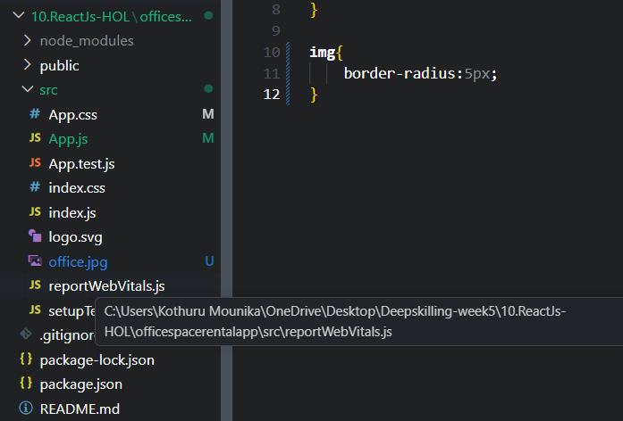

OUTPUT:



