12.REACTJS-HOL
THEORY
1Q.Explain about conditional rendering in React
1A. Conditional Rendering in React is the process of displaying different UI elements or components based on certain conditions. It works the same way as conditions in JavaScript, using statements or expressions such as if, if...else, the ternary operator (? :), and the logical AND (&&) operator.
Conditional rendering allows developers to show or hide content depending on values such as user login status, data availability, permissions, or application state.
Methods of Conditional Rendering
Method | Description
if statement | Used for complex conditions before returning JSX.
if...else | Displays different content based on two conditions.
Ternary Operator (? :) | Used for simple inline conditions.
Logical AND (&&) | Displays content only when the condition is true.
switch statement | Used for handling multiple conditions outside JSX.

Example 1:
Using if Statement:
function App() {
const isLoggedIn = true;
if (isLoggedIn) {
return <h2>Welcome User</h2>;
}
return <h2>Please Login</h2>;
}
Example 2:
Using Ternary Operator:
function App() {
const isLoggedIn = false;
return (
<h2>
{isLoggedIn ? "Welcome User" : "Please Login"}
</h2>
);
}
Example 3:
Using Logical AND:
function App() {
const isAdmin = true;
return (
<div>
{isAdmin && <h2>Admin Panel</h2>}
</div>
);
}

Advantages:
- Displays UI based on application state.
- Improves user experience.
- Reduces unnecessary rendering.
- Makes components more dynamic and reusable.
- Keeps code clean and readable.

2Q.Define element variables
2A. Element Variables are JavaScript variables used to store React elements (JSX). They help decide which element should be rendered based on a condition before returning JSX.
Using element variables makes conditional rendering easier, especially when the logic is more complex than a simple ternary operator.
Syntax:
let element;
The variable is assigned different JSX elements depending on the condition and is then returned inside the component.
Example
function App() {
const isLoggedIn = true;
let message
if (isLoggedIn) {
message = <h2>Welcome Back!</h2>;
} else {
message = <h2>Please Login</h2>;
}
return (
<div>
{message}
</div>
);
}
Another Example:
function App() {
const isMember = false;
let button;
if (isMember) {
button = <button>Logout</button>;
} else {
button = <button>Login</button>;
}
return (
<div>
{button}
</div>
);
}

Advantages
- Makes conditional rendering easier to understand.
- Reduces repeated JSX code.
- Improves code readability.
- Useful for handling multiple conditions.
- Keeps rendering logic organized.

3Q.Explain how to prevent components from rendering
3A. Sometimes, a React component should not render any UI based on a specific condition. In React, this is achieved by returning null from the component. When a component returns null, React does not display anything for that component, although the component still exists and can maintain its state or lifecycle.
This technique is useful when content should only be shown under certain conditions, such as user permissions, feature availability, or application state.
Example 1:
Returning null:
function Message(props) {
if (!props.show) {
return null;
}
return <h2>Welcome to React!</h2>;
}
function App() {
return <Message show={false} />;
}
Output:
Nothing is displayed because the component returns null.

Example 2:
Conditional Rendering of a Component:
function Profile() {
return <h2>User Profile</h2>;
}
function App() {
const isLoggedIn = false;
return (
<div>
{isLoggedIn && <Profile />}
</div>
);
}
Since isLoggedIn is false, the Profile component is not rendered.

Ways to Prevent Rendering:
Method | Description
return null | Prevents the component from rendering any UI.
Logical AND (&&) | Renders a component only if the condition is true.
Ternary Operator (? :) | Displays one component or another based on a condition.
Parent Component Check | The parent decides whether to render the child component.

Advantages:
- Prevents unnecessary UI rendering.
- Improves application performance.
- Makes components more flexible.
- Helps manage visibility based on conditions.
- Keeps the interface clean and user-friendly.

FOLDER STRUCTURE:
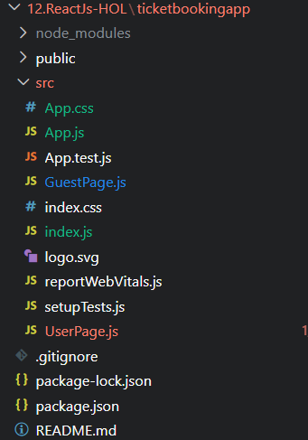

OUTPUT:
