13.REACTJS-HOL
THEORY
1Q.Explain various ways of conditional rendering
1A. Conditional rendering in React allows developers to display different UI elements based on certain conditions. React supports several JavaScript techniques to control what is rendered.

Ways of Conditional Rendering:
Method | Description
if Statement | Used for simple or complex conditions before returning JSX.
if...else Statement | Displays different UI based on two conditions.
Ternary Operator (? :) | Used for simple inline conditions inside JSX.
Logical AND (&&) | Renders content only when the condition is true.
switch Statement | Handles multiple conditions outside JSX.
Returning null | Prevents a component from rendering anything.

Example 1:
Using if Statement:
function App() {
const isLoggedIn = true;
if (isLoggedIn) {
return <h2>Welcome User</h2>;
}
return <h2>Please Login</h2>;
}
Example 2:
Using Ternary Operator:
function App() {
const isAdmin = false;

return (
<h2>
{isAdmin ? "Admin Dashboard" : "User Dashboard"}
</h2>
);
}
Example 3:
Using Logical AND:
function App() {
const showMessage = true;
return (
<div>
{showMessage && <h2>Hello React</h2>}
</div>
);
}

Advantages
- Displays UI dynamically.
- Improves user experience.
- Reduces unnecessary rendering.
- Makes applications interactive and flexible.

2Q.Explain how to render multiple components
2A. React applications are built using multiple reusable components. A parent component can render several child components by including them inside its JSX.
Rendering multiple components helps organize the application into smaller, reusable, and maintainable parts.
Example:
function Header() {
return <h2>Header</h2>;
}
function Content() {
return <p>This is the content section.</p>;
}
function Footer() {
return <h3>Footer</h3>;
}
function App() {
return (
<div>
<Header />
<Content />
<Footer />
</div>
);
}
Using React Fragment:
function App() {
return (
<>
<Header />
<Content />
<Footer />
</>
);
}
React Fragments (<>...</>) allow multiple components to be grouped without creating an extra HTML element.
Advantages
- Promotes code reusability.
- Improves readability.
- Makes applications modular.
- Simplifies maintenance.
- Encourages component-based development.

3Q.Define list component
3A. A List Component in React is a component used to display a collection of similar items such as names, products, students, or tasks. Lists are typically created by storing data in an array and using the map() function to convert each item into a React element.
Each item in the list should have a unique key to help React identify changes efficiently.
Example:
function App() {
const fruits = ["Apple", "Mango", "Orange"];
return (
<ul>
{fruits.map((fruit, index) => (
<li key={index}>{fruit}</li>
))}
</ul>
);
}

Output:
Apple
Mango
Orange

Advantages:
- Displays multiple items efficiently.
- Reduces repetitive code.
- Supports dynamic data.
- Easy to update and maintain.

4Q.Explain about keys in React applications
4A. A Key is a special attribute used when rendering lists in React. It uniquely identifies each element in a list so that React can determine which items have changed, been added, or removed.
Keys improve rendering performance and help React update only the necessary elements.

Syntax:
key={uniqueValue}
Example:
function App() {
const students = [
{ id: 1, name: "Rahul" },
{ id: 2, name: "Anjali" },
{ id: 3, name: "Kiran" }
];
return (
<ul>
{students.map(student => (
<li key={student.id}>
{student.name}
</li>
))}
</ul>
);
}
Rules for Keys
- Keys must be unique among sibling elements.
- Use stable IDs whenever possible.
- Avoid using array indexes if the list order may change.
- Keys are not accessible inside components as props.

Advantages
- Improves rendering performance.
- Helps React track list items.
- Prevents unnecessary re-rendering.
- Makes UI updates more efficient.

5Q.Explain how to extract components with keys
5A. When a list becomes large, it is good practice to move each list item into a separate component. The key should be assigned where the list is created, not inside the child component.
This keeps the code modular, reusable, and easier to maintain.
Example:
Student Component
function Student(props) {
return <li>{props.name}</li>;
}
App Component
function App() {
const students = [
{ id: 1, name: "Rahul" },
{ id: 2, name: "Anjali" },
{ id: 3, name: "Kiran" }
];
return (
<ul>
{students.map(student => (
<Student
key={student.id}
name={student.name}
/>
))}
</ul>
);
}
Important Note:
Correct: Assign the key when rendering the list.
<Student key={student.id} name={student.name} />
Incorrect: Assigning the key inside the Student component.
Advantages:
- Improves code organization.
- Encourages reusable components.
- Keeps list rendering efficient.
- Makes applications easier to maintain.

6Q.Explain React Map, map() function
6A. The map() function is a JavaScript array method widely used in React to display lists of data. It creates a new array by applying a function to each element of the original array.
In React, map() is commonly used to convert arrays into JSX elements.
Syntax:
array.map((item, index) => {
return JSX;
});
Example 1:
Simple List:
function App() {
const fruits = ["Apple", "Mango", "Orange"];
return (
<ul>
{fruits.map((fruit, index) => (
<li key={index}>{fruit}</li>
))}
</ul>
);}
Example 2: Object Array
function App() {
const employees = [
{ id: 1, name: "John" },
{ id: 2, name: "David" },
{ id: 3, name: "Emma" }
];
return (
<ul>
{employees.map(employee => (
<li key={employee.id}>
{employee.name}
</li>
))}
</ul>
);
}
How map() Works:
- Takes an array as input.
- Processes each element one by one.
- Returns a new array of JSX elements.
- React renders the returned elements as a list.
Advantages:
- Reduces repetitive code.
- Simplifies list rendering.
- Works efficiently with dynamic data.
- Makes code cleaner and more readable.
- Easily integrates with React components.

FOLDER STRUCTURE:

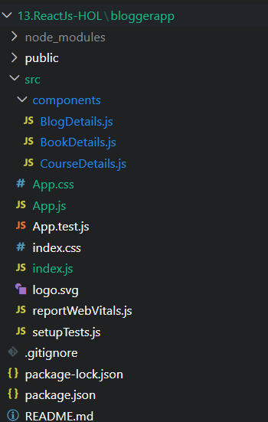

OUTPUT:
