14.REACTJS-HOL
THEORY
1Q.2Explain the need and Benefits of React Context API
1A. The React Context API is a built-in feature of React that allows data to be shared between multiple components without passing props manually through every level of the component tree (a problem known as prop drilling).
Normally, data is passed from a parent component to child components using props. However, when many nested components need the same data, passing props through each intermediate component becomes difficult. The Context API solves this problem by providing a centralized way to share data.
Need for React Context API:
- Eliminates prop drilling.
- Shares common data across multiple components.
- Makes state management easier.
- Reduces unnecessary props.
- Improves code readability and maintainability.
Benefits of React Context API
Benefit | Description
Avoids Prop Drilling | Data is shared directly without passing props through intermediate components.
Centralized Data | Stores common data in one place.
Better Code Organization | Makes components cleaner and easier to maintain.
Easy State Sharing | Multiple components can access the same data.
Built into React | No need for external libraries for simple state sharing.

Example:
import { createContext } from "react";
const UserContext = createContext();
<UserContext.Provider value="Mounika">
<Home />
</UserContext.Provider>
import { useContext } from "react";
function Home() {
const user = useContext(UserContext);
return <h2>Welcome {user}</h2>;
}

Advantages
- Simplifies data sharing.
- Reduces repetitive code.
- Improves application scalability.
- Easy to use with Hooks like useContext().
- Suitable for global data such as themes, user information, and language settings.

2Q.Working with createContext()
2A. createContext() is a React function used to create a Context object. This object allows data to be shared between components without manually passing props.
After creating a context, a Provider supplies the data, and consumer components access it using the useContext() Hook.
Syntax:
import { createContext } from "react";
const MyContext = createContext();

Steps to Use createContext():
Step | Description
1 | Create a Context using createContext().
2 | Wrap components with the Context Provider.
3 | Pass data using the value prop.
4 | Access the data using useContext().

Example:
Step 1:
Create Context
import { createContext } from "react";
export const UserContext = createContext();
Step 2:
Provide Context
import { UserContext } from "./UserContext";
function App() {
return (
<UserContext.Provider value="React User">
<Home />
</UserContext.Provider>
);
}
Step 3:
Consume Context
import { useContext } from "react";
import { UserContext } from "./UserContext";
function Home() {
const user = useContext(UserContext);
return <h2>Hello {user}</h2>;
}
Working Process:
createContext()
↓
Create Context Object
↓
Provider Supplies Data
↓
useContext() Reads Data
↓
Component Displays Data
Advantages:
- Easy global data sharing.
- Eliminates unnecessary prop passing.
- Works efficiently with functional components.
- Makes applications cleaner and more maintainable.

3Q.List the types of Router Components
3A. React Router is a library used for navigation in React applications. It allows users to move between different pages without reloading the browser.
React Router provides several router components, each designed for different environments and use cases.
Types of Router Components:
1. BrowserRouter
Most commonly used router for React web applications.
import { BrowserRouter } from "react-router-dom";
function App() {
return (
<BrowserRouter>
<Home />
</BrowserRouter>
);
}

2. HashRouter
Uses the hash (#) portion of the URL.
import { HashRouter } from "react-router-dom";
<HashRouter>
<App />
</HashRoute

Example URL
http://localhost:3000/#/home

3. MemoryRouter
Stores routes in memory instead of the browser address bar.
import { MemoryRouter } from "react-router-dom";
<MemoryRouter>
<App />
</MemoryRouter>
Used mainly for:
- Unit testing
- React Native
- Non-browser applications

4. StaticRouter
Used in server-side rendering (SSR) applications.
import { StaticRouter } from "react-router-dom/server";

5. RouterProvider
Introduced in React Router v6.4+ to support data routers.
import { RouterProvider } from "react-router-dom";
<RouterProvider router={router} />
Comparison Table:
Router | URL Changes | Common Use
BrowserRouter | Yes | Standard React web applications
HashRouter | Yes (#) | Static hosting or servers without route support
MemoryRouter | No | Testing and non-browser environments
StaticRouter | No | Server-side rendering (SSR)
RouterProvider | Yes | Modern React Router (v6.4+) with data routing

Advantages of React Router:
- Enables navigation without page refresh.
- Supports dynamic routing.
- Improves user experience.
- Provides nested routing.
- Allows protected routes and route parameters.
- Makes single-page applications (SPAs) easy to build.
FOLDER STRUCTURE:

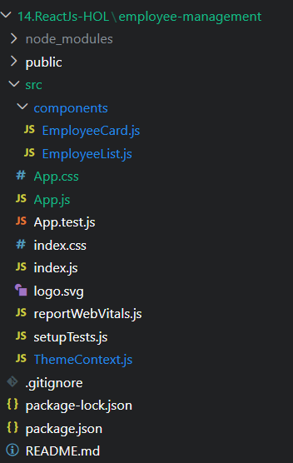

OUTPUT SCREEN:




