15.REACTJS-HOL
THEORY
1Q.Explain about React forms
1A. A React Form is used to collect user input such as names, email addresses, passwords, comments, and other data. React forms work similarly to HTML forms, but React manages the form data using state, making it easier to control, validate, and process user input.
In React, form elements like <input>, <textarea>, and <select> are typically implemented as controlled components, where their values are managed by the component's state.
Common Form Elements:
Form Element | Purpose
<input> | Accepts text, numbers, passwords, etc.
<textarea> | Accepts multi-line text input.
<select> | Creates a drop-down list.
<option> | Represents an option inside a <select>.
<button> | Submits or performs an action.
<form> | Groups form elements together.

Example:
function App() {
return (
<form>
<label>Name:</label>
<input type="text" />
<br /><br />
<button type="submit">
Submit
</button>
</form>
);
}

Features:
- Collects user input.
- Uses React state to manage values.
- Supports validation.
- Easy to handle form submission.
- Integrates with event handling.
Advantages:
- Better control over form data.
- Simplifies validation.
- Improves user experience.
- Supports dynamic forms.
- Makes applications more interactive.

2Q.Define controlled components
2A. A Controlled Component is a form element whose value is controlled by the React state. Instead of the browser managing the form data, React keeps the current value in the component's state and updates it whenever the user types.
This approach ensures that the UI and data remain synchronized.

How Controlled Components Work:
- Create a state variable.
- Bind the input's value to the state.
- Update the state using the onChange event.

Example:
import { useState } from "react";
function App() {
const [name, setName] = useState("");
return (
<div>
<input
type="text"
value={name}
onChange={(e) => setName(e.target.value)}
/>
<h3>Hello {name}</h3>
</div>
);
}

Characteristics:
- Value is controlled by React state.
- Uses the onChange event.
- Keeps UI synchronized with data.
- Makes validation easier.

Advantages:
- Easy to validate input.
- Better control over user data.
- Predictable application behavior.
- Simplifies form handling.

3Q.Explain about various input controls
3A. React supports different types of input controls for collecting various kinds of user data. These controls are similar to HTML form elements but are usually managed through React state.
Common Input Controls
Input Control | Description
Text Box | Accepts text input.
Password | Accepts hidden password input.
Email | Accepts email addresses.
Number | Accepts numeric values.
Radio Button | Allows selecting one option from a group.
Checkbox | Allows selecting multiple options.
Textarea | Accepts multi-line text.
Select | Creates a drop-down list.
File | Allows users to upload files.
Button | Performs an action or submits a form.

Example:
function App() {
return (
<form>
<input type="text" placeholder="Name" />
<br /><br />
<input type="password" placeholder="Password" />
<br /><br />
<input type="email" placeholder="Email" />
<br /><br />
<textarea placeholder="Comments"></textarea>
<br /><br />
<select>
<option>India</option>
<option>USA</option>
</select>
</form>
);
}

Advantages:
- Supports different types of user input.
- Improves data collection.
- Makes forms interactive.
- Provides a better user experience.

4Q.Explain about handling forms
4A. Handling forms in React means managing user input, updating state, validating data, and processing the form when the user interacts with it.

React handles forms mainly using:
- useState() for storing input values.
- onChange for updating state.
- onSubmit for processing the form submission.

Steps:
- Create state variables.
- Bind input values to state.
- Update state using onChange.
- Handle submission using onSubmit.

Example:
import { useState } from "react";
function App() {
const [name, setName] = useState("");
function handleChange(event) {
setName(event.target.value);
}
return (
<form>
<input
type="text"
value={name}
onChange={handleChange}
/>
<h3>{name}</h3>
</form>
);
}

Features:
- Manages form data with state.
- Supports real-time updates.
- Simplifies validation.
- Provides controlled input handling.

Advantages:
- Better data management.
- Easy validation.
- Keeps UI synchronized.
- Improves application reliability.

5Q.Explain about submitting forms
5A. Submitting a form in React is done using the onSubmit event. When the form is submitted, React executes a function that processes the entered data.
The event.preventDefault() method is commonly used to prevent the browser from reloading the page after form submission.

Syntax:
<form onSubmit={handleSubmit}>

Example:
import { useState } from "react";
function App() {
const [name, setName] = useState("");
function handleSubmit(event) {
event.preventDefault();
alert("Submitted: " + name);
}
return (
<form onSubmit={handleSubmit}>
<input
type="text"
value={name}
onChange={(e) => setName(e.target.value)}
/>
<button type="submit">
Submit
</button>
</form>
);
}

Working Process:

User Fills Form
↓
onChange Updates State
↓
User Clicks Submit
↓
onSubmit Event Triggered
↓
event.preventDefault()
↓
Process Form Data

Advantages:
- Prevents unnecessary page reloads.
- Makes form processing easier.
- Supports validation before submission.
- Improves user experience.
- Allows sending data to servers or APIs efficiently.
`

FOLDER STRUCTURE

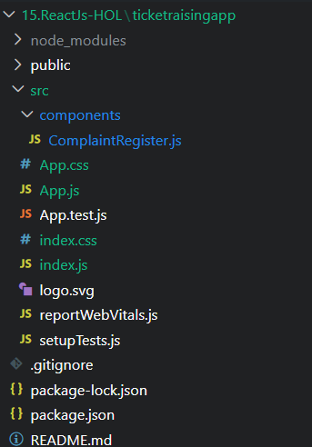

OUTPUT SCREEN
