6.REACTJS-HOL
THEORY

1Q.Explain the need and benefits of React Router
1A. NEED FOR REACT ROUTER
React is a JavaScript library used to build Single Page Applications (SPAs). In a traditional web application, every time the user clicks a link, the browser sends a request to the server and loads a completely new HTML page. This causes page refreshes, increases loading time, and provides a less smooth user experience.
React Router solves this problem by enabling client-side routing, where navigation happens inside the browser without refreshing the entire page. Instead of requesting a new page from the server, React Router dynamically loads only the required React component while keeping the rest of the application unchanged. This makes React applications faster, more interactive, and easier to use.
React Router also allows developers to organize applications into multiple pages such as Home, About, Contact, Dashboard, Profile, and Details pages while still maintaining the behavior of a Single Page Application.

BENEFITS OF REACT ROUTER
- Enables navigation without refreshing the browser.
- Supports Single Page Application (SPA) architecture.
- Improves application performance by loading only the required components.
- Provides a smoother and faster user experience.
- Reduces unnecessary communication with the server.
- Makes applications modular and easier to maintain.
- Supports dynamic routing through URL parameters.
- Allows browser history management using the History API.
- Simplifies navigation between multiple components.
- Supports nested routing for large and complex applications.
- Allows bookmarking and sharing of URLs.
- Makes applications more scalable and organized.

2Q.Identify the Components in React Router
2A. React Router provides several built-in components and hooks that help implement routing and navigation in React applications.
1. BrowserRouter
BrowserRouter is the root router component that enables routing in a React application. It uses the browser's HTML5 History API to keep the UI synchronized with the URL. It wraps the entire application and allows all child components to access routing features.
Example:
<BrowserRouter>
<App />
</BrowserRouter>
Purpose
- Enables client-side routing.
- Tracks browser history.
- Prevents page refresh during navigation.

2. Routes
Routes acts as a container for multiple Route components. It checks the current URL and renders only the component whose path matches the URL.
Example:
<Routes>
<Route path="/home" element={<Home />} />
</Routes>
Purpose
- Groups multiple routes together.
- Displays only the matched route.
- Improves route organization.

3. Route
Route maps a specific URL path to a React component.
Whenever the browser URL matches the specified path, the corresponding component is rendered.
Example
<Route path="/trainers" element={<TrainersList />} />

Purpose
- Maps URLs to components.
- Supports dynamic routes.
- Organizes navigation.

4. Link
Link is used to navigate between different pages inside a React application.
Unlike the HTML <a> tag, Link does not reload the page.
Example
<Link to="/trainers">
Trainers
</Link>
Purpose
- Enables fast navigation.
- Prevents page refresh.
- Maintains SPA behavior.

5. Navigate
Navigate is used to redirect users from one route to another automatically.
Example
<Route path="/" element={<Navigate to="/home" />} />
Purpose
- Redirect users.
- Handle default routes.
- Control application flow.

6. useParams()
useParams() is a React Router hook that retrieves parameters passed through the URL.
Example
const { id } = useParams();

If the URL is
/trainer/3
then
id = 3
Purpose
- Reads dynamic URL values.
- Displays specific record details.
- Supports dynamic pages.

3Q.List the types of Router Components
3A. React Router provides different router components for different application requirements.
1. BrowserRouter
BrowserRouter is the most commonly used router component in React applications. It uses the HTML5 History API to create clean and user-friendly URLs without using the # symbol.
Example URL:
http://localhost:3000/trainers
Advantages
- Clean URLs.
- Better SEO.
- Best choice for modern web applications.
- Faster navigation.

2. HashRouter
HashRouter stores routing information after the # symbol in the URL.
Example:
http://localhost:3000/#/trainers
It is mainly used when the web server does not support browser history.
Advantages
- Easy deployment.
- No server configuration needed.
- Works on static hosting.

Disadvantages
- URLs contain #.
- Less SEO-friendly.

3. MemoryRouter
MemoryRouter stores navigation history only in memory.
It does not change the browser URL.
It is mainly used for
- Testing React components
- React Native applications
Advantages
- Easy testing.
- Fast execution.
- No dependency on browser history.

4. StaticRouter
StaticRouter is mainly used for Server Side Rendering (SSR).
Frameworks like Next.js use StaticRouter for rendering pages on the server.
Advantages
- Improves SEO.
- Faster initial page load.
- Better performance for server-rendered applications.

4Q.Parameter passing via url
4A. React Router allows developers to pass data through the URL using route parameters.
A parameter is represented using a colon (:).
Example
<Route
path="/trainer/:id"
element={<TrainerDetails />}
/>

Suppose the user clicks
/trainer/2
The value
id = 2
is automatically extracted.
Inside the component, useParams() is used to retrieve the value.
const { id } = useParams();
The retrieved value is then used to search the trainer data and display the corresponding trainer's details.

ADVANTAGES OF URL PARAMETERS
- Enables dynamic routing.
- Displays individual records.
- Makes URLs meaningful.
- Improves application flexibility.
- Easy sharing of specific pages.
- Supports bookmarking.
- Increases code reusability.
- Simplifies data retrieval.

DIFFERENCE BETWEEN LINK AND ANCHOR TAG
Link (react-router-dom) | HTML Anchor (<a>)
Used for navigation in React applications | Used for navigation in HTML pages
Prevents page refresh | Reloads the entire page
Maintains SPA behavior | Loads a new page from the server
Uses the to attribute | Uses the href attribute
Faster navigation | Comparatively slower
Preserves application state | Application state may be lost
Improves user experience | Causes unnecessary page reloads

DIFFERENCE BETWEEN BROWSERROUTER AND HASHROUTER

BrowserRouter | HashRouter
Uses HTML5 History API | Uses URL hash (#)
Generates clean URLs | URLs contain #
Better SEO support | Limited SEO support
Requires server configuration | No server configuration required
Suitable for production applications | Suitable for static hosting
Preferred for modern React applications | Preferred when server routing is unavailable
Better user experience | Simpler deployment

ADVANTAGES OF REACT ROUTER
- Provides client-side routing.
- Supports Single Page Applications.
- Eliminates unnecessary page refreshes.
- Improves application performance.
- Makes navigation faster.
- Supports dynamic URL parameters.
- Enables nested routing.
- Simplifies application architecture.
- Provides browser history management.
- Supports route redirection.
- Allows code splitting with lazy loading.
- Makes applications modular.
- Improves code maintainability.
- Enhances user experience.
- Supports scalable application development.
- Works seamlessly with React components.
- Enables bookmarkable URLs.
- Reduces server load.

FOLDER STRUCTURE:
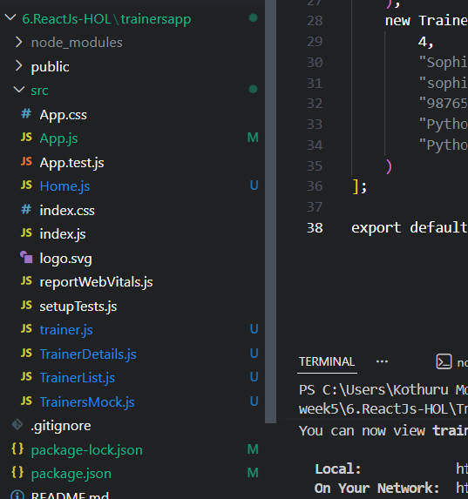

OUTPUT SCREEN:

