8.REACTJS
THEORY

1Q.Explain React State
1A. React State is a built-in object in React that is used to store and manage data that can change during the lifetime of a component. State allows a component to display dynamic information and automatically updates the user interface whenever its value changes. Unlike props, state is owned and controlled by the component itself and can be modified using the setState() method in class components.
State is commonly used to handle user interactions such as button clicks, form inputs, counters, login status, shopping carts, and API responses. Whenever the state is updated, React automatically re-renders the component and updates only the necessary parts of the page using the Virtual DOM, making the application fast and efficient.
In this hands-on lab, React State is used to store the entry count and exit count of people in a shopping mall. Initially, both values are set to zero in the constructor. When the Login button is clicked, the UpdateEntry() method increments the entry count, and when the Exit button is clicked, the UpdateExit() method increments the exit count using setState(). The updated values are immediately displayed on the screen without refreshing the page.

FEATURES OF REACT STATE
- Stores dynamic data within a component.
- Managed by the component itself.
- Can be updated using setState().
- Automatically re-renders the component when data changes.
- Supports different data types such as numbers, strings, arrays, objects, and booleans.
- Helps build interactive and dynamic user interfaces.

ADVANTAGES OF REACT STATE
- Makes applications interactive.
- Automatically updates the UI when data changes.
- Improves performance using the Virtual DOM.
- Reduces manual DOM manipulation.
- Makes code easier to maintain and manage.
- Supports real-time updates based on user actions.
FOLDER STRUCTURE

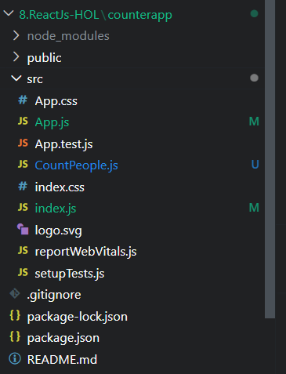

OUTPUT SCREEN

