This document covers the framework usage and how to execute the feature files independently and as a test suite.

This package contains all the page objects classes where actual logic is written.

Project Structure:

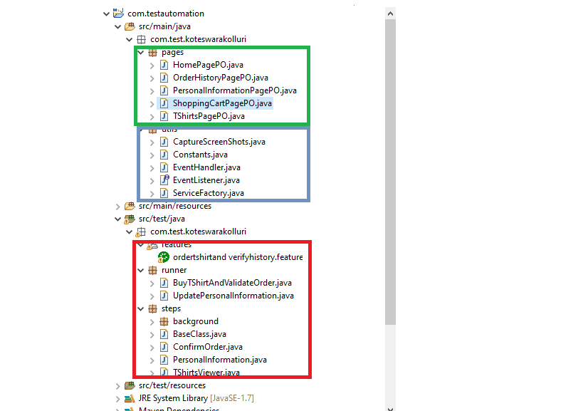

Feature’s package has all the feature files, runner package has all runner classes which are useful to run all the features configured, steps package has all the steps to run feature files.

v

This package contains all the reusable classes, the methods in these classes are used across other page object classes.

v

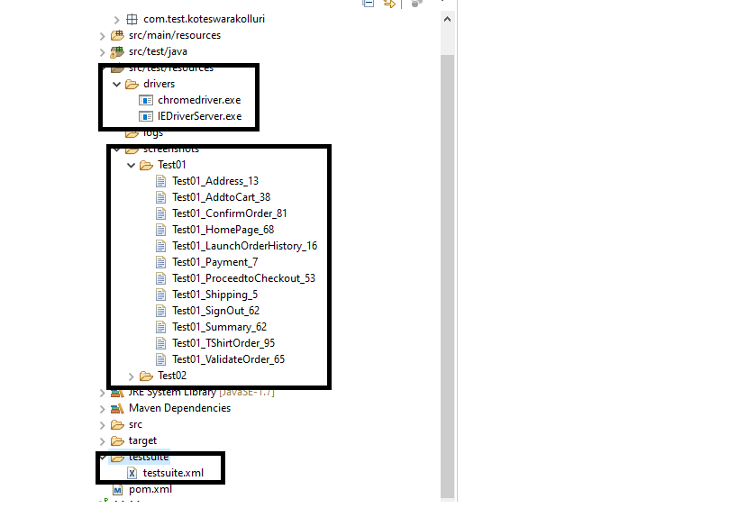

The runner files can be run as test suite using testsuite.xml file

All the screenshots are stored under src/test/resources/screenshots

All the driver executables are stored under src/test/resources/drivers