Group: Cloud-Ink

Cloud Enabled Interactive Virtual Smart Board

Project Summary
Imagine you are writing or drawing in the air and the computer understands it.
That’s exactly what Cloud-Ink does. It turns your hand into a pen, your gestures into commands, and your voice or movement into messages — all without touching a screen.
The system uses a simple webcam to track hand movements, so you can:
- Write, erase, or move things on a virtual whiteboard by waving your hand.
- Use special gestures to perform quick actions like clearing the board or selecting tools.
But Cloud-Ink does not stop there. It also helps people who find it hard to speak or move easily.
There a communication section with tiles — like “Water,” “Help,” or “Pain.”
When a user points to a tile, the system understands what they mean and says it aloud through a friendly computer voice.

Name | Role | Key Responsibilities
Koti Reddy Baddam | Cloud Engineer | Builds and manages all cloud parts of the project. Sets up AWS Bedrock for AI text generation, Amazon Polly for text-to-speech, and manages deployment using AWS ECS and S3. Makes sure the app runs smoothly online.
Trishal Varma Mudunuri | Full Stack Developer | Creates the web interface of the smart board — how users see, draw, and interact. Connects the front end (HTML/JS or Streamlit) with the backend (Python gesture logic). Handles integration between the visual board and AI outputs.
Sujith Reddy Yanamala | System Developer | Focuses on how the board understands gestures. Uses OpenCV and trained models to detect hand position, fingertip, and gestures like write/erase. Ensures the board responds quickly and accurately.
Mohammad Abdul Basith | Support Engineer | Handles testing, debugging, and documentation. Makes sure each feature works correctly, supports deployment, and maintains quality checks and performance logs.

- Virtual Board System
  - Detects hand movement through a webcam.
  - Lets you write, erase, move, and clear the board using only hand gestures.
- Gesture Recognition Engine
  - Uses trained models to detect hand and fingertip positions.
  - Maps each gesture (like one finger up = write, two fingers = erase, etc.) to board actions.
- Interactive Tiles (Assistive Mode)
  - Adds a tile-based area with messages like “Water,” “Help,” or “Pain.”
  - When a user holds their finger over a tile, it’s automatically selected.
- AI Response Layer (Planned Cloud Component)
  - Each tile corresponds to an intent (like “thirsty”).
  - AWS Bedrock (LLM) turns it into a polite, full sentence (“Could I have some water, please?”).
  - Amazon Polly or a local text-to-speech engine reads the sentence aloud.
- Local + Cloud Hybrid Design
  - Everything (camera, detection, board) runs locally for speed.
  - Only short text data (intent) is sent to the cloud for AI enhancement.
  - Makes the system private, efficient, and smart.
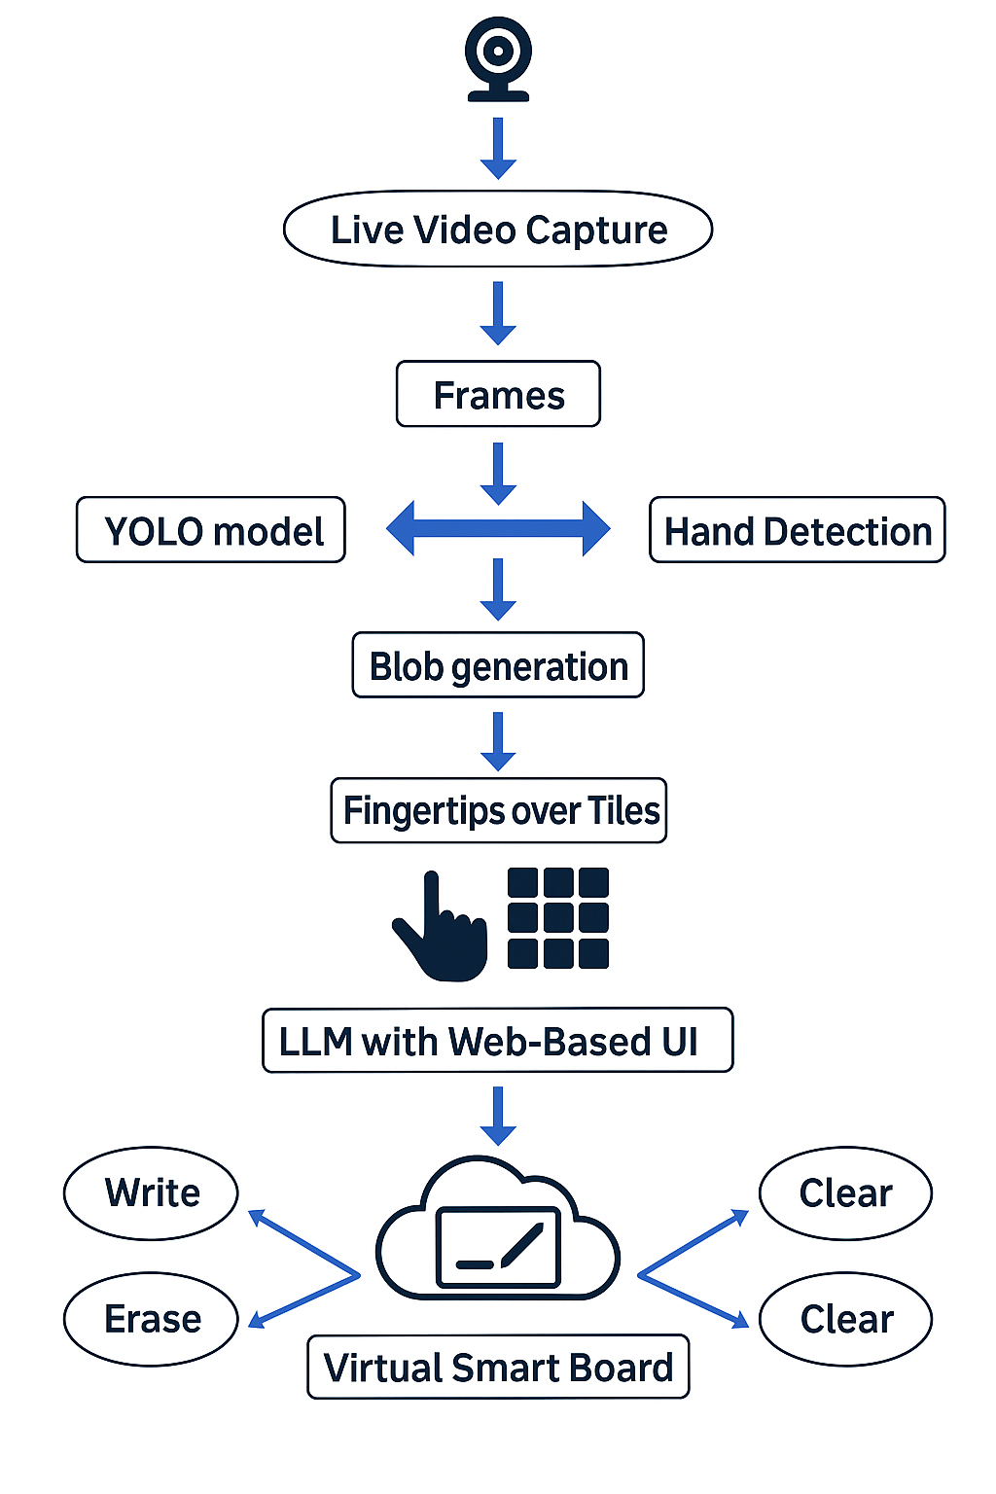
Updated Tech Stack
Languages & Libraries
- Python, OpenCV, NumPy
- PyTorch (or equivalent) for YOLOv2 & VGGNet models
Models
- YOLOv2 for real-time hand detection
- VGGNet for fingertip / gesture classification
- AWS Bedrock LLM (for intent → sentence generation)
Frameworks & Tools
- Flask / FastAPI or Streamlit for local web-based UI
- Docker for containerization
- GitHub Actions for CI/CD
Cloud & Services
- AWS ECS Fargate (container orchestration)
- AWS S3 (optional storage for logs, session exports)
- AWS CloudFront (optional content delivery)
- AWS CloudWatch (monitoring & logs)
- AWS Bedrock (LLM)
- AWS Polly or local TTS library (speech output)
Datasets
- Egocentric / Ego-Finger–style dataset for training & evaluating hand / fingertip detection.

Current Status
You can safely say something like:
- Completed
  - Core gesture-based virtual board (write, erase, move, clear)
  - YOLOv2 + VGGNet pipeline for hand & fingertip detection in real-time
  - Dockerized application structure and basic cloud deployment plan
- In Progress
  - Implementing tile-based communication board on top of the existing virtual board
  - Integrating AWS Bedrock for intent → sentence generation
  - Integrating TTS for spoken messages
  - Designing initial accessibility scenarios (e.g., basic needs requests)
- Planned
  - Multi-user viewing of the board through web UI (read-only or limited control)
  - Session logging and basic analytics (most-used tiles, latency, etc.)
  - Performance comparison: local-only vs cloud-assisted operation

Next Week Plan
You can list:
- Finalize gesture → tile → intent mapping for 6–10 communication tiles
- Implement a minimal Bedrock integration module with at least 2–3 sample intents
- Add a simple TTS pipeline and confirm end-to-end flow: gesture → tile → sentence → speech
- Prepare a short technical demo video showing:
  - writing on the virtual board
  - selecting a communication tile
  - generated sentence being spoken

Blockers / Risks
- Model retraining & tuning for robust fingertip detection across lighting and backgrounds
- Latency variability when calling Bedrock from cloud vs local demo
- Integration complexity: combining CV pipeline, web UI, and LLM/TTS cleanly
- Accessibility testing: limited time to test with real users, so scenarios are simulated

