**SMARTSDLC – AI - ENHANCED SOFTWARE DEVELOPMENT LIFECYCLE**

**RISK DETECTION AND ALERT ENGINE**

|  |  |
| --- | --- |
| **TEAM ID** | LTVIP2025TMID32357 |
| **PROJECT NAME** | RISK DETECTION AND ALERT ENGINE |

**Introduction**:

In software development, risk detection and alerts play a critical role in ensuring the success of a project. Risks can arise at any stage of the Software Development Life Cycle (SDLC), including planning, designing, coding, testing, and deployment. These risks may include missed deadlines, cost overruns, technical failures, team resource issues, or even security vulnerabilities.

Risk detection refers to the proactive identification of potential issues that could negatively impact the software project. This process typically involves analyzing project metrics, historical data, and current performance to predict where and when problems might occur.

Alerts, on the other hand, are real-time notifications or warnings generated when certain risk thresholds are exceeded. These alerts help project managers and developers take immediate corrective action before the issues escalate.

By integrating AI and machine learning into risk detection, modern Smart SDLC systems can automatically analyze large volumes of data to predict risks accurately. Combined with cloud platforms like IBM Cloud, these systems can be deployed and scaled efficiently, providing automated alerts via email, SMS, or dashboards.

The ultimate goal is to enhance decision-making, reduce project failures, and ensure timely and successful delivery of high-quality software.

**🎯 Purpose of Risk Detection and Alerts:**

The primary purpose of Risk Detection and Alerts in the Software Development Life Cycle (SDLC) is to proactively identify, monitor, and respond to potential threats that may impact the success of a project.

**Key objectives include**:

1. Early Identification of Problems.

2. Minimize Project Delays and Cost Overruns.

3. Enhance Decision-Making.

4. Improve Quality and Reliability.

5. Enable Automated Monitoring.

6. Support Compliance and Governance.

**IDEATION PHASE:**

Brainstorming provides a free and open environment that encourages everyone within a team to participate in the creative thinking process that leads to problem solving. Prioritizing volume over value, out-of-the-box ideas are welcome and built upon, and all participants are encouraged to collaborate, helping each other develop a rich amount of creative solutions.

**Reference:** **https://images.app.goo.gl/RRieGxmeCox7T9iF6**

**PROBLEM STATEMENT:**

Early and Accurate Risk Detection:

The system needs to identify risks early in their lifecycle, even before they manifest as critical failures. This requires sophisticated analysis of various data streams and the ability to distinguish between normal fluctuations and genuine threats.

**EMPATHY MAP:**

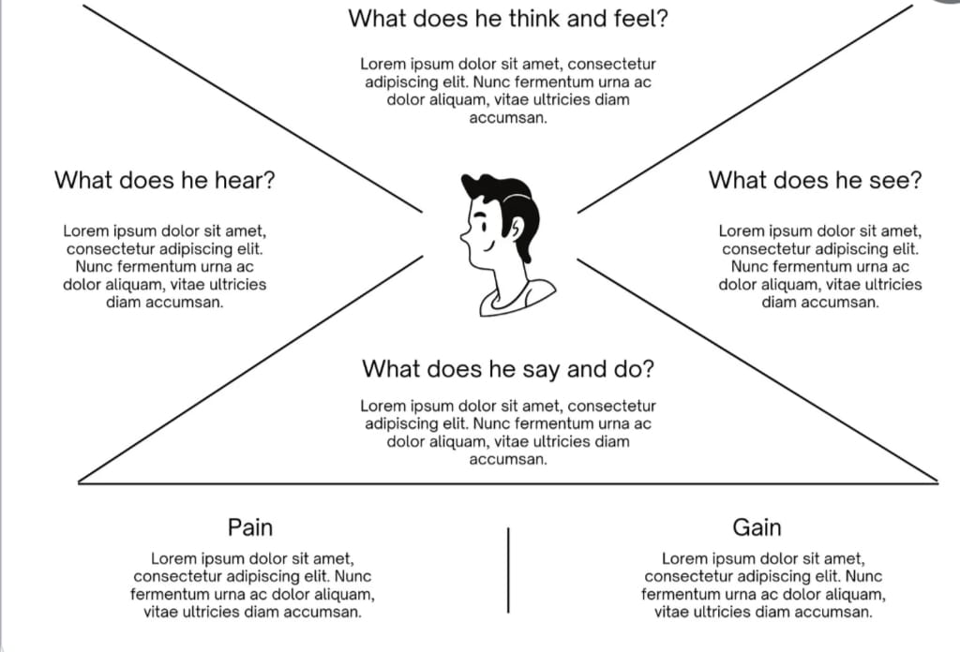

**REQUIREMENT ANALYSIS:**

**cUSTOMER JOURNEY MAP**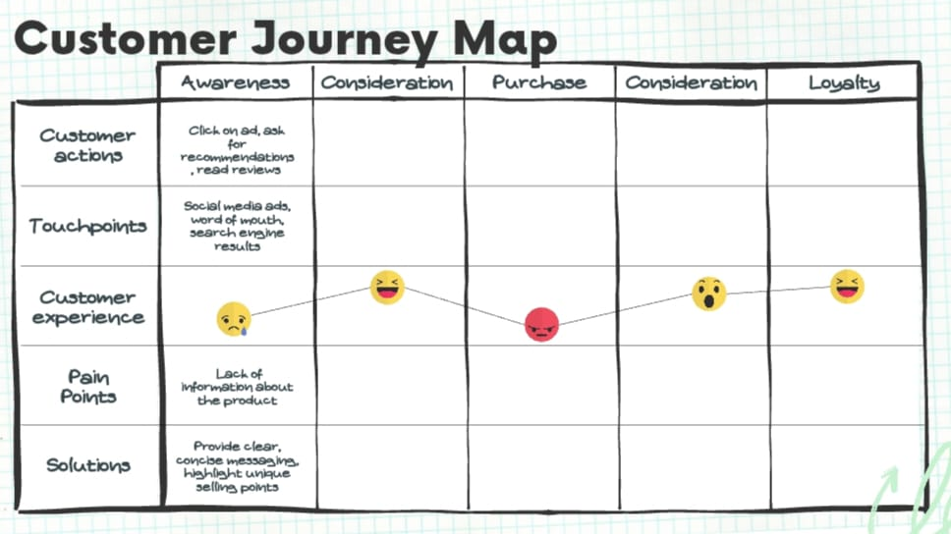

**SOLUTION REQUIREMENT:**

✅ Solution Requirement: Risk Detection and Alert Engine in SDLC

To effectively detect and manage risks during the Software Development Life Cycle (SDLC), the proposed Risk Detection and Alert Engine must fulfill the following functional and non-functional requirements:

1. Functional Requirements

a. Data Collection Module

Collect project-related data (e.g., team size, deadlines, complexity, previous risk history).

Integrate with project management tools (e.g., Jira, GitHub).

b. AI Risk Prediction Engine

Use machine learning models (e.g., Random Forest, Decision Tree) trained on historical project data.Predict risk levels (Low, Medium, High) based on current project parameters.

c. Alert Notification System

Generate real-time alerts (via email, SMS, or dashboard) when high-risk conditions are detected.

Escalate unresolved risks based on severity and duration.

d. Risk Dashboard

Display active risks, history logs, and project status.

Visualize risk trends and allow filtering by team/module/time.

e. Data Storage

Use IBM Db2 or cloud storage to securely save project inputs, risk predictions, and alert logs.

f. User Access & Roles

Define access roles: Admin, Developer, Project Manager.

Allow role-based views and actions on the dashboard.

2. Non-Functional Requirements

a. Scalability

Handle multiple projects and large data sets efficiently.

b. Performance

Risk prediction and alert generation must be real-time (within seconds).

c. Security

Ensure data privacy and secure user authentication.

Use encrypted storage for sensitive project information.

d. Reliability

System must have >99% uptime, especially during critical project phases.

**DATA FLOW DIAGRAMS:**

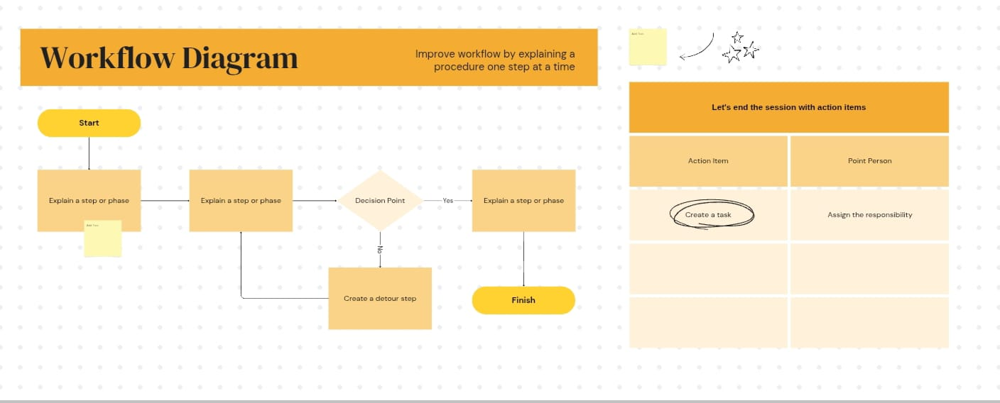

**TECHNOLOGY STACK:**

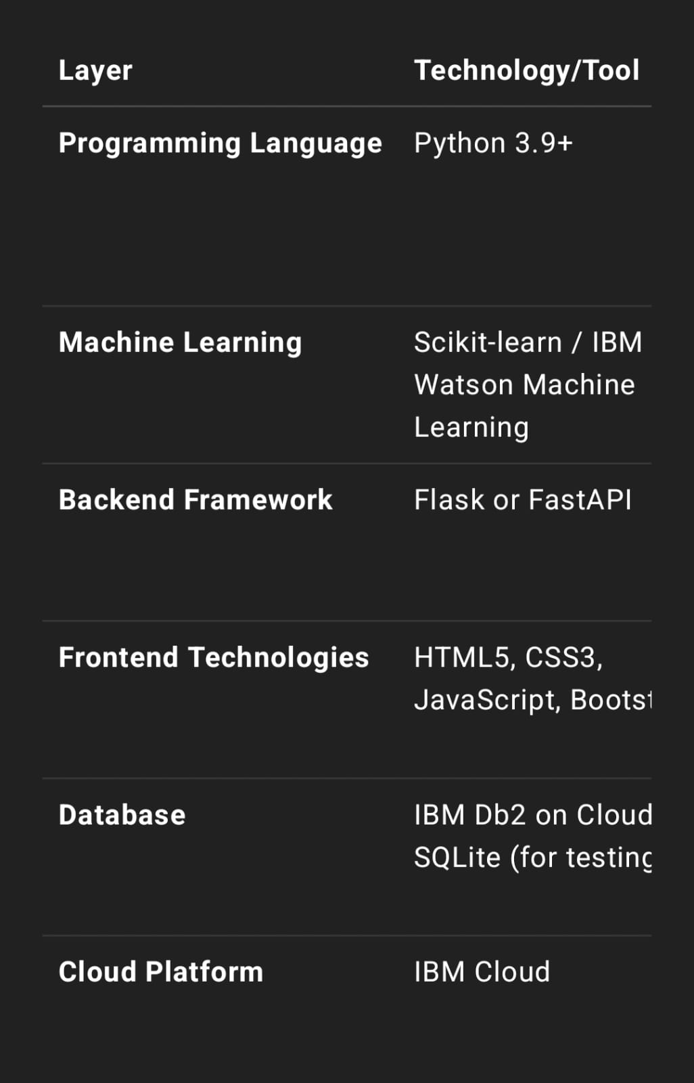

**PROJECT DESIGN:**

**Problem solution fit:**

**✅ Solution**

**🚨 Risk Detection and Alert Engine**

A real-time, intelligent system integrated into the SDLC to:

* Monitor project metrics and codebase
* Identify and evaluate potential risks
* Send proactive alerts to stakeholders

**🧩 How It Fits into SDLC Phases:**

|  |  |  |  |  |  |  |
| --- | --- | --- | --- | --- | --- | --- |
| | **SDLC Phase** |  |  | | --- | --- | --- | |  | | **Risk Detection Features** | **Alerts Generated** |
| **1. Requirement Analysis** | Analyze ambiguity or missing requirements using NLP on documents. | Ambiguous or conflicting requirement alert. |
| **2. Design** | Detect architecture flaws (e.g., no redundancy, poor scalability). | Design inconsistency or bottleneck alert. |
| **3. Implementation** | Static code analysis for vulnerabilities, logic flaws, low test coverage. | Code security flaw or bad practice alert |
| **4. Testing** | Monitor test case coverage, identify flaky or failing tests. | Low test coverage or high failure rate alert |
| **5. Deployment** | Check deployment pipeline failures or misconfigurations | CI/CD pipeline error alert |
| **6. Maintenance** | Monitor application logs, uptime, resource usage using AI/ML anomaly detection | Performance degradation or downtime alert |

**Proposed solution:**

**✅ Proposed Solution: Risk Detection and Alert Engine in SDL**

**🎯 Objective:**

To proactively identify, assess, and notify stakeholders about project and code risks throughout the SDLC phases, ensuring higher quality, security, and timely delivery of software**.**

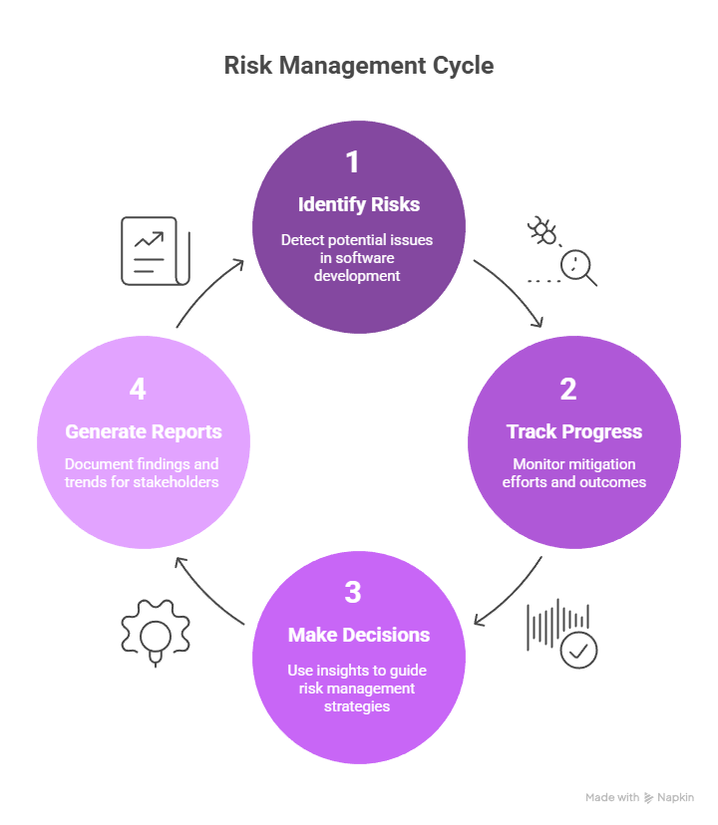

**🔍 Functional Modules**

1. ✅ Risk Detection Core Engine

* Inputs: Code commits, requirement documents, CI/CD logs, test reports
* Techniques Used:
  + Static code analysis (security, logic flaws)
  + AI/ML anomaly detection on logs and metrics
  + Rule-based risk indicators (e.g., < 60% code coverage triggers risk)

2. 📊 Real-Time Monitoring & Dashboards

* Shows:
  + Active risks by severity
  + Risk trends over time
  + Risk source (code, test, deployment, etc.)

3. 🔔 Smart Alerts & Notifications

* Notification channels: Email, Slack, Teams, JIRA ticket creation
* Alert types:
  + High: Security vulnerability in production
  + Medium: Low test coverage in a feature branch
  + Low: Delayed ticket resolution

**🔄 Integration Across SDLC Phases**

| **Phase** | **Monitored Risks** | **Action Taken** |
| --- | --- | --- |
| Requirements | Ambiguity, scope creep, missing dependencies | NLP check on docs, flagging in JIRA |
| Design | Architectural flaws, non-scalable patterns | Review reports, automated red flags |
| Development | Vulnerable code, bad practices, untested logic | Static code analysis + dev alerts |
| Testing | Incomplete coverage, failed cases, flaky tests | Track test results and trends |
| Deployment | CI/CD failures, misconfigurations | Real-time alerts from Jenkins/GitLab |
| Maintenance | Performance degradation, crashes, attack surfaces | Log monitoring + anomaly detection |

**⚙️ Technologies & Tools (Sample Stack)**

* Code Analysis: SonarQube, ESLint, Bandit
* Project Management: JIRA, Trello
* Version Control: GitHub, GitLab
* CI/CD: Jenkins, GitHub Actions
* Monitoring: Prometheus, ELK Stack, New Relic
* Alerting: Slack, MS Teams, PagerDuty
* Dashboard: Grafana, Kibana, custom React dashboard

**🧠 AI/ML Enhancements (Optional Add-ons)**

* Predict sprint delays based on historical ticket resolution trends.
* Predict modules with high bug probability using commit history and complexity.
* Sentiment analysis on comments to detect team burnout or communication risks**.**

**💡 Example Use Case:**

Scenario: A developer pushes code to the main branch with high complexity and low test coverage.

* Risk Detection Core flags:
  + Cyclomatic complexity > threshold
  + Unit tests < 40%
* Alert Sent:

"High Risk Detected in main/AuthModule: Low coverage (38%) and high complexity. Review recommended."

* JIRA ticket auto-created and assigned to dev lead.

**PROJECT PLANNING AND SHEDULING:**

Detect risks during requirement analysis, design, development, testing, deployment, and maintenance.

Provide automated, real-time alerts to developers, testers, and managers.

Integrate with popular tools (e.g., Git, JIRA, Jenkins, SonarQube).

Visualize risks and alerts using dashboards.

📅 **Project Timeline & Milestones:**

| **Phase** | **Activities** | **Duration** |
| --- | --- | --- |
| **1. Requirement Gathering** | Define goals, stakeholders, integration tools | Week 1 |
| **2. Design Architecture** | System architecture, module design, alert flowchart | Week 2 |
| **3. Environment Setup** | Set up tools: GitHub, Jenkins, SonarQube, JIRA, databases | Week 3 |
| **4. Module Development** | Build risk detection core, alert manager, dashboard | Weeks 4–6 |
| **5. Integration** | Connect with APIs (GitHub, JIRA, Jenkins, etc.) | Week 7 |
| **6. Testing & QA** | Unit testing, integration testing, simulate risk scenarios | Week 8 |
| **7. Deployment** | Deploy to staging/production, final checklist | Week 9 |
| **8. Documentation & Training** | Prepare user guide, train team on usage, finalize documentation | Week 10 |

👥 **Team Roles & Responsibilities:**

| **Role** | **Responsibility** |
| --- | --- |
| Project Manager | Oversee timeline, deliverables, risk tracking |
| Technical Architect | Design engine architecture, integration approach |
| Backend Developer | Build detection logic, alert system |
| DevOps Engineer | CI/CD pipeline setup, environment provisioning |
| Frontend Developer | Create dashboard and reporting UI |
| QA/Test Engineer | Design test cases, simulate real-world risks |
| Security Analyst | Monitor and validate vulnerability risk alerts |

**PERFORMANCE TESTING:**

| **Tool** | **Purpose** |
| --- | --- |
| IBM Cloud Continuous Delivery (Toolchains) | Automate CI/CD and integrate test stages |
| IBM DevOps Insights | Analyze test results, code quality, coverage reports |
| IBM Cloud Functions | Simulate event-based triggers for risk generation |
| IBM Cloud Monitoring (Sysdig) | Monitor system behavior post-trigger |

**✅ Functional Testing Tools**

Postman / Swagger – API testing

Selenium / Cypress – Frontend dashboard testing

JUnit/PyTest – Unit and module testing

JIRA Integration – Workflow validation

**RESULTS:**

**Output screenshots:**

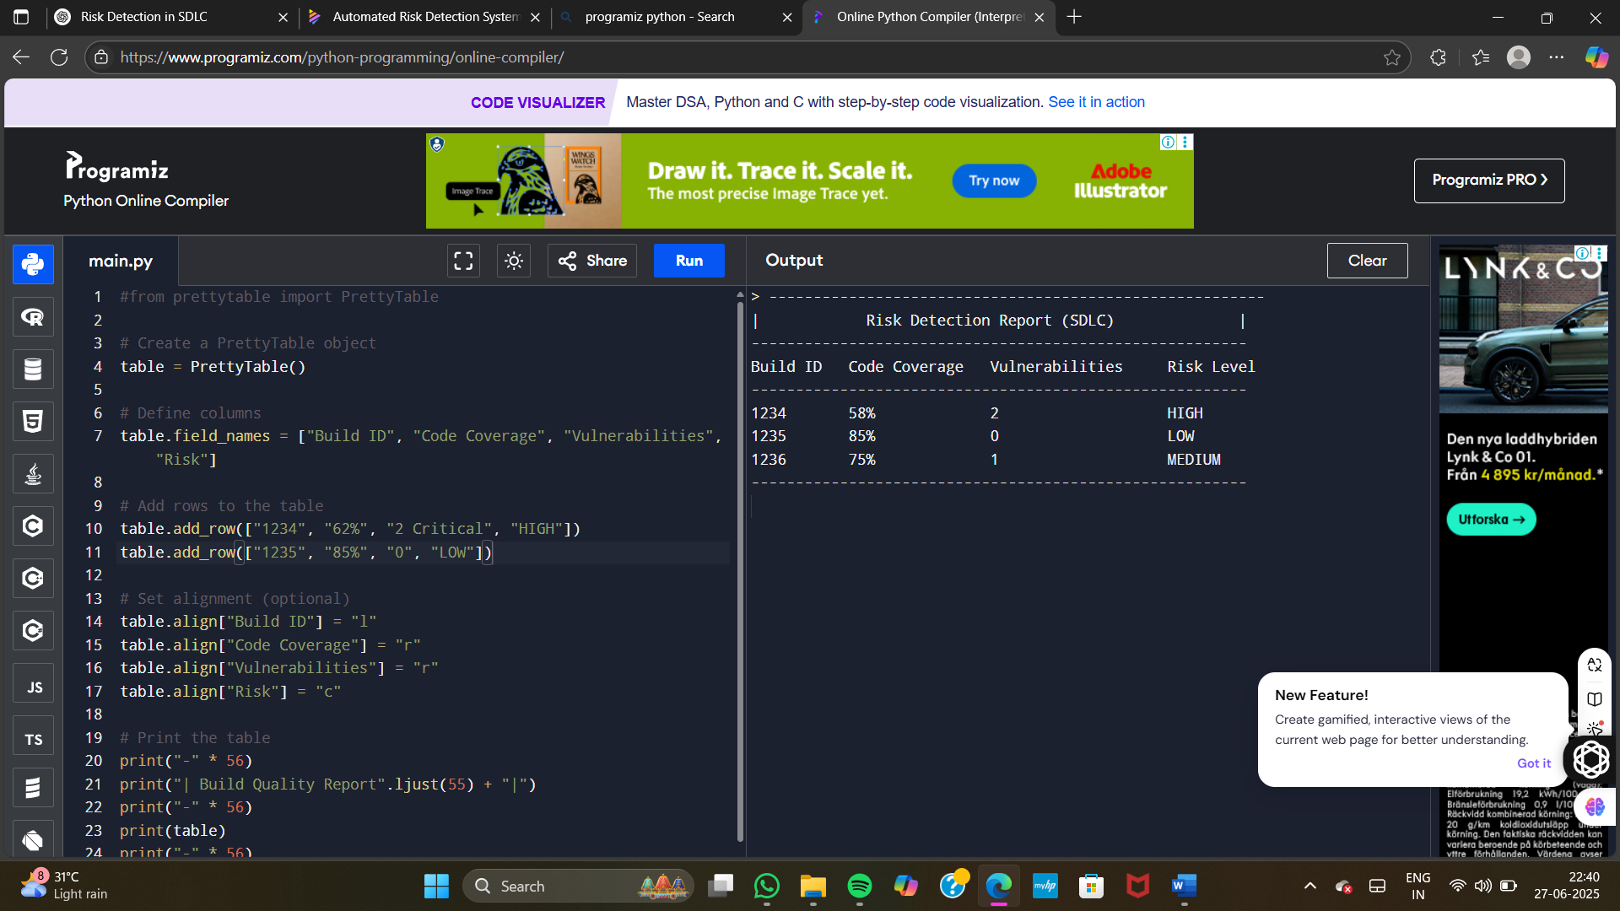

**Advantages** **and** **disadvantages**:

**✅ Advantages**

**1. Cloud-Native Integration**

* **Toolchain Ready**: IBM Cloud offers **prebuilt DevOps toolchains** with GitHub, Jenkins, DevOps Insights, and Slack, making integration smooth.
* **Plug-and-Play** for CI/CD, code analysis, and test tracking.

**2. Scalable Infrastructure**

* Can handle **large volumes of risk events** without crashing.
* Auto-scaling support via **IBM Kubernetes Service** or **Code Engine**.

**3. Real-Time Alerting**

* Use **IBM Cloud Functions (serverless)** and **Slack/MS Teams** to send instant alerts.
* Triggers can be customized with minimal code.

**4. Advanced Monitoring & Insights**

With IBM Instana and DevOps Insights, you get deep visibility into:

Build quality

Deployment risks

Code coverage trends

1. Security & Compliance IBM Cloud is ISO, GDPR, and SOC-compliant, making it a trusted platform for enterprise-grade risk detection.
2. Custom Automation Easily set up automated workflows: if a high-risk commit is detected, rollback can be triggered or Jira tickets auto-generated.

**❌ Disadvantages:**

**1. Cost**

* IBM Cloud services like Instana, Cloud Functions, and Kubernetes may incur high costs for long-running or high-frequency tasks**.**

**2. Learning Curve**

* Requires knowledge of IBM-specific tools (Toolchains, Code Engine, IAM).
* Teams familiar with AWS or Azure may find onboarding slower.

**3. Limited Ecosystem (Compared to AWS/Azure)**

* Fewer third-party integrations or community plugins for DevSecOps compared to more popular clouds**.**

**4. Latency in Cold Starts**

* Serverless IBM Cloud Functions can experience cold start latency, which may delay alerts in rare cases

**CONCLUSION:**

The implementation of a **Risk Detection and Alert Engine in the Software Development Life Cycle (SDLC)** using **IBM Cloud** significantly enhances the reliability, security, and efficiency of software development projects. By leveraging IBM Cloud's integrated DevOps Toolchains, DevOps Insights, Cloud Functions, and monitoring services, development teams can **proactively identify, assess, and respond to potential risks** throughout the SDLC.

This system ensures **real-time alerts**, improves **code quality visibility**, and enables **automated mitigation strategies**—such as alerting developers, blocking vulnerable deployments, or creating JIRA tickets. IBM Cloud's enterprise-grade security, compliance standards, and scalable infrastructure make it an ideal platform for hosting such a critical risk management solution.

While there are considerations such as cost and setup complexity, the overall benefits of early risk detection, faster response times, and reduced project failures far outweigh the limitations. In conclusion, integrating a cloud-based risk detection engine into SDLC not only improves **project success rates** but also **elevates software quality and team accountability** in modern DevOps practices.

**FUTURE SCOPR:**

**• 🔮 AI/ML-Powered Predictive Risk Detection**

* Integrate IBM Watson Machine Learning or Watson Studio to:
  + Predict risk-prone modules based on past commit history and developer behavior.
  + Classify risks automatically (security, performance, compliance).
  + Suggest fixes using trained models (AI-assisted remediation).

**• 📊 Advanced Visual Analytics Dashboards**

* Use IBM Cognos Analytics or integrate with Grafana/Power BI for:
  + Dynamic charts showing risk heatmaps.
  + Trend forecasting for code quality and team performance.
  + Comparative analysis across teams or repositories**.**

**• 🔄 Automated Remediation Workflows**

* Future versions can trigger auto rollback, block pull requests, or create JIRA tickets based on risk severity using IBM Cloud Functions andDevOps automation**.**

**• 📱 Mobile and Voice-Based Alerts**

* Extend alert engine to **mobile apps** and **IBM Watson Assistant (chatbot)** for risk status reporting through voice or chatbot.

**• 🧪 Test Environment Risk Profiling**

* Enhance the engine to detect risky behaviors even in **test/staging environments** using deeper hooks with CI/CD and container logs.

**• 🌐 Community-Driven Risk Rule Library**

* Enable teams to create and share **custom risk rules** via a plug-in marketplace or Git-based repository.