The Impact of Explainability and Accountability on User Perception of Mental Health Support Agents: A 2$×$2 Factorial Study
1. Study Overview
This study aims to investigate how the Explainability and Accountability of AI systems jointly influence user trust, perceived helpfulness, and the therapy experience.
Study Design: We use a 2 (Explainability: High vs. Low) $×$2 (Accountability: High vs. Low) between-subjects factorial design.
Control Strategy: To ensure fairness, we adopt a "Core Advice Anchoring" strategy. This ensures that the utility of the advice and the quality of the dialogue remain constant across all groups. We only change how the information is presented and the source of the AI.
2. Participants
Target Population: The study recruits university students who self-report recent mild-to-moderate stress or anxiety events. This is a non-clinical sample.
3. Materials & System Design
We developed four versions of AI mental health support agents. All agents are built on GPT-4o and use a protocol-driven phase-gating architecture to ensure treatment fidelity.
3.1 Variable Control Matrix
The participants are divided into four groups based on two variables:
- Group 1: High Accountability + High Explainability (Explicit diagnostic logic: Symptom → Mechanism → Advice).
- Group 2: High Accountability + Low Explainability (Implicit intuitive response: Validation → Advice).
- Group 3: Low Accountability + High Explainability.
- Group 4: Low Accountability + Low Explainability.
Group | Variable A: Accountability | Variable B: Explainability
G1 | High: Co-developed by renowned institutions | High: Explicit diagnostic logic (Symptom-Mechanism-Advice)
G2 | High: Co-developed by renowned institutions | Low: Implicit intuitive response (Validation-Advice)
G3 | Low: Ordinary experimental chatbot | High: Explicit diagnostic logic (Symptom-Mechanism-Advice)
G4 | Low: Ordinary experimental chatbot | Low: Implicit intuitive response (Validation-Advice)

3.2 Core Control Technology
To rule out "advice quality" as a confounding variable, the system uses a standard intervention library.
Anchoring Logic: For the same type of user problem (e.g., "exam anxiety"), all agents must give behavioral advice of the exact same quality.
Differential Rendering:
For the Explainable Group, the agent must explain the psychological mechanism behind the advice (e.g., "This activates the parasympathetic nervous system").
For the Non-Explainable Group, the agent only provides emotional support and the advice steps. It uses emotional words to fill the length, ensuring no significant difference in response length between the two groups.
3.3 Interaction Flow & Gating Mechanism
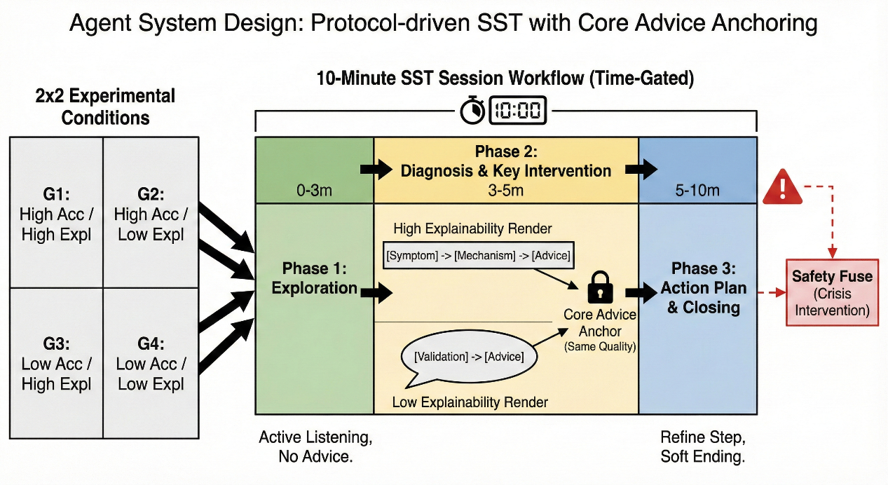
We referred to works such as Woebot (Fitzpatrick, K. K., et al., 2017) and Sharma (Sharma, A., et al., 2023) to design the agent using the Single-Session Therapy (SST) method. The system includes a background timer and a state machine to strictly control the 10-minute SST process:
Phase 1: Relationship Building and Exploration (0-3 min)
The system prompt is set to "Active Listening Mode" with a constraint to NOT give advice. The agent behaves by only asking clarifying questions to confirm the user's main stress source.
Phase 2: Diagnosis and Key Intervention (3-5 min)
At minute 3, the system forces an instruction: [SYSTEM: Perform Analysis Now].
The High-Explainability group outputs a structured report (Symptom Observation → Psychological Mechanism → Solution).
The Low-Explainability group outputs natural dialogue (Emotional Resonance → Solution).
Phase 3: Action Planning and Closing (5-10 min)
The system prompt is set to "Action Planning Mode" with the goal of refining one small step. At minute 9, the system injects the command [SYSTEM: Wrap up and say goodbye] to guide a soft ending.
4. Procedure
- Admission and Pre-test:
First, participants sign an informed consent form.
- Intervention:
Participants are randomly assigned to one of groups G1-G4 to engage in a 10-minute AI conversation (a countdown bar is shown on the screen). A safety cut-off is in place: if words like "die" or "suicide" are detected, the experiment stops immediately, and crisis intervention information is sent.
- Post-test:
After the chat ends, the page automatically jumps to the Qualtrics survey.
- Debriefing:
Finally, we inform participants of the real purpose of the experiment and provide contact information for the school counseling center.

