Software Metrics Assignment 1
Student: 2016078
Assignment Repository link: https://github.com/Kotliarenko02/Software-Metrics-Assigment-1

Codes:
- Python code (python_ex1.py)
- Java enterprise Hello world example - https://gist.github.com/lolzballs/2152bc0f31ee0286b722

Metrics:
- Pylint
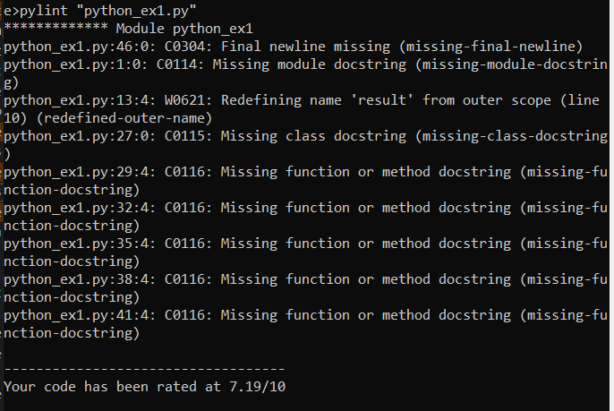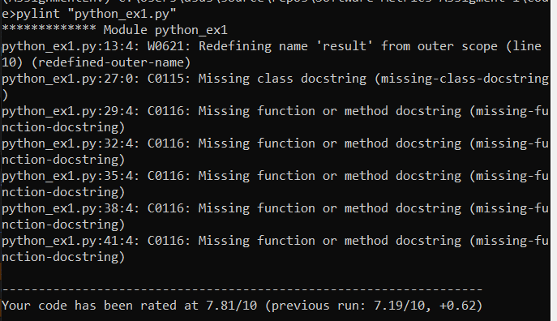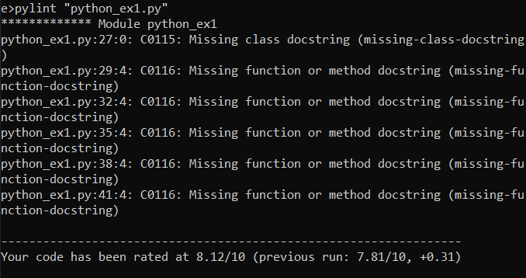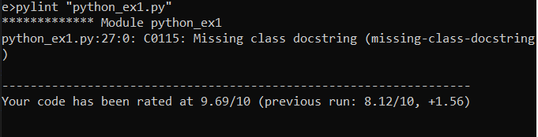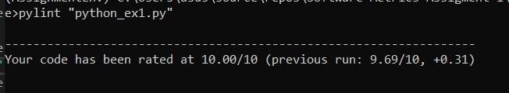
Code before updates:
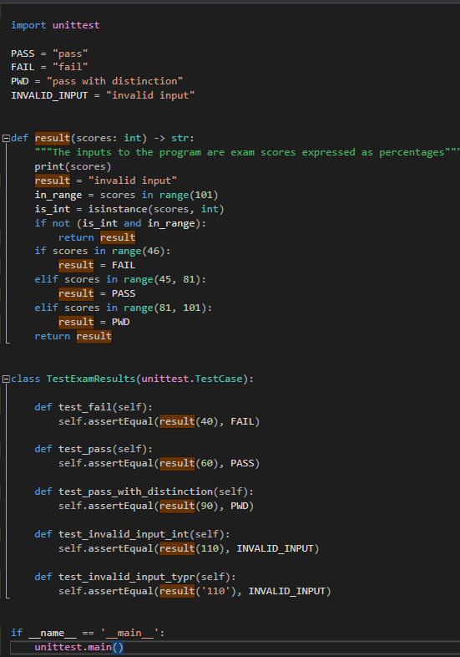
Code after updates:
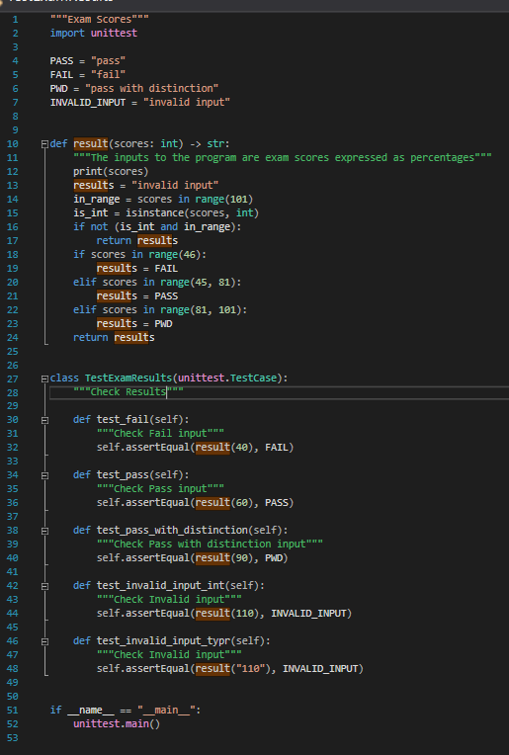
- Python_loc_counter (loc_counter.py)
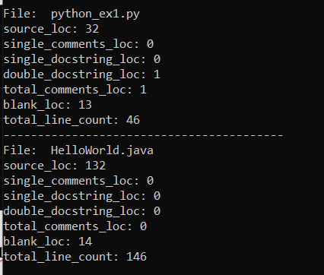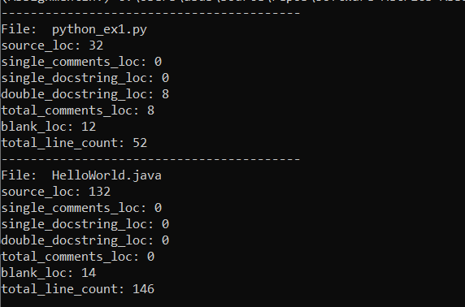
Results in “metrics\python_loc_counter” folder
  - HelloWorld.java
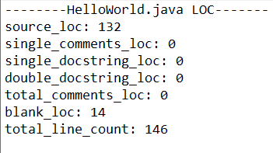
  - Python_ex1.py (a – before pylint, b – after pylint)
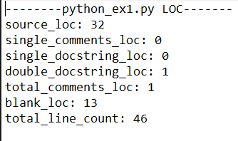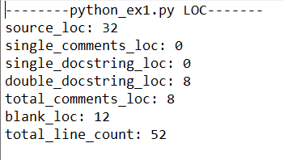
- Cloc
- HelloWorld.java
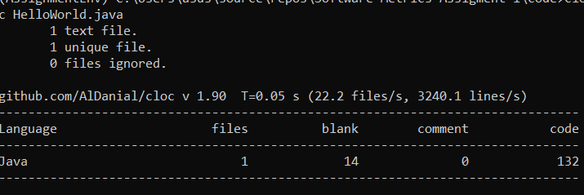
- Python_ex1.py (after pylint)
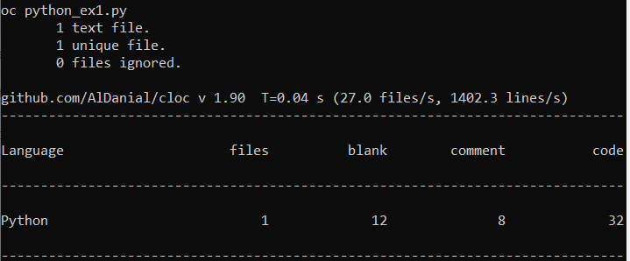
- Radon (for Python_ex1.py)
