**Assignment number:** HIEKBJ-1

**Filename:** esample_INQ-0151963319_HIEKBJ-1.docx



**Primary Editor Name*:** Earl

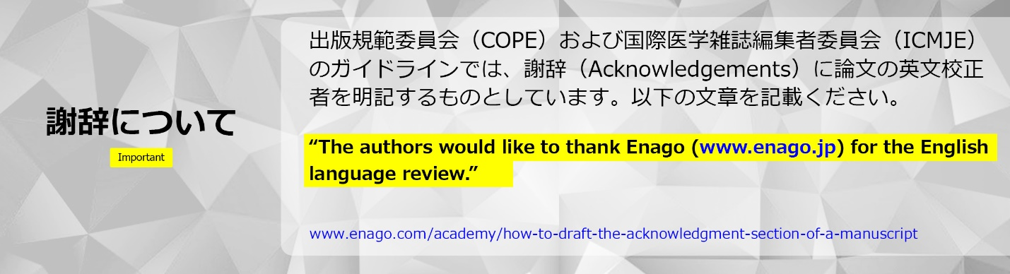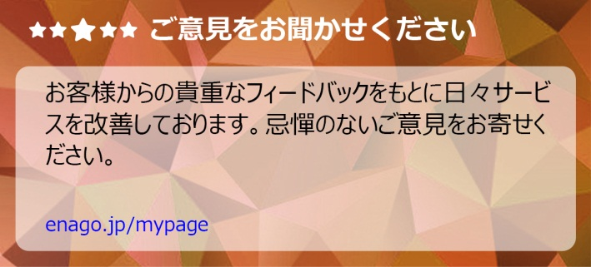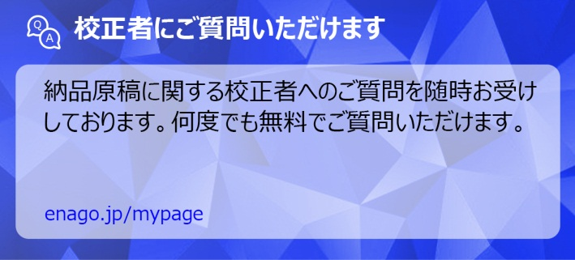

Dear Author:

Thank you for entrusting us with your manuscript and opting for our ノーマル英文校正サービス.

We have edited your assignment HIEKBJ-1 for language and grammar, from the aspect of fluency, and would like to share our experience in editing your manuscript.

Overall, we have made moderate revisions to the manuscript in terms of language and grammar. We have also made some sentence reconstructions and word choice changes for accuracy and enhanced clarity. We hope that the revisions meet your expectations from our service.

Please be assured that we have edited the manuscript to the best of our ability and have clarified some of our changes through remarks. As a step toward finalization, we suggest that you resolve all remarks in the main file, as this is important for successful publication.

We have added a tip on academic writing conventions specific to your manuscript in the edited file. We hope you find this tip helpful for future writing.

We wish you the very best for the successful publication of your manuscript and look forward to working with you again.

Sincerely,

Your Editor

Earl

**Note**

* Usually abbreviations are spelled out at their first use, both in the abstract and in the text. Please check if the abbreviations in this manuscript need to be spelled out. If they are mentioned in the journal's list of accepted abbreviations, then they do not have to be spelled out.
* Please note that as this is a converted file, the equations/notations do not appear as typed. We have carefully edited the text around them, and remarks have been written for changes in equations, if any.

