Table of Contents

Zittingslijsten — Process Sequence
Document-centric workflow from upload to download. The diagram below shows the happy path with the rejection branch; numbered steps under "Status transitions" map directly to HTTP endpoints in the app.

Sequence diagram
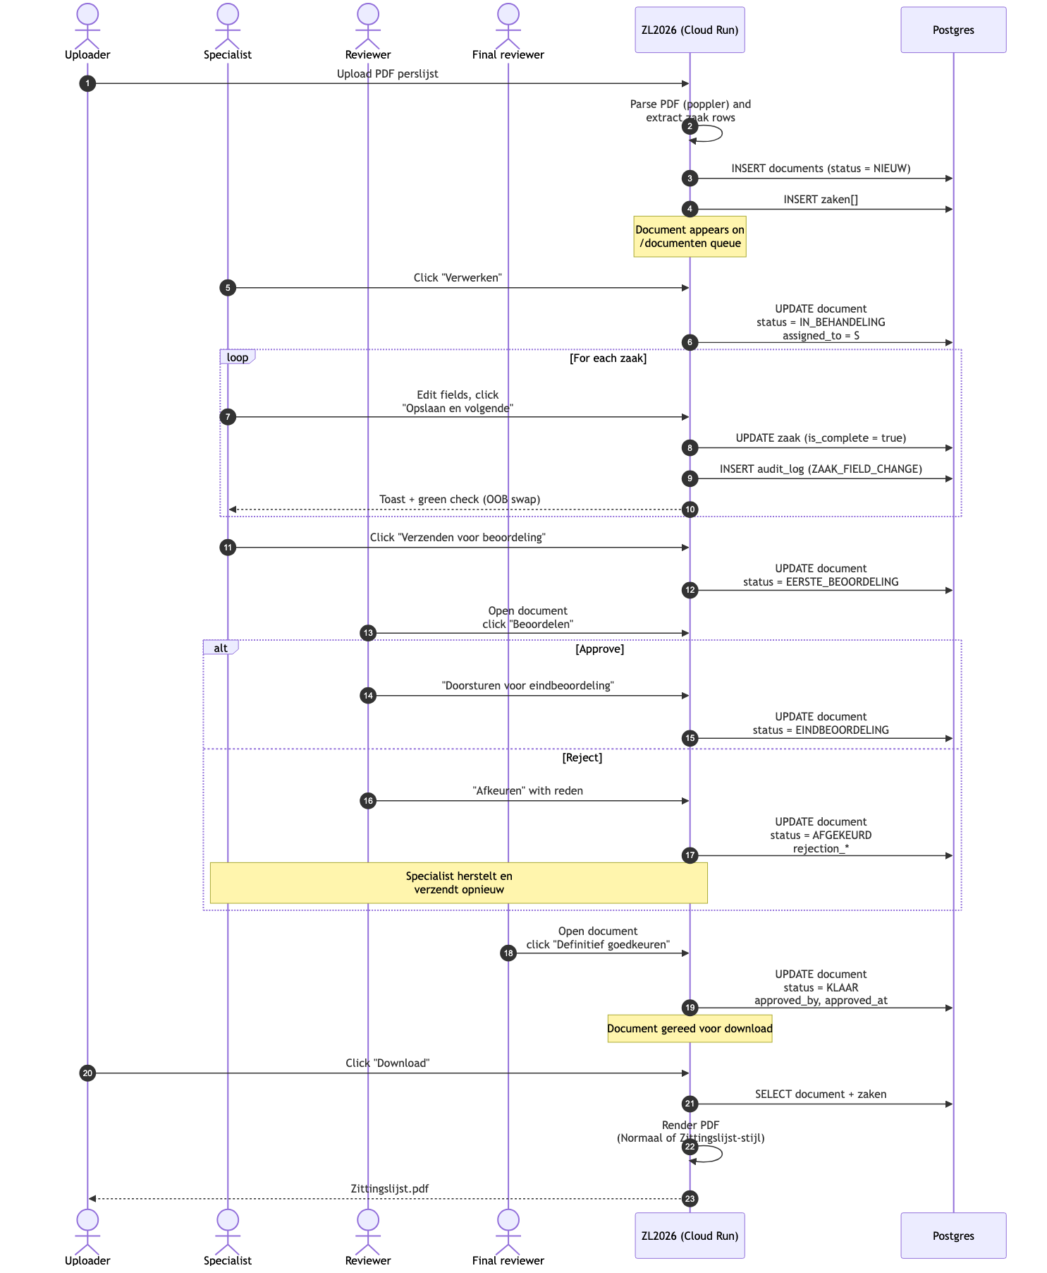

Actors
Actor | Application role
Uploader | Any logged-in Specialist who drops the perslijst PDF into /documenten.
Specialist | The user who picks up a document from the queue and edits the zaken.
Reviewer | A second Specialist who does the eerste beoordeling (R1).
Final reviewer | A third Specialist who does the eindbeoordeling (R2). Often the same person as a Reviewer; the system enforces that it cannot be the original Specialist.
Admin | Not in the diagram — has cross-cutting delete rights and read access to the audit log.

Document statuses
Status | Meaning | Set by
NIEUW | Just uploaded; on the queue, waiting to be picked up. | Upload handler
IN_BEHANDELING | A Specialist has claimed it and is filling in zaken. | POST /documenten/{id}/assign
EERSTE_BEOORDELING | All zaken complete; sent for review. | POST /documenten/{id}/submit
EINDBEOORDELING | Reviewer approved; sent for final approval. | POST /documenten/{id}/approve (R1)
AFGEKEURD | Reviewer rejected; goes back to the original Specialist. | POST /documenten/{id}/reject
KLAAR | Final approval; document is exportable. | POST /documenten/{id}/approve (R2)

Per-zaak save loop
While a document is in IN_BEHANDELING, the Specialist edits each zaak via the in-app card (Zittingslijst-stijl) or the original sectioned form. Saving a single zaak is a self-contained interaction:
- User clicks Zaak opslaan or Opslaan en volgende.
- Browser submits the form via HTMX (POST /documenten/zaak/{zaakId}/save).
- The handler updates the zaken row, marks is_complete = true, and writes an audit_log entry (ZAAK_FIELD_CHANGE with field-level diff, or ZAAK_SAVE if no fields changed).
- The response carries:
  - the new Opgeslagen om HH:MM save-hint in the form footer,
  - an HTMX out-of-band swap of <div id="zaak-check-{uuid}" class="zaak-check done"> so the tab indicator turns green immediately,
  - an HX-Trigger: zaakSaved header that fires a body-level event the client translates into a toast.
- If the user clicked Opslaan en volgende, a small JS handler advances to the next zaak tab once the toast event fires.
This is the only feedback loop driven from the client; everything else is server-rendered.

Rejection branch
When a reviewer clicks Afkeuren, the app collects:
- rejection_category (a fixed list, e.g. missing data, wrong court, style),
- rejection_notes (free text),
stores them on the document, sets rejected_by / rejected_at, and flips status back to IN_BEHANDELING while keeping the original assigned_to. The Specialist sees the rejection reason at the top of the editor and resubmits when fixed (the Verzenden voor beoordeling button is back).

Download
Once status = KLAAR, anyone with read access can click Download:
- The Download button opens an export modal with two formats: Normale output (legacy form layout) and Zittingslijst (the canonical card layout).
- The chosen renderer queries documents + zaken and streams a generated PDF; the source PDF in file_data stays separate (it remains accessible via the Losmaken button in the editor).

Audit trail
Every status transition writes an audit_log row with:
- user_id: who triggered it
- zaak_id: nullable for document-level events
- action: DOCUMENT_ASSIGN, DOCUMENT_UNASSIGN, DOCUMENT_SUBMIT, DOCUMENT_APPROVE, DOCUMENT_REJECT, ZAAK_FIELD_CHANGE, ZAAK_SAVE, ZAAK_DELETE, DOCUMENT_DELETE
- details: JSONB with field-level diffs where applicable
Surface: /admin/audit lists the most recent entries and supports filtering by user, action, and parketnummer.

Concurrency
A document can only be in IN_BEHANDELING for one Specialist at a time. While assigned to user A, user B sees the row with the assignee's name and a Bezet placeholder instead of the action button. Opslaan en vrijgeven lets A hand the document back to the queue mid-edit without losing changes; status returns to NIEUW.
The save endpoint is otherwise lock-free — last-write-wins on each zaak. Because zaken are partitioned by document and only one Specialist can hold a document at a time, this is safe.

