Charlotte MSA Commercial and Corporate Lending Indicators
An Exploratory Data Analysis of the Business Base and Banking Opportunities
Charlotte-Concord-Gastonia NC-SC | Updated October 26 2026
Charlotte’s industry activity supports focused commercial relationship prospecting across several sectors. BankUnited should qualify potential borrowers and investigate deposit trends before committing additional capital or physical presence. Corporate lending opportunities require company-level financial and ownership information.
BankUnited already operates in Charlotte. The question is where and how to expand within the metropolitan area, which includes surrounding communities in North Carolina and South Carolina. These indicators describe the market as a whole; they do not identify the next branch, office, or neighborhood.

The evidence at a glance
Indicator | Period | Change
Transportation and warehousing jobs | 2019 to 2023 | +35.7%
Real estate jobs | 2019 to 2023 | +25.4%
Nonresidential construction jobs | 2019 to 2023 | +23.1%
Deposits outside bank main offices | 2023 to 2024 | -9.4%

Sources [1, 5]. Sector growth uses the preferred recent comparison period. Deposits are June 30 balances.

What this means for the business
Industry data extend the prospecting base to transportation, manufacturing, wholesale trade, professional services, and health care. Payroll activity supports conversations about operating accounts, payments, and cash management. These are relationships to investigate; the data do not measure how much credit those businesses need.
Deposit totals need additional care. Total deposits increased in 2024, but all of that increase, and more, came from balances booked at bank main offices. Deposits outside those offices declined. The analysis does not establish why those balances moved.

Recommended direction
Prioritize a qualified prospect list for loans above $1 million and a bank-by-bank review of deposit changes. Combine those findings with current customer activity, the sales pipeline, property market conditions, and risk limits before selecting a location or recommending a capital allocation.
Industry data run through 2023; CRE and deposit data run through 2024. A reporting change limits interpretation of 2024 CRE growth. Refresh both datasets before a current expansion decision.

The business base has expanded
From 2019 to 2023, both sectors added business locations and jobs. Payroll increased faster than employment, which may reflect pay increases and changes in the workforce as well as expansion. Payroll growth does not establish that profits increased.
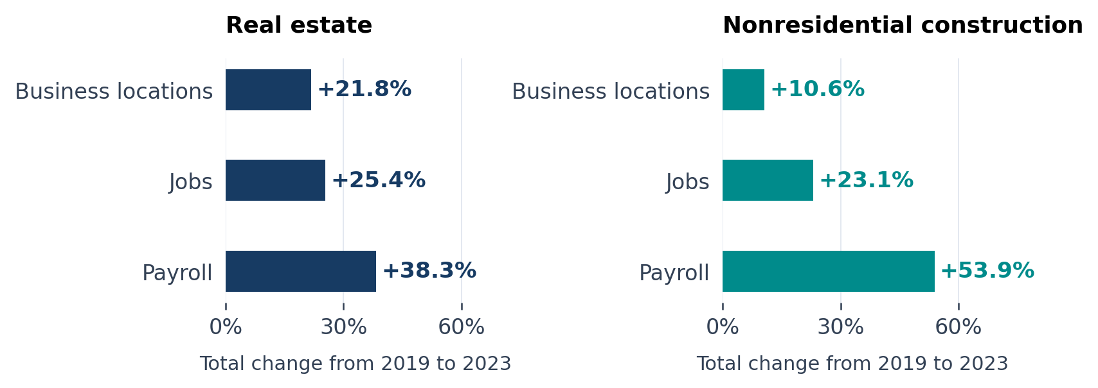
Figure 1. Total growth from 2019 to 2023. Payroll is not adjusted for inflation. Source [1].
Measure | 2019 | 2023 | 2024*
Real estate business locations | 3,677 | 4,479 | 5,006
Real estate jobs | 13,190 | 16,536 | 16,371
Real estate annual payroll | $840.9M | $1,163.1M | $1,452.7M
Construction business locations | 340 | 376 | 542
Construction jobs | 4,468 | 5,498 | 6,184
Construction annual payroll | $353.5M | $543.9M | $685.2M

* 2024 uses a different reporting source. These levels should not be treated as a fully comparable extension of the earlier series. M means million. Construction means nonresidential construction. Source [1].

Implications for commercial relationships
Real estate businesses added 802 locations and 3,346 jobs between 2019 and 2023. Contractors added 36 locations and 1,030 jobs. The contractor workforce grew faster than the number of locations, supporting further investigation of working capital, equipment financing, and cash management needs.
The next step is to identify individual companies and their financing needs. A business location is not a unique company or borrower. In 2023, employment averaged 3.7 people per real estate location and 14.6 per construction location; these averages cannot establish eligibility for a loan above $1 million.

Deposit growth needs a closer look
Charlotte recorded $457.31 billion in total deposits in 2024. Of that amount, $383.88 billion, or 83.9%, was booked at bank main offices. Subtracting those balances leaves $73.44 billion outside main offices. This gives another view of the market’s deposit base.
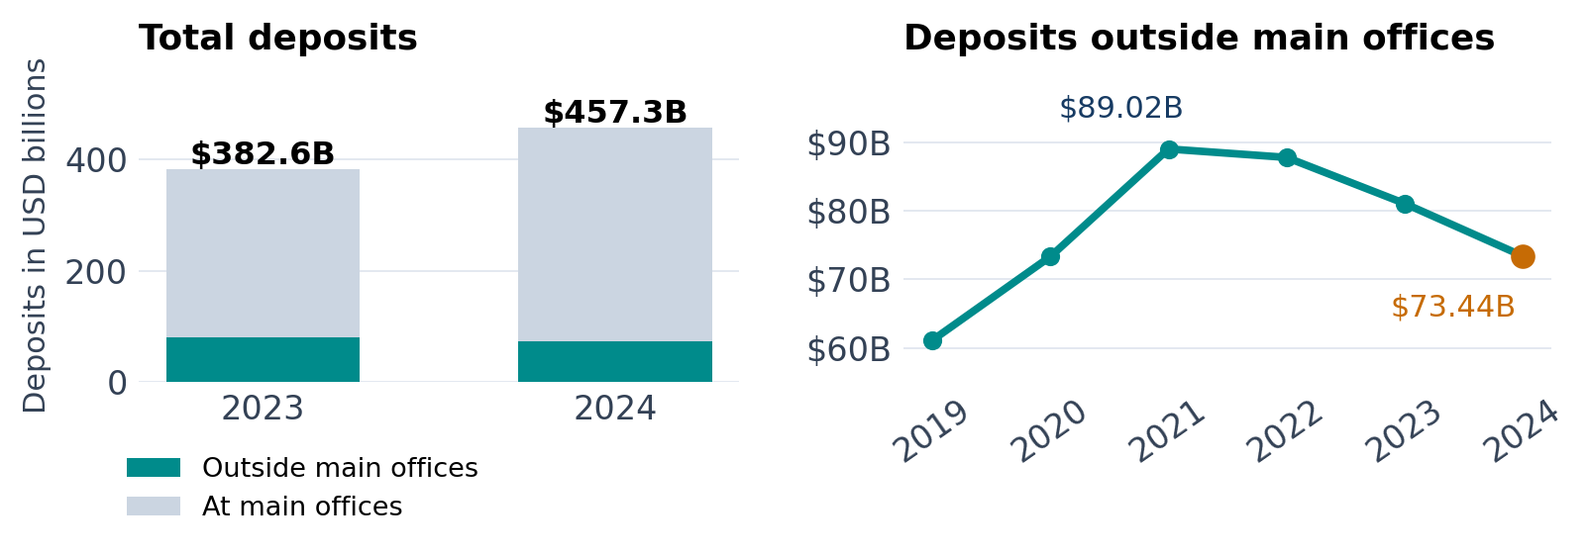
Figure 2. Deposits outside main offices fell for three consecutive years after their 2021 peak. Their 2024 balance remained 20.1% above 2019. Source [1].

Where the 2024 deposit increase was recorded
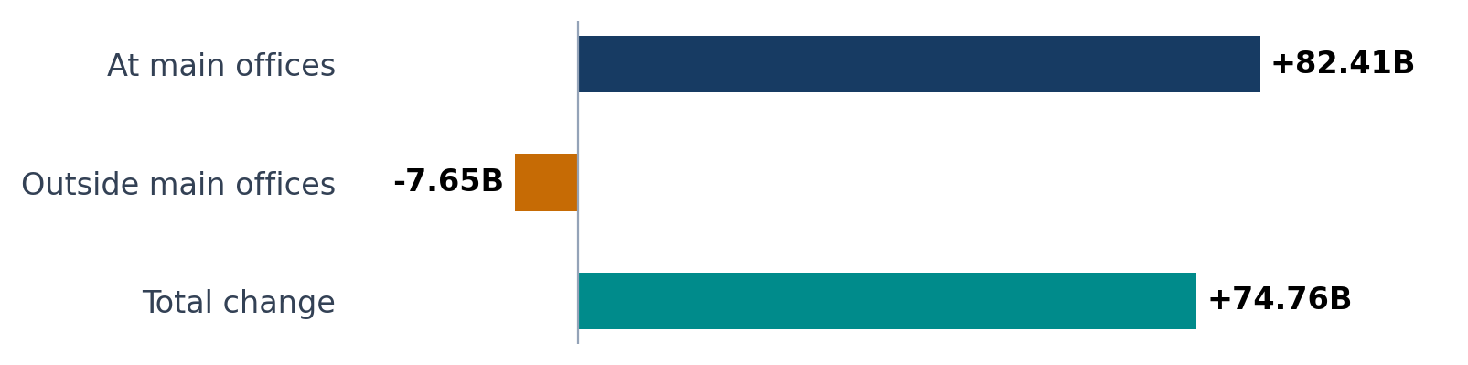
Figure 3. Change from 2023 to 2024 in USD billions. The first two changes add to the total. Source [1].
Total deposits grew 19.5% in 2024, while deposits outside main offices fell 9.4%. The outside balance was 17.5% below its 2021 peak. This pattern calls for a review by bank and branch before interpreting the market’s funding opportunity.
Excluding main offices also removes genuine customer balances held there. The remaining amount still mixes consumer and business deposits and may include booking effects. It is not a direct estimate of commercial deposits available for BankUnited to win.
The data show balances, not the reason for their movement. Customer withdrawals, acquisitions, branch changes, or internal booking transfers are possibilities to investigate rather than findings of this analysis. The FDIC deposit survey measures balances on June 30 each year [4].

Industry activity broadens the lending analysis
The industry dataset adds evidence about the potential commercial borrower base beyond real estate and construction. It identifies business locations, jobs, and payroll across 20 industry groups through 2023. The five sectors below illustrate different commercial relationships to investigate; they are not a ranked list of approved lending targets.
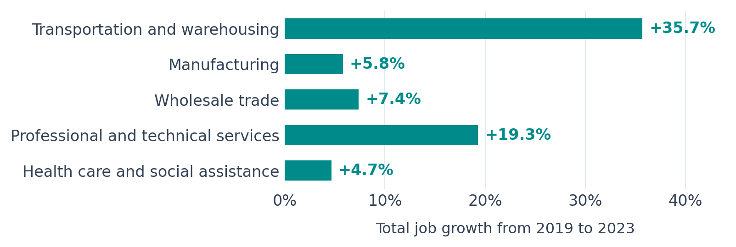
Figure 4. Job growth in five candidate industries. Each reports the 11-county reference count in every year from 2019 to 2023. This is a coverage check, not proof of identical coverage. Source [5].
Industry | Locations | Jobs | Payroll
Transportation and warehousing | 2,680 | 77,790 | $4.76B
Manufacturing | 2,341 | 110,240 | $6.98B
Wholesale trade | 3,683 | 65,207 | $5.23B
Professional and technical services | 8,569 | 84,134 | $7.93B
Health care and social assistance | 7,235 | 148,897 | $9.57B

Observed 2023 levels. Payroll is annual and not adjusted for inflation; B means billion. Professional and technical services includes scientific services. Source [5].

What the expansion suggests
Transportation and warehousing added business locations and jobs. Locations increased 26.6% and employment increased 35.7% from 2019 to 2023. This supports investigating fleet, equipment, receivables, and working-capital needs with individual firms.
Wholesale trade offers a different pattern: locations declined 3.8% while jobs grew 7.4%. Existing operators may be useful prospects to investigate. The data do not establish why locations declined or whether firms need additional credit.

How the indicators support larger loan prospecting
The industry measures provide a screening tool for commercial and corporate banking. Business counts describe where to look for prospects, growth identifies expansion to investigate, and employment per location adds operating-scale context. None directly measures requests for credit or eligibility for a loan above $1 million.
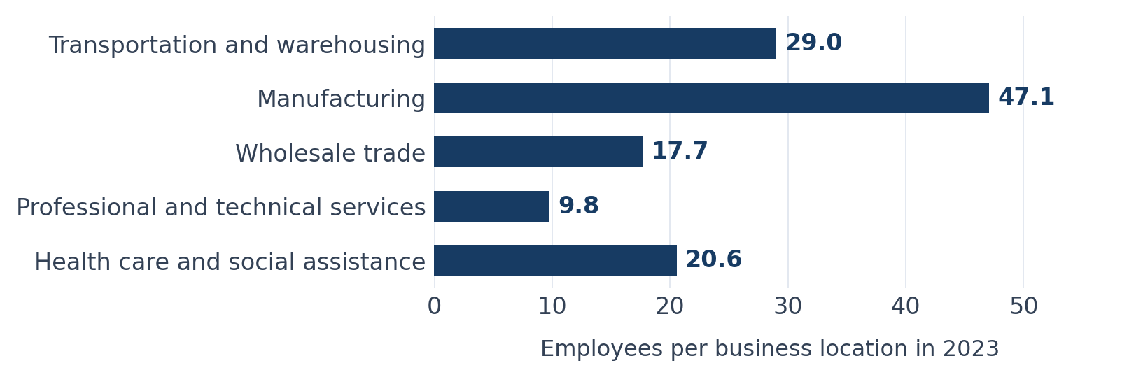
Figure 5. Local operating scale is an industry average, not the size of a consolidated company or a count of corporate borrowers. Source [5].

Commercial lending questions
Manufacturers may need machinery or inventory financing; wholesalers may need financing for inventory and receivables; growing transport firms may need vehicles or equipment. These are financing needs to test through company discussions. Rising jobs or payroll alone does not establish borrowing demand, repayment capacity, or credit quality.

Corporate lending needs company information
A large local operation may belong to a parent company whose financing decisions are made elsewhere. Identify the parent, consolidated revenue, existing debt, decision makers, and financing plans before treating it as a corporate lending prospect. Sector 55, management of companies, is useful context but is not a count of headquarters or unique parent companies. Finance and insurance also includes potential banking competitors.

Add business size to the next screening step
The original market file records 11,309 locations with at least 20 employees in 2023. Subtracting its 20 to 249 employee band yields 572 locations with 250 or more employees. These are all-industry location counts, not sector-specific counts or banking customer definitions [1].
Add employment size by industry and company revenue information to qualify these prospects. Census enterprise-size data can supplement local establishment statistics [6]. Use the combined evidence to prepare a prospect list and test fit with BankUnited’s strategy; do not convert business counts into an assumed volume of loans.

Recommended next steps
Use the market indicators to guide business development and further analysis. A positive growth signal should lead to a qualified prospect or a specific follow-up question before it influences capital or staffing decisions.

Validate the growth measures
Build a consistent history for both sectors using the same statistical source where possible. Confirm industry definitions, geographic boundaries, dollar units, and treatment of counties with unavailable detail. Refresh the latest data before assigning a current market score.

Qualify prospects for larger commercial loans
Use the industry screen to identify companies, then review revenue, company size, parent ownership, existing banking relationships, and financing needs. Obtain size bands within each sector to strengthen the prospect list. Assess fit with BankUnited’s focus on loans above $1 million and include operating accounts and payment services in discussions.

Explain the deposit movement
Reconcile the decline in balances outside main offices by institution and branch. Separate identifiable customer flows from acquisitions, changes in office classification, and booking transfers where the detail permits. Validate the commercial portion of the deposit opportunity through customer and relationship information.

Check property risks before expanding lending
For commercial real estate opportunities, add property type, location, vacancy, rents, construction pipeline, and borrower financial strength. Assess whether rental income and other cash flows can cover debt payments. Combine these results with internal pipeline and relationship-manager coverage before choosing a physical location or staffing level.

Deliverables for the next review
Suggested lead | Deliverable
Data and analytics | Consistent sector history and refreshed market indicators
Commercial banking | Industry-based company list with revenue and financing needs
Treasury and banking analytics | Deposit changes by bank and branch with explanations
Real estate risk and strategy | Property evidence and options for people and presence

These deliverables would support a more specific expansion recommendation. The current indicators do not quantify addressable loan dollars, expected returns, or the best location within the metropolitan area.

Assumptions and sources

How to interpret the 2024 reporting change
The 2023 real estate figures use Census County Business Patterns. Construction combines that source with a Bureau of Labor Statistics source for one county. In 2024, both sectors use the Bureau of Labor Statistics source across all 11 counties identified by the coverage fields [1].
The programs measure employment differently. Census uses a pay period around March 12; the Bureau’s annual measure averages employment across the year [2, 3]. For example, the reported 44.1% rise in construction locations in 2024 does not establish equivalent growth in business activity. Measurement changes and economic changes may both contribute.

Working assumptions
Comparison period. 2019 to 2023 is preferred because source labels and reported county counts remain stable. Construction still mixes two sources, and stable counts do not prove identical coverage.
Dollar values. Payroll and deposit amounts are assumed already expressed in dollars. Amounts are not adjusted for inflation. Payroll measures labor payments, not revenue or profit.
Business definitions. The real estate and nonresidential construction labels are accepted as sector groupings. Confirm the exact industry definitions before choosing target companies or property types.
Deposit interpretation. Deposits outside main offices equal total deposits less main-office balances. This does not isolate business-only deposits, locally generated deposits, or balances that are available to compete for.
Coverage and currency. Industry data end in 2023; original CRE and deposit data end in 2024. In 2023, sector totals fall below market totals by 17 locations, 904 jobs, and $83.7 million in payroll. These gaps remain disclosed. Reporting counts do not prove complete coverage; sector shares in the notebook use observed classified-sector totals [1, 5].

Sources and calculations
[1] Project market dataset. msa_year.parquet, metropolitan area 16740, 2015–2024. Source of original CRE, deposit, and aggregate location-size figures. Deposits outside main offices equal total less main-office balances.
[2] US Census Bureau. County Business Patterns program and employment definitions.
[3] US Bureau of Labor Statistics. Quarterly Census of Employment and Wages annual definitions.
[4] Federal Deposit Insurance Corporation. Summary of Deposits program and June 30 reference date.
[5] Project industry dataset. msa_naics_year.parquet, metropolitan area 16740, 2015–2023. Source of the new industry figures and visuals. Broad sector 23 includes all construction; 53 includes real estate plus rental and leasing. These differ from the narrower original CRE measures.
[6] US Census Bureau. Statistics of US Businesses and enterprise-size context.

