AKSK1
CIS 111B
EZU: JAVA BASED ECU COMMUNICATION API
TABLE OF CONTENTS

1 Introduction 1
1.1 Purpose 1
1.2 Scope 1
1.3 Definitions, Acronyms and Abbreviations 1
2 System Overview 2
2.1 System Characteristics 2
2.2 System Architecture 2
UML Document 3
Document Control 4
Document Signoff 4
Document Change Record 4

1 Introduction
- This document will provide an overview of the EZU API, the intended usage, and the plan for future development. The EZU system has been designed to be used concurrently with a system capable of interfacing with an ECU. In its current form, EZU has been built to handle backend operations for ECU communications. Any security issues or performance limitations must be identified and handled by end users.
- EZU was developed on Windows versions 7 through 10 in Java.

Purpose
          - This document describes the design structure and some of the design choices as it pertains to usage and future changes.
          - This document is intended for end users and potential contributors to gain a deeper understanding of the API and its usage.

Scope
          - This API was built to allow developers to create systems that allow end users to access and modify data produced by their ECUs to monitor and optimize the efficiency and performance of their vehicles.
          - This API in its current form will allow end users to access the data but not modify it. In later builds functionality will be added that allows greater data manipulation.
          - define relevant benefits, objectives and goals as precisely as possible;

Definitions, Acronyms and Abbreviations
ECU | Electronic Control Unit
API | Application Programming Interface

System Overview
- EZU was developed to act as an information handler and translator between either a user or a developed program and an ECU. In its current form it holds all sensor data in HashMap object. The choice of an asynchronous object to handle the data produced is intentional and will be discussed in detail.

System Characteristics
- EZU handles incoming and outgoing data in byte arrays. Responses from the ECU are taken in and interpreted by each individual sensor object. Interpreted data is held in each individual sensor as either Integer or Double objects. When requesting data from the system the returned value is always a String. All the sensor objects are associated with a HashMap, which is an asynchronous structure. The decision to use an asynchronous structure was done to ensure accurate data reads, particularly in real-time monitoring situations. Moving forward the only major change that would happen to this system would be the addition of a synchronous data structure, should the need arise.

System Architecture
- ECUInitializer is the de facto main class of EZU. Creating an instance of the ECUInitializer will instantiate a Hashmap with a single instance of every sensor available. These sensors themselves are subclasses of the abstract ECUSensor class. Grouping all sensors under an abstract class rather than an Interface is more effective in this instance because the general methods of all sensors will be handled the exact same way every time. Furthermore, grouping all the sensors under a parent class provides a way that a controller class, such as ECUInitializer, can be used. This effectively encapsulates all the sensors to ensure that only proper write commands are issued and therefor only proper messages will be produced. In the current build the sensors do not have protective accesses due to the need for testing purposes. The current structure allows for stronger access protection; however, this is a low priority for development as due to the nature of this API placing stronger access protection may only prove to inhibit application development. A copy of the UML class diagram will be provided on the following page. Further development of the API will consist almost solely of adding more sensor types which will look similar to the current sensors and will also be included in the com.ezu.sensors package.

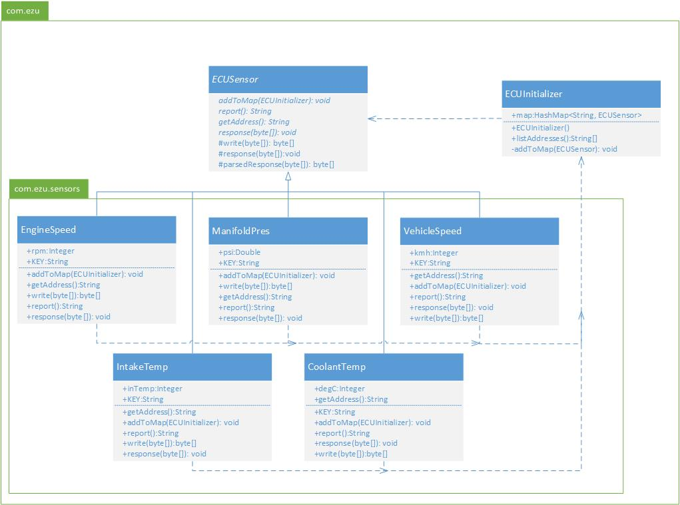

Document Control
Title: | EZU
Issue: | Issue 1
Date: | 06 May 2018
Author: | Anthony Kottke and Sean Kirwan
Control: | Reissue as complete document only
Document Signoff
Nature of Signoff | Person | Signature | Date | Role
Authors | Anthony Kottke  Sean Kirwan |  |  | Project Member
Document Change Record
Date | Version | Author | Change Details
06 May 2018 | Issue 1 | Anthony Kottke  Sean Kirwan | Created document

