Health Tracker And Web Application

A design thinking project report submitted to the department of Information Technology in partial fulfillment of the requirements for the Degree of Bachelor of Technology in BUSINESS SYSTEMS
By
KOTTU MOULI SAI PRASAD
( Regd. No. 23A21A6537)

Under the guidance of
Mr. CH.PRAVEEN
Assistant Professor, IT Dept.


DEPARTMENT OF INFORMATION TECHNOLOGY
SWARNANDHRA COLLEGE OF ENGINEERING & TECHNOLOGY
(Autonomous)
Seetharamapuram, Narsapur-534 280
(Approved by A.I.C.T.E & Affiliated to JNTU Kakinada)
(Accredited by NAAC with A Grade in 2nd Cycle)
(Accredited by National Board of Accreditation (NBA) under Tier-1)

2024-2025

CERTIFICATE

This is to certify that the Design Thinking & Innovation project entitled
“Health Tracker Web Application” is a Bonafide work of KOTTU MOULI SAI PRASAD(23A21A6537) in the Department of Information Technology, Swarnandhra College of Engineering & Technology Carried out during the year 2024 – 2025 in partial fulfilment for the award of the degree “BACHELOR OF TECHNOLOGY” in
CSE-BUSINESS SYSTEMS

Project Supervisor | Head of the Department
Mr. CH.PRAVEEN  Assistant Professor, IT Dept. | Dr. RVVSV Prasad  Professor & HOD, IT Dept

External Examiner

DECLARATION

I certify that Design Thinking & Innovation project work titled “Health Tracker Web Application”

- The project work contained in the report is original and has been done by me under the guidance of my supervisor.
- The work has not been submitted to any other University for the award of any degree or diploma.
- The guidelines of the college are followed in writing the project report.

Date:
KOTTU MOULI SAI PRASAD
(23A21A6537)

ABSTRACT

Title: Health Tracker Web Application: A Digital Solution for Enhancing Medication Adherence
Medication non-adherence remains one of the most persistent challenges in modern healthcare, often resulting in compromised treatment efficacy, increased hospitalizations, and preventable fatalities. The Health Tracker Web Application is designed to address this issue by offering a digital platform that facilitates timely medication intake through smart reminders, real-time alerts, and comprehensive reporting tools.
This project leverages a robust technical architecture, combining a ReactJS-based frontend for an interactive user interface with a Django-powered backend for secure and scalable operations. The application uses a MySQL relational database to maintain detailed logs of user inputs, medication schedules, and adherence statistics. Through Service Workers and scheduling algorithms, the platform delivers timely notifications to users, minimizing the risk of missed doses.
Two user roles are supported—caregivers (typically parents) and administrators—each with specific access privileges and functionality. The system empowers caregivers to manage medication details, set reminders, and view adherence reports. Administrators oversee system health, user accounts, and data integrity.
Reporting is another cornerstone of the platform. The system provides daily, weekly, and monthly adherence data via visually rich dashboards and downloadable formats (PDF/CSV), which are helpful in patient-doctor consultations.
Future enhancements include AI-based dosage recommendations, mobile application integration using Flutter or React Native, and cloud-based data storage to support synchronization across multiple devices.
With its emphasis on usability, reliability, and data-driven decision support, the Health Tracker Web Application aims to revolutionize medication management by significantly improving adherence, reducing caregiver burden, and ultimately enhancing health outcomes for users.

Health Tracker Web Application

The title slide sets the tone for the presentation. In this case, the phrase "Health Tracker Web Application" introduces a purpose-built digital system designed to enhance medication adherence and overall health management. This project sits at the intersection of healthcare, data science, and web technology, aiming to address a real-world issue through a structured, scalable software solution.
The title suggests that the tool is not just informative but also interactive and supportive, aligning with the needs of diverse users—from tech-savvy caregivers to elderly patients. The emphasis is on accessibility, reliability, and personalization. The subtitle or follow-up statement should reference the use of emerging technologies (like ReactJS, Django, and MySQL) and hint at long-term goals such as integration with mobile health apps or smart devices.
Additionally, the title reflects the growing trend of digital health applications being designed with patients and caregivers in mind, not just clinicians. The app aims to become a part of daily routines and a trusted support system that adapts to evolving health needs. The slide also serves to reassure stakeholders (doctors, institutions, families) that the solution is grounded in real, scalable tech and not just theoretical.

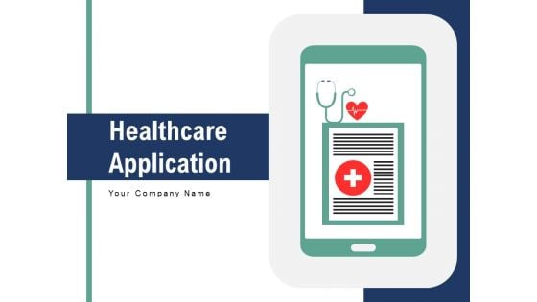

Problem Identification
Medication non-adherence is a complex issue with personal, social, and systemic consequences. From a public health standpoint, it leads to an estimated 125,000 preventable deaths annually and costs the healthcare system billions in avoidable hospitalizations. Reasons include forgetfulness, misunderstanding instructions, side effects, and economic constraints. Manual tracking solutions—pill organizers, calendars, or reminder notes—lack intelligence, adaptability, and accountability.
This slide must also explore the types of non-adherence:
- Intentional – Skipping due to side effects or doubts.
- Unintentional – Forgetting or confusion about timing/dosage.
In multi-medication households (e.g., elderly patients, children), managing overlapping medication schedules without assistance becomes overwhelming. Complex regimens require precision, and missing even a single dose of critical medications (e.g., blood pressure or insulin) can lead to life-threatening situations.
The slide must emphasize that traditional healthcare infrastructures are not equipped to follow up on every individual’s routine adherence. Hence, a technology-based solution becomes not just beneficial but essential. This tool supports continuity of care by connecting patients’ real-life routines with digital oversight. Such a digital interface ensures reminders are never missed, logs are stored automatically, and patients or caregivers are supported with intelligence-driven schedules.

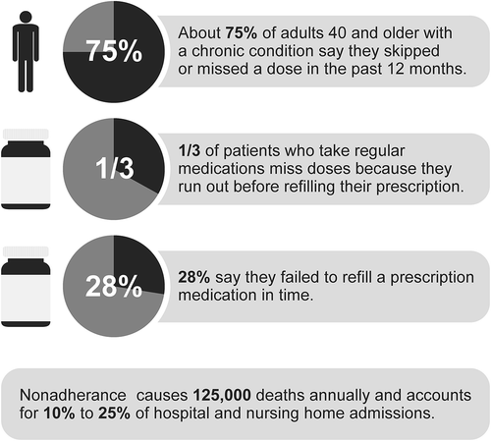

Motivation
The motivation behind this project originates from the direct pain points experienced by families and individuals managing multiple medication routines. It’s not uncommon for a parent to manage five or more prescriptions for a child recovering from surgery or for elderly individuals to forget doses that can be life-threatening if missed. The psychological load of remembering, cross-checking, and coordinating medicine schedules every day leads to stress and burnout.This system seeks to address that burden by turning medication management into a structured digital process. A digital tool removes the variability and inconsistency of manual tracking methods. It enhances confidence among caregivers by providing reminders, confirming actions, and generating reports without requiring any additional effort. This project is not just about coding an application but about creating a caregiving ally that operates silently in the background and steps up at the right moments.Moreover, the motivation also stems from systemic gaps in outpatient care. Once a patient leaves the hospital, responsibility often shifts entirely to the individual or their family. There’s minimal follow-up or automated checking to ensure adherence. This platform can help bridge that gap by making it easier for both patients and health professionals to maintain oversight in a decentralized way. Over time, the data collected through this system can serve to support research, improve treatment personalization, and even predict non-compliance trends in chronic illness management.

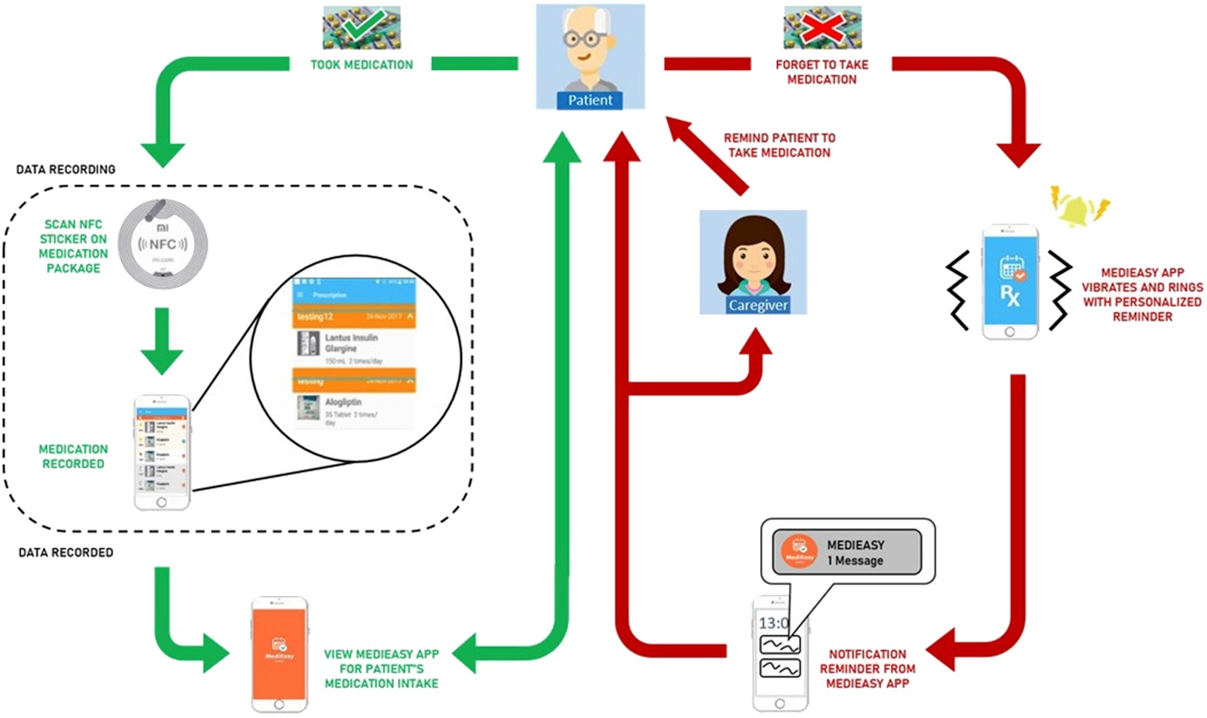

Objectives
- Enhance Adherence: The primary goal is to help users take medications on time through proactive notifications and intelligent reminders. Unlike static alarms, this system adapts to changes in routines and allows on-the-fly adjustments to medication schedules.
- Empower Caregivers: Caregivers can manage multiple users, such as children or elderly parents, by adding profiles, setting dosage information, and tracking logs—all within a centralized dashboard.
- Generate Clinical Reports: A reporting mechanism transforms adherence logs into clinically useful charts and summaries. This serves as a valuable communication tool between patients and doctors, improving decision-making based on actual data.
- Provide Seamless User Experience: The interface has been carefully designed to minimize cognitive overload. Even non-tech-savvy users can navigate the system with ease. Features such as visual medication cards, color-coded statuses, and one-click reminders contribute to the usability goals.
- Ensure Data Security: Sensitive health information requires robust security. Role-based access control (RBAC), encrypted sessions, and secure authentication ensure that user data is protected at all times. This objective underpins the project’s readiness for real-world deployment in regulated environments.

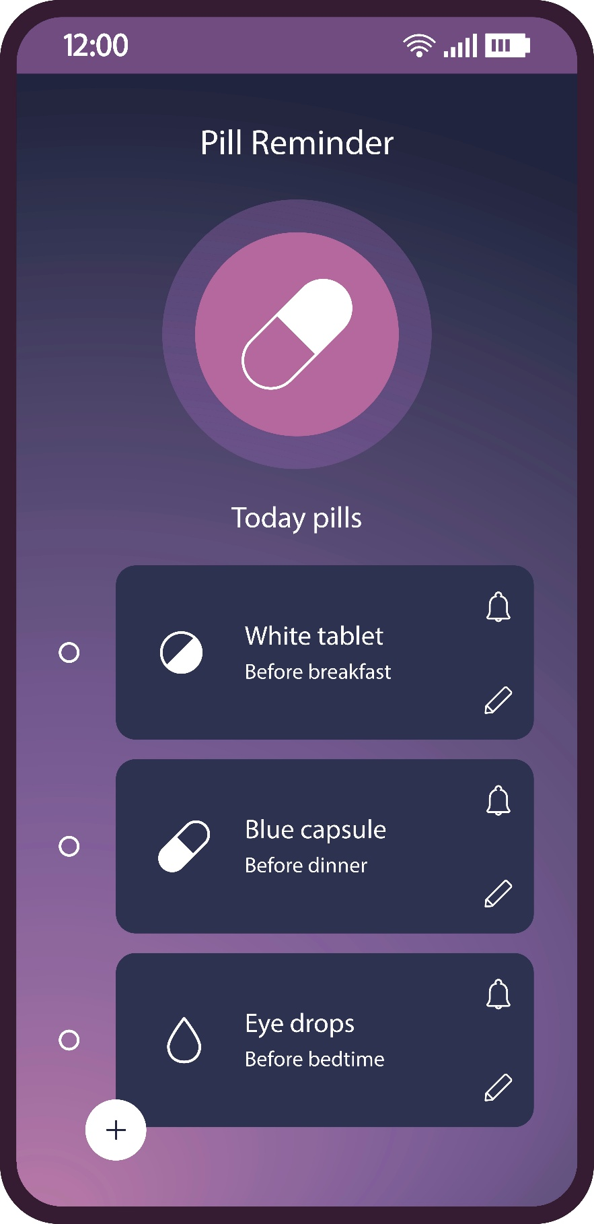

Technical Approach
The technical approach to this project is foundational to its reliability, scalability, and security. It leverages a modern full-stack architecture to provide an efficient, user-friendly, and extensible platform for managing medication adherence.
Frontend (ReactJS): React is used to build the user interface because of its component-based structure and its capacity for managing complex state across views. React enables the creation of dynamic, reusable UI components, facilitating faster development and easier maintenance. It also allows for responsive design, ensuring accessibility across desktops, tablets, and mobile devices. React's virtual DOM improves rendering performance, which is essential for real-time alert interfaces and smooth interactions.
Backend (Django): Django is a high-level Python web framework that encourages rapid development and clean, pragmatic design. It is ideal for handling back-end logic and ensuring data integrity. Django REST Framework (DRF) is used to create scalable APIs that connect the frontend to the backend logic. Authentication, data validation, and business rules are all enforced server-side, providing a secure backbone for the system.
Database (MySQL): MySQL serves as the relational database for this project. It is widely used for structured data and supports complex queries and transactions with high reliability. Medication records, user credentials, notification logs, and reporting metrics are stored here. Indexing and optimized queries help maintain system performance even as the database grows.
Notifications (Service Workers): JavaScript Service Workers run in the background to deliver real-time browser notifications, even when the user isn’t actively interacting with the web application. This ensures timely alerts regardless of tab focus or active sessions. Integration with APIs like Web Push and Firebase Cloud Messaging is planned for mobile push support.
Deployment (AWS/GCP): Hosting the app on cloud platforms like AWS or Google Cloud ensures scalability, availability, and fault tolerance. These environments support CI/CD pipelines for seamless updates and monitoring tools to track uptime, load, and error logging.
This multi-layered stack ensures performance, maintainability, and extensibility. It also prepares the application for future enhancements such as AI-based modules or integration with wearable health devices.

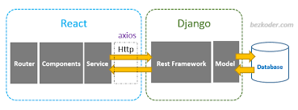

System Architecture
The architecture of the Health Tracker Web Application follows a modular, layered design to ensure separation of concerns, maintainability, and ease of expansion.
Client Layer: The user interacts with a React-powered front end that collects and validates user inputs, such as medication names, dosages, and schedules. This layer is designed for responsiveness and is capable of running seamlessly across devices.
API Layer: This is the communication bridge between the frontend and backend. Django REST APIs expose endpoints that the frontend can use to create, read, update, or delete data. The APIs are protected using authentication tokens (JWT), ensuring that only authorized users can interact with sensitive endpoints.
Application Logic Layer: This layer contains all the core functionalities, such as checking for scheduling conflicts, logging adherence data, triggering reminders, and generating reports. Django views and serializers process user input and apply business logic.
Data Layer: All structured information—users, medications, reminders, and logs—is stored in a MySQL database. The schema is normalized to support fast lookups and reduce redundancy. Transactions are handled securely, and backups are scheduled to ensure data resilience.
Security Layer: User sessions are authenticated using JWT tokens and permissions are governed by role-based access control (RBAC). The system enforces HTTPS and encrypts sensitive data at rest and in transit.
This architecture is designed with horizontal scalability in mind. Each component—UI, backend, database—can be deployed independently and scaled as demand increases. It also allows developers to plug in enhancements like machine learning models for recommendation systems or external APIs for pharmacy integrations.
The modular nature of the architecture means it is prepared for both immediate deployment and long-term evolution into a more comprehensive digital health ecosystem.

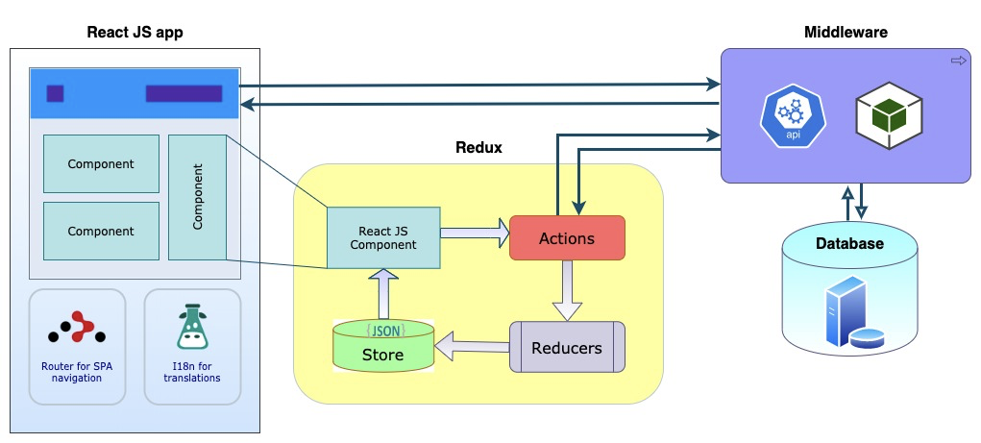

User Roles
Structured Access for Functionality and Security
The Health Tracker Web Application is built with role-based access control to ensure both usability and security. It supports two primary user roles:

- Caregivers (e.g., parents, guardians, patients themselves):
  - Responsible for managing medication schedules.
  - Can add medications, set reminders, and upload images for easy identification.
  - Receive real-time notifications and adherence updates.
  - Track daily, weekly, and monthly medication adherence through reports.
- Administrators (system overseers, healthcare providers):
  - Maintain overall system health and monitor user accounts.
  - Manage database integrity, ensuring medication details are not manipulated.
  - Have access to high-level analytics, auditing logs, and security protocols.
This distinction ensures that users can efficiently manage personal health, while administrators can oversee system-wide operations without interfering with individual medical records. A side-by-side table comparing access permissions helps clarify how each role interacts with the application.
Reminder System
Ensuring Timely Medication Intake
Medication adherence is largely dependent on reminders and alerts. The Health Tracker Web Application automates this process to minimize forgetfulness or inconsistencies in medication intake. The reminder system functions through multiple features:
- Medication Entry: Caregivers can input medication details, including dosage, frequency, start and end dates, and special instructions.
- Image Upload: Users can associate each medication with an image, allowing for easy recognition, which is particularly useful for elderly users or visually impaired individuals.
- Customizable Scheduling: The system allows flexible notification settings based on user preferences, including daily, weekly, or as-needed reminders.
- Background Notifications: Even if the browser tab is closed or the application is inactive, push notifications and alerts will still be delivered using Service Workers and Firebase push services.
- Auto-repeating Alerts: Notifications recur at designated times until the user confirms the dose, ensuring accountability.
This automation significantly reduces missed doses, reinforcing adherence while minimizing caregiver

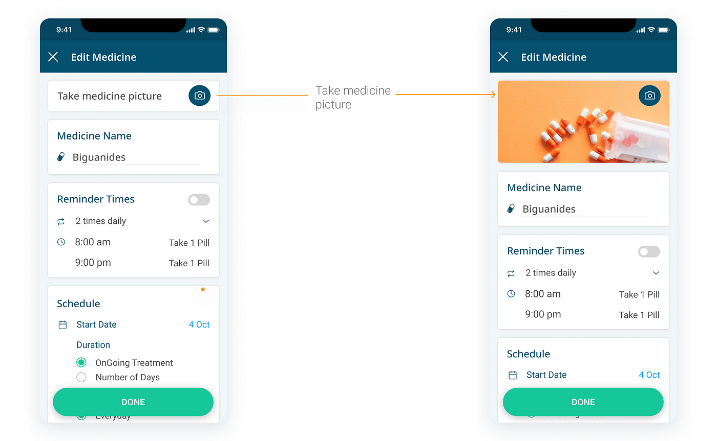

Reporting Mechanism
Transforming Data into Actionable Insights
Tracking medication adherence over time is critical for both patients and doctors. The Health Tracker Web Application offers detailed reports to analyze trends and help healthcare providers assess progress.
Types of reports generated:
- Daily Logs – Tracks each dose taken or missed, allowing users to stay informed of their adherence in real-time.
- Weekly Trends – Aggregates data to highlight recurring patterns, identifying any inconsistencies in medication intake.
- Monthly Summaries – Provides structured insights that can be exported in PDF or CSV format for doctor consultations and further evaluation.
Reports are visualized using graphs and charts, helping caregivers quickly interpret adherence behavior. Chart.js or similar libraries are used to create interactive graphical representations, making the data easy to understand.
Additionally, predictive analytics could be integrated in future versions, allowing the application to identify missed dose trends and suggest adjustments in medication schedules.

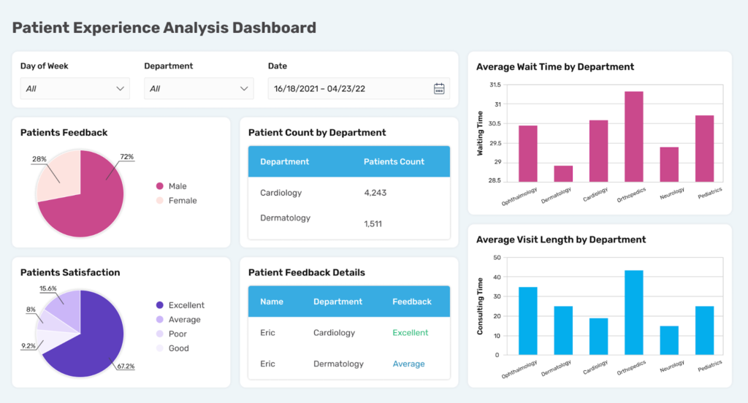

Future Enhancements
Expanding Functionality for Greater Impact
To ensure long-term usability and flexibility, the project roadmap includes several advanced features aimed at improving user experience and integration with broader healthcare systems.
Upcoming features include:
- Mobile App Integration – The development of a Flutter or React Native version will ensure accessibility across all devices, including smartphones and tablets.
- AI-Powered Dose Optimization – Machine learning models will analyze adherence patterns, detect frequent missed doses, and suggest optimized intake times for better compliance.
- Cloud Synchronization – Users will be able to access their medication records from any device, ensuring consistency in tracking.
- Pharmacy and EMR (Electronic Medical Records) Integration – A future goal is to allow direct integration with healthcare systems, enabling prescriptions and dosage adjustments through seamless connections with doctors and pharmacies.
These enhancements will elevate medication management from a simple reminder tool to an intelligent healthcare assistant, making adherence more efficient and predictive.

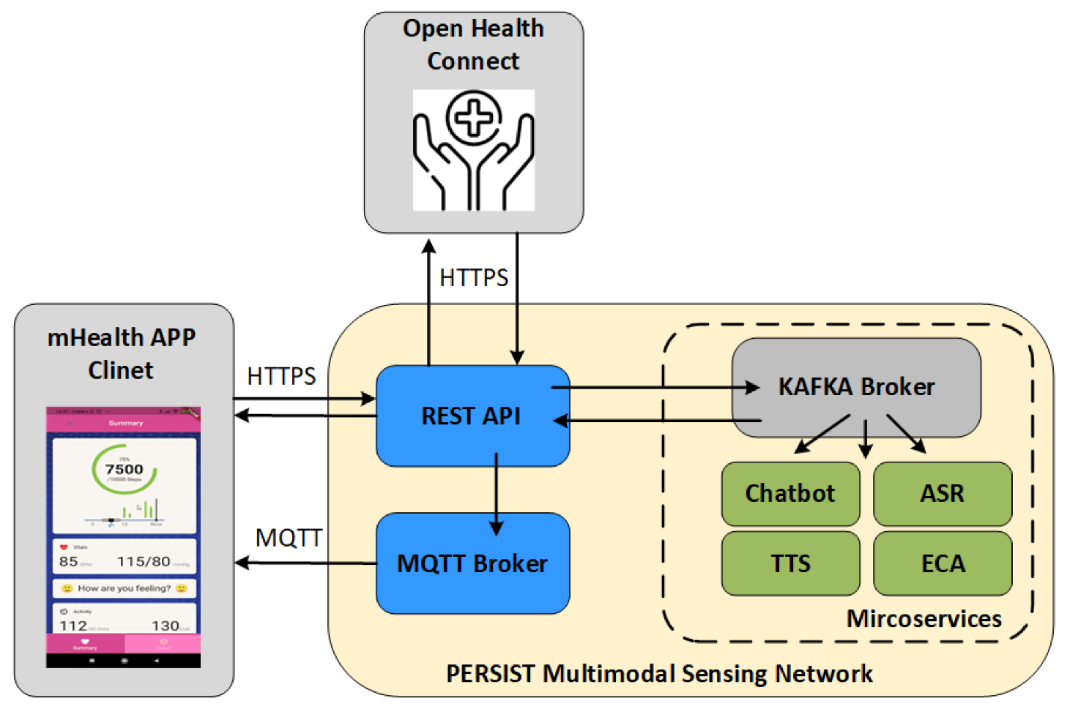

Workflow
Step-by-Step Functionality Breakdown
To provide a structured flow of operations, the Health Tracker Web Application follows a well-defined user journey:
- Login/Register – Users securely authenticate via JWT-based login, ensuring data protection.
- Add Medications – Inputs are validated to prevent conflicts, ensuring each medication is correctly recorded.
- Schedule Reminders – The system checks for overlaps and applies timezone offsets for accurate scheduling.
- Notifications Sent – Alerts are triggered via browser-based or mobile push notifications, ensuring users receive timely reminders.
- Track Adherence – Users confirm medication intake or note missed doses, logging their behavior for future analysis.
- Report Generation – Users and administrators can access comprehensive adherence insights in downloadable formats (PDF/CSV).
This workflow ensures seamless interaction, prioritizing ease of use and structured health management.

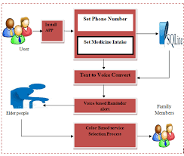

Conclusion
The Bigger Vision for Healthcare Management
The final slide summarizes the core strengths and impact of the application:
- Improving medication adherence through automated tracking and timely alerts.
- Reducing caregiver burden, minimizing the stress of managing complex medication schedules.
- Providing valuable health insights, enabling doctors to make data-driven decisions regarding patient care.
- Establishing a scalable and intelligent digital healthcare assistant, adaptable for future AI-powered enhancements and integrations.
The Health Tracker Web Application is not just a reminder tool—it represents a step toward smarter, more accessible digital healthcare, where technology actively supports patient adherence and treatment success.

