**Introduction:**

The objective of this case study is to design and develop Data Visualization Web Application using Plotly Dash framework in Python.

**What I have done:**

The data source for this project is provided in csv format and developed a web app.

**Bar Graph:**

It is designed with a custom Navbar and two dropdowns are developed i.e., Region and Country with a submit button of which the Country dropdown is dependent on the Region dropdown. In detail, there are 8 Regions, if we select a region for suppose South Asia then the Countries which fall under South Asian Region are the values in Country dropdown. If we select the values from both the dropdowns and click on submit, the graph will be updated accordingly as per the selection.

Note: Only the bar graph data will be reflected by the Region & Country dropdowns followed by the submit button. No other widgets will be affected by these.

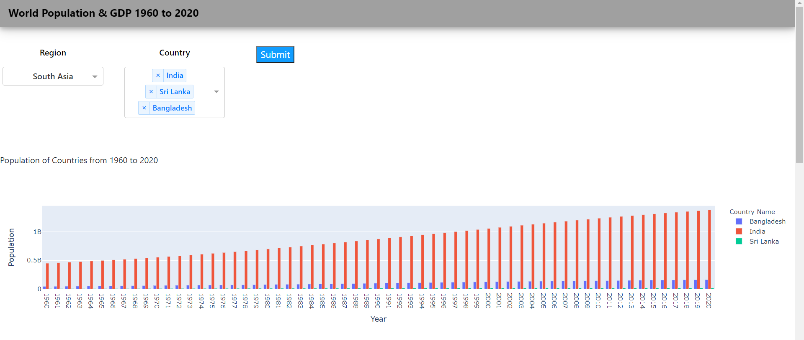

**Choropleth Map:**

In this an Input box to enter the Year of the user’s choice is provided with submit button. The minimum value to be entered is 1960 and maximum is 2020 based on the data source. Also, the Year in the title “Population of Countries in 2007” changes according to the value entered in the input box. The data of Country Name, Year, Population and GDP is shown as the user hover the mouse over the map. 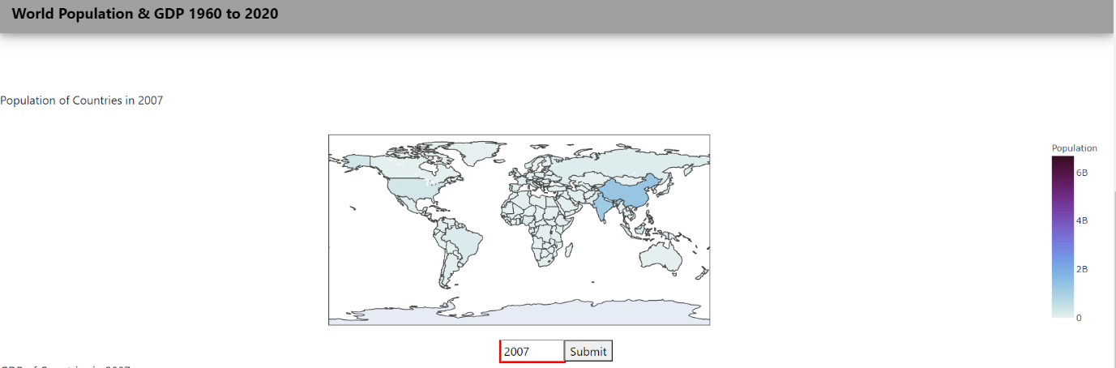

**Data Table:**

Here, the same input box filter reflects the data in the data table as the input is modified. An “Export” button is placed on top left corner of the data table to download the data table in csv format.

