5G00GC09-3003 Datapipelines [sic]

Data Pipeline Project

This pipeline-construction assignment is an individual work.
Deadline: March 15, 2026, 23:59 EET
First, you are to make an overall plan about a pipeline, select technologies, and get ready to acquire the needed data. Then, you are to implement the pipeline and test that it works.
Report your work by filling this document and submitting it in Moodle before the deadline along with the required material. For details, see Submission. Notice that answer cells in tables should not be left empty.
The grading (max 6 XPs) is based on your report (as indicated in this template), your pipeline being in accordance with the requirements, and the submission having been made in time as instructed.
Use of AI tools is OK when creating the pipeline (), but this document must be filled with your own, thoughtful answers ().

Planning the Pipeline: the Overall Idea
The data pipeline to be implemented must satisfy these requirements:
- The pipeline must somehow make your life (personally) easier. I.e., the pipeline must be actually useful for you. (The pipeline can be related to, for example, school, hobbies/interests, economy, planning/scheduling, decision-making, or something else.)
- The pipeline must gather data from several (more than one) sources and combine them in a sensible manner.
- The pipeline must include several distinct steps of moving/processing data. The split into these steps (tasks) must be logical, and each of them must have a well-defined purpose. Ideally, the tasks and executing them can be distributed across multiple computers (not strictly required, though).
- The pipeline must be robust and work reliably. Even if you know that the data sources generally produce high-quality data, the pipeline must validate the data and be prepared for unexpected situations. Erroneour data should be corrected, if possible. Some kind of a retry functionality should be included.
- The pipeline must clearly transform the data (to gain some benefit / make the data more valuable). Some (useful) new data must be produced by the process.
- Data must be read from or loaded into a database at some point during the process. For example, a simple, local memory- or file-based SQLite or DuckDB database will do, but some kind of database management system should be involved, anyway. (That is, regarding fulfilling this requirement, e.g., directly reading data from or writing data to a file in the file system is not considered as using a database.)
Plan the pipeline you are going to implement and fill the table completely and carefully.
Question | Answer
What should the pipeline do? | The pipeline collects football match data from multiple external APIs, processes and validates the data, stores it in a database, and then uses statistical models and machine learning techniques to predict the outcomes of upcoming English Premier League matches.
What kind of a pipeline is it: a batch-processing pipeline, a stream-based one, or what? Is the pipeline run manually, is it triggered by some event, or is it, perhaps, run periodically by some timer or scheduling mechanism? Is parallel execution applied? | The pipeline is primarily a batch-processing and manually executed data pipeline, but it could be easy to implement a Cron job-based automation. No explicit parallel execution is implemented, but the pipeline is designed in modular tasks so in a distributed system API fetching, feature engineering,  modelling and predictions could be run in parallel on separate workers or machines.
What is the actual purpose/goal? (Why is the pipeline useful for you? What problem does the pipeline solve?) | The pipeline solves the problem of predicting football match outcomes using data-driven models. It leverages sports analytics, machine learning, and statistical modelling to transform raw match data into advanced predictive insights such as expected goals and scoreline probabilities. It is a versatile tool for football research and betting analysis, enabling precise match forecasting and predictive modelling experimentation.
How are the outputs of the pipeline used? (Perhaps visualized by some dashboard view? Written into reports – to be used how? Emailed? Posted somewhere? ...) | There is a predictions Database stored in predictions.db, that contains upcoming matches, predicted outcomes, expected goals and probability distributions. In the console it prints predictions, summaries and most recent matches. Also, it could be used in sports analytics research.
What input data are used by the pipeline and from which sources? Can you acquire them legally and without ethical problems? (If not, you should, naturally, modify/change your pipeline idea...) | The pipeline ensures legal and ethical data acquisition by utilizing authorized API keys to access public sports data from football-data.org and API-Football. These sources provide the foundational match results, fixtures, and goal statistics necessary to drive the system's predictive analytics.
Tell about your expectations regarding the input data. Consider, e.g., the quality and availability of them. What kinds of data-related problems may occur? | While these APIs typically provide accurate match results and reliable sports statistics in structured JSON formats, occasional data quality issues may still occur. To address data quality, the pipeline automatically removes incomplete or duplicate matches and implements retries for API rate limits or downtime. It further handles team name inconsistencies by assigning neutral strengths to any unrecognized teams.
How are the data transformed when processed by the pipeline? | The pipeline transforms raw match data into engineered features and expected goals (xG) metrics to quantify team strengths. These values feed into a Poisson model and a Random Forest regressor to generate specific scoreline probabilities and final match outcome predictions.
What kind of a database(s) is going to be used, for what, and how? | The system utilizes two SQLite databases to separate historical match analysis and engineered features in football_pipeline.db from future match forecasts stored in predictions.db.
/0.5 XPs
Add here a figure/diagram illustrating different tasks/phases of the pipeline and how the data flows between them. Use boxes or ellipses or some other suitable shapes for the tasks and arrows between them to indicate the data flows. Also, add text to clarify the situation; at least names for the tasks and some explanations/descriptions about the nature of the data flowing between them (alongside the arrows) should be present.
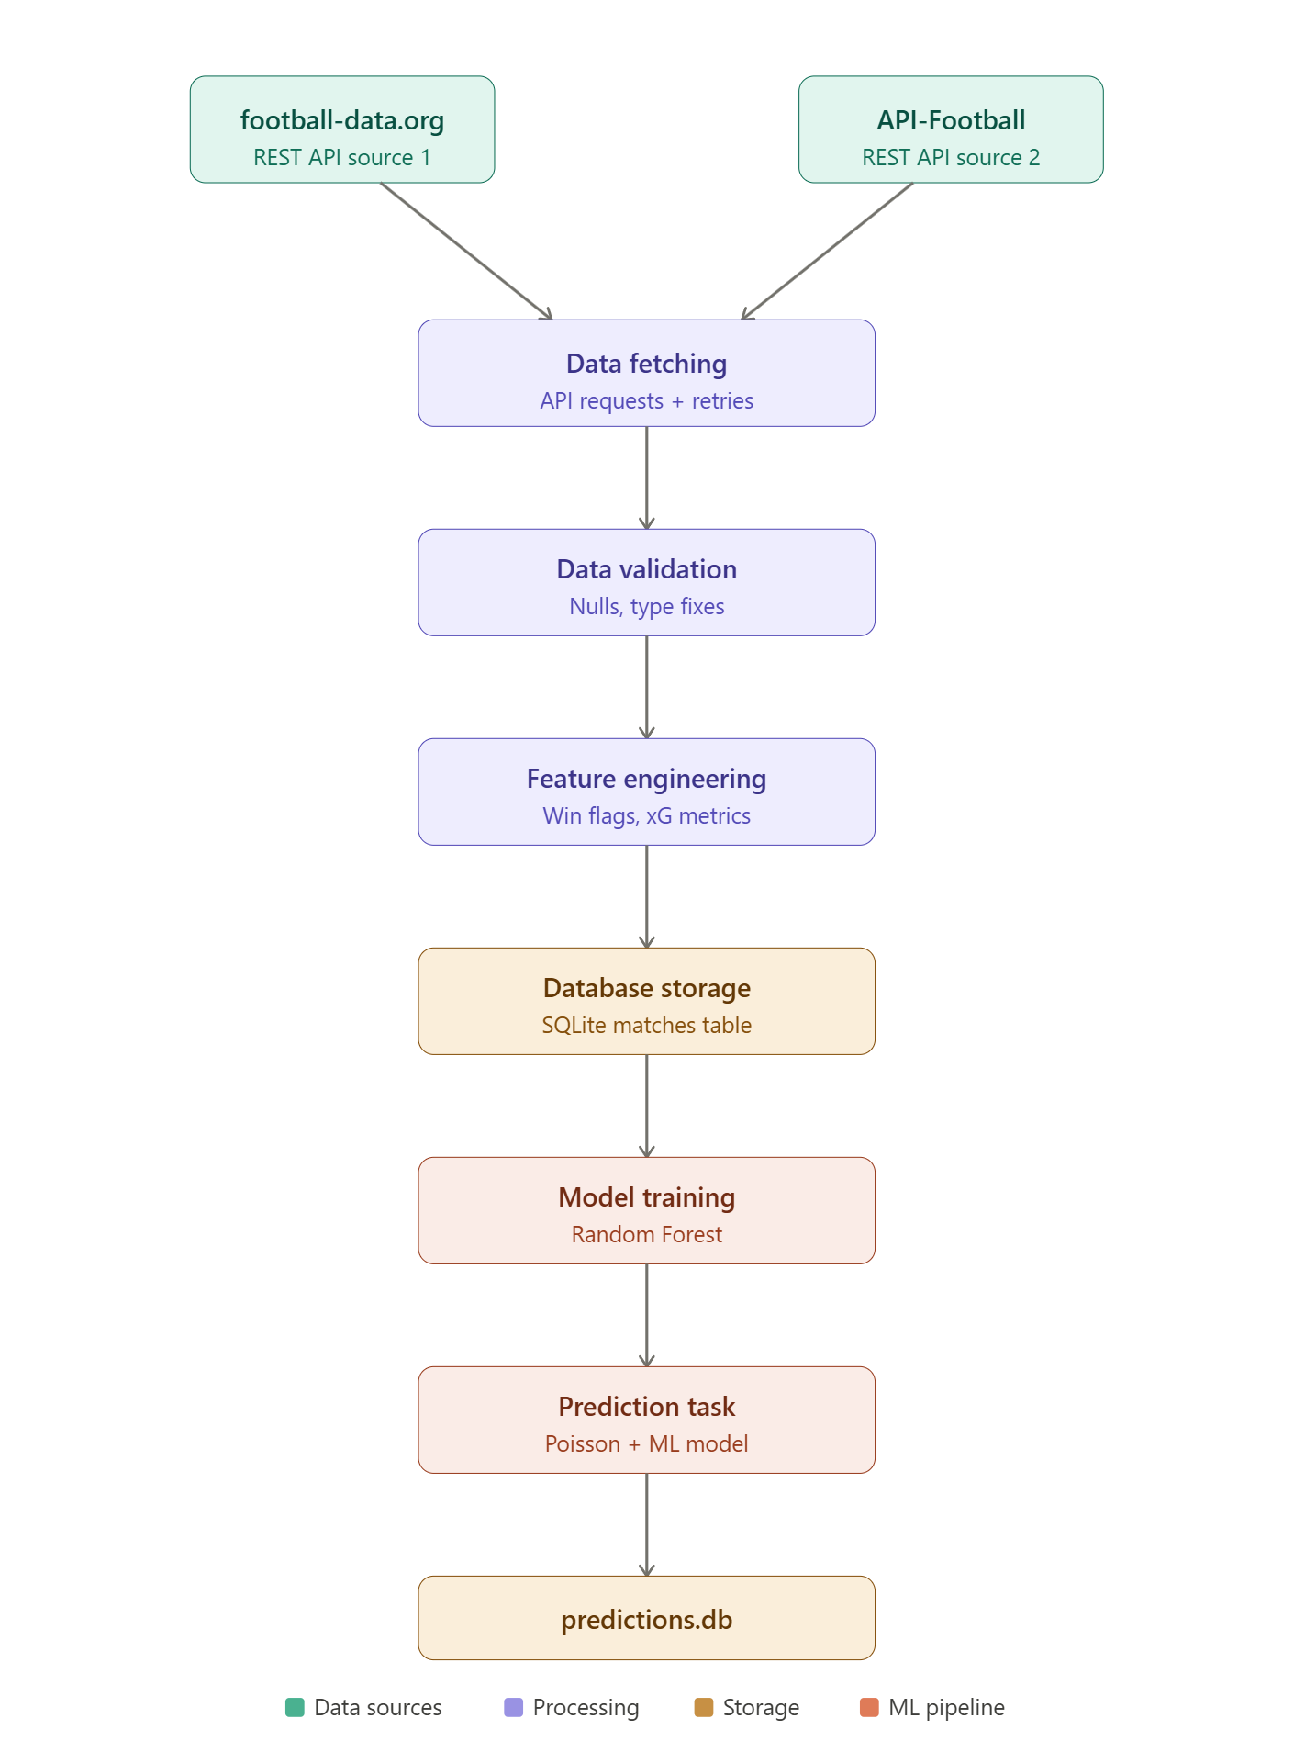
/0.5 XPs
For each individual task (or such) depicted in the figure you added, fill a table row (every column). (Add rows as necessary.)
Name of the task | Input data for this task and its origin(s) (e.g., another task) | Output data and its destination(s) (e.g., receiving task(s)) | The purpose/function of the task explained briefly | List errors/problems that may occur when running this task. How is data quality guaranteed and how are errors handled?
Data Fetching | API data from football-data.org and API-Football | Raw match dataset | Collect match results | API failures handled by retry logic additionally, logging records API requests and potential failures to the pipeline.log file.
Data Validation | Raw match data | Clean match data | Remove missing values and invalid matches | Null values removed
Feature Engineering | Clean match data | xG, win indicators | Create analytical features | Missing teams handled with default values
Database Storage | Processed dataset | SQLite tables | Store historical data | SQLite errors handled by connection checks
Model Training | Feature dataset | Trained Random Forest model | Train predictive model | Training/test split prevents overfitting
Prediction | Model + team strengths | Match predictions | Predict outcomes and probabilities | Unknown teams default to neutral stats and u nexpected errors are captured using exception handling and recorded through the logging system
Prediction Storage | Predictions | SQLite predictions table | Save outputs | Database overwritten safely
Data Fetching | API data from football-data.org and API-Football | Raw match dataset | Collect match results | API failures handled by retry logic
Data Validation | Raw match data | Clean match data | Remove missing values and invalid matches | Null values removed
/1 XP

Technologies
Consider technologies (programs/platforms/frameworks/libraries/languages/...) that might be used to implement your pipeline. You should consider several options and try to find a good one for the task at hand. Fill the table by answering all the questions carefully.
Question | Answer
What technologies do you intend to use? (Consider all the parts of the pipeline.) | Python, Pandas, NumPy, Requests, SciPy, Scikit-learn, SQLite, logging
Why? What are their benefits regarding your intents, goals, and problem setting? | The pipeline is implemented using Python. Libraries used include requests for API access, pandas and numpy for data processing, scikit-learn for machine learning, scipy for statistical modelling, sqlite3 for database storage, and the built-in logging module for monitoring pipeline execution and recording errors.
What alternatives were considered, and why were they dismissed? | Apache Spark, PostgreSQL, Airflow, they were dismissed, because they were too heavy for a small academic pipeline.
Based on the technological choices made, is it possible to distribute the execution of the tasks of the pipeline across multiple computers? Regarding which tasks and how? | Yes. API fetching and model training could run on separate machines.
Are there any special constraints, limitations, or needs (e.g., regarding hardware requirements, software licences, or the ways of implementing the data-processing logic) or other matters you have to take into account in your implementation because of the technological choices? | API rate limits and machine learning training performance
/0.5 XPs

Implementing the Pipeline
Implement the pipeline as planned. (If necessary, update the plans along the way.)
Running the Pipeline Normally
Add here screen captures demonstrating running your pipeline normally – hopefully successfully. Based on these pictures, one should be able to understand, what happens, and it should be clear, if the pipeline works as intended or not. Use as many pictures as necessary. Also explain each picture briefly textually.
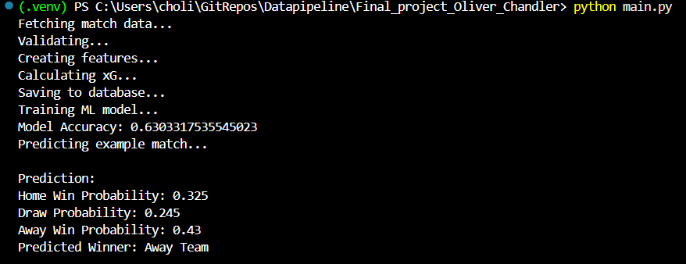
This screenshot shows the pipeline being executed from the command line. The pipeline begins by fetching match data from two external APIs, then validates and processes the data before training the machine learning model. Then it trains a Random Forest machine learning model using engineered features such as expected goals and team strengths. The accuracy score shown in the console output indicates how well the model performs when predicting match outcomes. After training the model, the pipeline predicts the outcome of an example match using statistical models and machine learning. The probabilities represent the likelihood of each possible outcome.
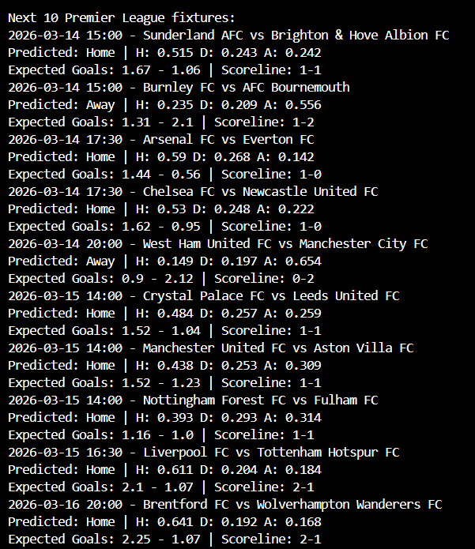
The pipeline fetches upcoming Premier League fixtures and predicts the match outcomes using a combination of expected goals modelling, Poisson distribution, and a machine learning classifier.
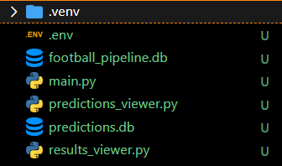
This is the project’s directory containing all the files.
Testing Robustness
Introduce artificially some data-related problems, and add here screen captures demonstrating, how your pipeline behaves under non-optimal conditions. It should become clear, what is the problem and how the pipeline handles the problem. Once again, use as many pictures as necessary, and explain the pictures, problems, and ways to tackle them. At least some kind of retrying or error-correcting behavior should be demonstrated.
I changed the API keys so it should retry it multiple times:
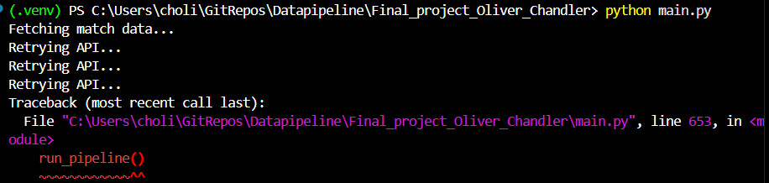
This screenshot demonstrates the retry functionality implemented in the pipeline. If an API request fails due to network issues or invalid responses, the pipeline retries the request multiple times before raising an error.
Added temporarily to the dataset:
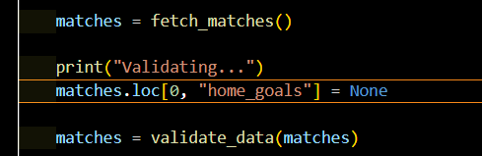
The pipeline still runs successfully:
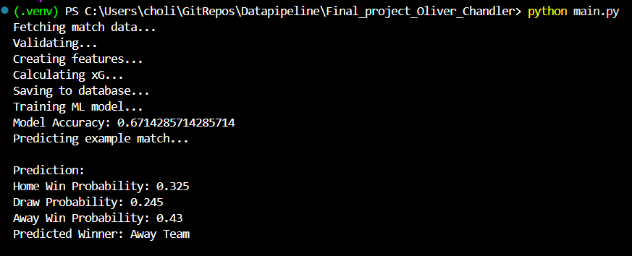
The pipeline includes validation steps that remove incomplete or invalid records. Rows containing missing values are removed during the validation phase to ensure data quality.
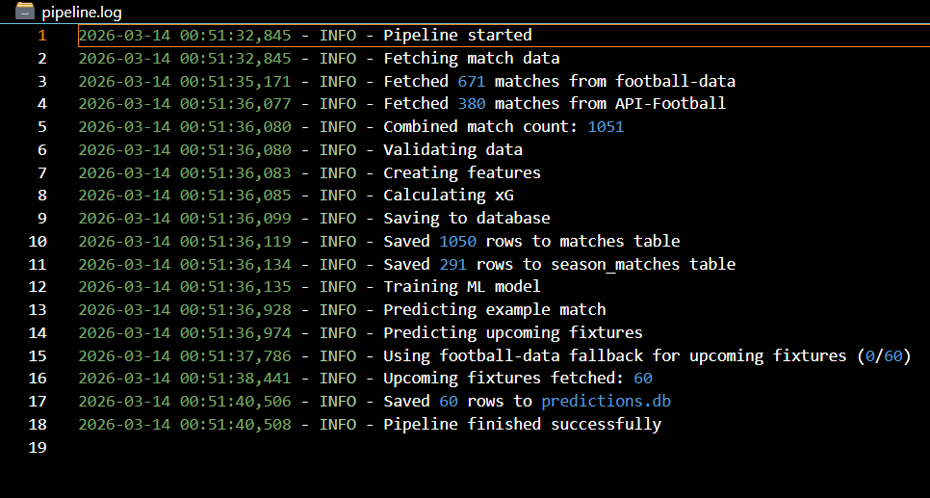
To improve robustness, a logging system was implemented. The pipeline records important execution steps and potential errors in a log file (pipeline.log). Logging ensures observability of the pipeline and provides an audit trail of executed tasks, which is an important practice in real-world data engineering systems.
Database
Add here screen captures demonstrating that data has been written to a database as a result of running your pipeline. (You can – e.g., using a command line tool – fetch and print some data from a database in which your pipeline has stored them or show the data using some database management UI; the important thing is that it is demonstrated that your pipeline has communicated with a database reading or storing data according to your plans. Once again, use as many pictures as necessary, and explain the pictures textually.
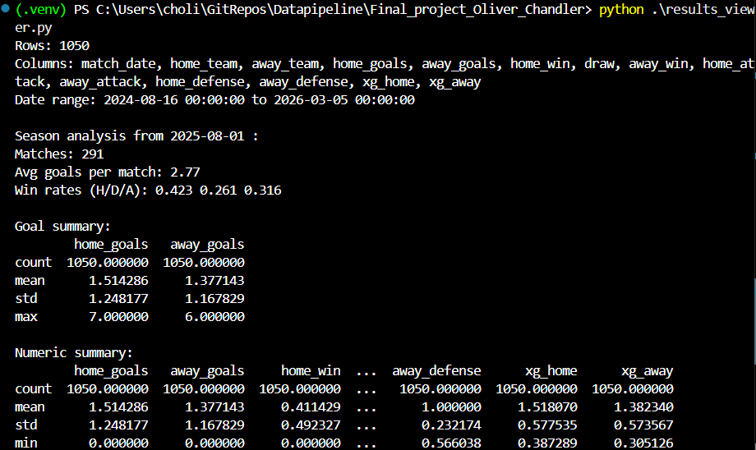
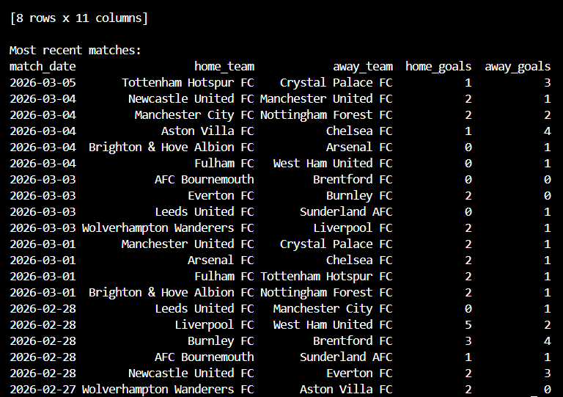
This screenshot shows the contents of the SQLite database where the processed match data is stored. The database contains historical match results used to train the prediction model.
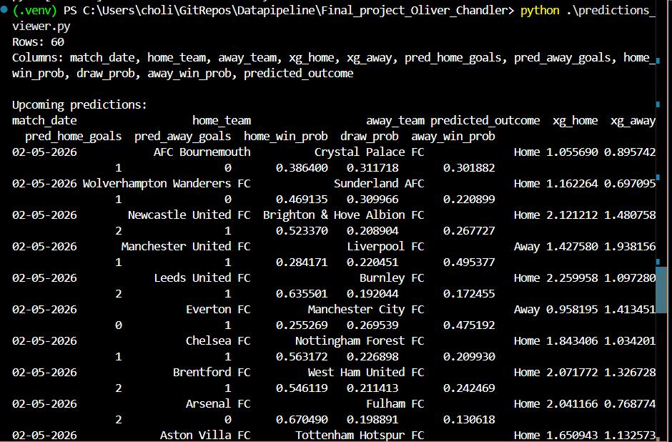
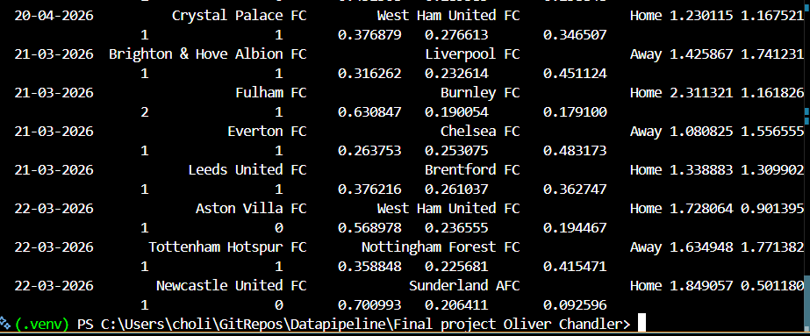
The pipeline stores match predictions in a separate SQLite database. This screenshot demonstrates that predicted match outcomes and probabilities were successfully written to the predictions table.
Results
Add here screen captures demonstrating the final outputs of your pipeline or their use (depending on what your pipeline actually does and what is its intended use). (A representative sample is enough – no need to show everything, if the amount of output is huge or showing everything is otherwise inconvenient.) The point is that it should become clear that your pipeline produces something usable that can be used for the purpose for which the pipeline was built. Depending on the nature of the pipeline, your screen captures may show, e.g., some file content, some stdout output, or a user interface showing some visualization, or something else. Once again, use as many pictures as necessary, and explain the pictures textually.
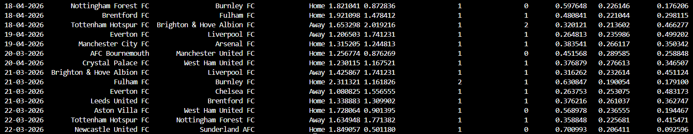
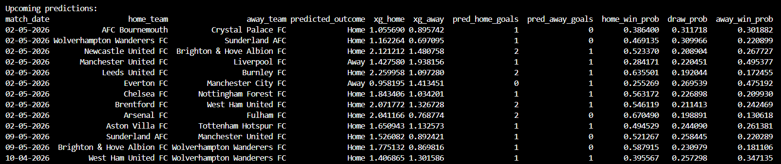
This screenshot shows the final output of the pipeline. The system produces expected goals values, predicted scorelines, and win probabilities for upcoming matches. These predictions can be used for sports analytics, forecasting, or betting analysis.
/2 XPs

Summary and Evaluation

Fill the table answering all the questions carefully.
Question | Answer
How were your plans/choices updated/revised during the development process? If you followed the original plan without any needs for modifications, tell also that explicitly. | The pipeline was extended to include Poisson models and expected goals.
Based on this experience, to which features you are going to pay more attention in your future projects related to data handling / pipelines? | Better feature engineering and automated scheduling
Did you use some tools or technologies on which you did not have prior experience? Which ones? Were they suitable for your purposes? Tell about your opinions on these tools/technologies based on your experiences. | sports analytics modelling and a little bit of machine learning, but even without knowing everything these tools worked very well for building the pipeline
/0.5 XPs
Fill the table answering all the questions carefully.
Question | Answer
Overall, how well does your pipeline work? Can it be used for the purpose for which it was created? Are you actually going to use it? | The pipeline successfully collects data, trains models, and produces match predictions
Does it do everything that was planned and should do? Were some features (which?) left unimplemented? Are there some features that do not work reliably or quite as intended? | Data ingestion, modelling, prediction, and storage are implemented, the features that are missing are automatic scheduling and a visualization dashboard
Besides fixing possible bugs and adding the planned features that may have been left unimplemented at this point, how could your pipeline still be improved? (Consider efficiency, maintainability, additional features, etc.) | I could add more statistical features and advanced ML models
What kind of challenges were encountered during the pipeline-building process and how were they surpassed? | API integration, data consistency across APIs, and modelling football match outcomes, robustness of the pipeline and this was improved by retry mechanisms, error logging, and simplified debugging.
/1 XP

Submission
Before the deadline, submit separately in the relevant Moodle area
- this document and
- a ZIP package containing the pipeline code (or, depending on the used technical platform/framework/solution, configuration files or something else that basically implements the pipeline). The size of the package should be less than one MB – only include the most essential material. Since different tools and environments have been allowed and you may have used, for example, your own cloud databases, etc., being able to run the pipeline directly based on the submitted files is not required this time. You can – and should – leave out all the secrets or replace them by some placeholders. However, based on the submitted material, one should be able to understand the way you have implemented your pipeline. (If you very strongly prefer giving an address to your repository instead of submitting a ZIP file, that is acceptable, but in that case, make sure that the teacher has access to the repo! (GitHub: tjheinimaki, gitlab.com: tjheinimaki, Tite GitLab: teemu.heinimaki@tuni.fi).)

Totally: /6 XPs

This document should, naturally, be filled properly. Besides the content added by you, all the original content and formatting of the template should still be present in the submitted report – do not remove anything! Also, the submitted report should still be in ODT format.

