5G00GC09-3003 Datapipelines [sic], Exercise 1 (Still Practicing Basic Pythoning)

Download the file ex01.py from Moodle and complete the functions encode, neighbor_count_map, and ai_usage with appropriate implementations so that they work as described in that file. (The functionality of the original descriptions is, naturally, expected, so modifying the descriptions in the file is not useful.) More instructions/requirements can be found in the code file itself.
Do not alter the parameters, and clean up all unnecessary code from the version to be submitted, including calls to the implemented functions. (It makes, of course, sense to call the functions during development to test and verify their functionality, but in the submitted version, the functions should not be called.) The file to be submitted should not print anything that is not necessary for the required functionality. Naturally, it should be possible to run the code (at least with valid function parameters) without crashes.
Submit ex01.py – with its original name, completed with your code additions – in the corresponding Moodle submission area by the deadline.


AI usage is to be reported by implementing the function ai_usage as instructed. (Of course you can, in addition to this, also write comments in relevant places in your code.)

To clarify: the basic idea applied in this exercise (and probably in others in the future):
Phase |  | Example
1. You get a file with functions with empty bodies. |  | monkey.py
  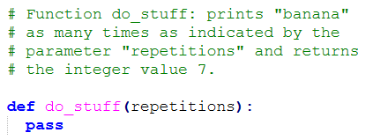
2. You read the function descriptions and write the function bodies accordingly so that the functions work as they should. You test the functionality. |  | monkey.py
  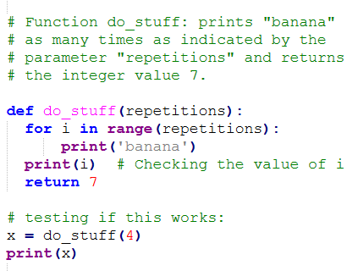
3. You clean the code removing prints and function calls that are not required by the instructions. |  | monkey.py
  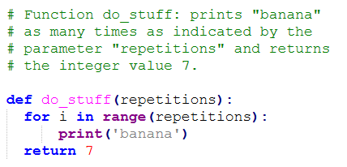
4. You submit the file in Moodle.

5. In addition to just looking at the code, the functionality of your work is checked by importing your functions from test code and running them with test parameters. |  | test_monkey.py
  