Fengshui
An agentic personal health companion for Apple Watch and iPhone
Deliverables 1 and 2: Design document and GitHub repository
Repository: https://github.com/Kouki-chan/fengshui

1. Project Overview

1.1 Project title
Fengshui: an agentic personal health companion that turns Apple Watch and iPhone data into clear answers, clinician-ready reports and timely alerts.

1.2 Team members
Name | Background
Kevin Chen | Computer Scientist
Koushik Das | Engineering Physics
Deron Smoot | Biochemistry
Everett Labrecque | Biology

1.3 Problem statement
Smartwatches and phones now record a person's heart rate, heart-rate variability, blood oxygen, breathing rate, sleep stages, steps, workouts and daily routines around the clock. This data is rarely useful to the person who owns it:
- Too much, too scattered. Apple Health holds hundreds of data types across years. Charts show what happened, not what it means or whether it matters.
- Hard to bring to a clinician. In a 10-minute appointment, a patient can't hand over months of raw wearable data. Clinicians need a short, factual summary of the relevant measurements with units, trends and gaps.
- Warning signs are missed. A resting heart rate that stays high, or blood oxygen that dips at night, is easy to miss unless someone is actively watching. Fixed thresholds alone produce false alarms, for example a high heart rate during exercise.
- Privacy concerns. Uploading raw health data to a third-party service to analyse it is a barrier for many people.

1.4 Target users
- Health-conscious individuals who wear an Apple Watch and want plain-language answers about their sleep, activity and recovery.
- Patients preparing for a medical appointment who need a concise report on sleep, heart or activity for their GP, cardiologist or sleep specialist.
- People who want a safety net for a period of time, such as after an illness, during travel or while starting a new medication, and want to be alerted about unusual readings.
- Health professionals (secondary users) who receive the reports: clinicians get structured, sourced data instead of screenshots.

1.5 Proposed solution
Fengshui is an iPhone app with a companion Apple Watch app and a small server that runs on the user's own Mac. The devices collect data and an on-device engine turns it into processed measurements and inferences. A Claude agent, the FengShui Agent, reasons over that processed data through narrowly scoped tools. Its main capabilities:
- Ask FengShui Agent: a chat where the user asks questions such as “How did I sleep this week?”. The agent fetches only the data it needs, cites it, and can draw on PubMed for evidence.
- Clinician reports: the user picks a day or date range and a purpose. The agent proposes which data types to include, the user adjusts them, and the agent writes a factual summary. The app renders a shareable PDF with charts and tables. Every question asked also saves a report.
- Health monitor: for a period the user chooses, the server checks readings at the chosen interval. Fixed rules flag anything unusual, and only then does the agent look at the context and decide whether to notify.
- Scheduled check-ins: a scheduled deployment runs the agent periodically; its message lands in the app's inbox.
- Data and inbox: a live data dashboard and an inbox of notifications the user can read, select and delete.
Raw watch sensor data never leaves the user's devices for the AI: the agent only receives processed values through tools, and the user decides what is shared with a clinician.

1.6 Why Agentic AI is appropriate
A fixed pipeline or a single prompt is not enough here, for four reasons:
- Open-ended questions need dynamic data retrieval. “Why am I so tired lately?” may require sleep nights, resting heart rate, activity and the evening routine across different periods. The agent decides which tools to call, in what order and over which dates, instead of loading everything into one prompt.
- Judgment under context. A heart rate of 125 bpm is alarming at rest and normal on a run. The rules catch the number; the agent checks steps, timing and the person's baseline before deciding whether an alert is warranted. This cuts false alarms without hiding real ones.
- Multi-step tasks with a deliverable. A clinician report is a sequence: discover the available data, choose what is relevant to the purpose, read it, summarise it accurately, then call the report tool. That is planning plus tool use, which is what agents are for.
- Acting asynchronously. Monitoring and scheduled check-ins run without the user present. The agent acts within strict boundaries (read-only data tools, one notification tool) and hands decisions back to the person.
Deterministic code still does what it does best: sensor processing, sleep detection, safety thresholds and PDF rendering. The agent is used only where reasoning adds value.

2. Agentic AI Design

2.1 Overall workflow
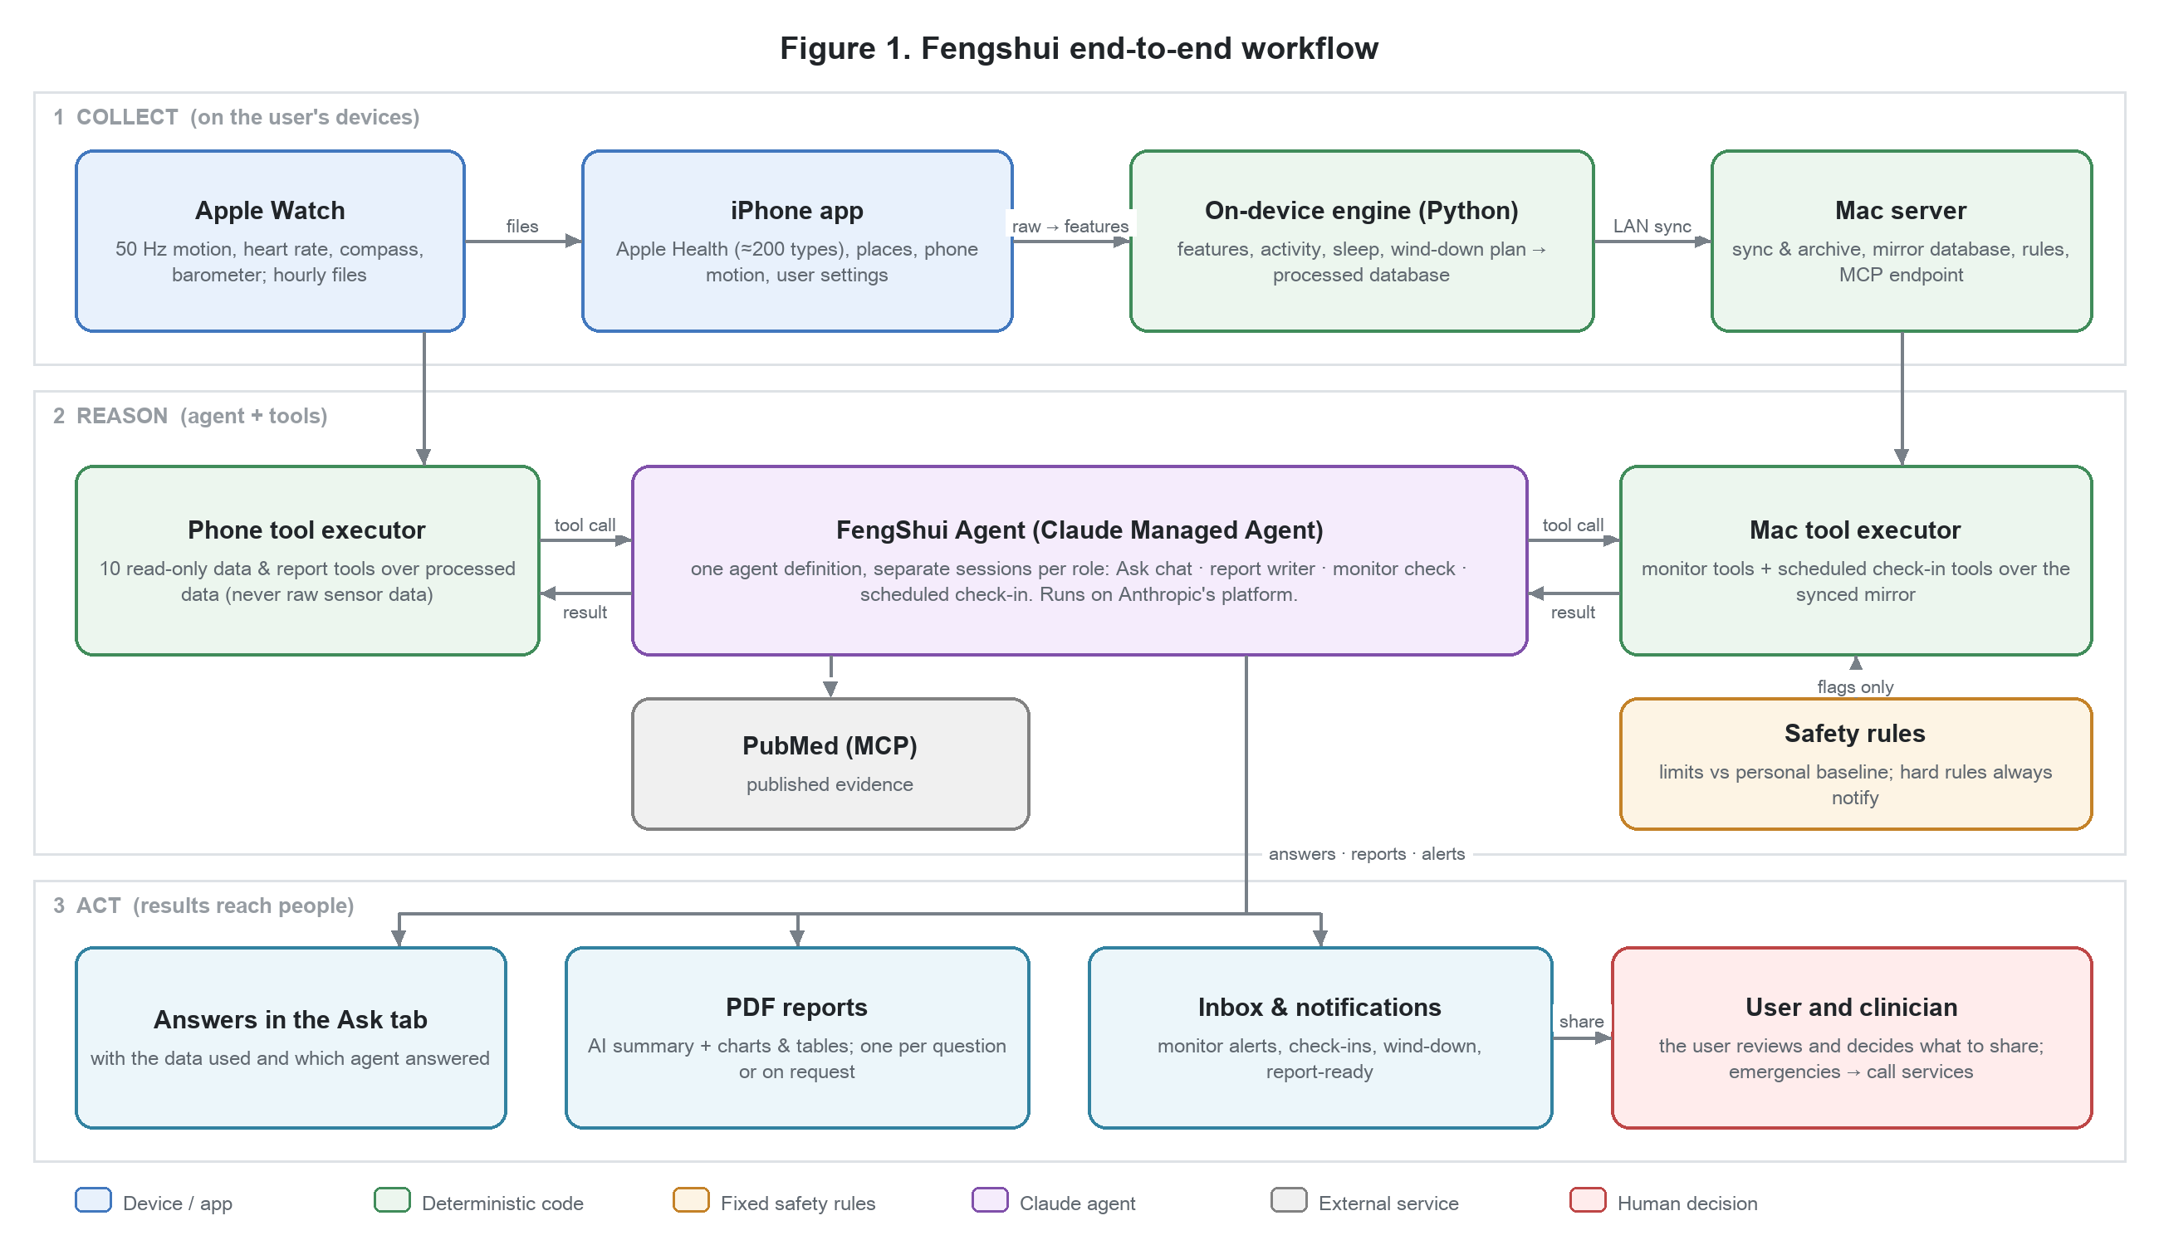
Figure 1. End-to-end workflow: collect on the devices, reason with the agent through tools, act through answers, reports and alerts.
The workflow has three stages:
- Collect. The Apple Watch records motion (50 Hz), heart rate, compass and barometer and sends hourly files to the iPhone. The iPhone reads about 200 Apple Health data types, the user's places and phone motion. An embedded Python engine computes features, activity bouts, sleep nights and a nightly wind-down plan, and stores them in a local database, which syncs to the user's Mac over the home network.
- Reason. When the user asks a question, requests a report, or the monitor flags a reading, the app starts or continues a session with the FengShui Agent (a Claude Managed Agent). The agent calls Fengshui's custom tools; each call is executed on the phone or the Mac against processed data, and the result is returned to the agent. The agent can also query PubMed through MCP.
- Act. The agent's output becomes an answer in the Ask tab, a PDF report, or an alert in the inbox and as a notification. The user reviews it and decides what to do, including what to share with a clinician.

2.2 Agent responsibilities
One agent definition (the FengShui Agent) is used in four roles. Each role runs in its own session, so its context and history stay separate.
Role (session) | Triggered by | Responsibilities | Output
Ask chat  one ongoing session | User asks a question in the Ask tab | Work out what data answers the question; call data tools; explain in plain language with dates, values and units; cite PubMed when using medical facts; say when data is missing; never diagnose; recommend a professional when warranted | Answer, plus an automatic question report
Report writer  fresh session per step | User taps “Let AI choose the data” or “Create PDF report” | List the data available in the period; propose relevant labels with reasons; after the user's review, read the data and write a factual summary for a clinician; call create_report | Label proposal, then a PDF report
Monitor check  fresh session per flag | A safety rule flags a reading during a monitoring session | Inspect the flags, recent readings and personal baselines; judge whether the pattern is real and worth attention; write a short, calm notification; end with send_alert or no_alert | Alert (or a recorded decision not to alert)
Scheduled check-in  deployment session | The scheduled deployment fires | Review recent data for a periodic summary; call notify_user with the result | Inbox message / push notification

2.3 Tools and external resources
The agent can only act through these tools. Data tools are read-only and run on the user's own devices.
Tool | Purpose | Runs on
list_available_data | Which data types exist, date ranges, row counts | Phone / Mac
get_series | One measurement over time in buckets (5 min to 1 day; avg/sum/min/max) | Phone / Mac
get_sleep_nights | Sleep per night: onset, wake, minutes asleep, stages, latency | Phone / Mac
get_daily_summary | One day: sleep, activity, places, wind-down plan and outcome | Phone
get_inferences | Engine results: activity bouts and days, wind-down plans and outcomes | Phone / Mac
get_visits / get_screen_events | Visits by place name (no coordinates); Screen Time thresholds | Phone / Mac
list_report_labels | Data types available for a report period, grouped (Vitals, Sleep, Activity…) | Phone / Mac
propose_report_labels | Hand a label proposal with reasons back to the user for review | Phone
create_report | Render the PDF report (the user's filter overrides the agent's arguments) | Phone
get_flags / get_recent_readings / get_baselines | Monitor context for one flagged check | Mac
send_alert / no_alert | The monitor decision (severity, title, body) or the reason not to alert | Mac
notify_user | Put a scheduled check-in message in the user's inbox | Mac

External resources:
- Claude Managed Agents (Anthropic): hosts the agent loop, sessions, event streams and the scheduled deployment. The direct Claude Messages API is a fallback when no agent is configured.
- PubMed (MCP server): peer-reviewed evidence for explanations, queried with general terms only, never the user's values or identity.
- Apple frameworks: HealthKit, Core Motion, Core Location, WatchConnectivity, and Apple Push Notifications (push requires a paid developer account; until then the monitor runs while the app is open).
- Fengshui MCP server: the Mac server also exposes the read-only data tools over MCP, so other Claude clients (for example Claude Code) can use the same data with the same rules.

2.4 Context and information required
Context | Source | Why the agent needs it
The question, purpose or flag | User, Report tab, safety rules | Defines the task
Current date, time and time zone | Phone clock (sent with each message) | Resolve “today”, “last night” and local dates
Processed measurements | Data tools (on demand) | Values, trends and units the answer is based on
Engine inferences | get_inferences, get_sleep_nights | Activity, sleep and wind-down already computed deterministically
Personal baselines | 30-day medians computed on the phone | Judge what is unusual for this person, not the population
Report filter | User's period and label selection | Bounds what the report may contain
Session history | Managed Agent session | Follow-up questions in the chat keep their context
Published evidence | PubMed via MCP | Support explanations with sources

Excluded context. What the agent never receives: raw watch sensor data (accelerometer, gyroscope, barometer streams), location coordinates, API keys or tokens, and anything the user hasn't chosen to sync. These limits are enforced in code: the tools open the database read-only and refuse any query naming the raw tables, and automated tests scan every request the app builds.

2.5 Human-in-the-loop decisions
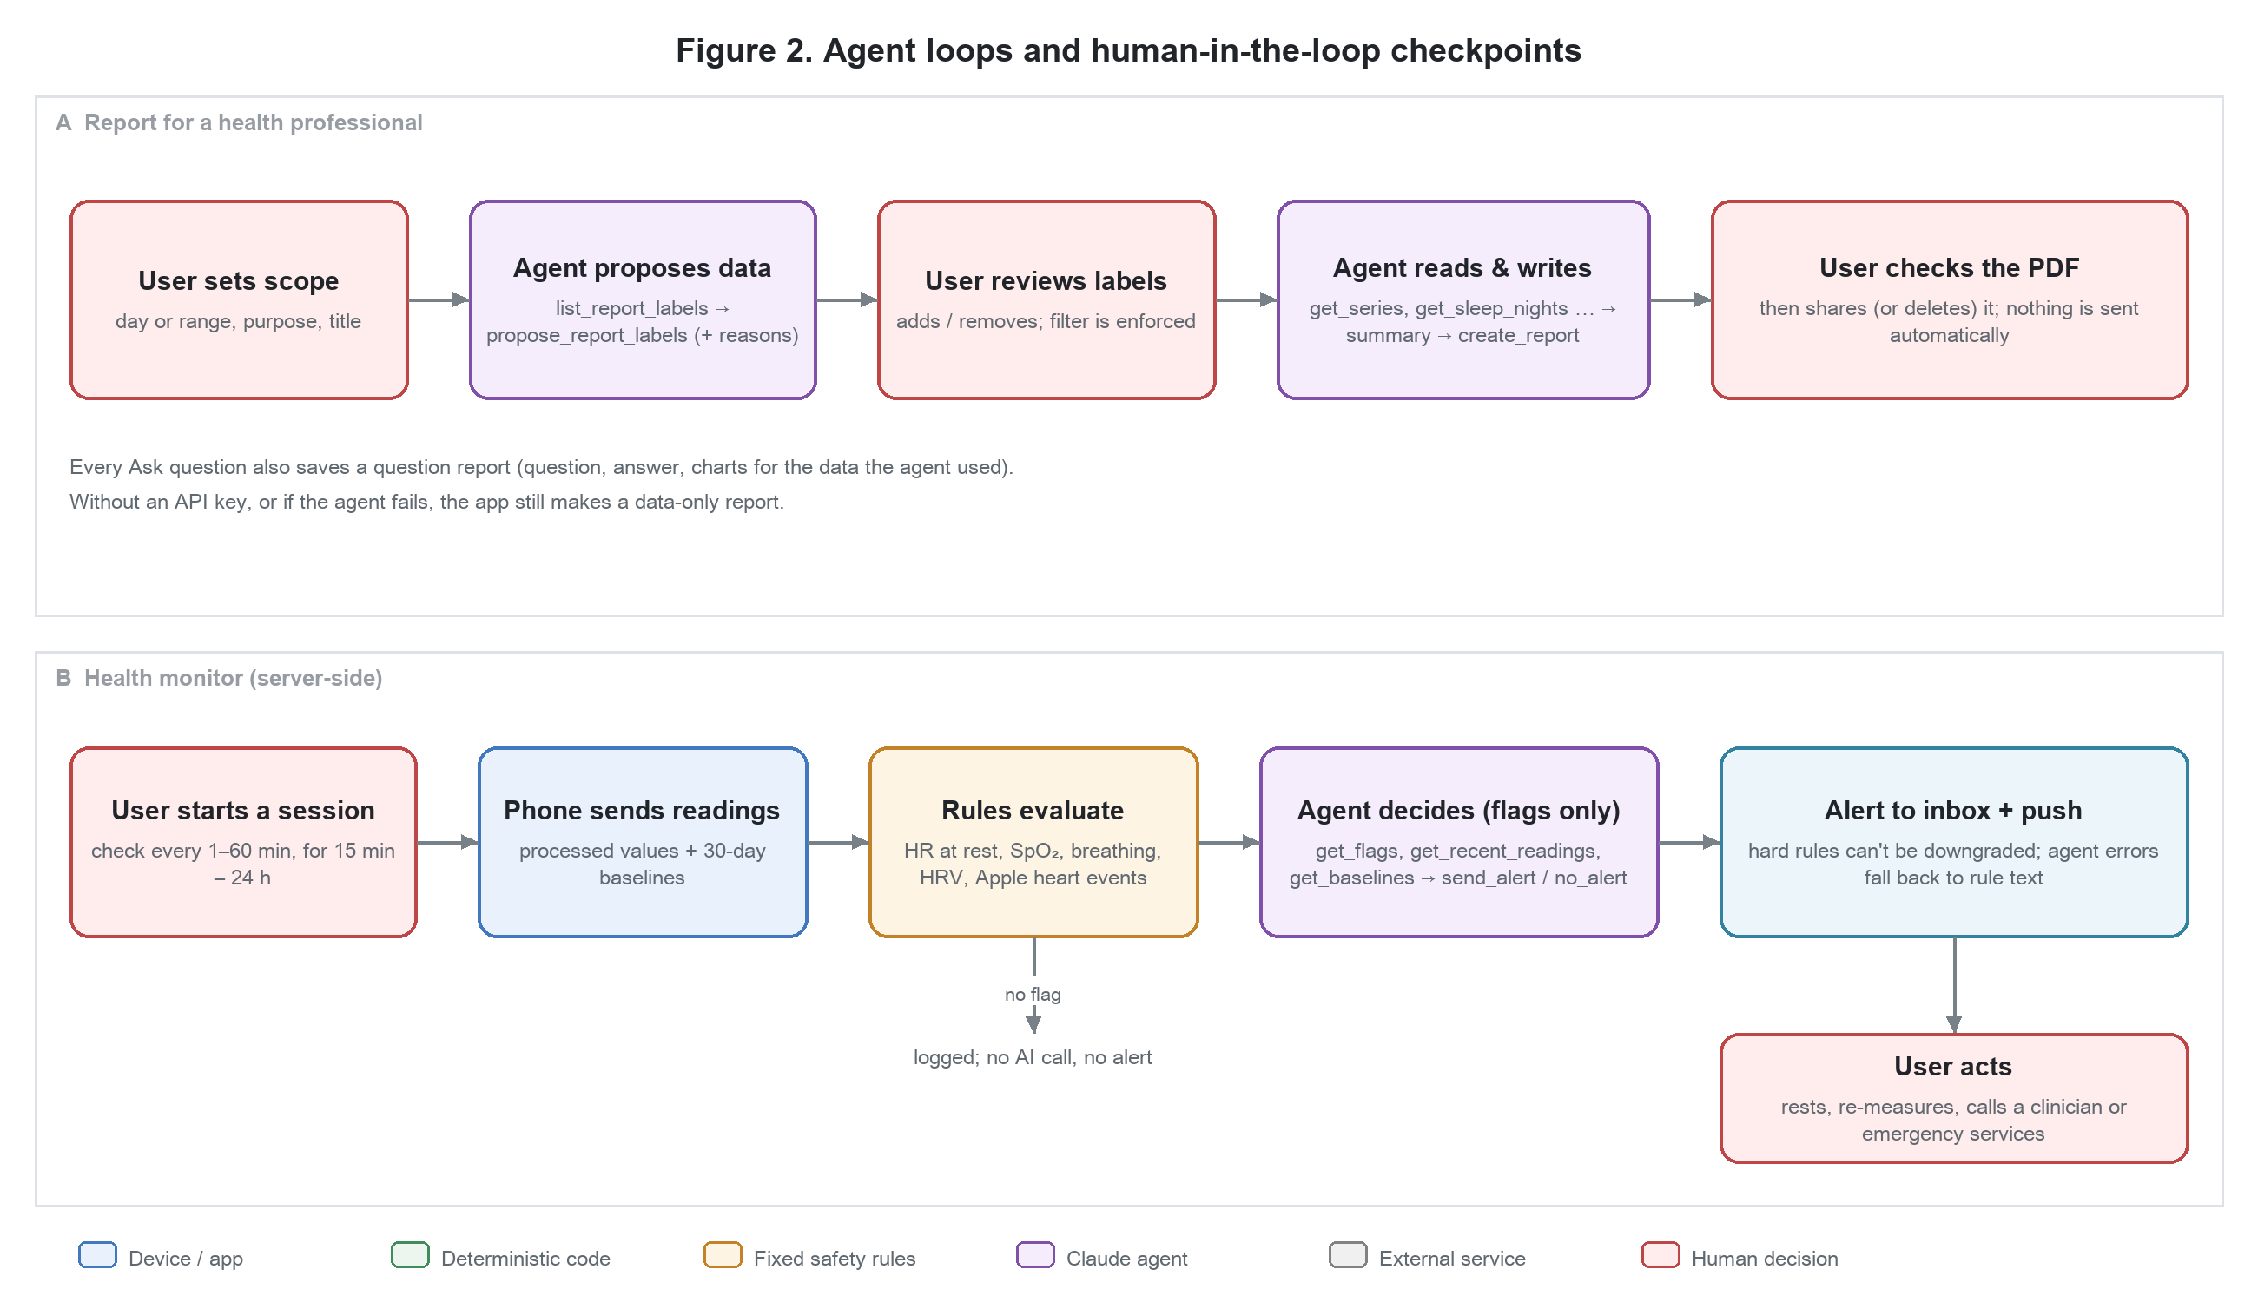
Figure 2. The two main agent loops. Red boxes are decisions made by a person.
Decision point | Who decides | Why a human is involved
What a report covers (period, purpose) | User | Only the patient knows the reason for the appointment
Which data types go into a report | User reviews the agent's proposal | The agent suggests with reasons; the user's selection is enforced
Whether to share a report, and with whom | User | Nothing is sent to clinicians automatically
Starting monitoring: interval and duration | User | Monitoring is opt-in and time-boxed
Responding to an alert | User (and clinician) | The agent informs; it never diagnoses or treats
Hard safety alerts | Fixed rules, not the agent | Very low blood oxygen, a very high resting heart rate and Apple's heart events always notify; the agent cannot suppress or downgrade them
Changing the agent's configuration | Owner | Adding tools or editing the agent is run by the owner, never by the app
Keeping or deleting messages and reports | User | Select and delete, or delete after reading

2.6 Architecture: single agent, role-specific sessions
Fengshui uses a single-agent architecture: one Claude Managed Agent definition with one persona and one toolset, run in separate sessions for each role (Section 2.2). The app adds the role's tools to each session (a session-local override) without modifying the agent itself.
Why not multi-agent? The roles don't need to talk to each other, and each task is small enough for one agent with the right tools. Separate sessions already give isolation: report prompts don't clutter the chat, and a monitor check can't see the chat history. A single agent is cheaper, easier to test and easier to audit. The design can grow into a multi-agent one later, for example a reviewer agent that checks report summaries against the tables, without changing the tools.
Around the agent sit deterministic components that it can't override:
- Engine (Python, on device): sensor features, activity, sleep and wind-down, the same code on phone and Mac.
- Safety rules (server): thresholds that trigger the agent and the hard rules that always notify.
- Tool executors (phone and Mac): read-only, capped in size and number of calls, logged.
- Fallbacks: if the agent is unavailable, reports are still created without a summary and alerts use rule text.

3. GitHub Repository (Deliverable 2)
Repository: https://github.com/Kouki-chan/fengshui
The repository is private. Reviewers need to be added as collaborators (GitHub → Settings → Collaborators).
Folder | Contents
apple/Fengshui | iPhone app (SwiftUI): Health sync, Data, Reports, Ask, inbox, monitor, Managed Agent client
apple/FengshuiWatch | Apple Watch app: sensor recording, sessions, transfer to the phone
engine/ | Python engine (features, activity, sleep, wind-down), embedded in the app and used on the Mac
server/ | Mac server (FastAPI): sync, health monitor, monitor agent, deployment watcher, MCP endpoint
apple/Tests, engine/tests, server/tests | Automated tests (unit, integration, UI)
scripts/ | Bootstrap, run server, install on devices, run all tests, agent setup
docs/ | Specification, plan, test strategy, design decisions (D-01 to D-22), progress, device checklist

Quality: one command (scripts/test_all.sh) runs 12 test layers with more than 280 automated tests, covering the engine, server, iPhone and watch apps, the agent tool loop (with a simulated agent), the privacy scan, and an end-to-end UI flow. All pass on the current version.
Privacy: real health data, keys, tokens and account identifiers are kept out of the repository by gitignored configuration files and a pre-commit check; the full history was scanned before the first push.

