CLOUD SERVERLESS COMPUTING PROJECT

P. Koundinya

2100030417

**TITLE:**

Building a Serverless Web Application

Application Architecture:

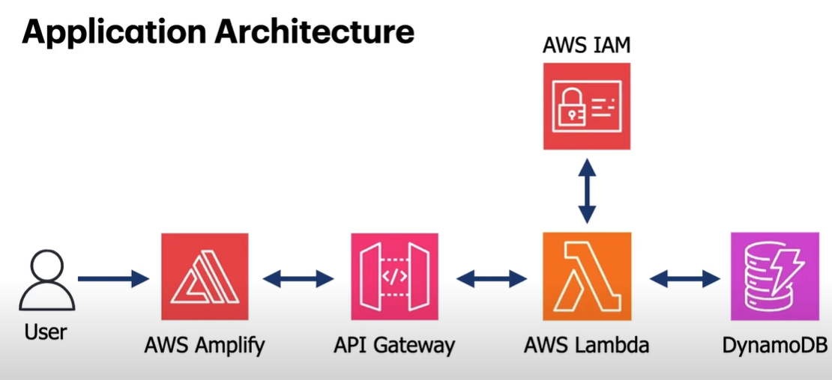

**Overview Of the Services:**

**Lambda:**

AWS Lambda is an event-driven, serverless computing platform provided by Amazon as a part of Amazon Web Services. It is a computing service that runs code in response to events and automatically manages the computing resources required by that code.

**DynamoDB:**

Amazon DynamoDB is a fully managed proprietary NoSQL database service that supports key–value and document data structures and is offered by Amazon.com as part of the Amazon Web Services portfolio. DynamoDB exposes a similar data model to and derives its name from Dynamo, but has a different underlying implementation.

**API Gateway:**

Amazon API Gateway is an AWS service for creating, publishing, maintaining, monitoring, and securing REST, HTTP, and Web Socket APIs at any scale. API developers can create APIs that access AWS or other web services, as well as data stored in the AWS Cloud .

**AWS AMPLIFY:**

AWS Amplify is a collection of tools and features designed to streamline the development process for full-stack web and mobile applications on Amazon Web Services (AWS). It caters to frontend developers by simplifying cloud integration tasks commonly encountered during app creation.

**AWS IAM:**

AWS Identity and Access Management (IAM) is a service for securely controlling access to AWS resources. It functions like a digital doorman, ensuring only authorized users and applications can perform actions on your AWS account.

**STEPS:**

**Step-1:**

In Aws Management Console Go to Lambda and click on create function.

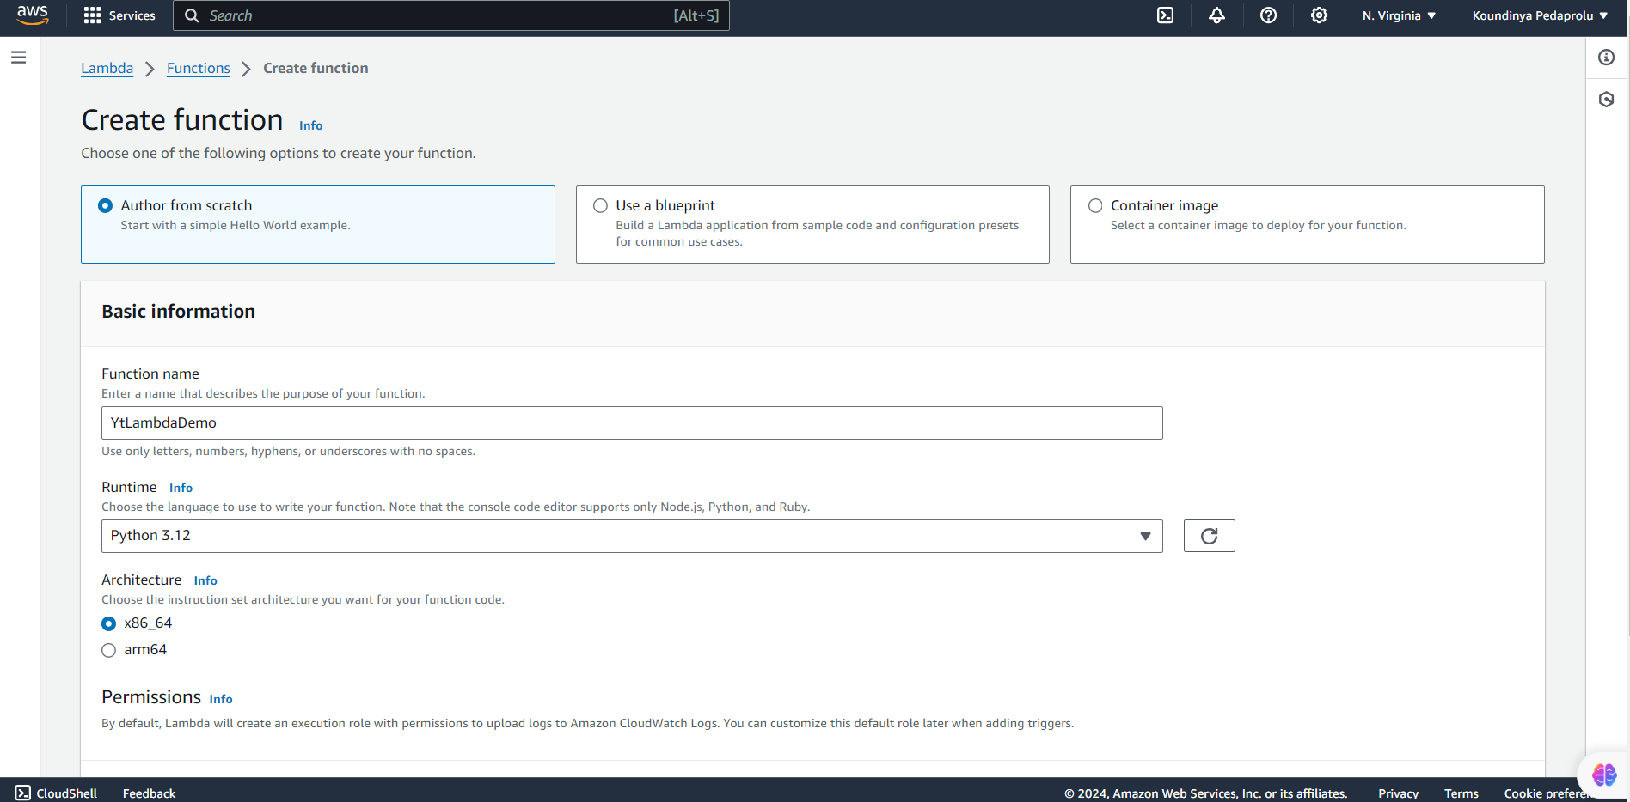

**Step-2:**

Now, Go to the tables section in Lambda service and Click on “Create Function” and give the unique name for the function name .

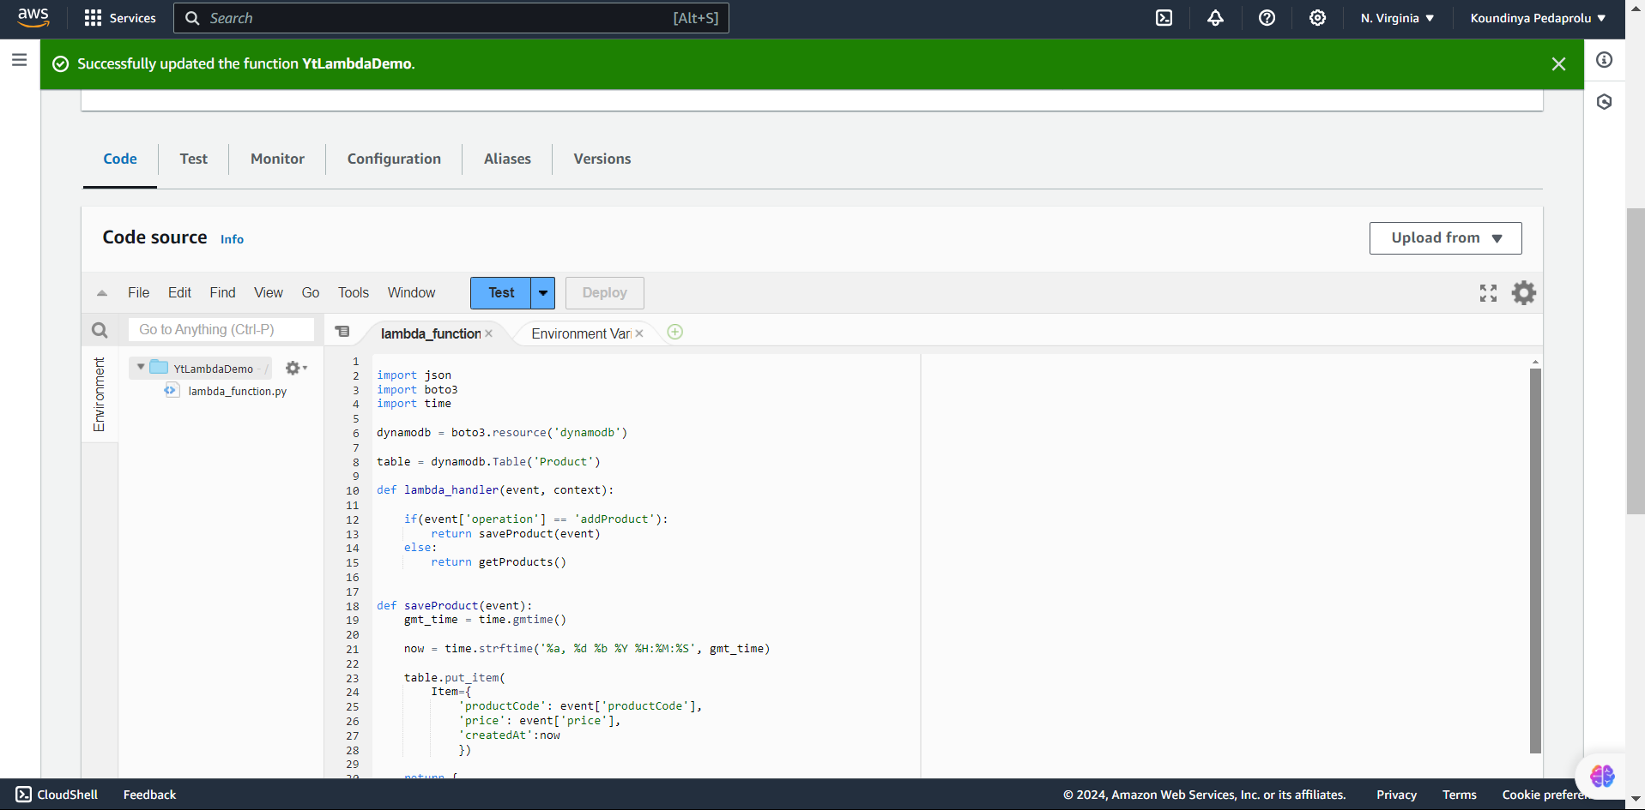

**Step-3:**

Click on resources and Add ARN’s and paste the resource arn” https://k5m8p8yh30.execute-api.us-east-1.amazonaws.com/dev/getData” and add them.

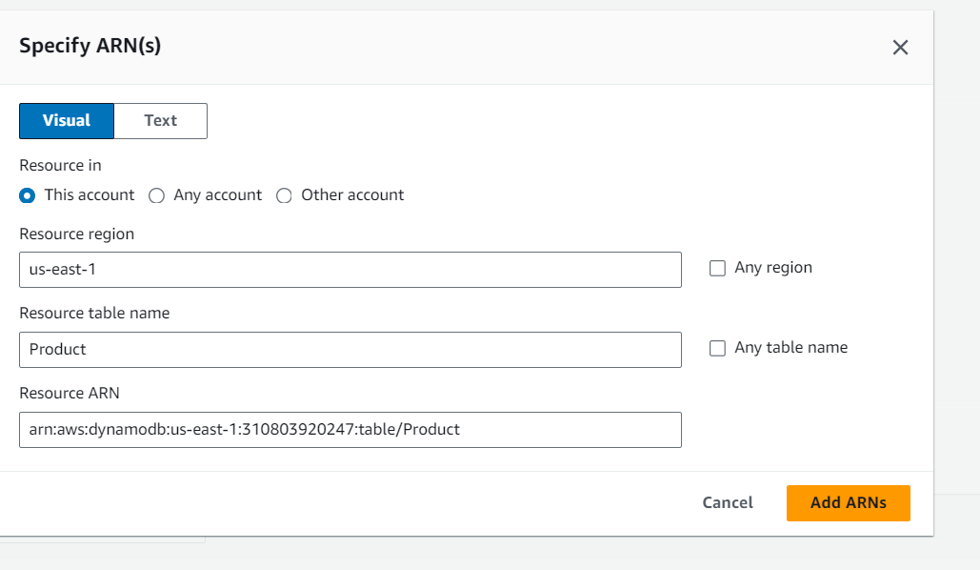

**Step-4:**

In the created role click on your role and create a policy.

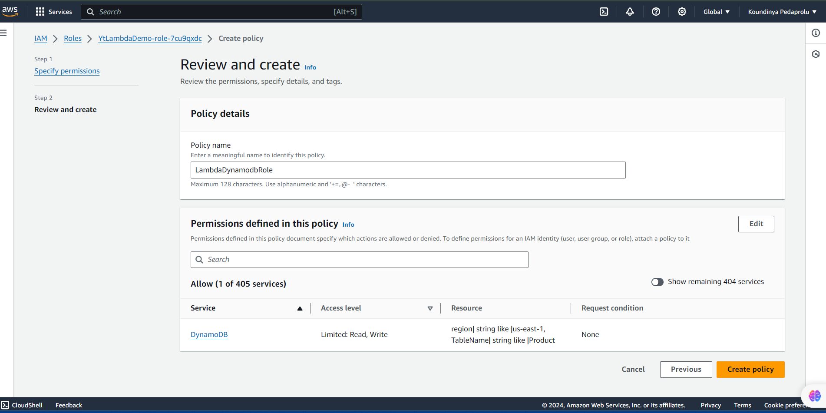

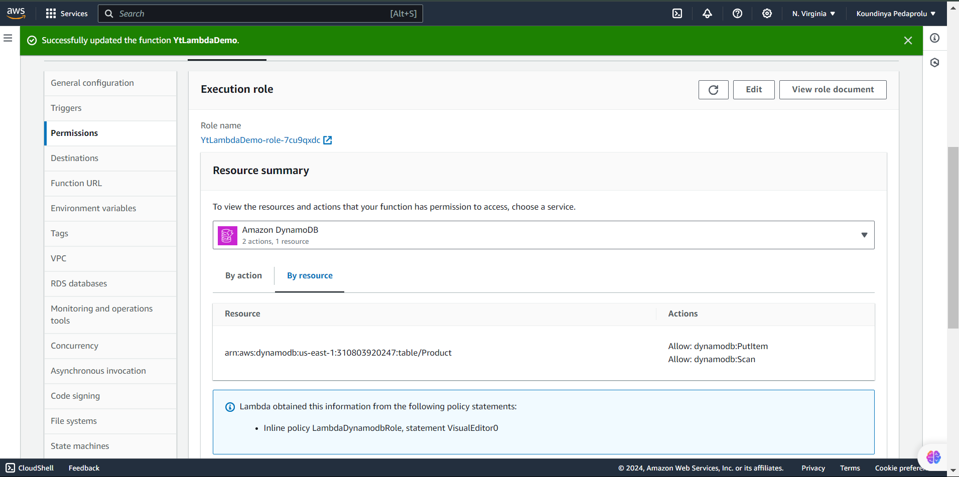

**Step-5:**

In the API Gateway click on REST API and create on CREATE API.

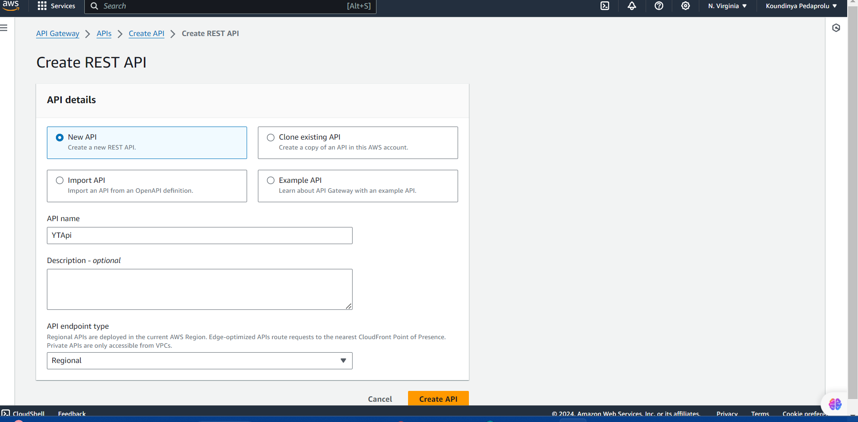

**Step-6:**

Click on configure test event and in the Json code enter the respective keys and values and click on save and finally click on test function.

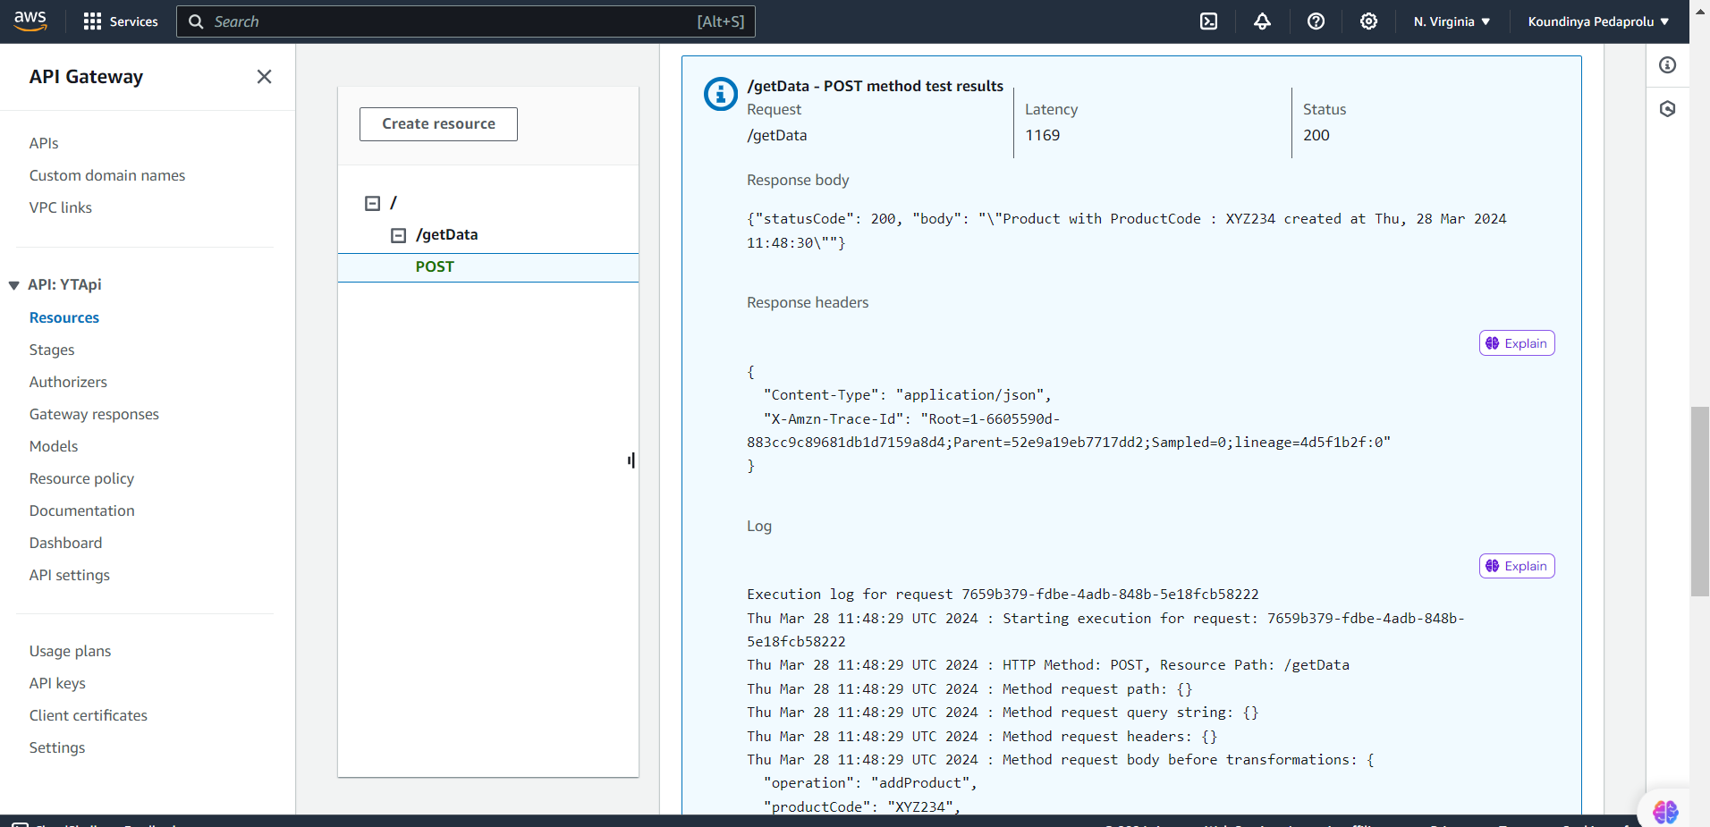

**Step-7:**

We can observe that we have received the response product with the product code which Hs been created at this particular time.

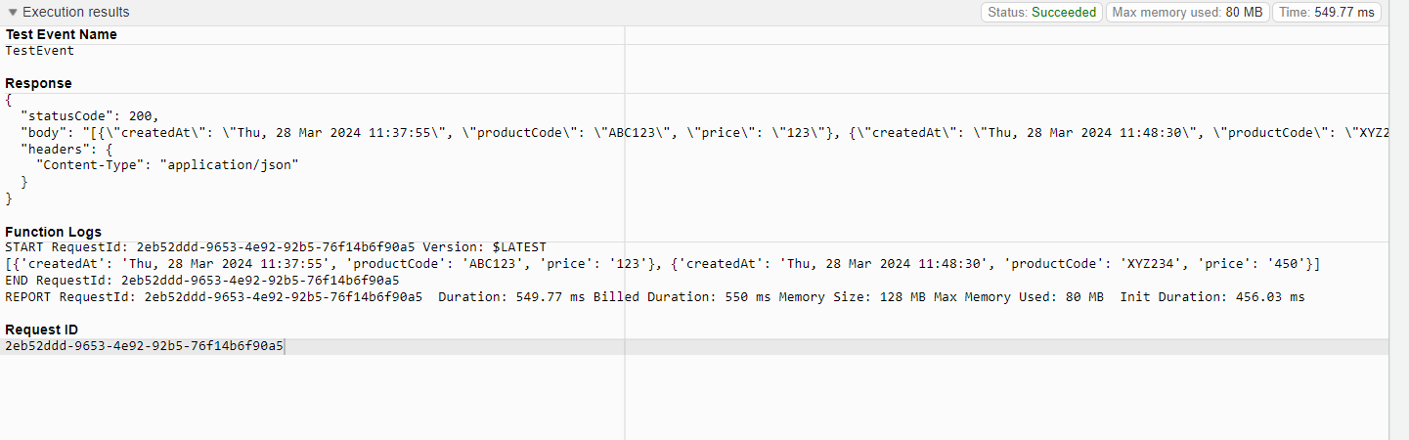

**Step-8:**

Now in the Search Bar click on AWS Amplify and we will create a small hosting web application and click on Get Started.

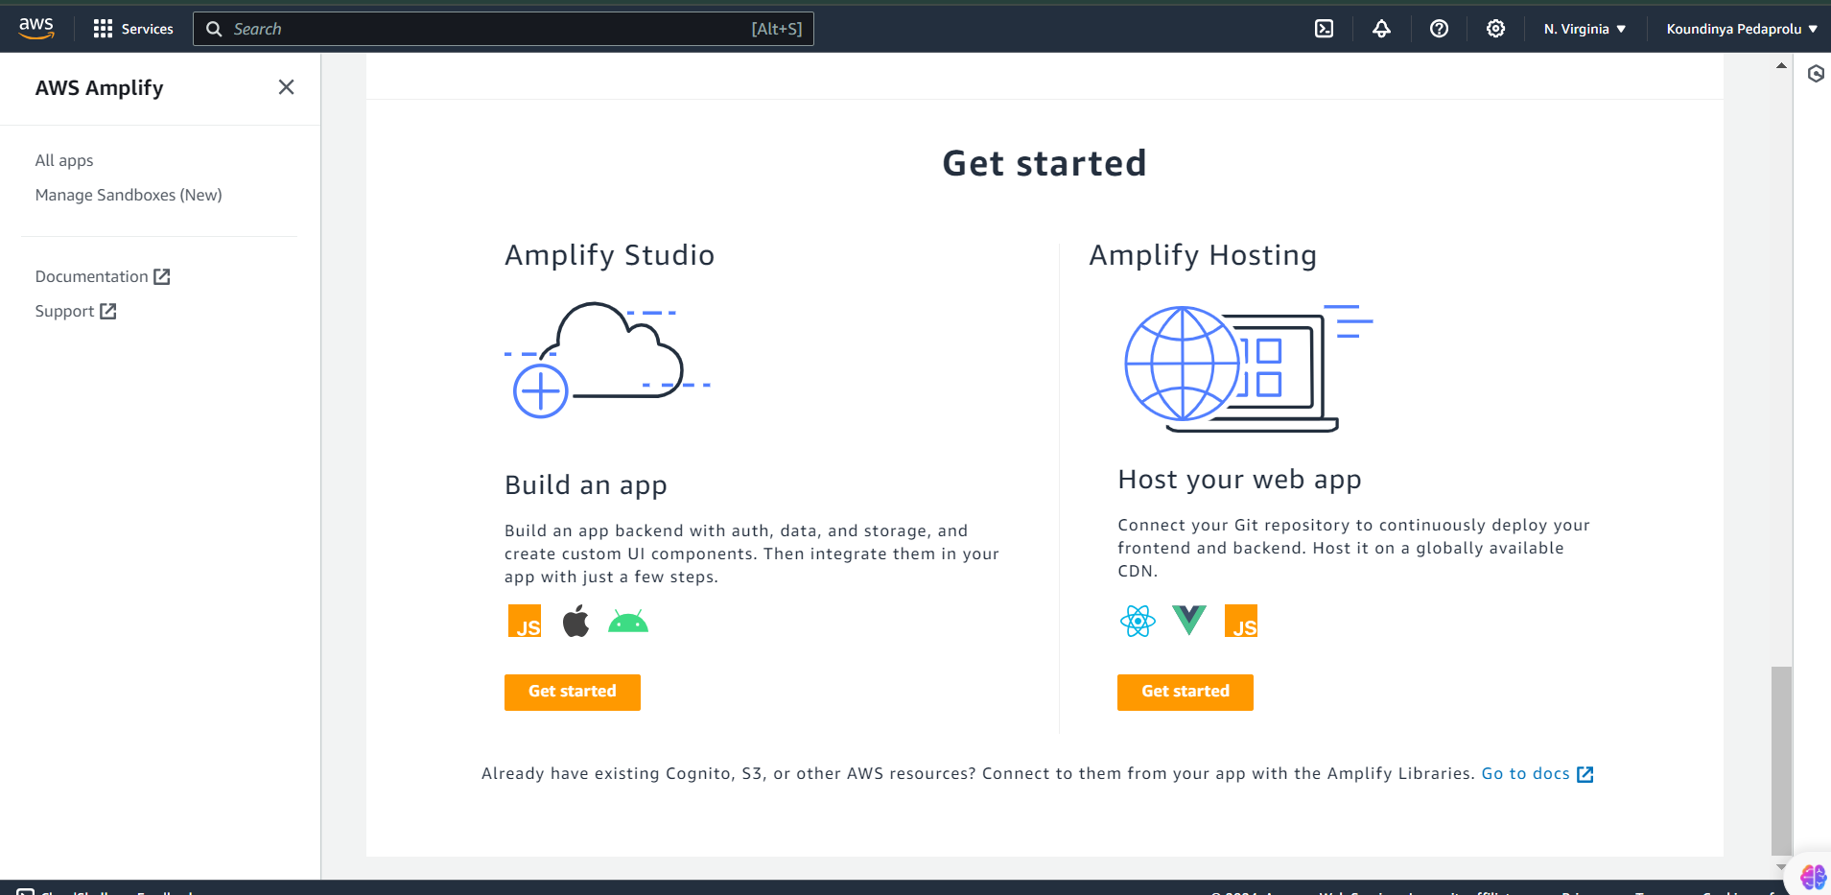

. This is the basic HTML Code which is done is VS code and click on open with Live Server.

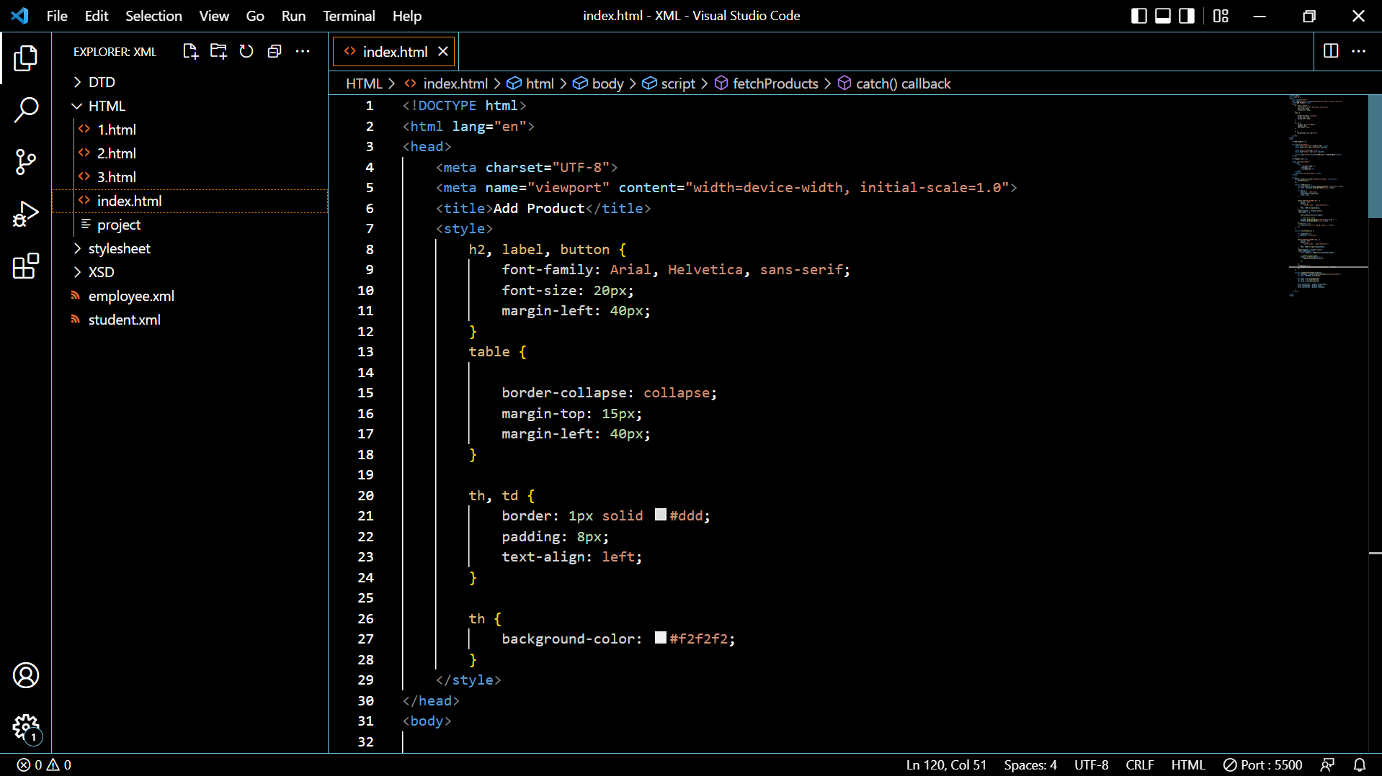

. This is the resultant output of the HTML code which is executed on VS Code.

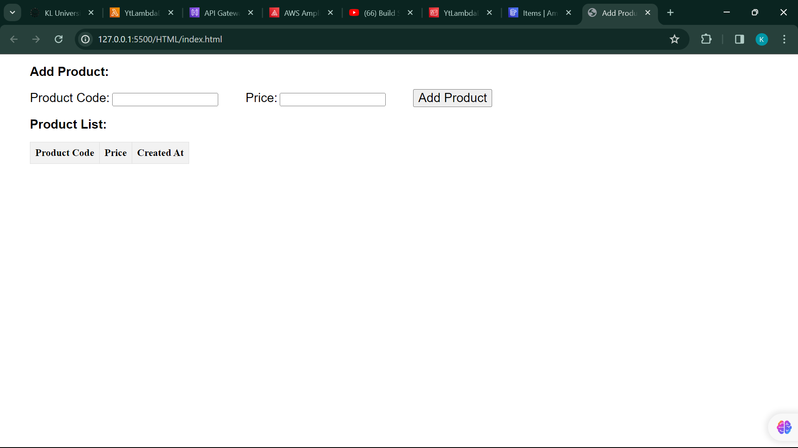

**Step-9:**

Open API Gateway and in the resources column click on the CORS enable button and select the post method and click on save.

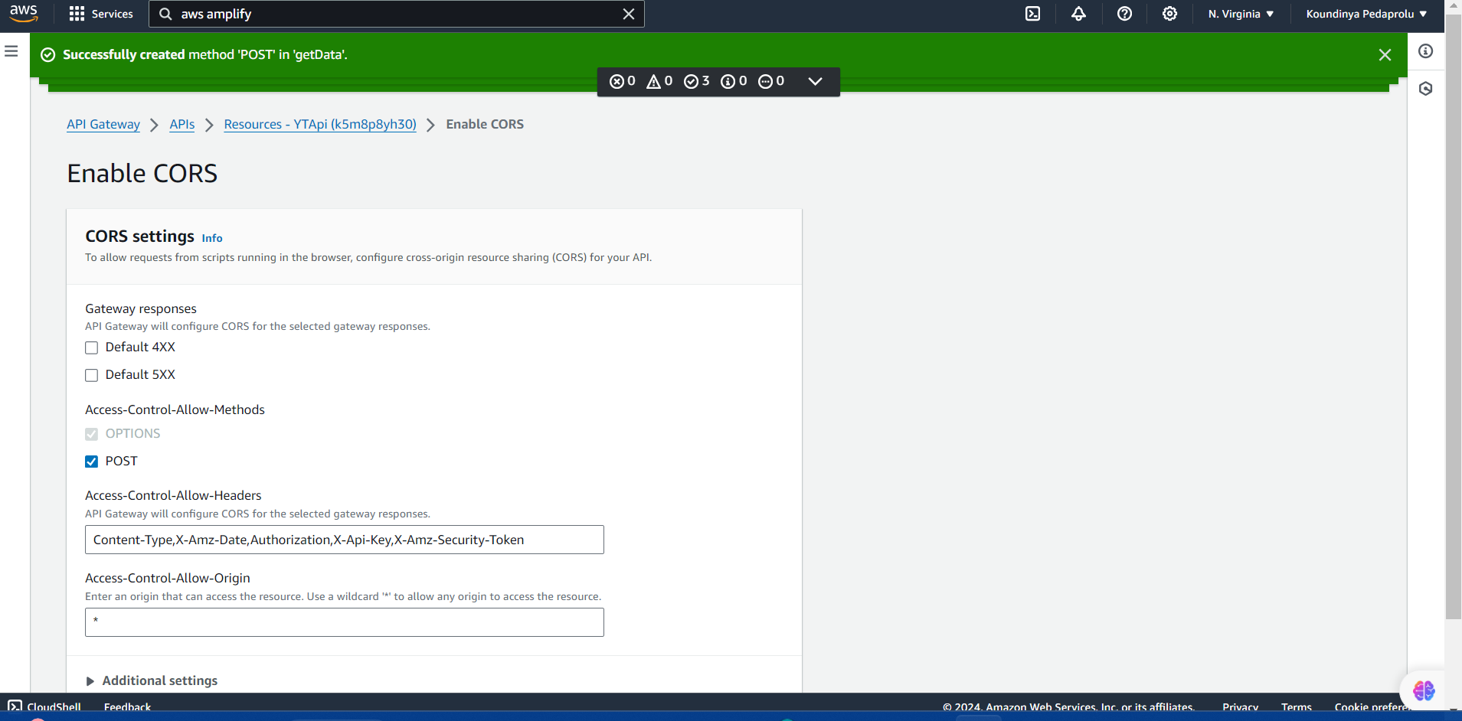

**Step-10:**

After creating the App required in the hosting environment we can observe the Domain URL that we got under the hosting environments and click on that link.

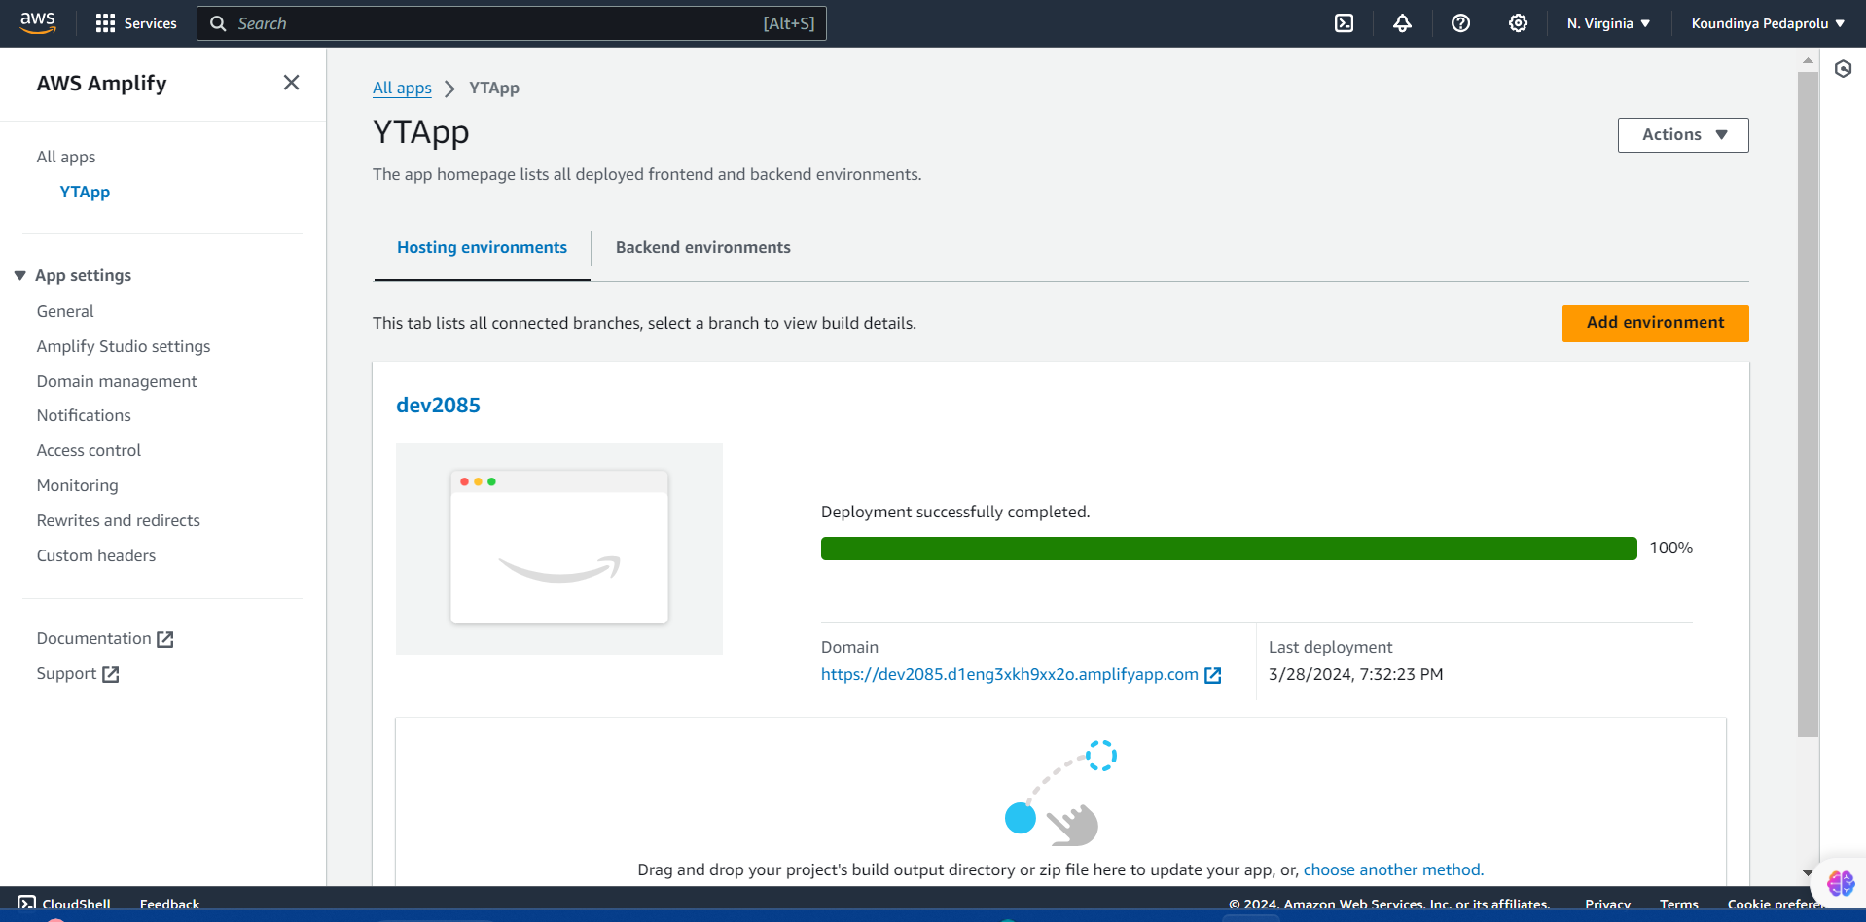

**Step-11:**

It will Redirect to the HTML output page where by entering the product code and the price we can see a small popup window telling about the Code ID and Price required.

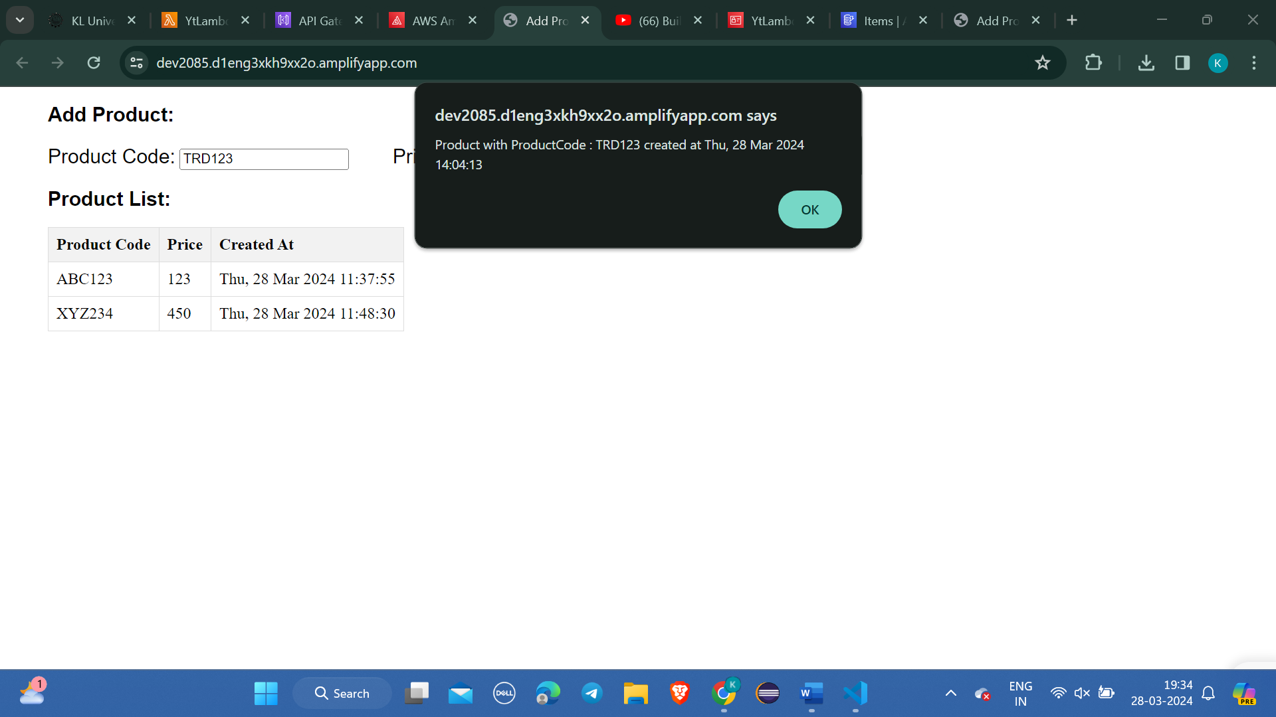

**Step-12:**

For viewing the entered product by refreshing the page we will get a new column showing the details that we filled before clicking on Add Product Button.

