

Guide to Monitoring Real-time Marine Mammal Detections using Autonomous Platforms in the Santa Barbara Channel

*1/21/2020*

**Texas A&M University Galveston**

Ana Širović & Megan Wood

**Woods Hole Oceanographic Institution**

Mark Baumgartner

(Revised from document developed for northwest Atlantic Ocean on 12/5/2014 by NOAA NEFSC Passive Acoustics Research Group: Julianne Bonnell, Genevieve Davis, Danielle Cholewiak, Annamaria DeAngelis, Dana Gerlach and Sofie Van Parijs)

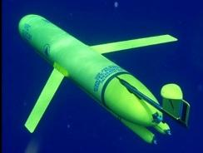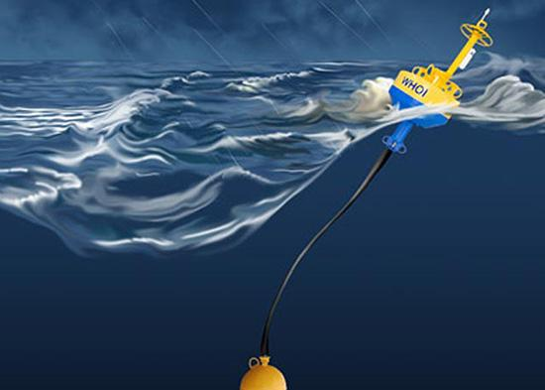

**Table of Contents**

Introduction 2

Background 2

Reference Study 2

Purpose 2

Getting Started 3

Active Studies: Your Project 3

Species call counts 3

Glider track 3

Mapped call counts 3

Background noise 3

Daily tally tables 3

Evaluation Procedure 4

Using the “Pitch Track” Page 4

Determining Species 6

The Four Main Criteria for Determining Species 6

Blue whale 8

Fin whale 13

Humpback whale 18

Known Idiosyncrasies 25

Artifacts of the pitch tracking algorithm 25

Webpage updates 25

# Introduction

## Background

The low-frequency detection and classification system (LFDCS) is a system to detect the calls of marine mammals written by Mark Baumgartner at WHOI. It analyzes acoustic data, traces frequency modulated signals (pitch tracks), and compares attributes of these signals to a reference library of species-specific call types (e.g., fins, humpbacks). For near-real-time applications, the LFDCS runs on the digital acoustic monitoring (DMON) instrument, which has integrated hydrophones for collecting, processing, and recording audio.

When autonomous real time detections are occurring from gliders, moorings, etc., detections are uploaded onto Mark’s **Autonomous Real-time Marine Mammal Detections** webpage (<http://dcs.whoi.edu/>) under **Active Studies**, then the project’s title. Detections are reported in tables, figures, and pitch tracks which can then be reviewed by an analyst.

For more information, please refer to Mark’s main page on his website. Links to his papers and description of the platforms/software can be found there.

## Reference Study

If at any point in time you have a question about a call type, or how to classify a detection, please refer to the [*Roseway Basin, Southwestern Scotian Shelf, Canada, Summer 2014*](http://dcs.whoi.edu/rb0914/rb0914.shtml) study, as that was all annotated by Mark.

## Purpose

The purpose of this document is to outline a procedure to be followed when evaluating near real-time pitch tracks. Examples will be based on the *Santa Barbara Channel* project. The hope is that this document will help to standardize the evaluation process between analysts for future real-time detection projects.

Back to Top

# Getting Started

## Active Studies: Your Project

On the main page of the website, click on your project’s title. This can be found under the **Active studies** section at the top of the page. Each project’s main page may look a little different depending on the purpose of the project. Since we are focusing on evaluating incoming detections, we are going to ignore other sections of the page and focus on the **Real-time Whale Detections** section of the project’s page. Under the **Real-time Whale Detections**section will be a list of all the platforms that are being used for that project. Clicking on any of those platforms will bring you to the data for that platform.

### Species call counts

The **Species call counts** section will display a time series of automatically detected and classified calls over the course of the study. These *do not* reflect analyst verified calls.

### Glider track

The **Glider track** section shows a map of where the glider is currently and where it has been. The date/time listed under **Last** tells you the timestamp of the last upload from the platform in local time.

### Mapped call counts

The **Mapped call counts** section shows maps of where calls that were automatically classified as a particular species are located along the trackline (for gliders).

### Background noise

The **Background noise** section shows a long-term spectrogram of the audio.

### Daily tally tables

The **Daily tally tables** section is what you as an analyst will be using the most. The incoming data is separated by days, and you can access data from a particular day by clicking on the link. The data for the current day will be displayed right there on the project page (without a day link).

Each row in the table corresponds to a nominal 15-minute summary period, and the date/time displayed for a row corresponds to the date/time of the end of the 15-minute period (in local time). This is followed by the number of calls the DMON/LFDCS has classified per species. There is also an “Other” column for those sounds that did not match any calls in the call library. The “Duration” column refers to the duration in the summary period (in seconds); this should typically be 900 seconds (15 minutes) unless pitch tracking was turned off for a glider surfacing (Slocum glider only) or the DMON audio was muted to assess noise conditions and produce a time mark in the audio recording. The “Tracks” column will show you which summary periods contain pitch track information (noted by a “PT”). Note that a maximum of 8 KB of pitch track data per hour is transmitted to shore via Iridium satellite to minimize cost, so not all summary periods have associated pitch track data available. To evaluate a summary period with pitch tracks, click on the “PT” link; this is further explained in the Using the “Pitch Track” Page section of this document. If there is a “Map” and “Latitude/Longitude” columns, those will indicate the position of the glider at that particular point in time.

Back to Top

# Evaluation Procedure

## Using the “Pitch Track” Page

Click on the first “PT” in the tally table. This will bring you to a page that will have pitch tracks for that summary period (henceforth known as the “Pitch Track” page). The transmission time information and species counts will be displayed at the top of the page (which is identical to the row from the tally table). Next you should see fifteen 1-minute figures containing the pitch tracks. There may be dotted vertical lines with a code above that will indicate when pitch tracks are being generated or transmitted by the DMON/LFDCS. The codes and their definitions are as follows:

* MUTEON: the hydrophone is muted to assess system noise and to provide a time mark in the audio recording.
* MUTEOFF: the hydrophone is unmuted and normal recording has resumed.
* ADDET_OFF: a maximum of 8 KB of pitch track data per hour is transmitted by the glider. The ADDET_OFF message indicates that this limit has been reached.
* ADDET_ON: transmission of pitch track data has resumed.
* $ADRUN, 0: the glider has reached the surface and will begin data transmission home, so pitch tracking is terminated (Slocum glider only).
* $ADRUN, 3: the glider has finished data transmission at the surface and is initiating a dive, so pitch tracking has resumed (Slocum glider only).

There may be a portion of the 1-minute figures that appear as gray boxes in association with some of the codes. *Any pitch tracks that appear within the gray boxes should be disregarded during the analysis*, as they may be duplicate data that appear in previous or following periods. To prevent scoring the same data twice, only use pitch track data in the black areas to score periods for species presence.

The pitch tracks will be color coded, where cooler colors (blue) represents quieter signals and warmer colors (red) represents louder signals. Sounds that the DMON/LFDCS classifies as a known call type (from the call library) will have two white numbers displayed below the call. The top number represents the species ID and the bottom number represents the Mahalanobis distance. The latter is not typically used in the evaluation process, but the former is very important. For the northeast United States call library, the species call types are as follows:

* Fin whale 20-Hz pulse: label 80
* Blue whale D call: label 1
  + Blue whale B call: label 10 (with downstep), 12 (without downstep), or 20 (after-step)
* Blue whale A call: label 40
* Humpback whale (various calls): unclassified

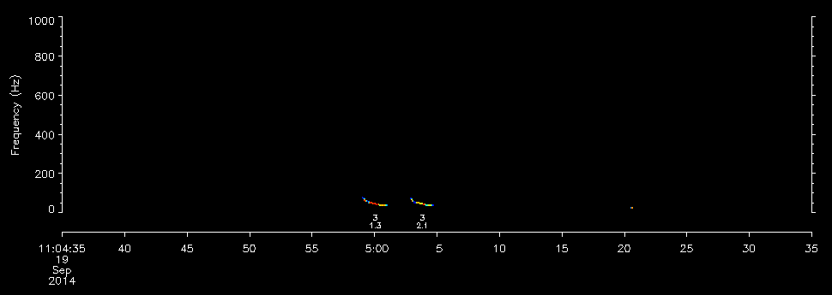

If you want to know what the species IDs are for your project, go to any Pitch Track page and scroll down to the bottom. Mark has written down the species IDs and vertical line codes (which have been copied onto this document).

Below the pitch tracks is the form that will be filled out after reviewing the pitch tracks. There are 3 choices per species, “Detected”, “Possibly detected”, and “Not detected” (default). When to assign a category to a species is covered in the Determining Species section of this document. Below the table is a text field (“Notes”) where you can enter comments about what you observed. Things to write down include unknown signals that could be of interest, signals that could belong to a species but there was not enough evidence to label as “Possibly detected”, and documentation (evidence) of species presence. Essentially, you would want to have notes of the times of interest such that once the platform is out of the water and the data are back at the lab, you can go through the spectrograms and listen to signals to confirm/reject what you originally thought it was.

Once you have completed the form, click on the “Submit” button. This will prompt you for a username and password. Each analyst will receive their own unique username and password. You will only be prompted for these credentials once during a session.

Once the form has been filled out and you click the “Submit” button, the website will bring you to the next Pitch Track page. You can also maneuver between Pitch Track pages by either the “Back” or “Next” buttons at the bottom of the page. If you want to change a previous form submission, just navigate to that Pitch Track’s page, re-fill the form, and press “Submit”.

## Determining Species

The biggest thing to keep in mind is to *be conservative* when determining the detection of a species. Four main criteria exist for determining species from pitch track data: amplitude, shape, isolation, and classification. However, each species require different variations of these criteria for it to be considered “Detected” or “Possibly detected”. The following sections describe the main criteria and the specific criteria used for determining the detection of each species. If you are still in doubt, please refer to the [Roseway Basin](http://dcs.whoi.edu/rb0914/rb0914.shtml) study to see how Mark has classified his pitch tracks.

### The Four Main Criteria for Determining Species

* Amplitude of the signal
* Shape of the pitch track
* Isolation from other pitch tracks (context)
* Species classification based on the detector’s call library

#### Amplitude

The amplitude of a signal (i.e., how loud or quiet it is) can sometimes be helpful in assessing pitch tracks. Faint (blue) pitch tracks can be produced either by faint whale calls or in some circumstances, by noise. For example, spurious pitch tracks can be produced by the low-frequency whooshing sound produced by breaking waves as a Slocum glider nears the surface. On rare occasions, these spurious pitch tracks can resemble actual whale calls. These pitch tracks are often quiet, so quiet calls should always be eyed with some suspicion. However, use the criteria described in the following sections of this document for each species and if the context, pattern, or accompanying calls lead you to believe a quiet call is genuinely produced by a whale, then score it as such. Loud tonal frequency modulated sounds that are not at the very base of the spectrogram, in contrast, are typically not spurious and they are usually well pitch-tracked. These should be viewed with much less suspicion.

#### Shape

The shape of a pitch track can be used to assess whether it is a true call or just noise. A call is easier to identify if it has “good shape”, meaning it is smooth and/or has a form that is characteristic of the species in question. A pitch track that has poor shape may be broken or jagged. Sometimes the pitch tracks will have straight lines connecting it to other calls or noise. This is because the algorithm that produces the pitch tracks believes that those two sounds belong together, even if they do not. When this happens, we will use the term “artifact”. These artifacts can distort pitch tracks and make it difficult to determine whether the call is real or if it is just noise. Examples of artifacts are shown in the Humpback whale: Possibly detected section of this document.

#### Isolation or context

The degree of isolation of a call from spurious pitch tracks or calls made by another species can be helpful in determining its source. Usually assessing the 5 seconds before and after the call can clue the analyst into possible noise or biological sources that could have produced a deceiving pitch track. For example, if the call is surrounded by pitch tracks that look relatively similar and appear to be produced by random noise, the analyst should be more skeptical.

In other cases, it may be helpful to assess longer periods of time surrounding the call. Analyzing a full minute before and after a call or occasionally the entire 15-minute period can provide contextual information about other species present in the area that may be producing similar calls. For example, if there is a potential blue whale D call but humpback calling is also observed in the same period, the analyst should be cautious and assess whether the D call appears to be “in-rhythm” with the humpback song pattern or similar to calls that are in pattern, or whether it is sufficiently isolated and dissimilar to be considered as a blue whale.

#### Species classification (Species ID)

If the call has been classified by the DMON/LFDCS classification system and assigned a Species ID number (see the Using the “Pitch Track” Page section), that classification can be used to support whether a species is present or not.

Back to Top

### Blue Whale

#### Quick guide

| A/B calls | LFDCS Classified (Y/N) | Pattern | Context | Number of calls needed |
| --- | --- | --- | --- | --- |
| Detected | Y/N | A-B song | If only A, caution when other noises around | 1+ A-B sequence (classified or nor) or  2+ A or B, at regular interval classified or not |
| Possibly detected | Y/N | No observed pattern |  | 1 A or B, classified or not |
| Not detected | N | NA | N/A | NA |

| D calls | LFDCS Classified (Y/N) | Pattern | Context | Number of calls needed |
| --- | --- | --- | --- | --- |
| Detected | Y/N | No observed pattern, >1s duration | If humpbacks or other LF sounds around, exercise caution | 2+ D calls classified or  3+ D calls not classified |
| Possibly detected | Y/N | No observed pattern, >1s duration |  | 1 D classified or 2 unclassified |
| Not detected | N | NA | N/A | NA |

#### General

Blue whales of both sexes emit downsweeps (also called D calls), sweeping typically from as high as 100-120 Hz to as low as 25 Hz and lasting more than 1 second. While blue whale D calls are generally low-frequency, signals that begin below 50Hz or approach/touch 0Hz should be viewed with suspicion. Additionally, signals that are ragged are more likely to be a product of spurious noise rather than biological sourcing. Furthermore, humpback whales may also produce downsweeps that can be mistaken for blue whale D calls. Humpback calls are typically higher in frequency, usually above 150Hz, but can occasionally approach the same frequencies as blue whale D calls. In these instances context can be an important cue for discerning species. If the downsweep occurs absent humpback calls, it is more likely to be a product of blue whale calling. Calls classified as blue whale downsweeps will be labeled as type 1 calls.

Male blue whales also produce stereotyped A and B calls which, when patterned in sequences, are considered song. In southern California, the A call is a series of rapid pulses with peak energy around 90Hz. When produced as part of a song sequence, it is followed by a long tonal near 45Hz, termed a B call, which has slight frequency modulation and often features an obvious downstep. The B call occasionally contains a step-down in frequency at the end of the call. Calls classified by the detector as call A will be labeled type 40 while call B will be labeled as 10 or 12 (depending on presence of step-down) and the step-down will be labeled as 20. For more information regarding blue whale calling behavior, consult Lewis & Širović (2017) (<https://onlinelibrary.wiley.com/doi/abs/10.1111/mms.12458>) and Oleson et al. 2007 (<https://www.int-res.com/abstracts/meps/v330/p269-284/>).

#### Detected

To score a summary period as “Detected” for blue whales, at least three D calls should be present (only 2 needed if both are classified) or at least 2 A and/or B calls. 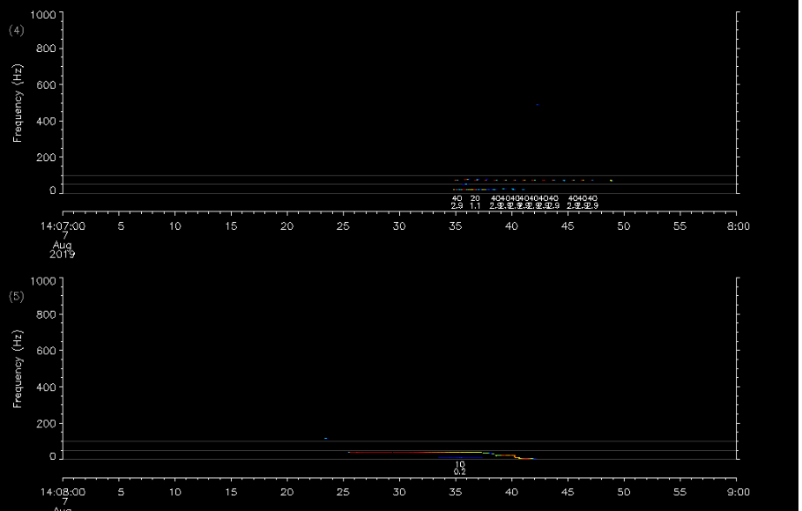



#### Possibly detected

If there is only a single classified D call in a tally period, or less than 3 quality unclassified D calls, that period should be marked as “Possibly detected” for blue whales. If there is only a single A or B call in a tally period, it should also be classified as “Possibly detected”.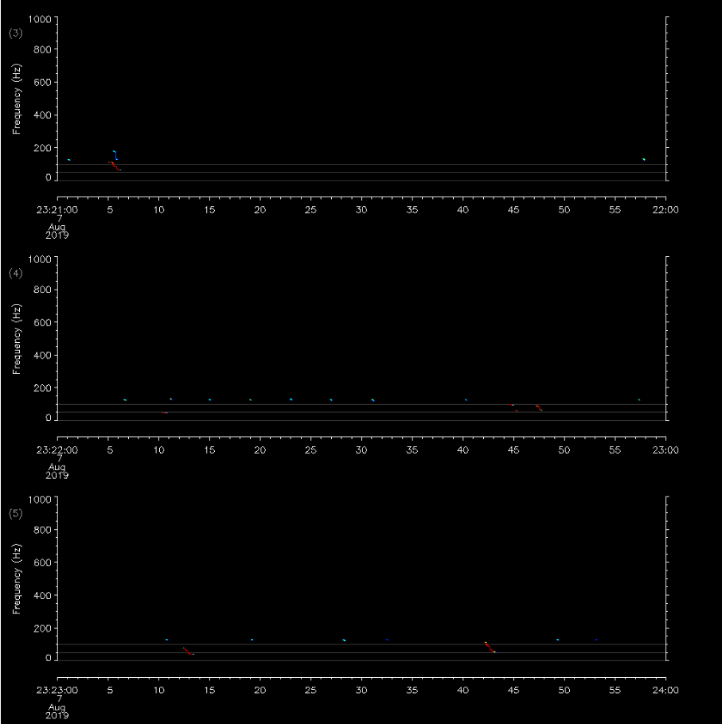

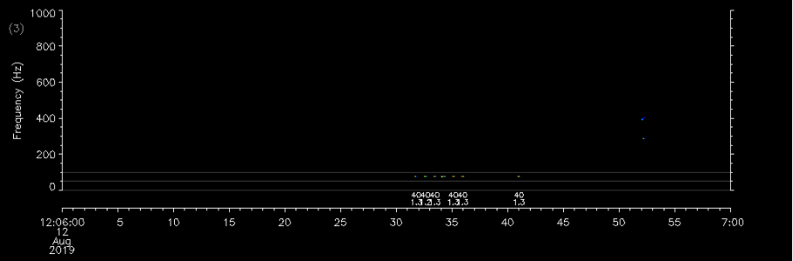

#### Not detected

If there is a singular unclassified downsweep in a summary period, then it can be considered “Not detected”. If there are several possible downsweeps but they are too short, ragged, or not in the expected frequency range, then score it as “Not detected”. Singular pulses labeled as type 40 blue should also be viewed with suspicion, as spurious low frequency noise can be classified thusly by the detector.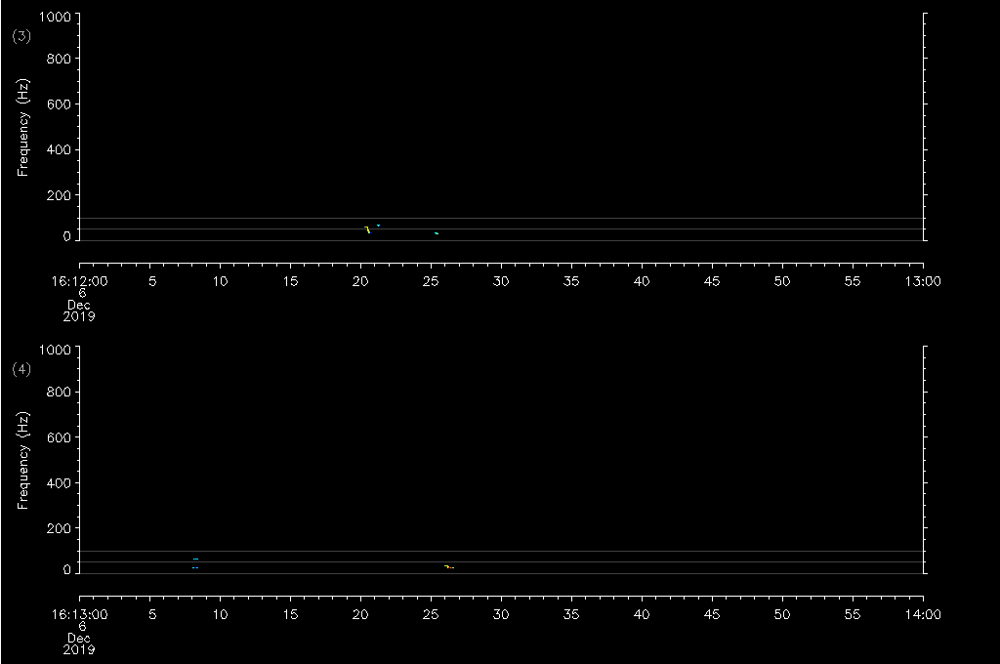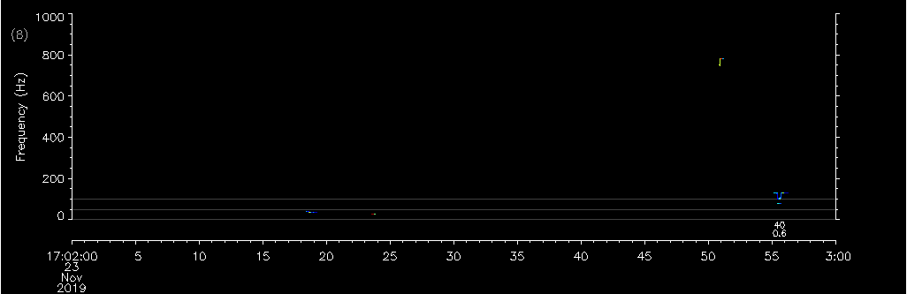

#### Unique situations

Back to Top

Back to The Four Main Criteria

### Fin whale

#### Quick guide

|  | LFDCS Classified (Y/N) | Pattern | Context | Number of calls needed |
| --- | --- | --- | --- | --- |
| Detected | Y | Repeated with constant ~18-24s interval (do not count missing calls as part of pattern) | NA | 4+ calls in pattern (2+ must be classified as fin) |
| Possibly detected | Y | 3 calls in pattern with constant 18-24s interval (do not count missing calls as part of pattern) | NA | 3 in pattern (2+ must be classified as fin) |
| Not detected | N | No pattern or irregular pattern | NA | NA |

#### General

#### Fin whales emit short (<1 s) 20 Hz pulses (downsweeps) that often occur in regular patterns as song although they can also occur intermittently. Inter-pulse intervals in these songs can be between 18 and 24 seconds. This pattern will change interannually and seasonally, for a more detailed overview see Širović et al. (2017) (<https://www.nature.com/articles/s41598-017-09979-4>). Calls comprising sequences should have similar amplitudes. Spurious low-frequency noise can often be falsely classified by the detector as a fin whale pulse, so be sure to pay attention to the patterning. While 20 Hz pulses can occur singularly or not in a song-like pattern, detections will only be considered when patterned song is present because in this context, the irregular signals are too difficult to distinguish from noise.

#### Detected

Fin whales can be considered “Detected” if a sequence comprised of 4 or more 20 Hz pulses (2 or more of which are classified as fin whales) with a constant inter-pulse interval of 18-24 seconds occurs in a 15-minute summary period. An example of this is shown below.

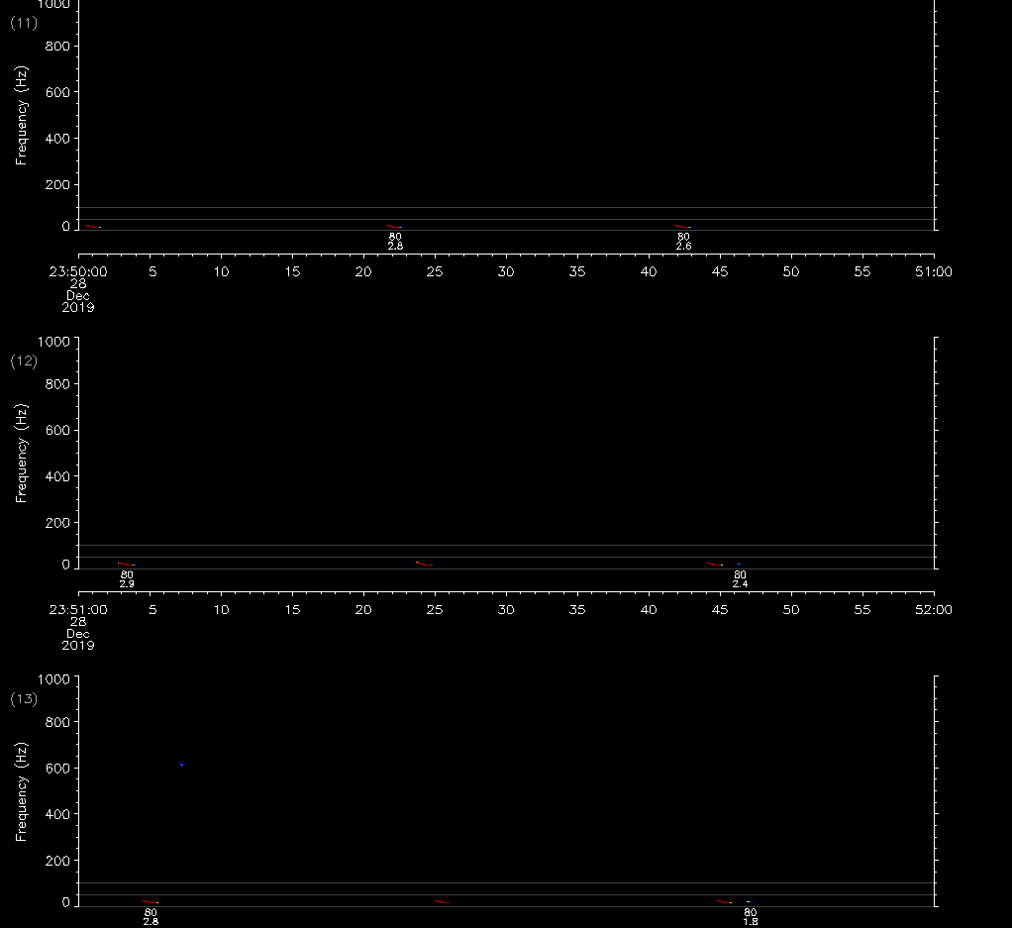

#### Possibly detected

When there are only 3 pulses in a sequence (2 or more of which have been classified by the DMON/LFDCS as a “fin whale”), then it should be marked as “Possibly detected”. Be careful that pulse trains can be “broken”, particularly when the calls are faint (i.e., there is a silent period where a pulse should be based on the inter-pulse interval). Do not count missing pulses (i.e., “phantom” pulses) as part of the pulse train. Exercise caution when there is an abundance of low-frequency noise that is being pitch tracked; some low-frequency sounds may look like fin whale calls, but it is difficult to discriminate frequencies by eye near the bottom of the spectrogram. 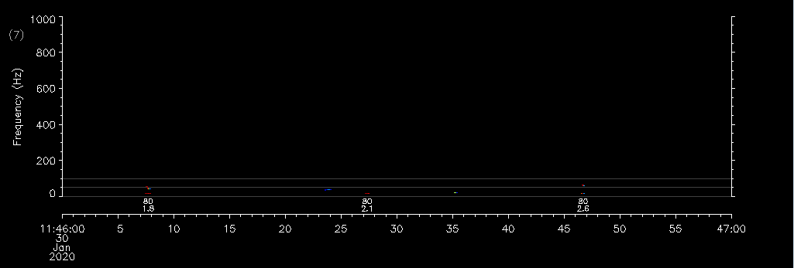

#### Not detected

For a pulse train to be considered “Not detected”, none of the calls in the pulse train are classified or the inter-pulse interval varies, or the inter-pulse interval is not within the 18-24 second bounds.

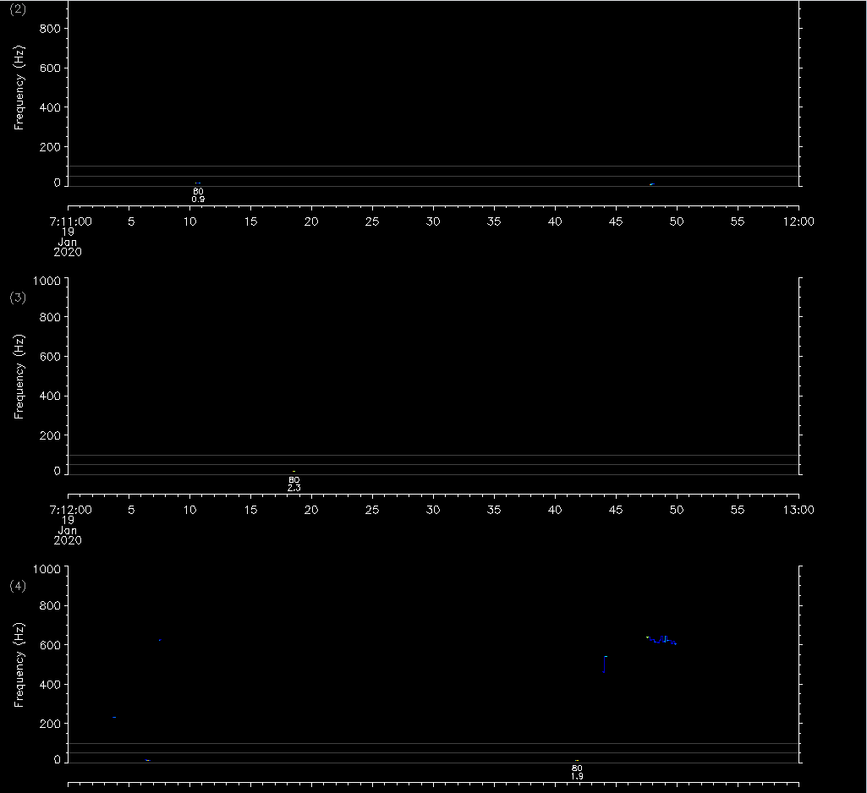



#### Unique Situations



Back to Top

Back to The Four Main Criteria



### Humpback whale

#### General

Humpback whale song is produced in identifiable patterns (unlike humpback social sounds, which have less patterned structure). Individual calls comprising these patterns can have frequencies ranging from 10s to 1000s of Hz. These patterns are unambiguous in the pitch tracks when they are present and loud. Humpback whale call types from California are currently not integrated into the DMON/LFDCS call library, therefore humpback whale calls are grouped in the ‘Other’ category of the classifier.

Off the California coast, we often believe that many unknown pitch-tracked sounds are produced by humpback whales. While there are little hard data to back up this belief, it is based upon the idea that humpback whales produce such a high variety of different sounds; so, when an unknown loud tonal sound is encountered, it is evaluated against the possibility of being another call in the vast humpback whale call repertoire. As such, you may encounter unknown, well-pitch-tracked, high intensity frequency-modulated sounds in isolation (not accompanied by other sounds) that may or may not be produced with irregular intervals. These calls should be scored as “Detected” if you have other corroborating evidence of humpback presence (e.g., humpback singing in the previous 15-minute summary period), “Possibly detected” if you have other evidence, but there is still some doubt, or “Not detected” if you have no additional evidence for species attribution. Whatever you score, be sure to explain your reasoning in the Notes section for these types of calls. To emphasize again, our overriding principle is being conservative, so only mark a summary period as “Detected” if you are very sure of that species’ presence.

Noise in the upper half of the monitored frequency range can create spurious quiet pitch tracks that sometimes resemble faint humpback calling. Pitch tracks that are in the 500-1000 Hz band, are faint, and change frequency very quickly (making them look almost disjointed) should be viewed with some suspicion.

#### Quick guide

|  | LFDCS Classified (Y/N) | Pattern | Context | Number of calls needed |
| --- | --- | --- | --- | --- |
| Detected | N/A | Often many calls grouped together that are repeated | None | Many (5+) |
| Possibly detected | N/A | Some calls in repetition or no pattern | None | Few (1-4) |
| Not detected | N/A | None | None | NA |

#### Detected

If you see patterned calling (e.g., song), then mark the summary period as “Detected” for humpback whales. If patterned calling is not present, look for frequency-modulated calls of moderate to high amplitude (loudness) that are not attributable to any other species. 







#### Possibly detected

Signals that are faint should be marked as “Possibly detected”. Some signals may also have connecting artifacts which can increase the difficulty when determining whether a pitch track is depicting a real call or just noise. This is explained in more detail in The Four Main Criteria: Shape section of this document.

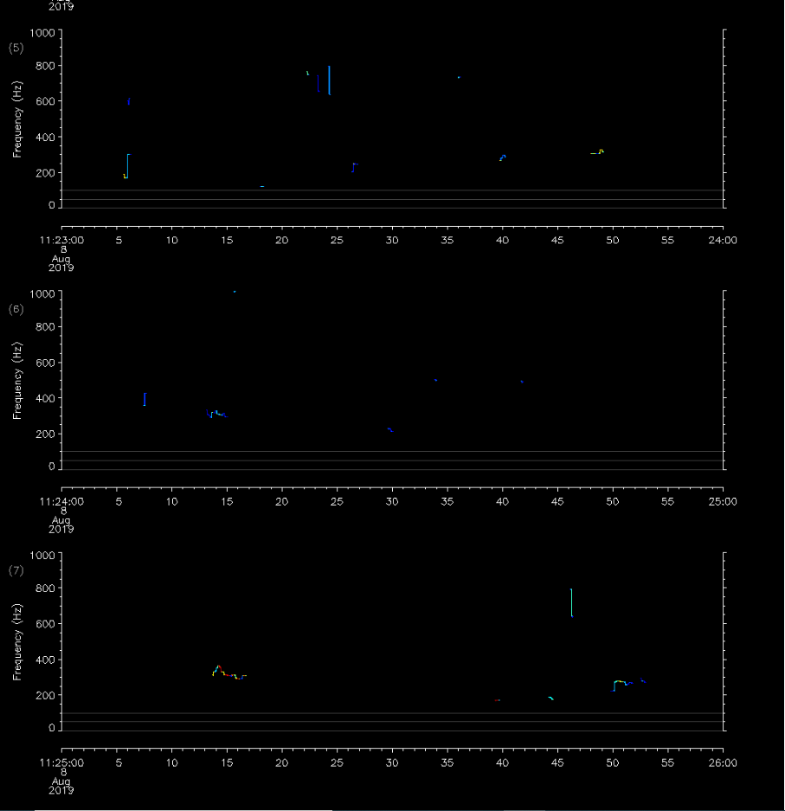



#### Not detected

When there are only a few faint calls, mark the 15-minute summary period as “Not detected”. Calls that are very spurious should also be considered as “Not detected”.

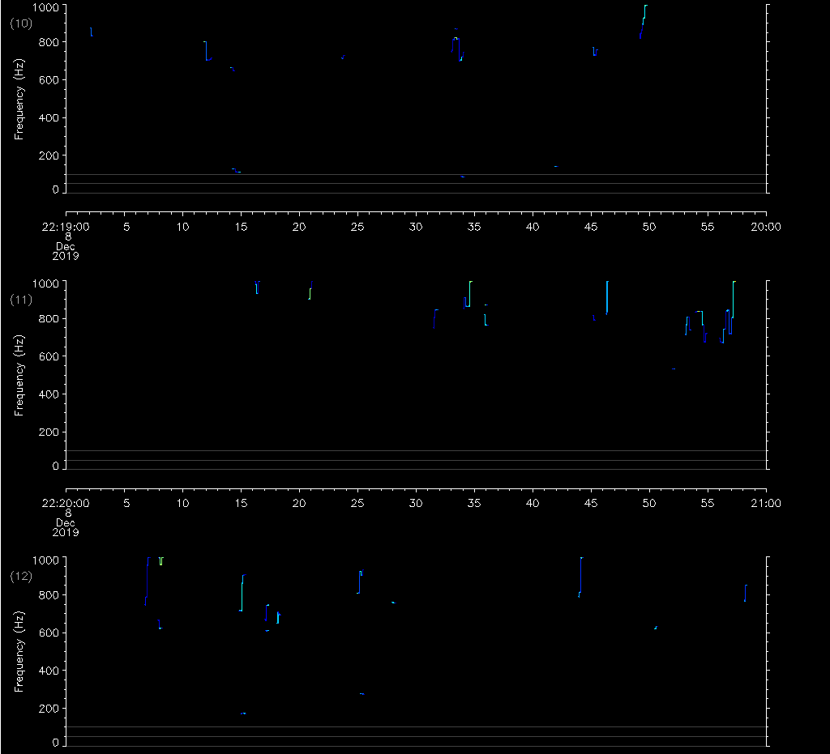

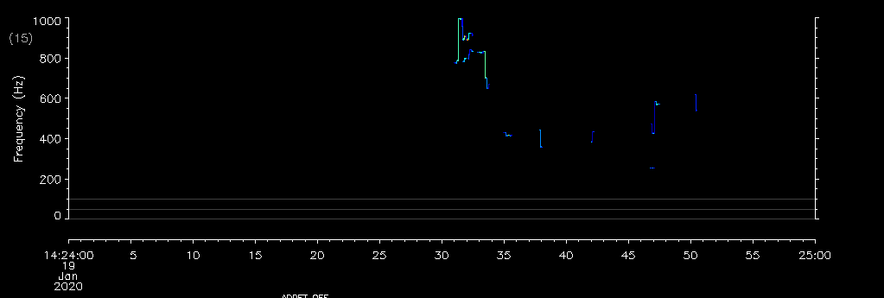

#### Unique Situations

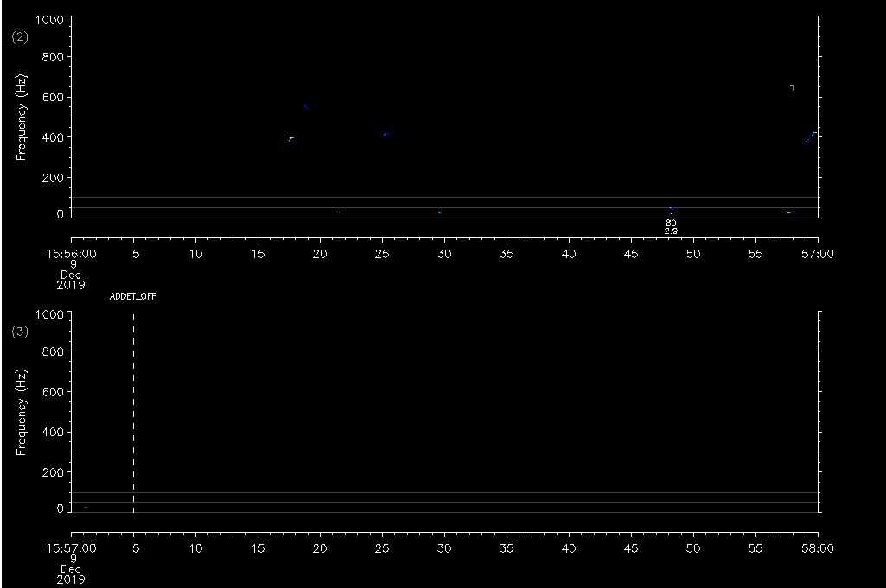

Back to Top

Back to The Four Main Criteria

# Known Idiosyncrasies

## Artifacts of the pitch tracking algorithm

This has been explained in The Four Main Criteria: Shape section, with examples in the Humpback whale: Possibly detected section. It is important to note that not just humpbacks are susceptible to artifacts.

## Call types 40 & 80

The DMON/LFDCS classification may label spurious pitch tracks of low frequency noise with either blue whale type 40 or fin whale type 80. These classifications should be disregarded when analyzing pitch tracks for species presence. This situation can be seen in the Blue Whale: Not detected and Fin whale: Not detected sections.

## Webpage updates

If there is a “Daily analyst review” table in your project, it is important to note that after you have reviewed a pitch track (or multiple pitch tracks), it will take between 5-10 minutes for your classifications to be shown on that table. This is also generally true for filling out forms; if you go back to review a recently modified form, you may see that the form has not been filled out. That is not true, but rather that the web browser has not automatically refreshed the page. Simply click the “Reload” or “Refresh” button on your browser and the data that you entered into the form will be visible.

Back to Top