DATA SCIENCE – UNIVARIATE ANALYSIS

# Central Tendency

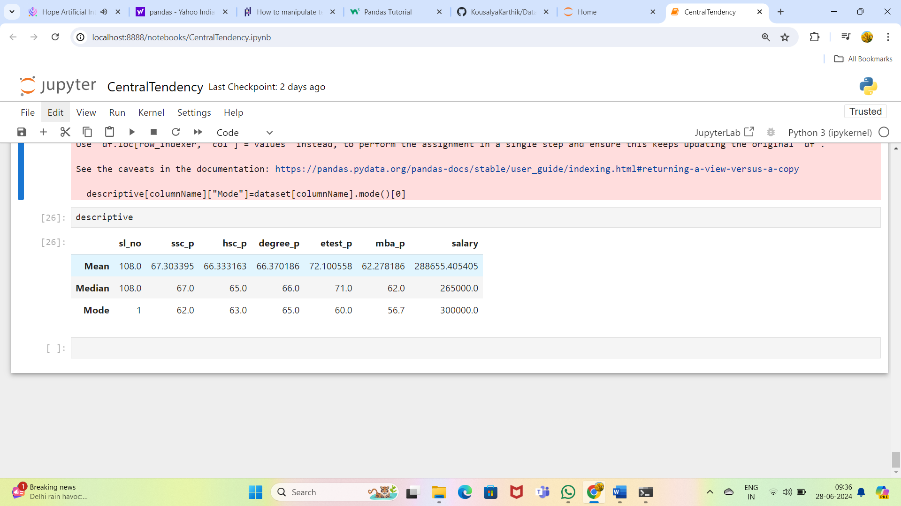

**Mean**:

Students of this data has got average marks in (ssc_p, hsc_p, degree_p, mba_p)

But in (etest_p) alone there performance is good.

**Median**:

There is a outlier in the salary data for this data since there is a difference of (288655.405405 -265000.0 =23,655.405405) compared to Mean and median salary.

**Mode**:

Repeated values for

| ssc_p : 62.0 | hsc_p: 63.0 | degree_p: 65.0 | etest_p: 60.0 | mba_p: 56.7 | Salary: 300000.0 |
| --- | --- | --- | --- | --- | --- |

# PERCENTILE

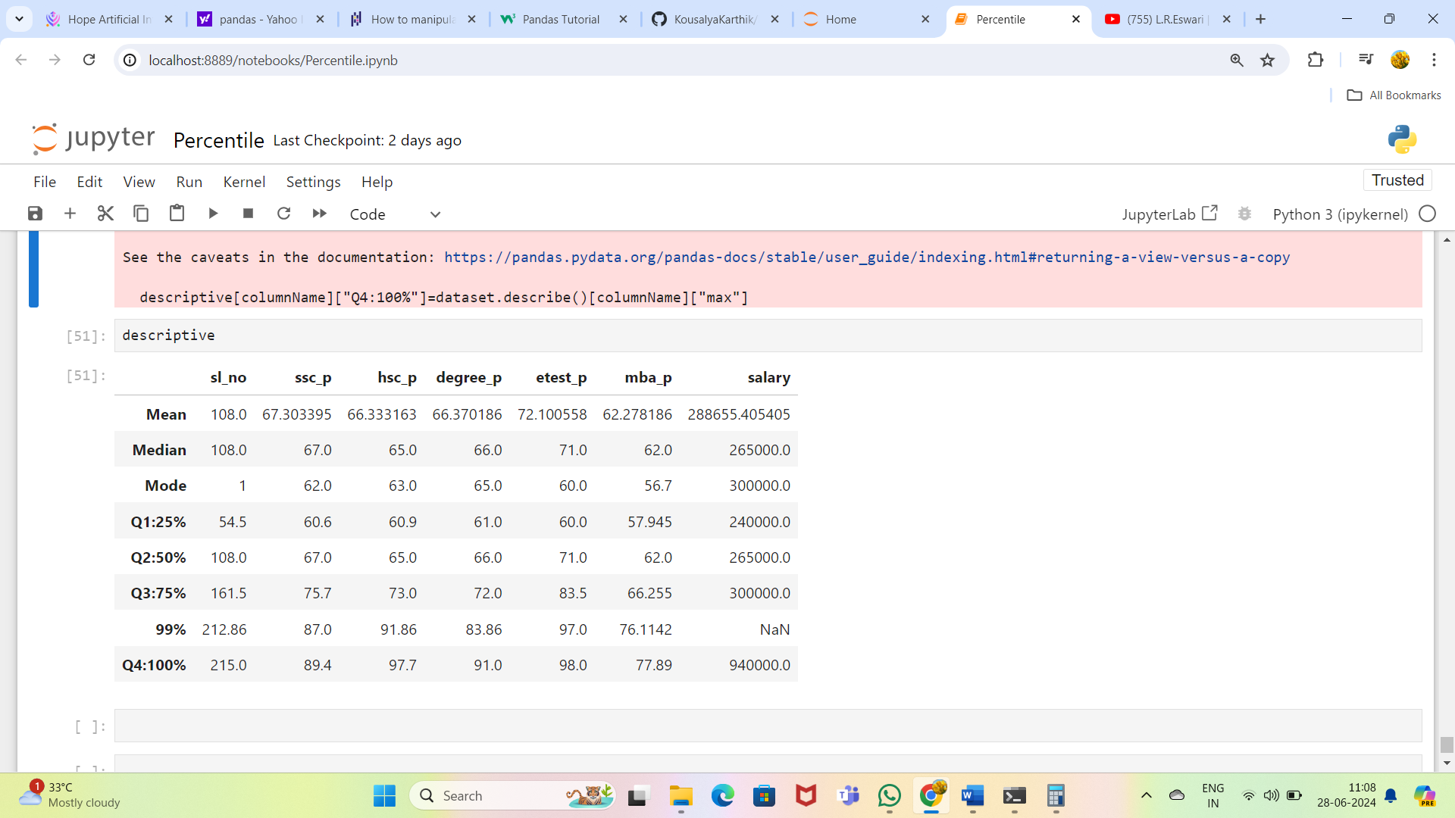

**ssc_p**

25% of the ssc_p mark exists within the value 60.6

50% of the ssc_p mark exists within the value 67.0

75% of the ssc_p mark exists within the value 75.7

100% of the ssc_p mark exists within the value 89.4

**hsc_p**

25% of the hsc_p mark exists within the value 60.9

50% of the ssc_p mark exists within the value 65.0

75% of the ssc_p mark exists within the value 73.0

100% of the ssc_p mark exists within the value 97.7

# IQR

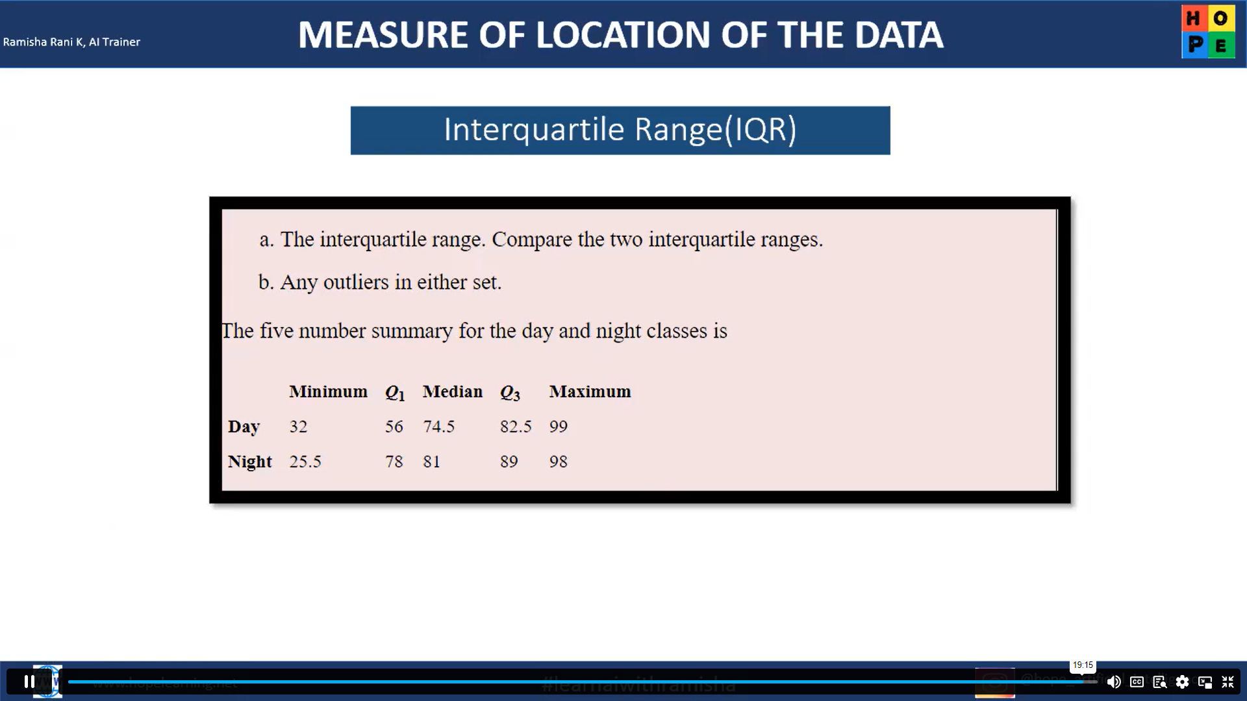

**Lesser than outlier – For Day**

Less than outlier = Q1 -1.5*IQR

IQR = Q3-Q1 =26.5

LTO = 56-1.5*26.5 =16.25

There is no lesser than outlier for day since the minimum value is not less than 16.25

**Greater than outlier – For Day**

GTO =Q3 + 1.5*IQR

GTO = 82.5+1.5*26.5 =122.25

There is no greater than outlier for day since the maximum value is not greater than 122.25

**Lesser than outlier – For Night**

Less than outlier = Q1 -1.5*IQR

IQR = Q3-Q1 =89-78 =11

LTO = 78-1.5*11 =61.5

There is no lesser than outlier for night since the minimum value is not less than 25.5

**Greater than outlier – For Night**

GTO =Q3 + 1.5*IQR

GTO = 89+1.5*11 =105.5

There is greater than outlier for night since the maximum value is greater than 98

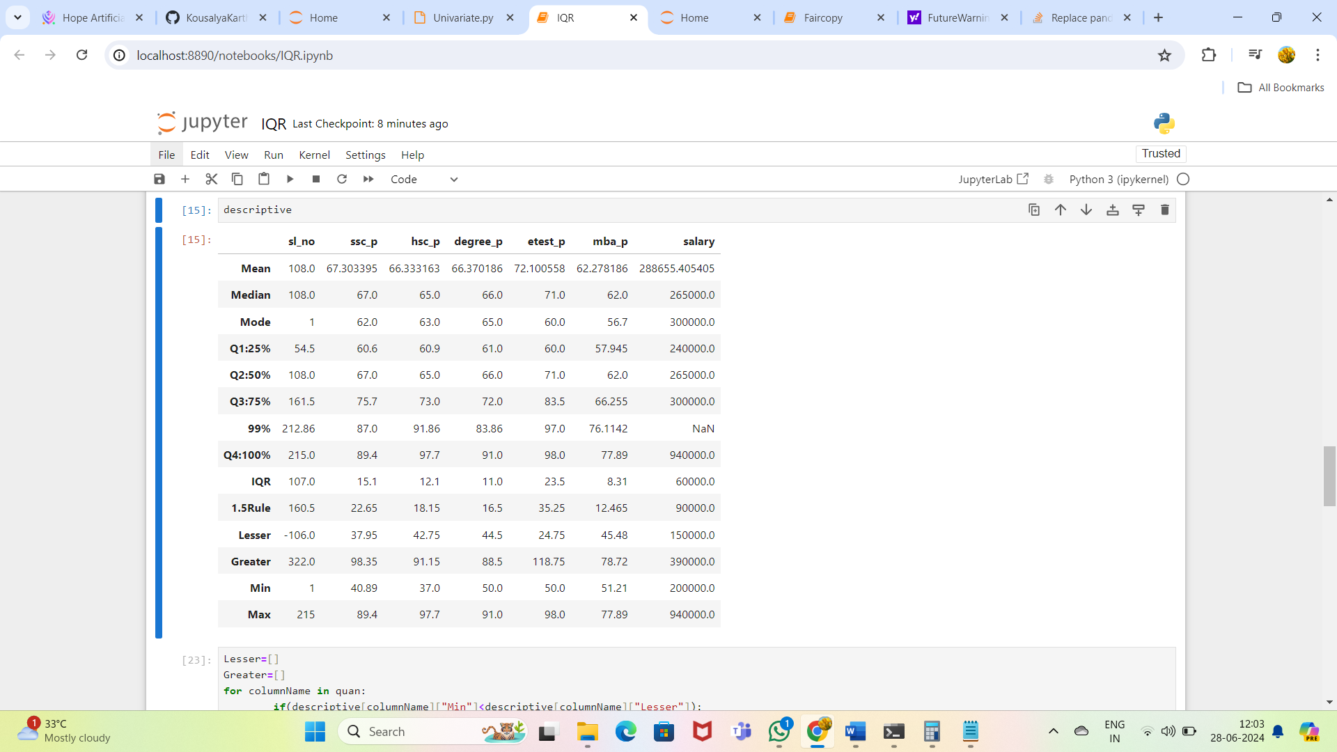

hsc_p column has lesser than outlier since min value is less than 42.75

['hsc_p', 'degree_p', 'salary'] columns have greater than outlier since max value is greater than their respective greater than outlier values