Confusion Matrix

# Random Forest

Picture: Sample Output Data

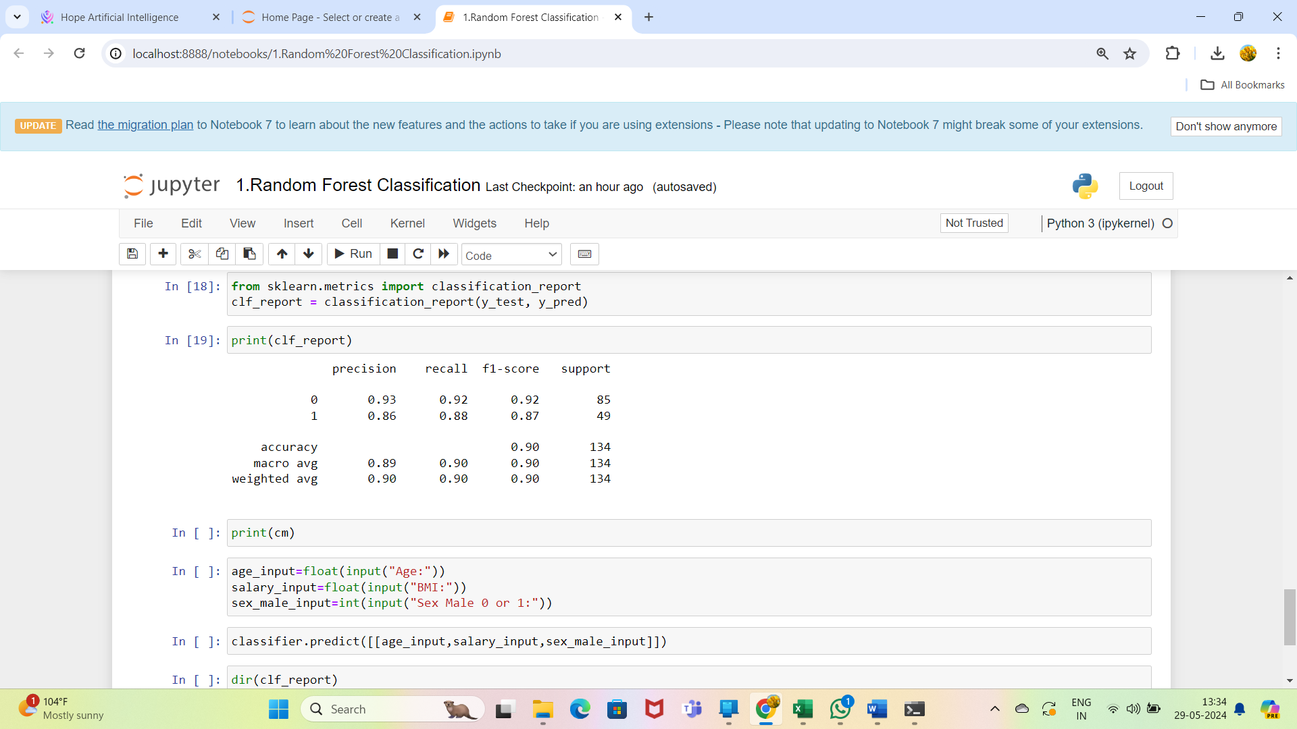

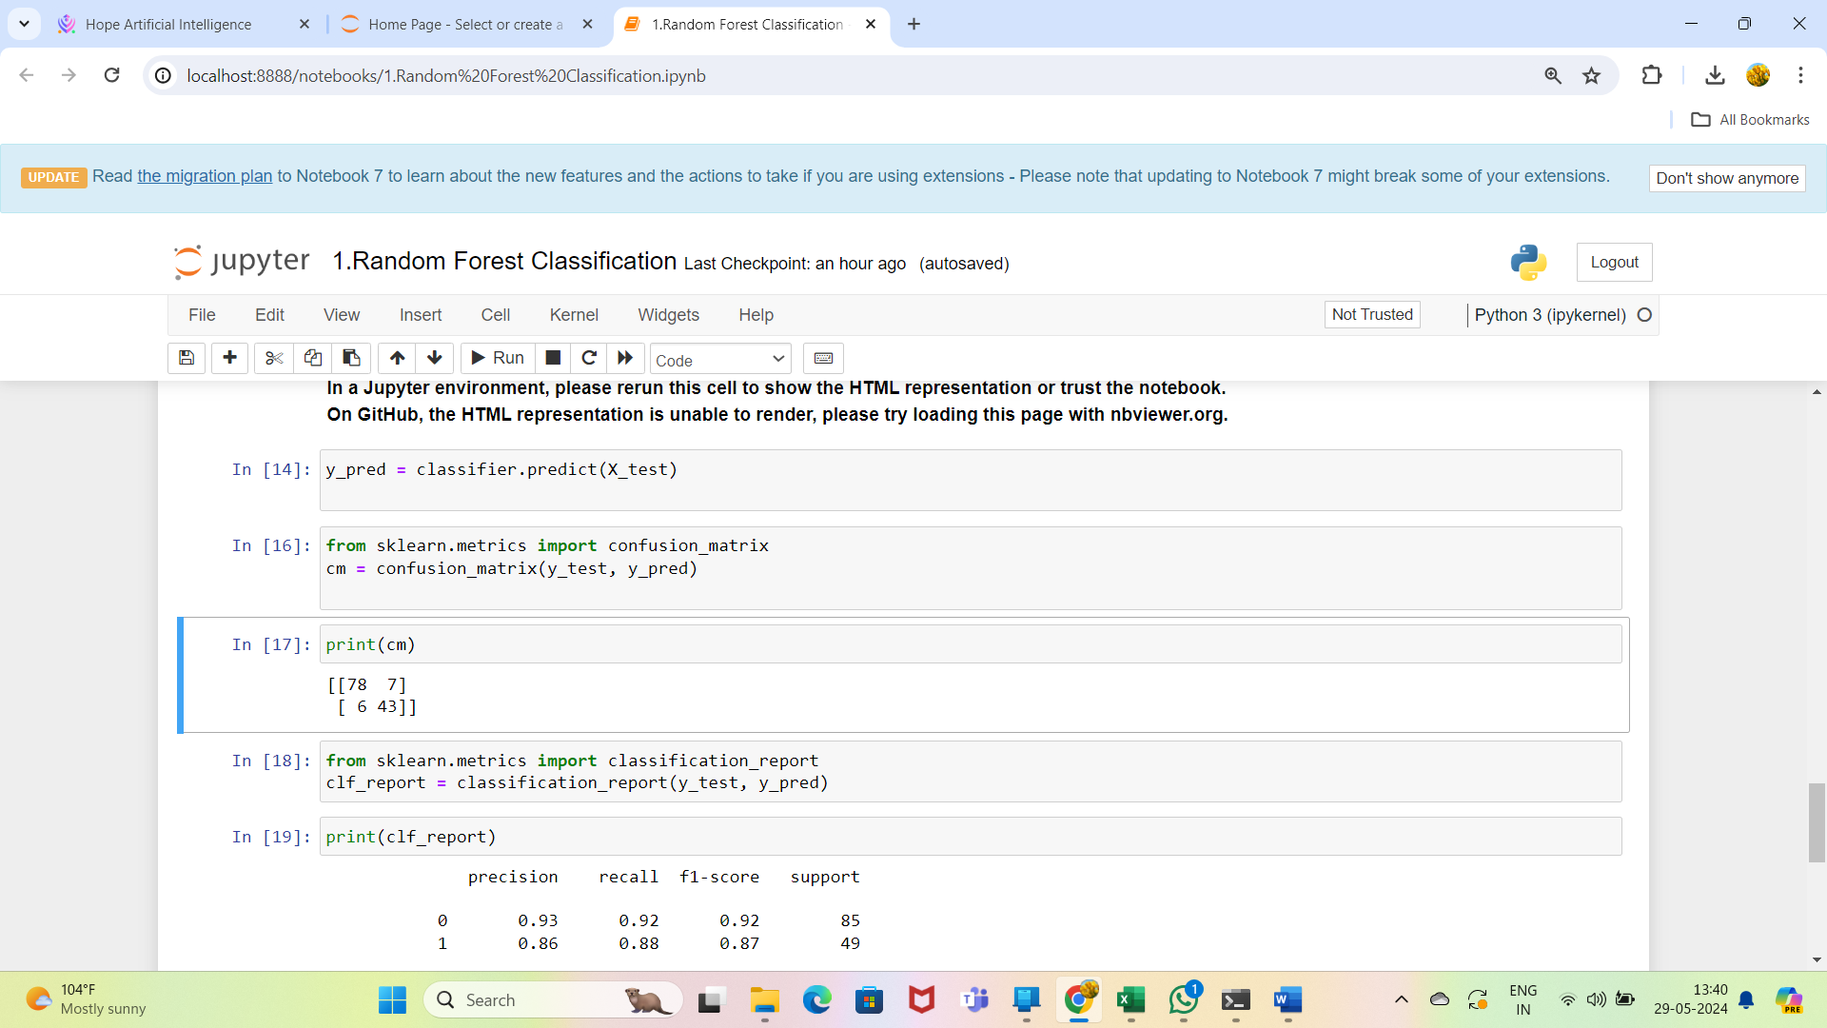

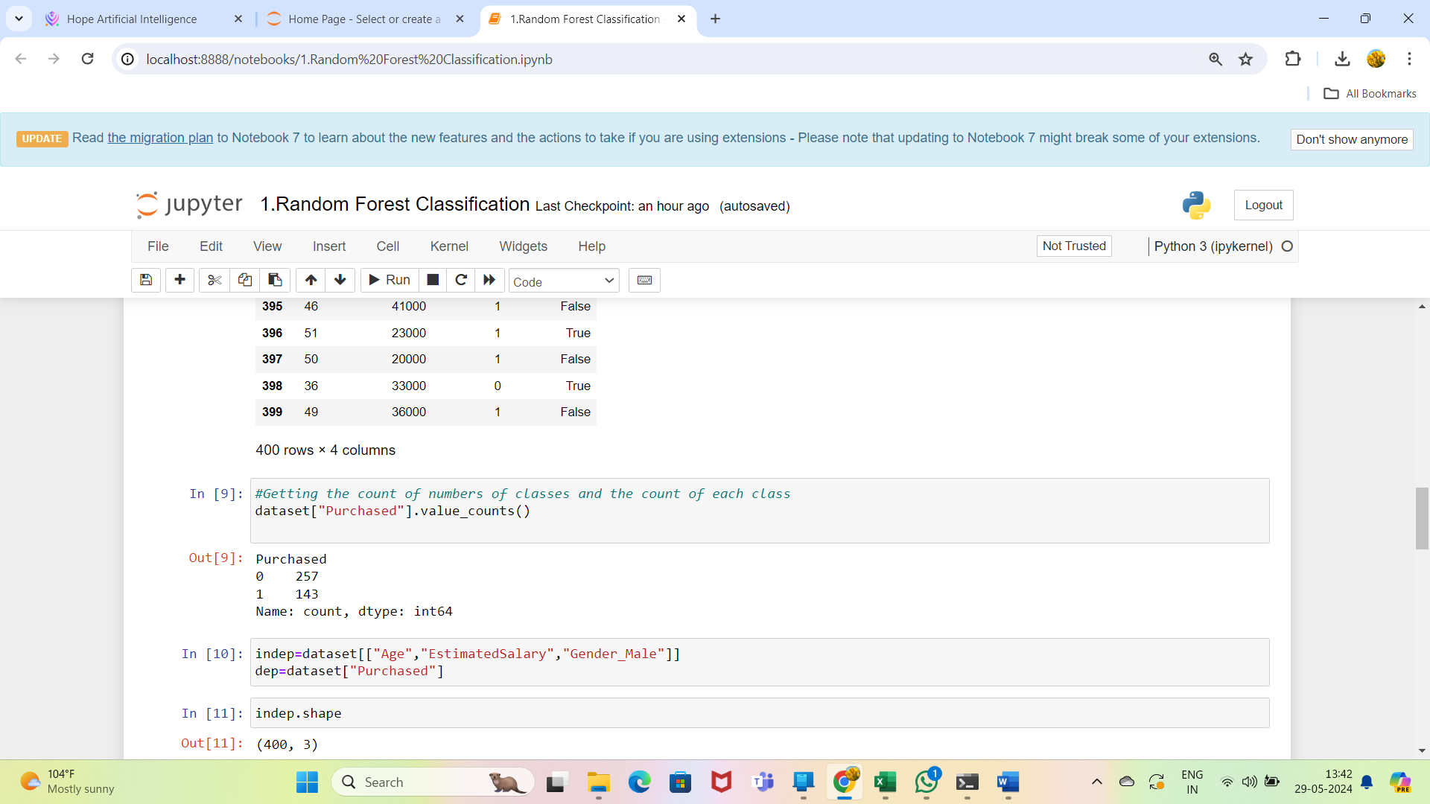

**Questions:**

1.How many classes to be classified here?

Ans:**2**

2.Whether the data is balanced or imbalanced?

Ans:**Imbalanced**

3.What is the overall performance of the model?

Ans: **Accuracy:0.90**

4.What is the correct classification of purchased to the total input of purchased in the test data?

Ans: **Recall:0.88**

5.What is the percentage of correct classification of not purchased to the sum of correctly classified as not purchased and wrongly classified as not purchased?

Ans: **Precision:0.93**

6.What is the overall performance of not purchased?

Ans : **F1 Measure for Not purchased:0.92**

6.What is the overall performance of purchased?

Ans : **F1 Measure for purchased:0.87**

7.What is the average performance of precision?

Ans: **Macro- Average for precision:0.89**

8.What is the average performance of Recall?

Ans: **Macro- Average for Recall:0.90**

7.What is the average performance of F1 Score?

Ans: **Macro- Average for F1 Score:0.90**

8.What is the sum of product of proportion rate(weight)of each class?

Ans: **Weighted Average for Precision: 0.90**

**Weighted Average for Recall: 0.90**

**Weighted Average for F1 Score: 0.90**

# Decision Tree

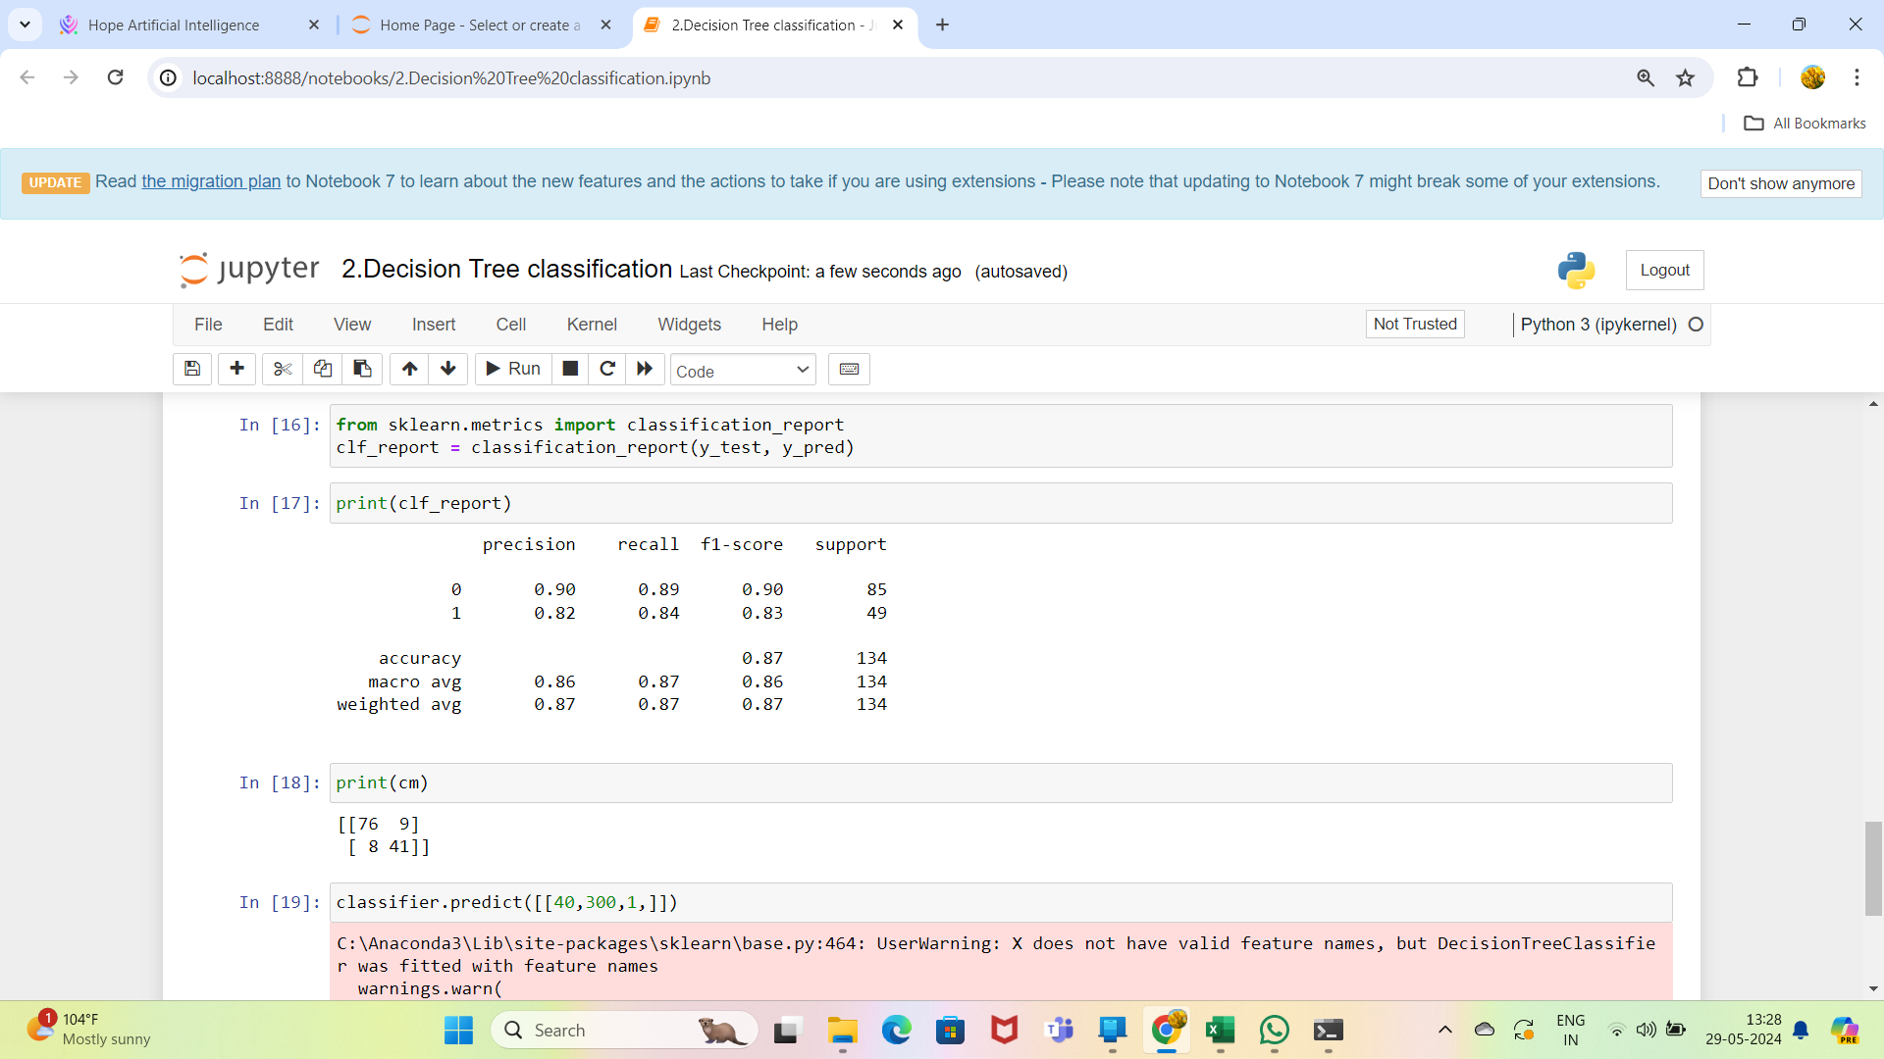



**Questions:**

1.How many classes to be classified here?

Ans:**2**

2.Whether the data is balanced or imbalanced?

Ans:**Imbalanced**

3.What is the overall performance of the model?

Ans: **Accuracy:0.87**

4.What is the correct classification of purchased to the total input of purchased in the test data?

Ans: **Recall:0.84**

5.What is the percentage of correct classification of not purchased to the sum of correctly classified as not purchased and wrongly classified as not purchased?

Ans: **Precision:0.90**

6.What is the overall performance of not purchased?

Ans : **F1 Measure for Not purchased:0.90**

6.What is the overall performance of purchased?

Ans : **F1 Measure for purchased:0.83**

7.What is the average performance of precision?

Ans: **Macro- Average for precision:0.86**

8.What is the average performance of Recall?

Ans: **Macro- Average for Recall:0.87**

7.What is the average performance of F1 Score?

Ans: **Macro- Average for F1 Score:0.86**

8.What is the sum of product of proportion rate(weight)of each class?

Ans: **Weighted Average for Precision: 0.87**

**Weighted Average for Recall: 0.87**

**Weighted Average for F1 Score:0.87**

# Support Vector Machine

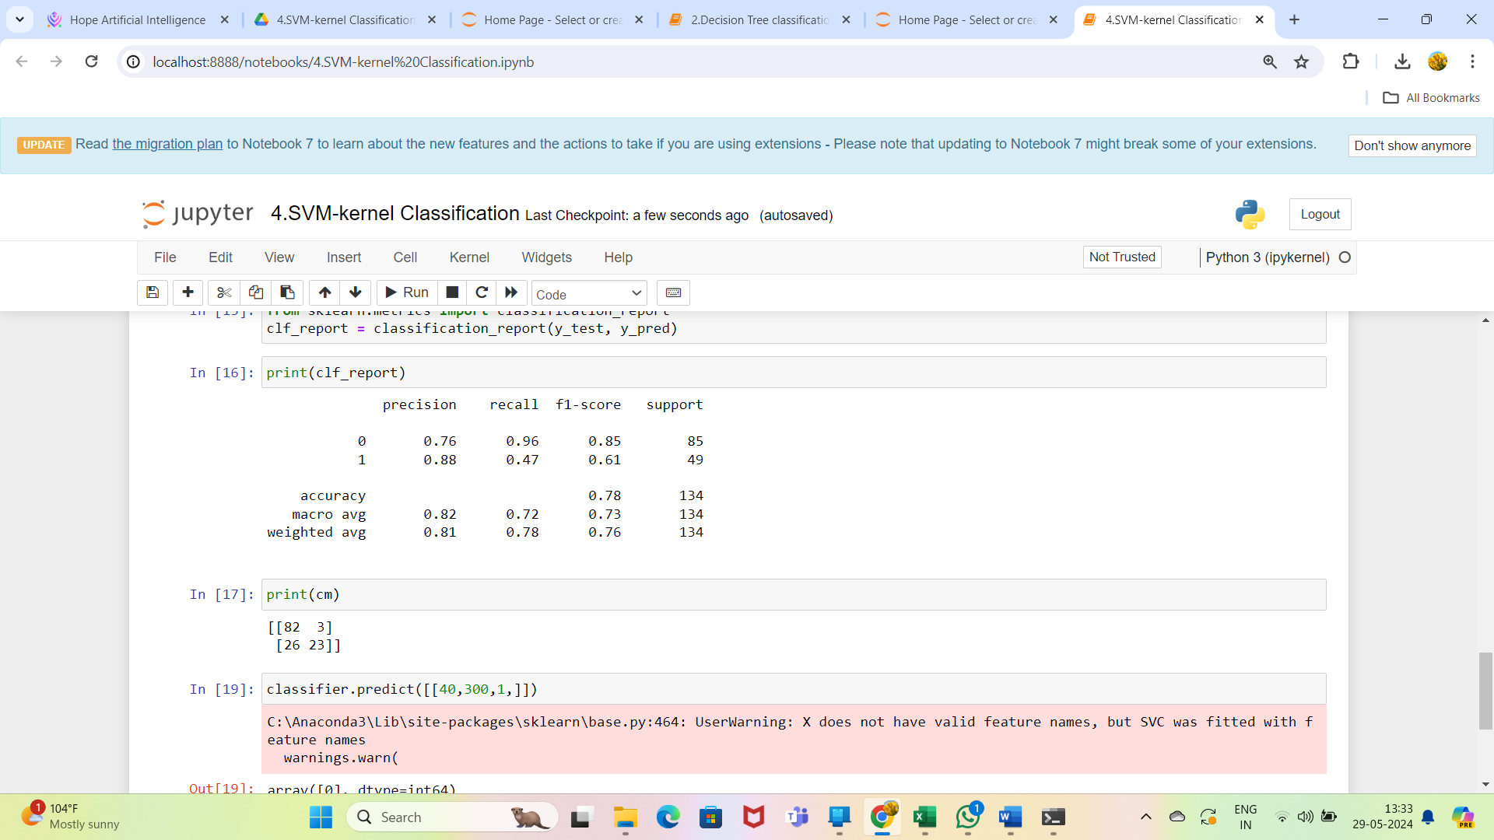



**Questions:**

1.How many classes to be classified here?

Ans:**2**

2.Whether the data is balanced or imbalanced?

Ans:**Imbalanced**

3.What is the overall performance of the model?

Ans: **Accuracy:0.78**

4.What is the correct classification of purchased to the total input of purchased in the test data?

Ans: **Recall:0.47**

5.What is the percentage of correct classification of not purchased to the sum of correctly classified as not purchased and wrongly classified as not purchased?

Ans: **Precision:0.76**

6.What is the overall performance of not purchased?

Ans : **F1 Measure for Not purchased:0.85**

6.What is the overall performance of purchased?

Ans : **F1 Measure for purchased:0.61**

7.What is the average performance of precision?

Ans: **Macro- Average for precision:0.82**

8.What is the average performance of Recall?

Ans: **Macro- Average for Recall:0.72**

7.What is the average performance of F1 Score?

Ans: **Macro- Average for F1 Score:0.73**

8.What is the sum of product of proportion rate(weight)of each class?

Ans: **Weighted Average for Precision: 0.81**

**Weighted Average for Recall: 0.78**

**Weighted Average for F1 Score:0.76**