Clustering Implementation and Visualization
Objective
To perform clustering using K-Means and DBSCAN and compare their results.
Dataset
Synthetic dataset generated using make_blobs().
Methodology
- Generated dataset
- Applied K-Means
- Applied DBSCAN
- Visualized clusters
Results
Insert screenshots of:
- Original Dataset
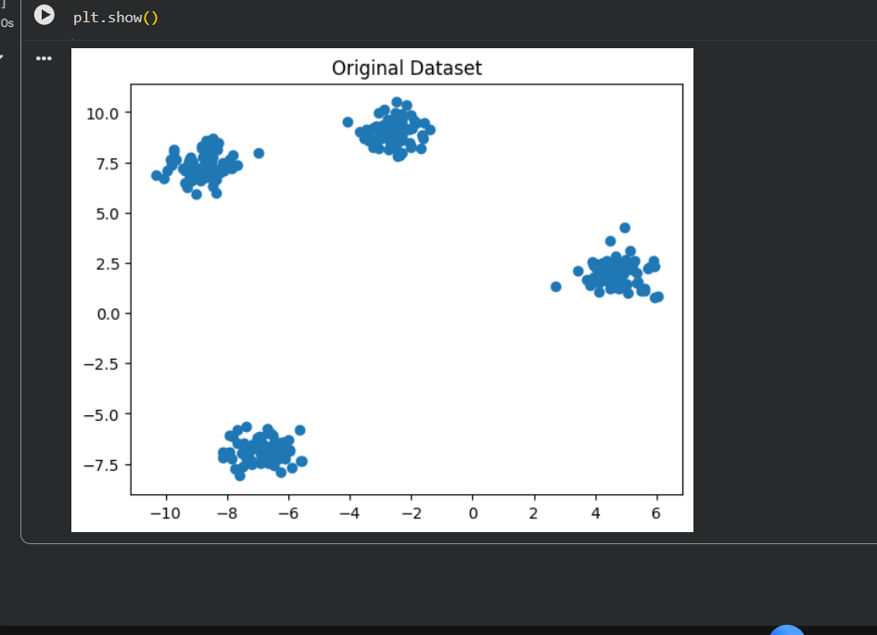
- K-Means Plot
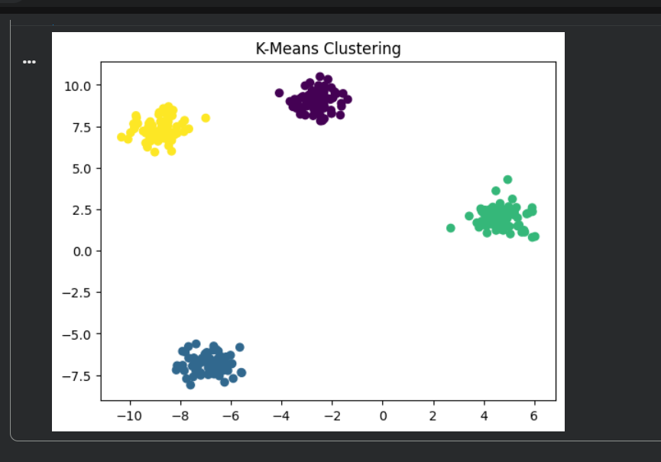
- DBSCAN Plot
