🛠️ Bearing RUL Diagnostic System
Uncertainty-Aware Bearing Remaining Useful Life Prediction with Maintenance Scheduling
An AI-based predictive maintenance system designed to estimate the Remaining Useful Life (RUL) of rolling-element bearings using vibration data. The system combines machine learning, uncertainty estimation, SHAP explainability, maintenance decision policies, and AI-generated maintenance explanations.

📌 Project Overview
Unexpected bearing failures can cause production downtime, increased maintenance costs, and equipment damage. Traditional maintenance strategies such as reactive maintenance and fixed time-based replacement may either replace healthy components too early or fail to prevent unexpected failures.
This project addresses this problem by developing an Uncertainty-Aware Bearing Remaining Useful Life Prediction System.
The system analyzes bearing vibration signals, extracts meaningful features, predicts the remaining useful life of the bearing, estimates prediction uncertainty, and recommends appropriate maintenance actions.
The application also provides an explainability module using SHAP, helping users understand which vibration features influence the RUL prediction.

🎯 Objectives
The main objectives of this project are:
- Predict the Remaining Useful Life (RUL) of bearings.
- Extract meaningful features from vibration signals.
- Compare machine learning models for RUL prediction.
- Estimate uncertainty in predictions using prediction intervals.
- Evaluate models using appropriate performance metrics.
- Provide maintenance recommendations based on predicted RUL and uncertainty.
- Explain model predictions using SHAP feature importance.
- Provide AI-assisted maintenance explanations.
- Develop an interactive diagnostic dashboard using Streamlit.

⚙️ System Architecture
The project follows the following workflow:
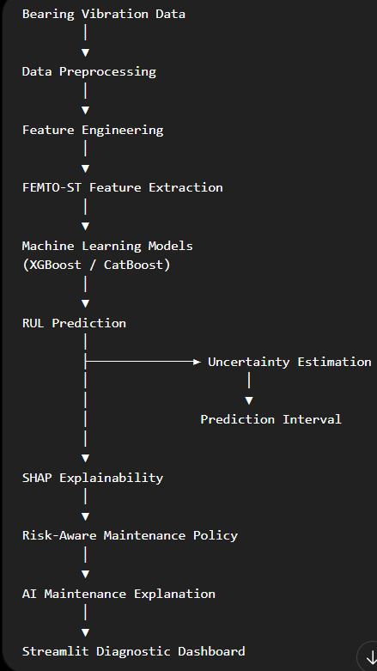

📊 Key Features
🔹 RUL Prediction
The system predicts the Remaining Useful Life of a bearing based on extracted vibration features.
🔹 Feature Engineering
Features are extracted from horizontal and vertical vibration signals.
Examples include:
- Mean
- Standard Deviation
- Variance
- RMS
- Skewness
- Kurtosis
- Peak Values
- Shape Factor
- Frequency Band Energy
- Spectral Features

🔹 Model Comparison
Multiple machine learning models can be evaluated to identify the best-performing model.
Models include:
- XGBoost
- LightGBM
- Random Forest
- CatBoost
Performance results are stored for comparison.

🔹 Uncertainty Estimation
Instead of providing only a single RUL prediction, the system estimates a prediction interval.
For example:
Predicted RUL: 74.8%
Prediction Interval: 9.4% – 98.1%
This provides additional information about the confidence and reliability of the prediction.

🔹 SHAP Explainability
SHAP analysis is used to identify the features that have the greatest influence on RUL predictions.
Example important features:
horiz_band_energy_2
horiz_band_energy_5
horiz_std
horiz_shape_factor
horiz_variance
horiz_peak
This helps make the machine learning predictions more interpretable.

🔹 Risk-Aware Maintenance Policy
The system uses predicted RUL and uncertainty information to recommend maintenance actions.
Possible actions include:
- Continue Operation
- Monitor Closely
- Schedule Maintenance
- Inspect Before Replacement
- Immediate Maintenance
The recommendations help support predictive maintenance decision-making.

🔹 AI-Assisted Maintenance Explanation
The explainability section generates a plain-language maintenance explanation based on:
- Selected bearing
- Current snapshot
- Predicted RUL
- Prediction interval
- SHAP feature importance
- Maintenance recommendation
Example explanation areas:
- Bearing Health Summary
- RUL Interpretation
- Uncertainty Interpretation
- SHAP Feature Insights
- Maintenance Recommendation
The AI explanation is grounded using the prediction values already generated by the system.

🖥️ Streamlit Dashboard
The application provides an interactive diagnostic and maintenance dashboard with the following sections:
1. Overview
Provides a summary of the project and system status.
2. RUL Prediction
Displays:
- Bearing selection
- Snapshot selection
- Predicted Remaining Useful Life
3. Model Performance
Displays model evaluation and comparison results.
4. Uncertainty
Displays uncertainty metrics and prediction intervals.
5. Maintenance Policy
Provides maintenance recommendations based on prediction and uncertainty.
6. Explainability
Displays:
- SHAP feature importance
- Important prediction drivers
- AI-generated maintenance explanation

📁 Dataset
This project uses bearing vibration data for Remaining Useful Life prediction.
The dataset contains vibration signals collected from bearings under different operating conditions and degradation stages.
The vibration signals are processed to extract statistical, time-domain, and frequency-domain features used for machine learning-based RUL prediction.

📂 Project Structure
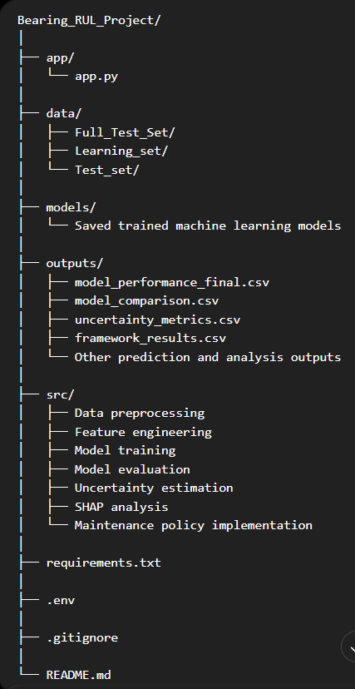
🧠 Machine Learning Pipeline
Step 1: Data Collection
Bearing vibration data is loaded from the available dataset.
Step 2: Data Preprocessing
The data is cleaned and prepared for analysis.
Step 3: Feature Extraction
Statistical and frequency-based features are extracted from vibration signals.
Step 4: Model Training
Machine learning models are trained using the extracted features.
Step 5: Model Evaluation
Models are evaluated and compared based on prediction performance.
Step 6: Uncertainty Estimation
Prediction intervals and uncertainty metrics are calculated.
Step 7: SHAP Analysis
SHAP values are used to determine the importance of individual features.
Step 8: Maintenance Decision
A risk-aware policy generates maintenance recommendations.
Step 9: Dashboard Visualization
Results are presented through an interactive Streamlit application.

📈 Evaluation Metrics
The system evaluates prediction performance using metrics such as:
- Mean Absolute Error (MAE)
- Model comparison metrics
- Prediction Interval Coverage Probability (PICP)
- Uncertainty-related metrics
These metrics help evaluate both the accuracy and reliability of the RUL prediction system.

🚀 Installation
1. Clone the Repository
git clone https://github.com/Koushal06/Bearing-RUL-Diagnostic-System.git
2. Navigate to the Project Folder
cd Bearing-RUL-Diagnostic-System
3. Create a Virtual Environment
python -m venv venv
4. Activate the Virtual Environment
Windows
venv\Scripts\activate
Linux / macOS
source venv/bin/activate
5. Install Dependencies
pip install -r requirements.txt

▶️ Running the Application
Run the Streamlit application using:
streamlit run app/app.py
After running the command, open:
http://localhost:8501
The Bearing RUL Diagnostic and Maintenance Console will open in your browser.

🛡️ Maintenance Decision Logic
The maintenance policy considers both:
- Predicted Remaining Useful Life
- Prediction Uncertainty
This is important because a prediction alone may not be sufficient for a reliable maintenance decision.
For example:
This approach supports more informed and risk-aware maintenance decisions.

🔍 Explainability Example
The system identifies the features that contribute most to a prediction.
Example:
Top Driving Feature:
horiz_band_energy_2
Other Important Features:
horiz_band_energy_5
horiz_std
horiz_shape_factor
horiz_variance
SHAP values help answer:
Why did the model predict this RUL value?
This improves the transparency and interpretability of the predictive maintenance system.

💻 Technologies Used
Programming Language
- Python
Machine Learning
- XGBoost
- CatBoost
- Scikit-learn
Explainable AI
- SHAP
Data Processing
- NumPy
- Pandas
- SciPy
Visualization
- Matplotlib
- Plotly
Web Application
- Streamlit
Environment Management
- Python Dotenv
Version Control
- Git
- GitHub

🎓 Academic Project
This project was developed as an academic project focused on:
Uncertainty-Aware Bearing Remaining Useful Life (RUL) Prediction with Cost-Based / Risk-Aware Maintenance Scheduling
The project combines concepts from:
- Machine Learning
- Predictive Maintenance
- Remaining Useful Life Prediction
- Uncertainty Quantification
- Explainable Artificial Intelligence
- Decision Support Systems

🔮 Future Enhancements
Possible future improvements include:
- Real-time sensor data integration.
- IoT-based vibration monitoring.
- Deep learning models such as LSTM and CNN.
- Advanced uncertainty estimation techniques.
- Automated maintenance alerts.
- Cloud deployment.
- Database integration.
- Multi-bearing fleet monitoring.
- Maintenance cost optimization.
- Enhanced AI-generated maintenance reports.

👨‍💻 Author
Koushal V
GitHub: Koushal06

⭐ Conclusion
The Bearing RUL Diagnostic System provides an end-to-end framework for predicting bearing degradation and supporting maintenance decisions. By combining RUL prediction, uncertainty estimation, SHAP explainability, and risk-aware maintenance recommendations, the system provides more than just a prediction—it delivers an interpretable and actionable diagnostic solution.

