EXP:2 | PaaS in Public Cloud Using Render

AIM
To develop and deploy a simple web application using Render, a Platform as a Service (PaaS), and understand how a cloud platform hosts an application without requiring the user to manage the underlying servers.

REQUIREMENTS
- Computer with Internet connection
- Python 3.10 or later
- Git / GitHub account
- GitHub repository
- Render account

APPLICATION USED
A simple Python Flask web application was created with two routes: the Home page (/) and the About page (/about). The application was stored in GitHub and deployed as a Web Service on Render.

PROJECT FILES
Project structure:
RenderHelloApp/
├── app.py
└── requirements.txt
Contents of app.py:
from flask import Flask

app = Flask(__name__)

@app.route("/")
def home():
return "Hello! Welcome to Render PaaS."

@app.route("/about")
def about():
return "This application is deployed on Render."

if __name__ == "__main__":
app.run(host="0.0.0.0", port=5000)
Contents of requirements.txt:
Flask==3.0.3
gunicorn==22.0.0

PROCEDURE
- Create a project folder named RenderHelloApp.
- Create app.py and requirements.txt inside the project folder and enter the required Flask application code and dependencies.
- Create a public GitHub repository named RenderHelloApp.
- Upload app.py and requirements.txt to the GitHub repository and commit the changes.
- Open Render and create a new Web Service.
- Connect the GitHub account and select the RenderHelloApp repository.
- Configure the service with Python as the language/environment and main as the branch.
- Leave the Root Directory blank.
- Set the Build Command to: pip install -r requirements.txt
- Set the Start Command to: gunicorn app:app
- Select the Free compute instance when available.
- Deploy the Web Service.
- Wait until the Render dashboard displays Deploy succeeded / Live.
- Open the generated public URL and verify the Home page.
- Open the /about route and verify the About page.

COMMANDS / CONFIGURATION USED
Build command:
pip install -r requirements.txt
Start command:
gunicorn app:app
Application routes:
https://renderhelloapp-d7i6.onrender.com/
https://renderhelloapp-d7i6.onrender.com/about

OUTPUT
After successful deployment, Render displayed the service as live.
Test Case | URL | Expected / Obtained Output
Render Deployment | Render Dashboard | Deploy succeeded | Live
Test Case 1 – Home Page | https://renderhelloapp-d7i6.onrender.com/ | Hello! Welcome to Render PaaS.
Test Case 2 – About Page | https://renderhelloapp-d7i6.onrender.com/about | This application is deployed on Render.

SCREENSHOTS / EVIDENCE
Attach the following screenshots in the record:
- Screenshot 1 – Render Dashboard showing “Deploy succeeded | Live” and the public URL.
- Screenshot 2 – Home page showing “Hello! Welcome to Render PaaS.”
- Screenshot 3 – About page showing “This application is deployed on Render.”
[SCREENSHOT 1]
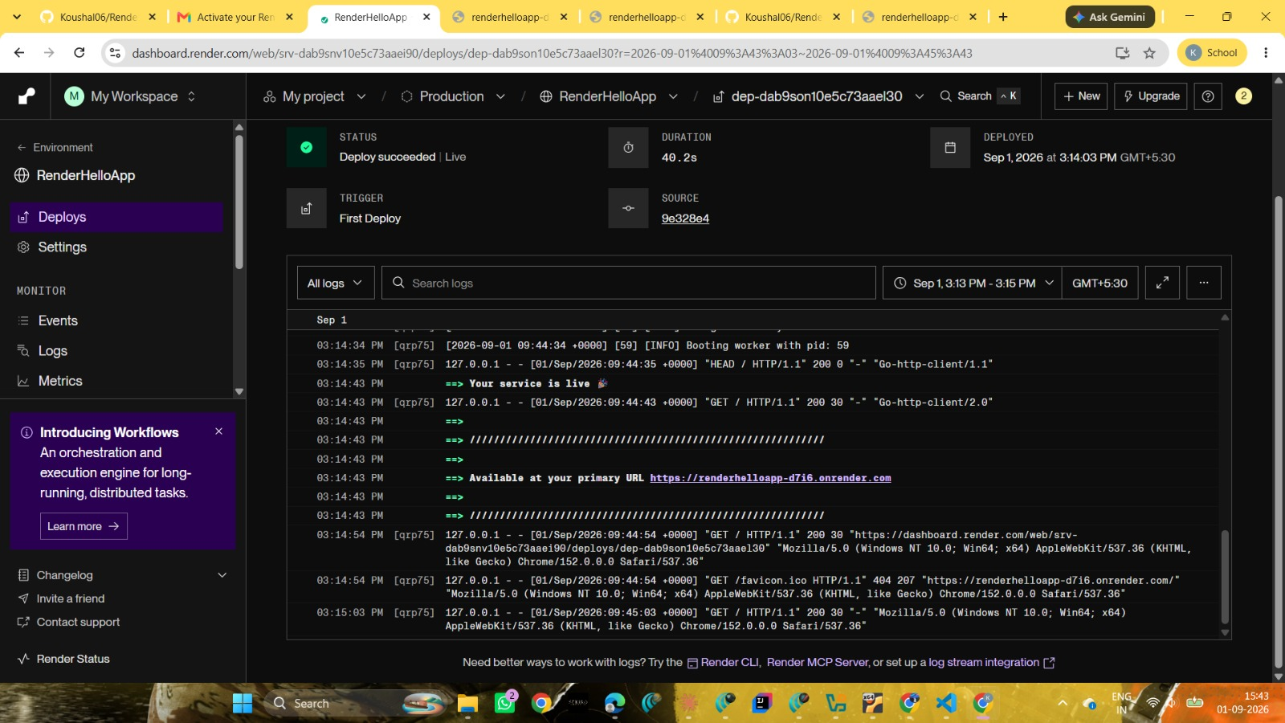
Render Dashboard – Deployment successful / Live

[SCREENSHOT 2]
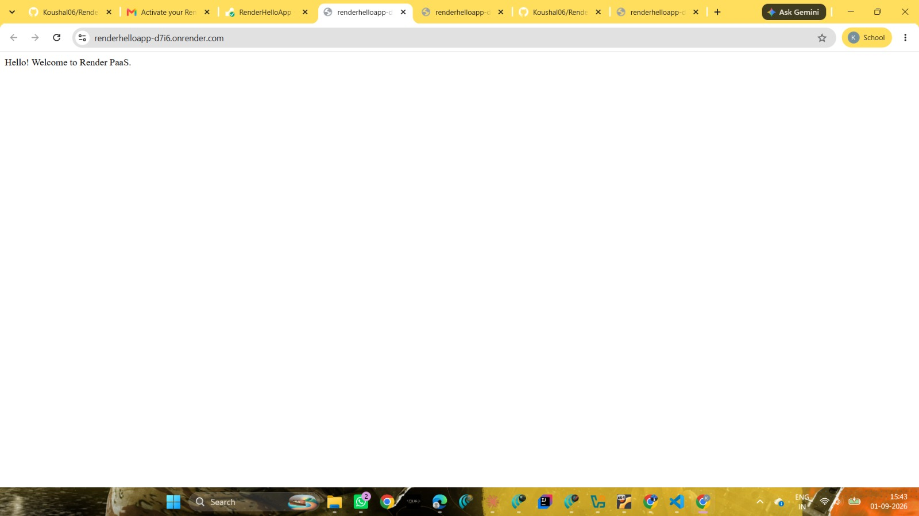
Home Page – Hello! Welcome to Render PaaS.

[SCREENSHOT 3]
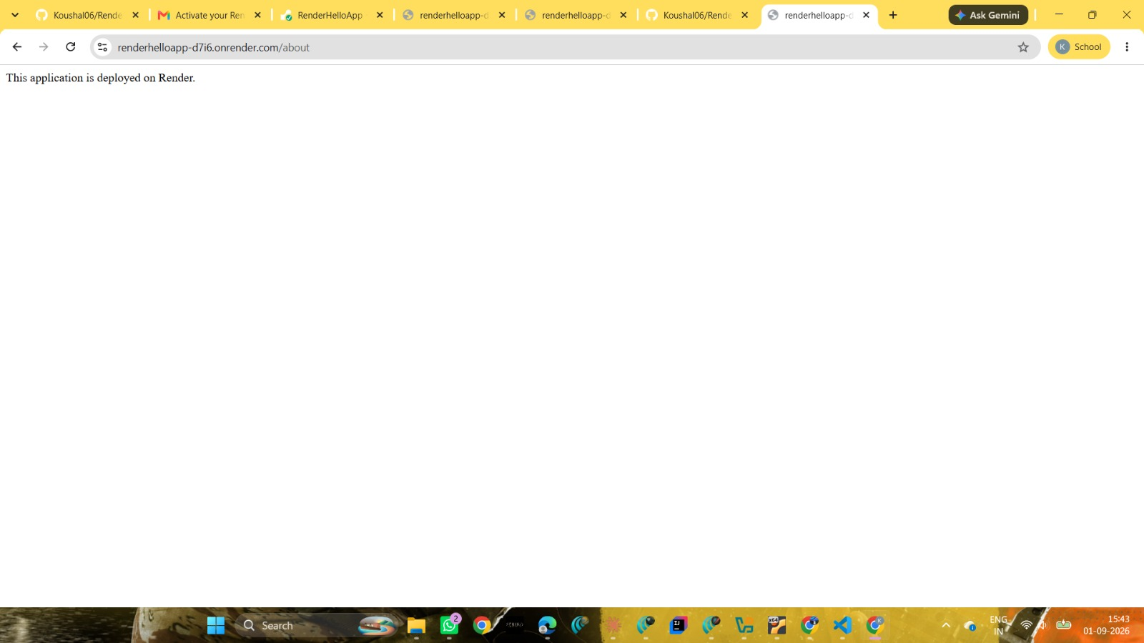
About Page – This application is deployed on Render.

RESULT
Thus, a simple Flask web application was successfully developed, uploaded to GitHub, and deployed on Render using Platform as a Service (PaaS). The Home and About routes were successfully accessed through the public Render URL.

CONCLUSION
The experiment demonstrated how a PaaS platform simplifies cloud application deployment by providing the runtime environment, dependency installation, web server execution, and public access without requiring manual server management.

