EXP:3 | Setting Up Hybrid Cloud Connectivity Using Cisco Packet Tracer

AIM
To simulate a secure hybrid cloud connection between an on-premises data center and a cloud network using routers, switches, subnets, and routing in Cisco Packet Tracer.

SOFTWARE / COMPONENTS REQUIRED
- Cisco Packet Tracer
- Two Cisco 2911 routers
- Two Cisco 2960-24TT switches
- One PC
- One Server
- Copper Straight-Through cables
- Copper Cross-Over cable for the router-to-router link

NETWORK TOPOLOGY
The simulated network consists of an on-premises LAN connected to a cloud/server LAN through two routers. Static routing is used between the two networks.
PC0 | → | Switch0 | → | Router1
Router1 | → | 10.10.10.0/30 | → | Router2
Router2 | → | Switch1 | → | Server0
PC Network | → | 192.168.1.0/24
Server Network | → | 10.0.0.0/24

IP ADDRESSING TABLE
Device | Interface | IP Address | Subnet Mask | Purpose
Router1 | GigabitEthernet0/0 | 192.168.1.1 | 255.255.255.0 | On-premises LAN gateway
Router1 | GigabitEthernet0/1 | 10.10.10.1 | 255.255.255.252 | Router-to-router link
Router2 | GigabitEthernet0/0 | 10.0.0.1 | 255.255.255.0 | Cloud LAN gateway
Router2 | GigabitEthernet0/1 | 10.10.10.2 | 255.255.255.252 | Router-to-router link
PC0 | FastEthernet0 | 192.168.1.10 | 255.255.255.0 | On-premises host
Server0 | FastEthernet0 | 10.0.0.10 | 255.255.255.0 | Cloud server

PROCEDURE
1. Open Cisco Packet Tracer and create a new logical workspace.
2. Place two 2911 routers, two 2960 switches, one PC and one Server.
3. Connect PC0 to Switch0 and Switch0 to Router1 using Copper Straight-Through cables.
4. Connect Server0 to Switch1 and Switch1 to Router2 using Copper Straight-Through cables.
5. Connect Router1 GigabitEthernet0/1 to Router2 GigabitEthernet0/1 using a Copper Cross-Over cable.
6. Open Router1 CLI. When prompted for the initial configuration dialog, enter no and press Enter.
7. Configure Router1's LAN and inter-router interfaces.
8. Verify Router1 interfaces using show ip interface brief.
9. Open Router2 CLI and configure its LAN and inter-router interfaces.
10. Configure PC0 with IP address 192.168.1.10, subnet mask 255.255.255.0 and default gateway 192.168.1.1.
11. Configure Server0 with IP address 10.0.0.10, subnet mask 255.255.255.0 and default gateway 10.0.0.1.
12. Configure static routes on both routers so that the two LANs can communicate.
13. Verify the routing tables using show ip route.
14. From PC0, use ping 10.0.0.10 to verify end-to-end connectivity.
15. Save the router configurations using copy running-config startup-config.

ROUTER CONFIGURATION COMMANDS

Router1 Configuration
enable
configure terminal
interface gigabitEthernet0/0
ip address 192.168.1.1 255.255.255.0
no shutdown
exit
interface gigabitEthernet0/1
ip address 10.10.10.1 255.255.255.252
no shutdown
exit
ip route 10.0.0.0 255.255.255.0 10.10.10.2
exit
copy running-config startup-config

Router2 Configuration
enable
configure terminal
interface gigabitEthernet0/0
ip address 10.0.0.1 255.255.255.0
no shutdown
exit
interface gigabitEthernet0/1
ip address 10.10.10.2 255.255.255.252
no shutdown
exit
ip route 192.168.1.0 255.255.255.0 10.10.10.1
exit
copy running-config startup-config

Verification Commands
do show ip interface brief
show ip route
ping 10.0.0.10

OUTPUT / OBSERVATION
The following outputs were obtained during the simulation.

Router1 Interface Verification
Interface IP-Address Status Protocol
GigabitEthernet0/0 192.168.1.1 up up
GigabitEthernet0/1 10.10.10.1 up up
GigabitEthernet0/2 unassigned administratively down down
Vlan1 unassigned administratively down down

Router2 Interface Verification
Interface IP-Address Status Protocol
GigabitEthernet0/0 10.0.0.1 up up
GigabitEthernet0/1 10.10.10.2 up up
GigabitEthernet0/2 unassigned administratively down down
Vlan1 unassigned administratively down down

Router1 Routing Table – Static Route
S 10.0.0.0/24 [1/0] via 10.10.10.2
C 10.10.10.0/30 is directly connected, GigabitEthernet0/1
L 10.10.10.1/32 is directly connected, GigabitEthernet0/1
C 192.168.1.0/24 is directly connected, GigabitEthernet0/0
L 192.168.1.1/32 is directly connected, GigabitEthernet0/0

Router2 Routing Table – Static Route
C 10.0.0.0/24 is directly connected, GigabitEthernet0/0
L 10.0.0.1/32 is directly connected, GigabitEthernet0/0
C 10.10.10.0/30 is directly connected, GigabitEthernet0/1
L 10.10.10.2/32 is directly connected, GigabitEthernet0/1
S 192.168.1.0/24 [1/0] via 10.10.10.1

Connectivity Test
C:\>ping 10.0.0.10
Pinging 10.0.0.10 with 32 bytes of data:
Reply from 10.0.0.10: bytes=32 time<1ms TTL=126
Reply from 10.0.0.10: bytes=32 time<1ms TTL=126
Reply from 10.0.0.10: bytes=32 time<1ms TTL=126
Reply from 10.0.0.10: bytes=32 time<1ms TTL=126
Ping statistics for 10.0.0.10:
Packets: Sent = 4, Received = 4, Lost = 0 (0% loss)
Minimum = 0ms, Maximum = 1ms, Average = 0ms

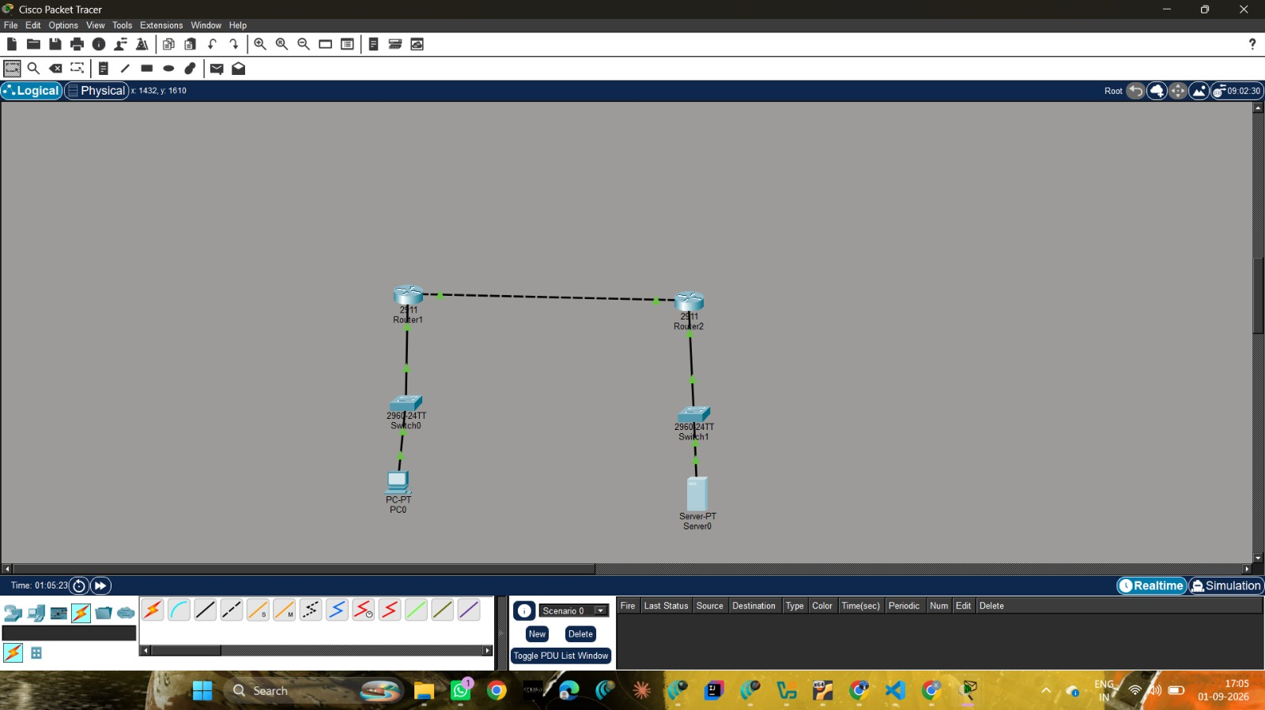

RESULT
A hybrid cloud network was successfully simulated using Cisco Packet Tracer. The on-premises network and cloud network were interconnected through routers configured with static routing. Communication between PC0 and Server0 was verified successfully using the ping command, demonstrating end-to-end connectivity.

CONCLUSION
The experiment demonstrated the configuration of a basic hybrid cloud connectivity scenario using routers, switches, an end device and a server. Static routes enabled traffic to travel between the 192.168.1.0/24 and 10.0.0.0/24 networks.

