Assignment
1. Creating and Renaming Files/Directories
Create a directory named test_dir using mkdir.
Inside test_dir, create an empty file called example.txt.
Rename example.txt to renamed_example.txt using mv

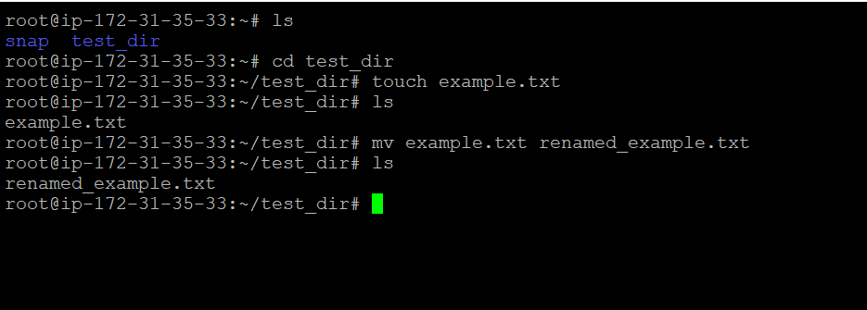

In this task, I created a directory using mkdir, navigated into it using cd, created a file using touch, renamed it using mv, and verified the result using ls. This demonstrates basic Linux file management operations.

2. Viewing File Contents
Use cat to display the contents of /etc/passwd.
Display only the first 5 lines of /etc/passwd using head.
Display only the last 5 lines of /etc/passwd using tail.
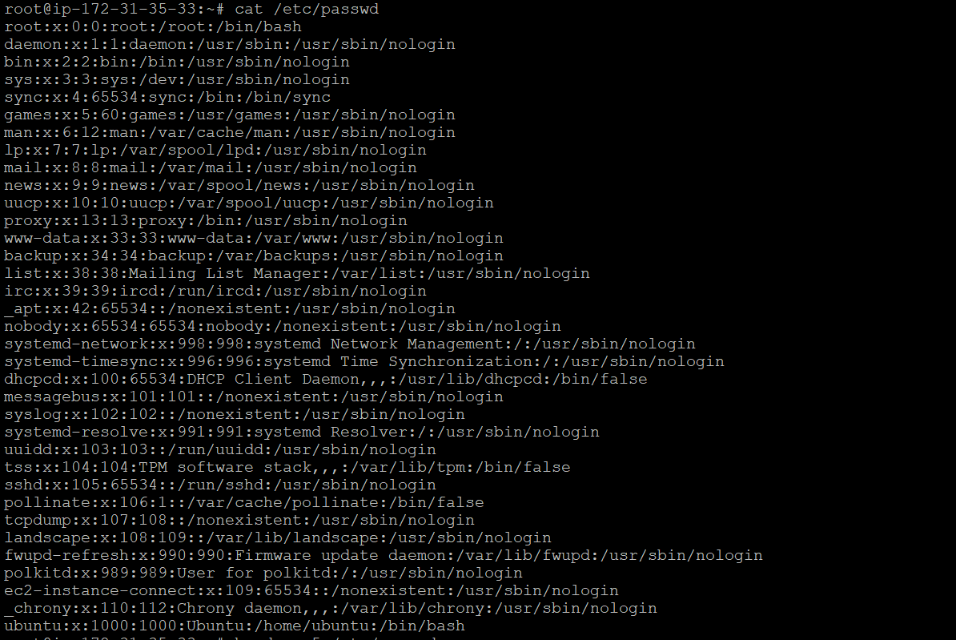

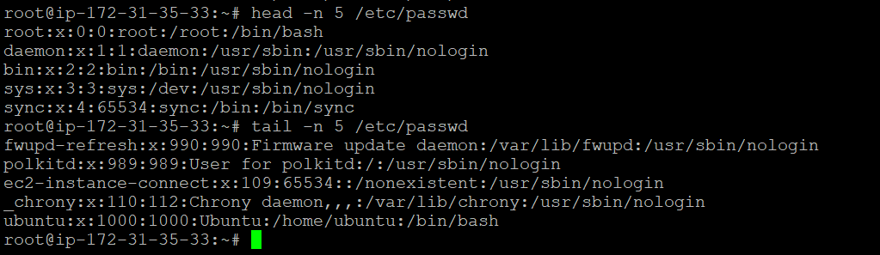

Used cat to view the full file, head -n 5 to view the first 5 lines, and tail -n 5 to view the last 5 lines of /etc/passwd.
3. Searching for Patterns
Use grep to find all lines containing the word "root" in /etc/passwd.
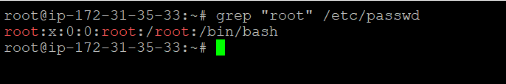

Used grep "root" /etc/passwd to search and display lines containing the word "root".

4. Zipping and Unzipping
Compress the test_dir directory into a file named test_dir.zip using zip.
Unzip test_dir.zip into a new directory named unzipped_dir.

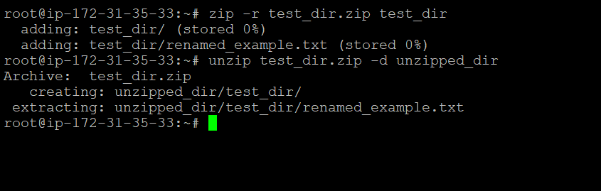

Used zip -r to compress the directory and unzip -d to extract it into a new folder.

5. Downloading Files
Use wget to download a file from a URL (e.g., https://example.com/sample.txt).
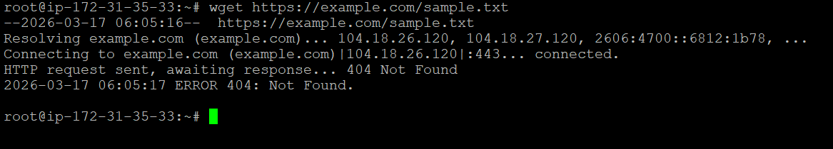

Used wget to download a file from a given URL into the current directory.
6. Changing Permissions
Create a file named secure.txt and change its permissions to read-only for everyone using chmod.
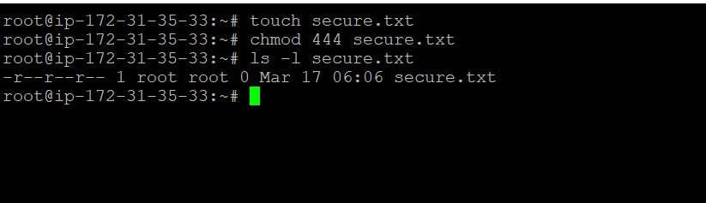
Created a file using touch and set it to read-only using chmod 444.

7. Working with Environment Variables
Use export to set a new environment variable called MY_VAR with the value "Hello, Linux!".
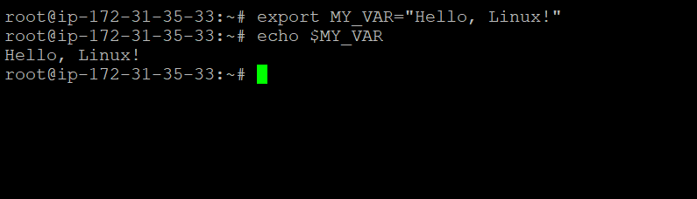

An environment variable was created using the export command.
The command export MY_VAR="Hello, Linux!" sets a new environment variable named MY_VAR with the value "Hello, Linux!". Environment variables are used in Linux to store system-wide or session-specific values that can be accessed by programs and scripts.
The variable can be verified using the echo $MY_VAR command, which displays its value.
It is important to note that variables set using export are temporary and will be available only for the current session unless added to configuration files like .bashrc

