Computer Networks Coursework - 262984

Describing my protocols, the source code, and the design decisions:

To implement the protocol correctly, I began by reading how the RFC 1350 TFTP Client–Server works to ensure that I understood how they communicate effectively as well as what the packet structures are for each type, when they are used, and how they are implemented. The packet structure of each packet that I have used in my code is the exact one from RFC 1350. I have read/write requests, acknowledgments, timeouts, error handling, and support for simultaneous file transfers as required.

Packet Structure in my code:

Read Request (RRQ)/ Write Request (WRQ)
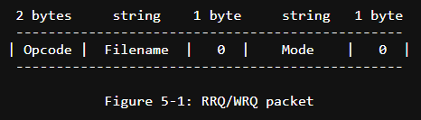
Data Packet (DATA)
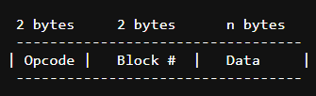
Acknowledgment Packet (ACK)
2 bytes 2 bytes
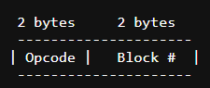
Error Packet (ERROR)
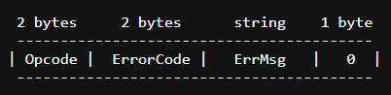

The Read Request (RRQ) and Write Request (WRQ) packets are made in the createReadRequest() and createWriteRequest(). The error (ERROR) packets are also created in their own method called sendErrorMessage(). However, the Acknowledgement (ACK) and Data (DATA) packets that are created don’t have a method each instead they are created whenever it’s necessary. These packets are sent as bytes as mentioned in the requirements and RFC 1350. Finally, there are methods to handle these packets as well when they are received.

Handling TFTP Requests:
Handling RRQ Packets
When a read request is sent to the server from the client, the server will unpack the request and check if it’s a read request. If it's not a read request, then it will be handled accordingly. If it is a read request, then the handleReadRequest() is called. Then the server tries to find the file in the current directory, if the file is not found, an ERROR packet is sent to the client with the error code and the error message. If the file does exist, then the server immediately starts sending the DATA packets to the client.

Handling WRQ Packets
When a write request is sent to the server from the client, the server will unpack the request and check if it’s a write request. If it's not a write request, then it will be handled accordingly. If it is a write request, then the handleWriteRequest() is called. Then the server sends an ACK packet back letting the client know that it’s ready for file transfer.

Handling DATA and ACK Packets
DATA packets are a maximum size of 512 bytes (excluding headers) each (as mentioned in RFC 1350). The ACK packets are 4 bytes each (as mentioned in RFC 1350). When a DATA packet is sent from the sender and is received by the recipient, the data is extracted and checked its block with the recipient's block code+ 1. If it’s not the same, it will be handled accordingly. If it is the same, then the recipient will send its corresponding ACK packet back. Once the sender receives the ACK, it will send the next DATA packet and this process will continue until the end of the file transfer. If the DATA packet received is less than 512 bytes (excluding headers), then it means the file transfer is done. These DATA packets are converted to files and saved in the current directory to make it easier to find where all the files are read/written to in both the server and the client.
Handling ERROR Packets
When an ERROR Packet is sent (only sent if File not Found as the requirement says), both the client and server have a sendError() which builds the ERROR packet and sends it to the recipient, and a handleError() which extracts the error code and the error message from the ERROR packet which then is outputted.

Client Implementation
In both, I have implemented a console-based menu that allows the user to execute read and write. So when you run the code, it will ask if the user wants to retrieve a file or send a file and after that, the user will input the filename. Then depending on what the inputs are, a method will be called to handle this request.

Main Differences:
UDP:
- Datagram Socket
- Datagram Packet
- Sending data is a raw sequence of bytes (as the requirement says)
- Done in octet mode (as the requirement says)
- Building Packets
- Handling Packets
- End of File transfer – Packet size < 512 (excluding headers)
TCP:
- Buffered Reader
- Buffered Writer
- Print Writer
- TCP Sockets
- No building or handling Packets
- End of File transfer – A simple “EOFT” message sent

Server Implementation:
In the UDP server, I have used Datagram Sockets to receive and send data over. Here, I didn’t need to implement a separate class just for a client handler as the server interacts directly with clients using their IP addresses and port numbers. Both handleReadRequest() and handleWriteRequest() have the IP address and client port as parameters to ensure that the server can support simultaneous file transfers to and from multiple clients (as the requirement says). When a request is sent from the client, the server checks what the request is, and then handles it accordingly using various methods in my code. The server listens on port 9000 (which can be changed to 69 to test for interoperability with Third-Party).

In the TCP server, I have used Server Sockets to accept requests from a client socket. To make it so the server can support simultaneous file transfers to and from multiple clients (as the requirement says), I have implemented a client handler that would create a new thread for each client using their client Socket. The client's request is then handled according by readFile() or writeFile() on the server side. The server listens on port 9000.

In both servers, I have implemented timeouts in case the server was listening and was not receiving anything for a specific duration of time (I have set it to 60 seconds). Furthermore, in both servers, there is some way to communicate errors such as the “File not Found” error.

Interoperability
To show that my UDP Client-Server is implemented correctly as described in RFC 1350, I used a third-party application called Tftpd64. To demonstrate that the server works correctly, I have decided to download the RFC1350 and save it as a text file called test.txt which we will be using.
Link to Tftpd64:
https://pjo2.github.io/tftpd64/

Third-Party Client retrieves a File from my TFTP Server:
My TFTP Server runs locally on port 9000. In the screenshots below, I have ensured that the packets sent and received are traceable so it’s easier to understand. Additionally, the client should be on octet mode for this file transfer to work. To retrieve a file from the server, we use GET to retrieve the file. The Local file directory is where I want to save the file, and the Remote file is the file I send from the server (in our case, test.txt).

Tftp64:
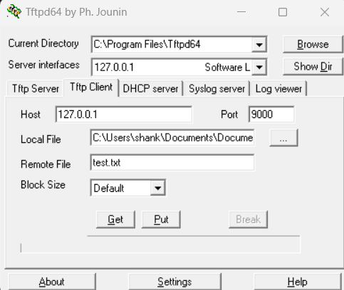
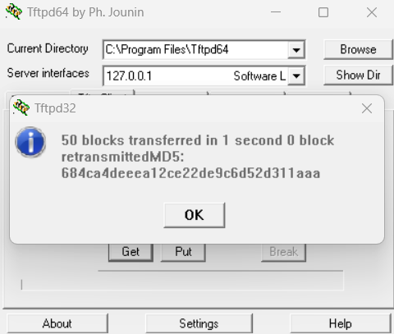
Before File Transfer After File Transfer

Before File Transfer
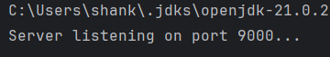
After File Transfer – Start of the output from the server.
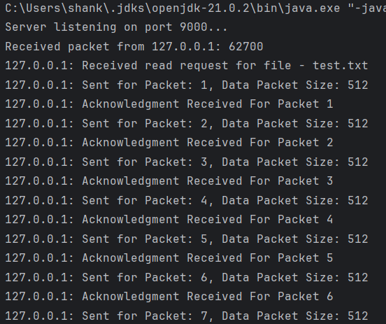
After File Transfer – End of the output from the server.
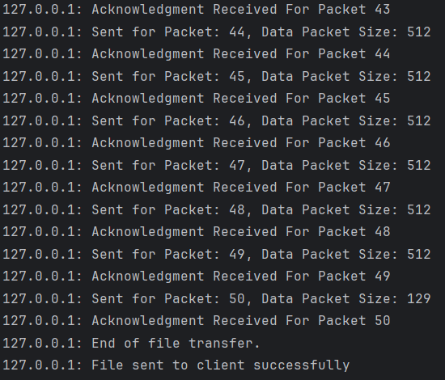

As you can see from the outputs, they work perfectly due to the fact that they both say block number 50 at the end before the file transfer is finished. Now let’s check the file to see if the file has been sent correctly to double-check.
Top of the test.txt (File that was Transfer)
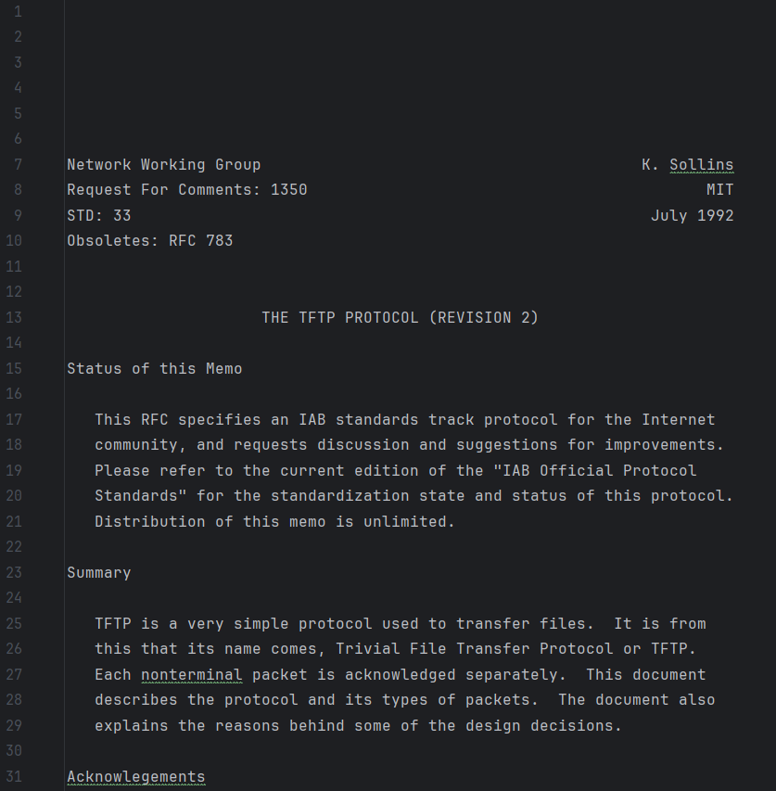

Bottom of the test.txt (File that was Transfer)
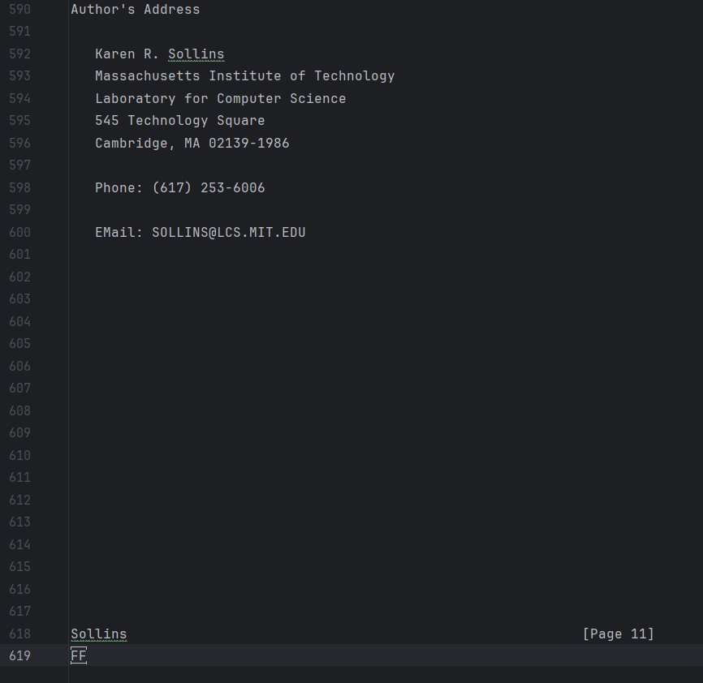

From the pictures above, you can see that the file transfer for indeed successful, and the file has been saved under the current directory to make it easier to test and check the file transfer. Furthermore, I have compared the number of lines to ensure no data was lost and I can confirm that it’s the same, so no data was lost.

Third-Party Client sends a File to my TFTP Server:
To send a file to the server, we use PUT to send the file. The Local file directory is the file I’m sending (in our case, test.txt), and the Remote file is where I store it on the server. But before we do this, let’s make sure to delete the file from the server to ensure that the client is actually sending the file rather than it existing from the previous test (GET).

Tftp64:
Before File Transfer After File Transfer

Before File Transfer After File Transfer
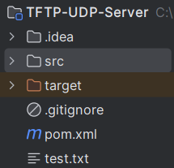
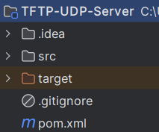

Before File Transfer

After File Transfer – Start of the output from the server.
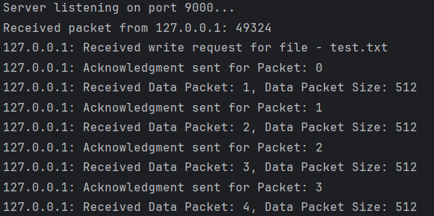
After File Transfer – End of the output from the server.
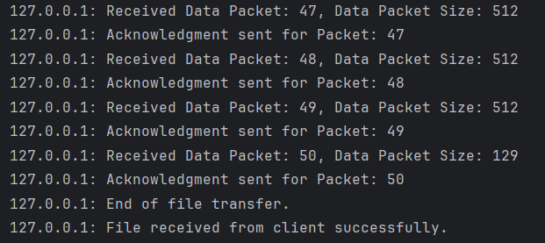

As you can see from the outputs, they work perfectly due to the fact that they both say block number 50 at the end before the file transfer is finished. Now let’s check the file to see if the file has been sent correctly to double-check.

Top of the test.txt (File that was Transfer)

Bottom of the test.txt (File that was Transfer)

From the pictures above, you can see that the file transfer for indeed successful, and the file has been saved under the current directory to make it easier to test and check the file transfer. Furthermore, I have compared the number of lines to ensure no data was lost and I can confirm that it’s the same, so no data was lost.

My Client retrieves a File from the Third-Party TFTP Server:
The Third-Party TFTP Server runs locally on port 69 so I had to change my port from 9000 to 69. In the screenshots below, I have ensured that the packets sent and received are traceable so it’s easier to understand. Additionally, the client should be on octet mode for this file transfer to work. To retrieve a file to the server, we can use the simple console-based menu I have created with my client. I ensured that the current director is the one that contains the file so I set it to the project folder (current directory as the requirement says) as it contains ‘test.txt’.

Tftp64:
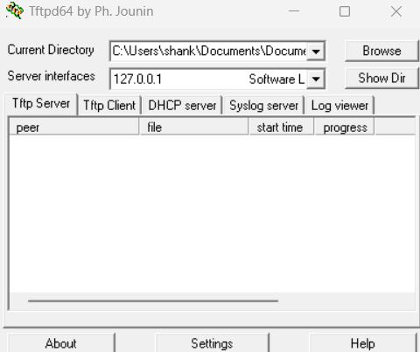
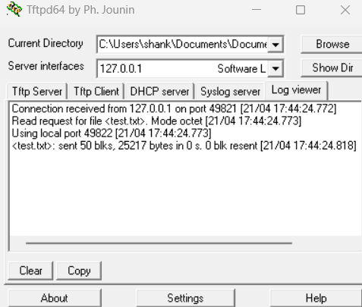
Before File Transfer After File Transfer

Before File Transfer After File Transfer
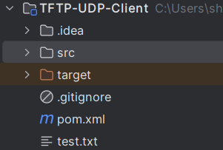
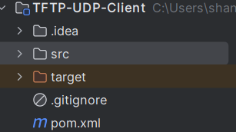

Console-Base Menu
After File Transfer – Start of the output from the client.
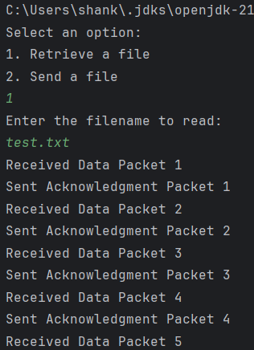

After File Transfer – End of the output from the client.
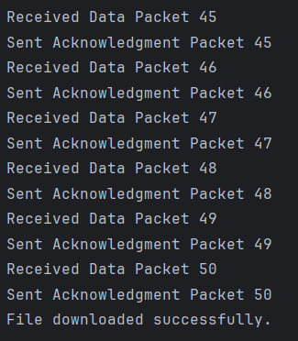

As you can see from the outputs, they work perfectly due to the fact that they both say block number 50 at the end before the file transfer is finished. Another way we know it’s correct is that we got 50 when we tested for my TFTP Server above. Now let’s check the file to see if the file has been sent correctly to double-check.

Top of the test.txt (File that was Transfer)

Bottom of the test.txt (File that was Transfer)

From the pictures above, you can see that the file transfer for indeed successful, and the file has been saved under the current directory to make it easier to test and check the file transfer. Furthermore, I have compared the number of lines to ensure no data was lost and I can confirm that it’s the same, so no data was lost.

My Client sending a File to the Third-Party TFTP Server:
To send a file to the TFTP Server, we can use the simple console-based menu I have created with my client. Before we do the test for this, let’s make sure to delete the file from the server to ensure that the client is actually sending the file rather than it existing from the previous test. Once again, the test.txt file will be used.
Before File Transfer After File Transfer
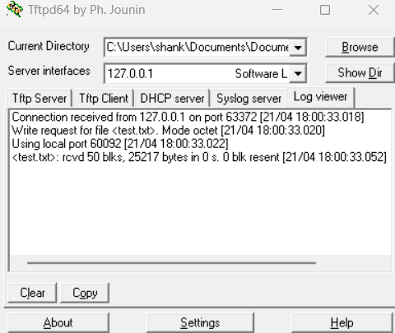
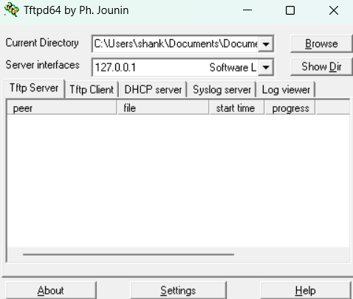

Directory Before File Transfer Directory After File Transfer
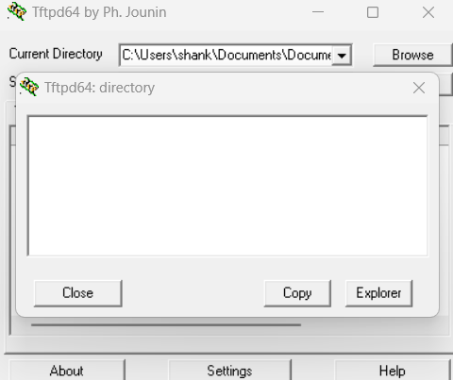
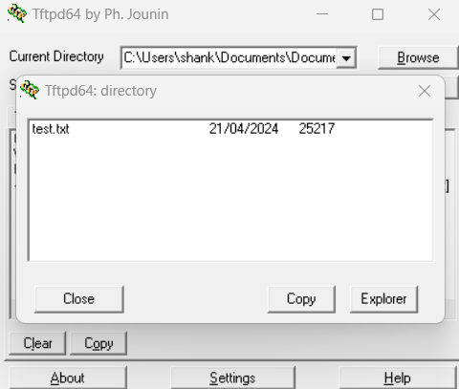

Console-Base Menu
After File Transfer – Start of the output from the client.
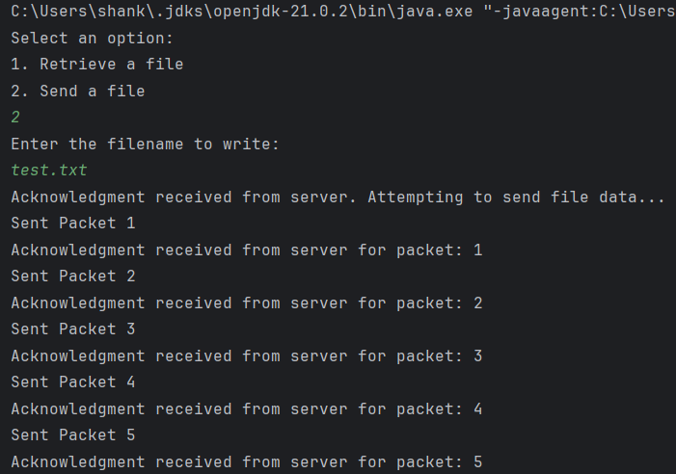
After File Transfer – End of the output from the client.
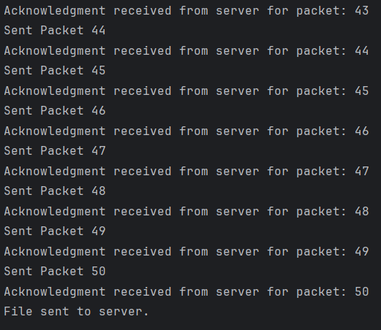

Top of the test.txt (File that was Transfer)

Bottom of the test.txt (File that was Transfer)
From the pictures above, you can see that the file transfer for indeed successful, and the file has been saved under the current directory to make it easier to test and check the file transfer. Furthermore, I have compared the number of lines to ensure no data was lost and I can confirm that it’s the same, so no data was lost.

