TASK:1
Implementation of Graph search algorithms (Breadth first search and Depth First Search)
using following constraints.
Aim: To Implement of Graph search algorithms (Breadth first search and Depth
First Search) using Python.
Task 1A
Algorithm:
BFS
Step 1: Start by putting any one of the graph’s vertices at the back of the queue.
Step 2: Now take the front item of the queue and add it to the visited list.
Step 3: Create a list of that vertex's adjacent nodes. Add those which are not within the
visited list to the rear of the queue.
Step 4: Keep continuing steps two and three till the queue is empty.
Program
from collections import deque
def bfs(graph, start):
queue, visited = deque([start]), set()
print("BFS:", end=" ")
while queue:
node = queue.popleft()
if node not in visited:
print(node, end=" ")
visited.add(node)
queue.extend(neighbor for neighbor in graph[node] if neighbor not in visited)
print()
# Example graph:
Graph = {
1: [2, 3],
2: [4, 5],
3: [6],
4: [],
5: [],
6: []
}
bfs(graph, 1)
Output:
BFS: 1 2 3 4 5 6
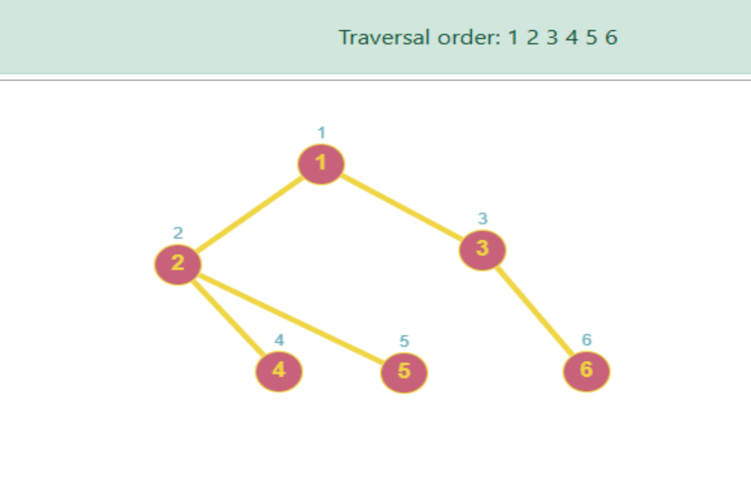

Task1 b
Algorithm DFS –
Step 1: Declare a queue and insert the starting Vertex.
Step 2: Initialize a visited array and mark the starting Vertex as visited.
Step3: Remove the First vertex of queue.
Step 4: Mark that vertex as visited
Step 5: Insert all the unvisited neighbors of the vertex into queue.
Step 6: stop.
Program
from collections import deque
def dfs(graph, start):
stack, visited = [start], set()
print("DFS:", end=" ")
while stack:
node = stack.pop()
if node not in visited:
print(node, end=" ")
visited.add(node)
stack.extend(reversed([neighbor for neighbor in graph[node] if neighbor not in visited]))
print()
# Example graph
graph = {
1: [2, 3],
2: [4, 5],
3: [6],
4: [],
5: [],
6: []
}
dfs(graph, 1)
Output:
DFS: 1 2 4 5 3 6
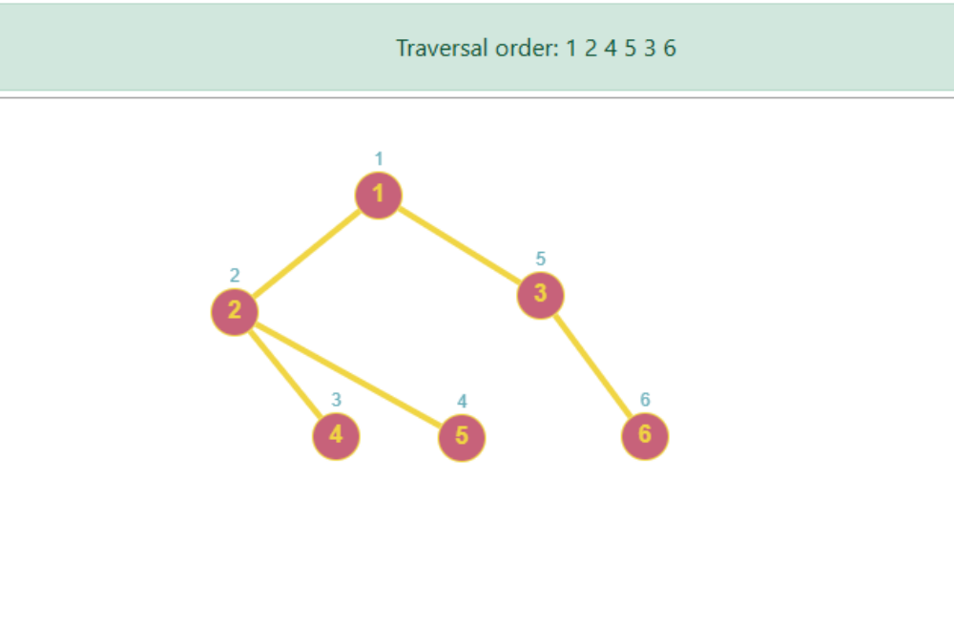

Result:
Thus the Implementation of Graph search algorithms (Breadth first search and Depth First
Search) using Python was successfully executed and output was verified.

