TASK:6

Solve a Map Coloring problem using constraint satisfaction approach by applying following constraints
Aim: To Solve a Map Coloring problem using constraint satisfaction approach using Graphonline and visualago online simulator.

Algorithm:
Step 1: Confirm whether it is valid to color the current vertex worth the current color (by checking whether any of its adjacent vertices are colored with the same color)
Step 2: If yes then color it and otherwise try a different color
Step 3: check if all vertices are colored or not
Step 4: If not then move to the next adjacent uncolored vertex
Step 5: Here backtracking means to stop further recursive calls on adjacent vertices.

Program:

class Graph:
def __init__(self, vertices):
self.v = vertices
self.graph = [[0 for column in range(vertices)] for row in range(vertices)]

# A utility function to check if the current color assignment is safe for vertex v
def is_safe(self, v, color, c):
for i in range(self.v):
if self.graph[v][i] == 1 and color[i] == c:
return False
return True

# A recursive utility function to solve m-coloring problem
def graph_color_util(self, m, color, v):
if v == self.v:
return True
for c in range(1, m+1):
if self.is_safe(v, color, c):
color[v] = c
if self.graph_color_util(m, color, v+1):
return True
color[v] = 0
return False

def graph_coloring(self, m):
color = [0] * self.v
if not self.graph_color_util(m, color, 0):
print("Solution does not exist with", m, "colors")
return False

print("Solution exists and following are the assigned colors:")
for c in color:
print(c, end=" ")
print()
return True

# Driver Code
if __name__ == '__main__':
# Example: Graph with 5 vertices (pentagon)
g = Graph(5)

g.graph = [
[0, 1, 0, 0, 1], # Vertex 0 connected to 1,4
[1, 0, 1, 0, 0], # Vertex 1 connected to 0,2
[0, 1, 0, 1, 0], # Vertex 2 connected to 1,3
[0, 0, 1, 0, 1], # Vertex 3 connected to 2,4
[1, 0, 0, 1, 0] # Vertex 4 connected to 0,3
]

m = 3 # number of colors
g.graph_coloring(m)
Output:

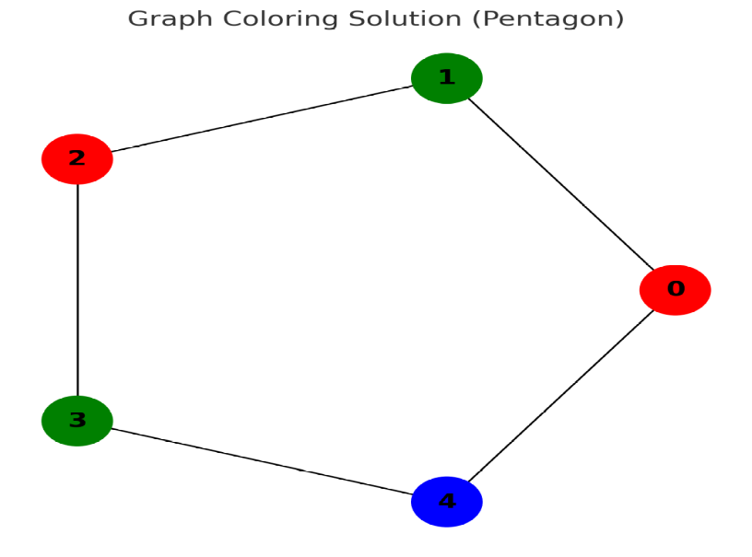

Result:
Thus Solving a Map Coloring problem using constraint satisfaction approach using Graphonline and visulago online simulator was successfully executed and output was verified.

