|  |  |  |
| --- | --- | --- |
| G:\nsu-logo.png  **North South University**  Department of Electrical & Computer Engineering    **LAB REPORT**  Course Name:CSE332L  Experiment Number: **06**     |  | | --- | | Experiment Name: **Design of an ALU.** |   Experiment Date: 28/04/2021  Report Submission Date: 05/05/2021  Faculty: SFM  Submitted to: Md Saidur Rahman  Section: 06 | |
| Student Name: **Koushik Banerjee** | Score |
| Student ID: **1812171642** |  |
| Remarks: |

**Title: Lab 06– Design of an ALU.**

**Objective:**

We will have the following objectives to fulfill:

1) Build 1-bit ALU with a specific set of instructions

2) Incorporate equality check (zero signal), overflow detection, and other necessary flags

3) Build 12-bit ALU by connecting 12 one-bit ALU**.**

**Logic Circuit Diagram:**

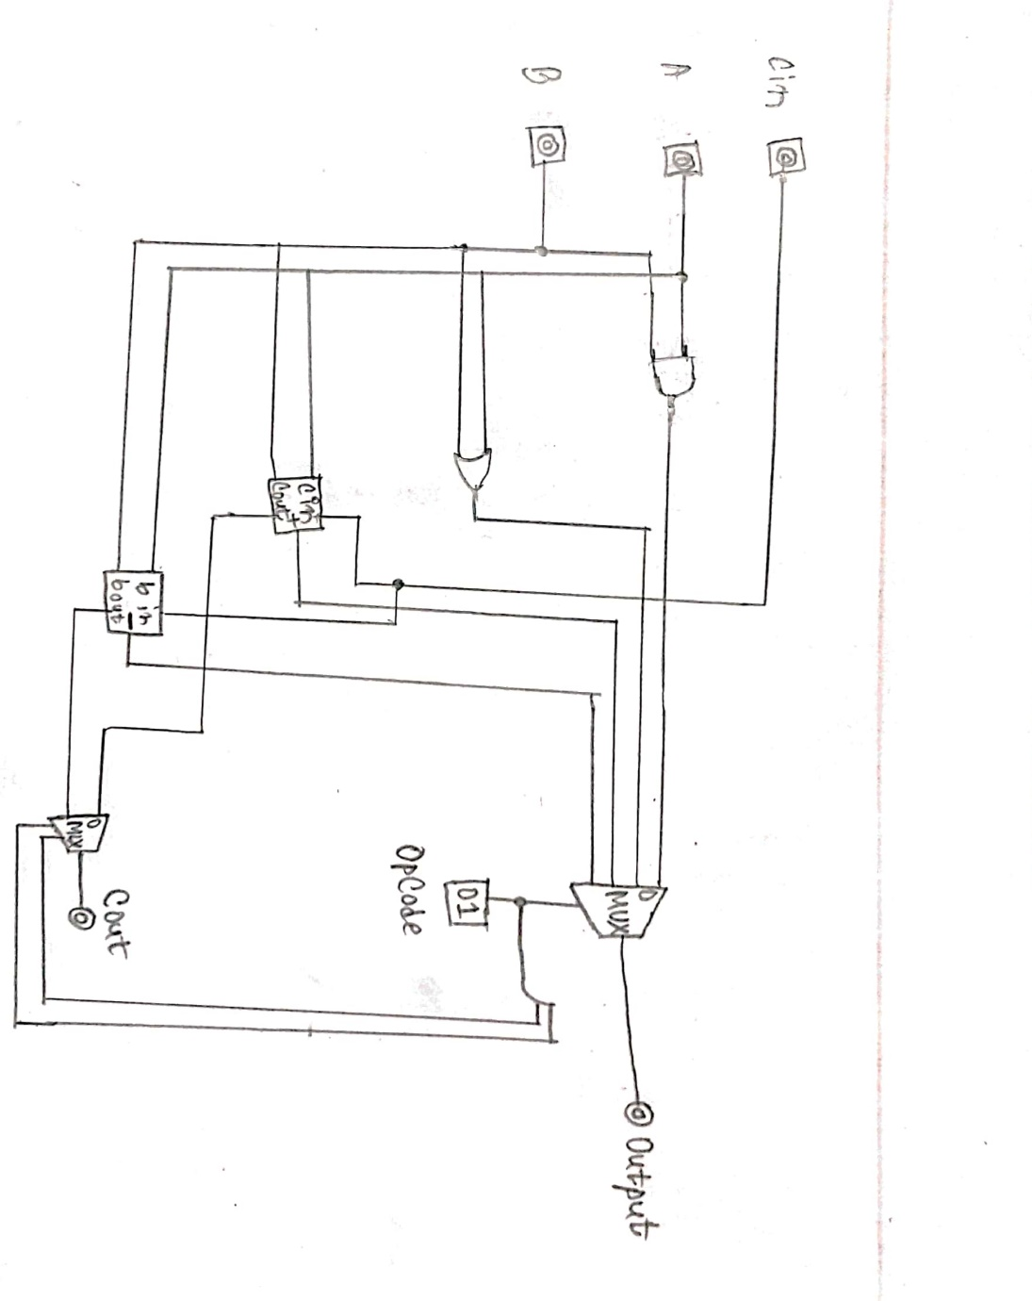

**Logisim works screenshot(s):**

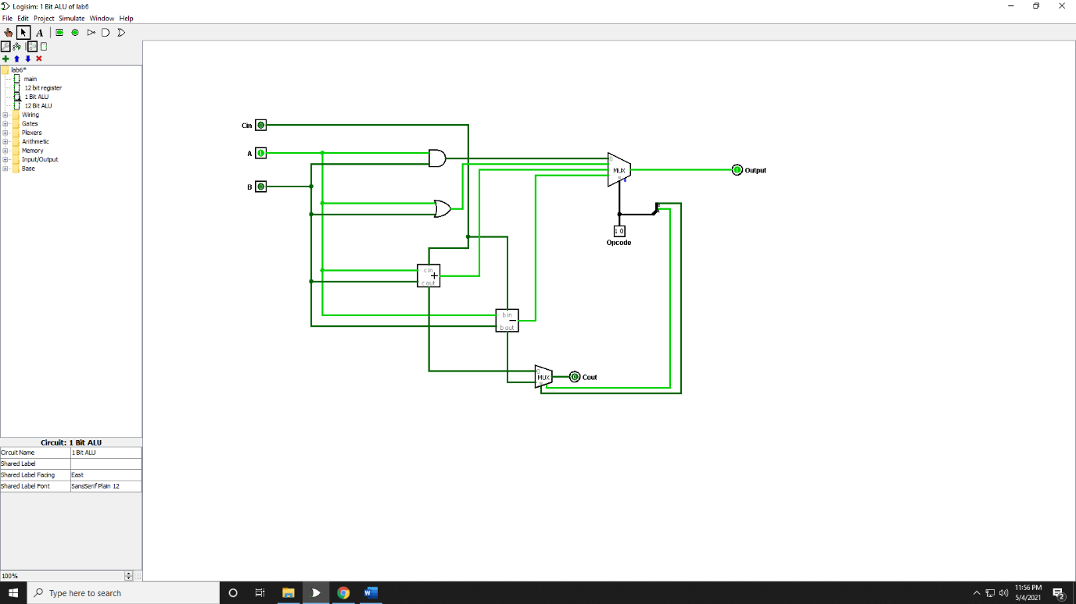

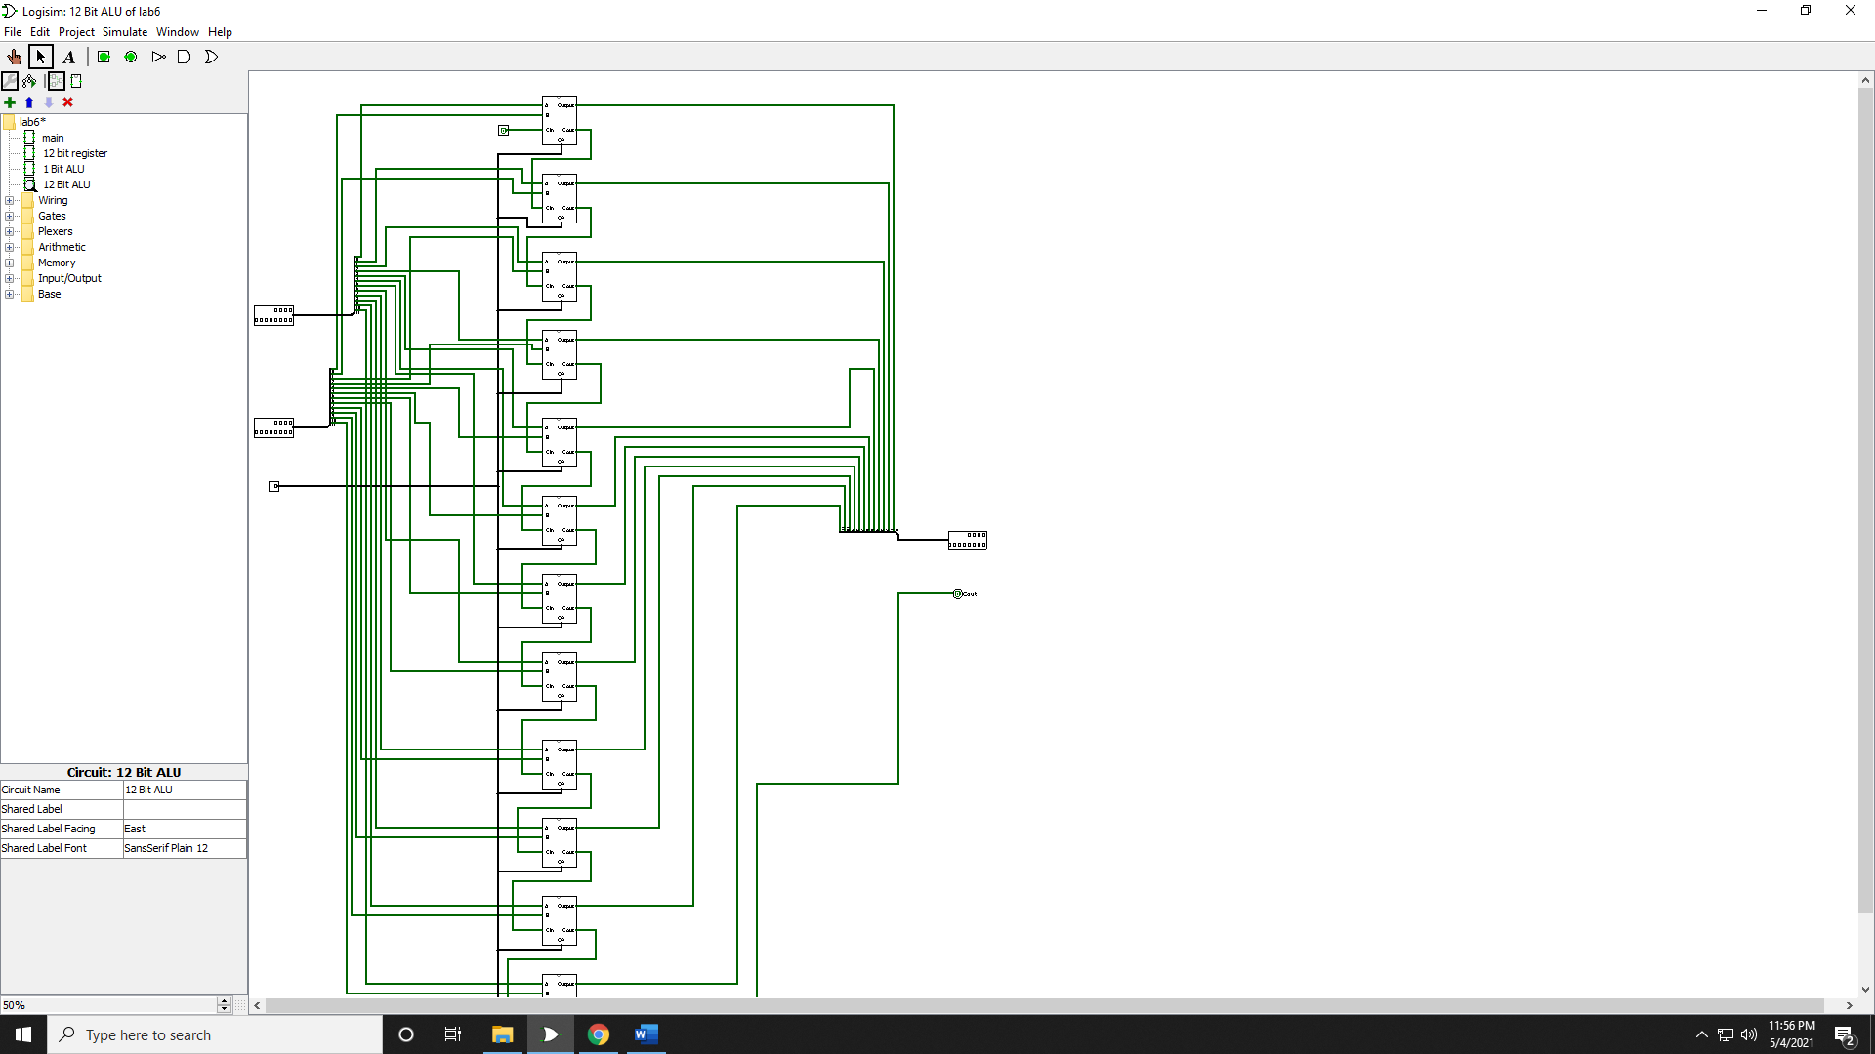

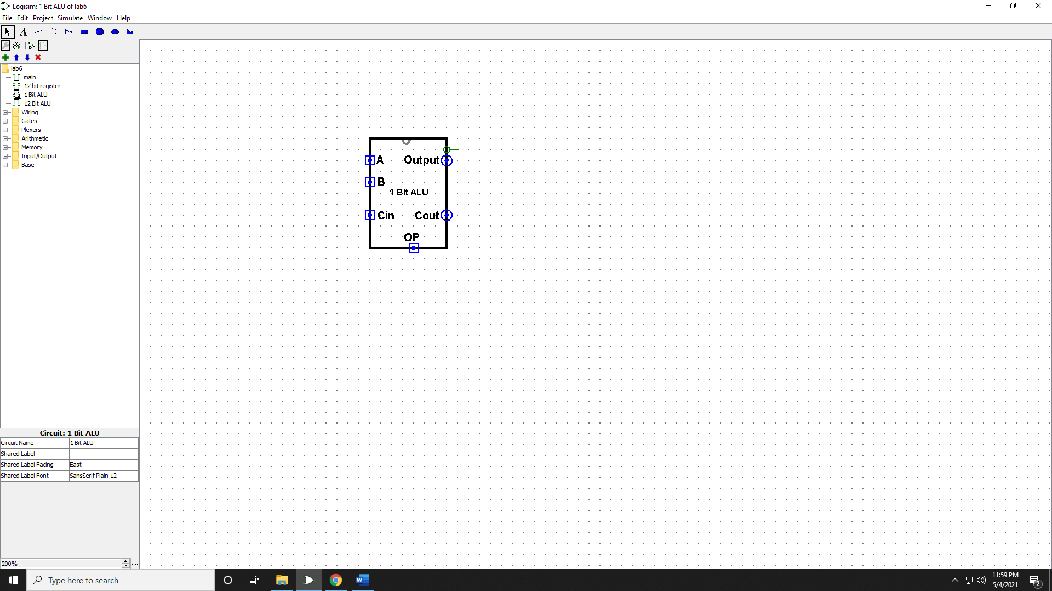

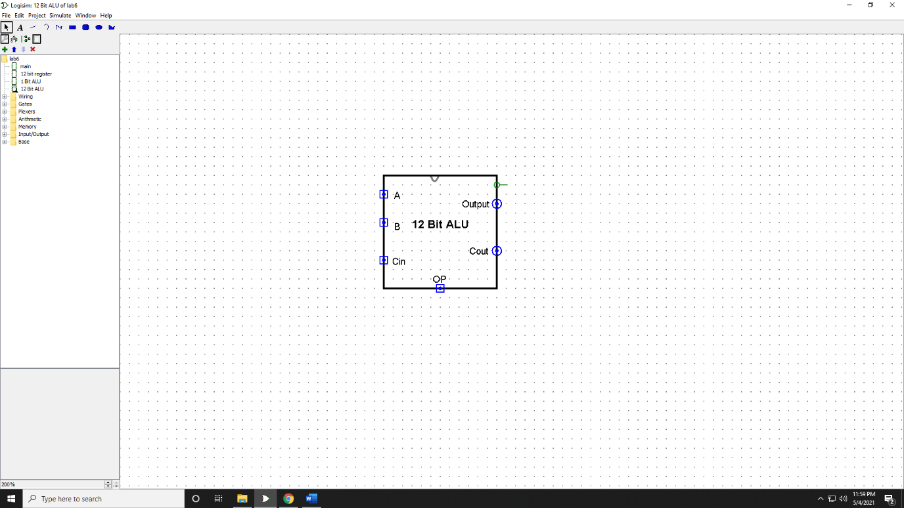

**Discussion:**

In lab 6, I learn how to design an ALU. The essential objective of this exploration is to plan a 1-bit ALU with particular information and plan a 12-bit ALU by interfacing 12 one-bit ALU. In this test, I’ve created a 12-bit ALU by utilizing the Logisim device. Firstly, I have planned a 1bit ALU utilizing 1 AND gate,1 OR door, 1x1 bit adder,1x1 bit subtractor. The yield of these four has passed through a 4x1 bit Mux. The yield of the MUX specifically goes to the result segment. Within the Mux, there's a 2-bit choice for ALU opcode that must be changed whereas performing the rationale operation. For Controlling that portion, we utilized one more mux 2x1. A and B are the two inputs that are given by the client. There's C-in that has to be associated with adder’s and sub tractor’s C-in. Within the moment portion, I have created a 12-bit ALU by utilizing 12 one-bit ALU. In this area, the inputs are A and B. Both of them comprise 12 bits. So also, each bit ALU takes inputs from A and B. the yield is associated with the result.