|  |  |  |
| --- | --- | --- |
| G:\nsu-logo.png  **North South University**  Department of Electrical & Computer Engineering    **LAB REPORT**  Course Name:CSE332L  Experiment Number: 01     |  | | --- | | Experiment Name: Design of a 2-bit logic unit. |   Experiment Date: 03/03/2021  Report Submission Date: 10/03/2021  Faculty: SFM  Submitted to: Md Saidur RRahman  Section: 06 | |
| Student Name: **Koushik Banerjee** | Score |
| Student ID: **1812171642** |  |
| Remarks: |

**Objectives:**

In this experiment, we are going to construct a 2-bit logic unit which is a part of an arithmetic logic unit (ALU). This logic unit will have 4 micro-operations which are AND, OR, XOR, and NOT operations. They can be used to change bit values, delete a group of bits or insert a new set of bits in a register. Logic micro-operations are very useful for manipulating individual bits or a portion of a word stored in a register. As we are going to design a 2-bit logic unit, we will have two outputs which are one output for each of the 2 bits.

**Apparatus:**

* Trainer board
* IC 7404,7408,7432,7486, 74F153 Wires for connection.

**Circuit Diagram:**

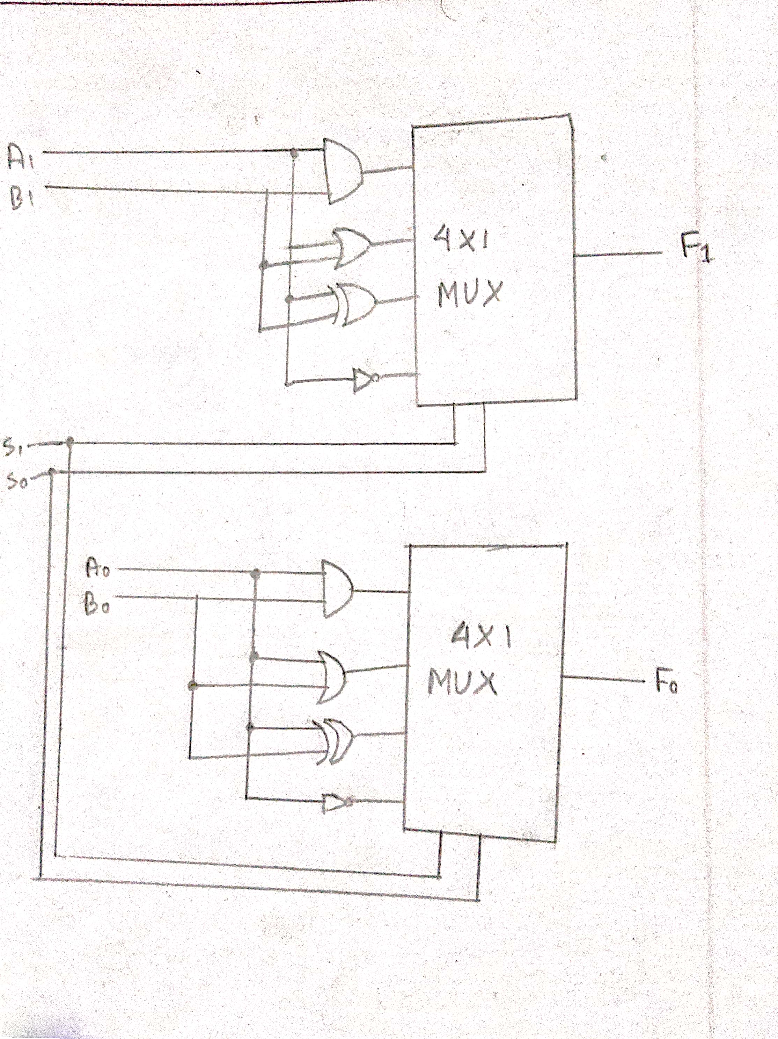

**Logic Table:**

|  |  |  |  |  |  |  |  |  |  |  |  |
| --- | --- | --- | --- | --- | --- | --- | --- | --- | --- | --- | --- |
| A1 | A0 | B1 | B0 | AND1 | AND0 | OR1 | OR0 | XOR1 | XOR0 | NOT  A1 | NOT  A0 |
| 0 | 0 | 0 | 0 | 0 | 0 | 0 | 0 | 0 | 0 | 1 | 1 |
| 0 | 0 | 0 | 1 | 0 | 0 | 0 | 1 | 0 | 1 | 1 | 1 |
| 0 | 0 | 1 | 0 | 0 | 0 | 1 | 0 | 1 | 0 | 1 | 1 |
| 0 | 0 | 1 | 1 | 0 | 0 | 1 | 1 | 1 | 1 | 1 | 1 |
| 0 | 1 | 0 | 0 | 0 | 0 | 0 | 1 | 0 | 1 | 1 | 0 |
| 0 | 1 | 0 | 1 | 0 | 1 | 0 | 1 | 0 | 0 | 1 | 0 |
| 0 | 1 | 1 | 0 | 0 | 0 | 1 | 1 | 1 | 1 | 1 | 0 |
| 0 | 1 | 1 | 1 | 0 | 1 | 1 | 1 | 1 | 0 | 1 | 0 |
| 1 | 0 | 0 | 0 | 0 | 0 | 1 | 0 | 1 | 0 | 0 | 1 |
| 1 | 0 | 0 | 1 | 0 | 0 | 1 | 1 | 1 | 1 | 0 | 1 |
| 1 | 0 | 1 | 0 | 1 | 0 | 1 | 0 | 0 | 0 | 0 | 1 |
| 1 | 0 | 1 | 1 | 1 | 0 | 1 | 1 | 0 | 1 | 0 | 1 |
| 1 | 1 | 0 | 0 | 0 | 0 | 1 | 1 | 1 | 1 | 0 | 0 |
| 1 | 1 | 0 | 1 | 0 | 1 | 1 | 1 | 1 | 0 | 0 | 0 |
| 1 | 1 | 1 | 0 | 1 | 0 | 1 | 1 | 0 | 1 | 0 | 0 |
| 1 | 1 | 1 | 1 | 1 | 1 | 1 | 1 | 0 | 0 | 0 | 0 |

**Instruction:**

1) Place the ICs on the trainer board.

2) Connect Vcc and ground to the respective pins of IC.

3) Connect the inputs with the switches and the outputs with LEDs.

4) Apply various combinations of inputs and observe the outputs.

5) Verify the experimental outputs with the Truth Table.

**Pin configuration of ICs:**

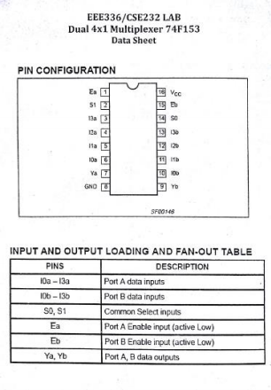

**Logisim works screenshot(s) :**

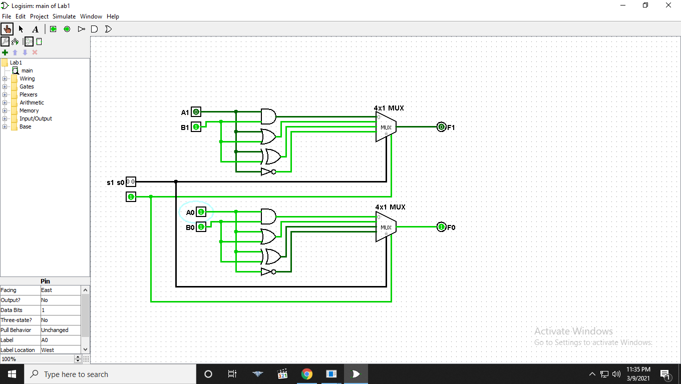

**Discussion:**

In lab 1 and in the lab class I face some problem doing the 4x1 MUX. I had done mistake, in min terms but I solve that by following the equation. There are 4 input, two select line, an enable key. Every component in the circuit is 2 bit. But this lab was pretty simple. It took some time but finally I found out where the problem was and fix IC circuit and then solved it properly. By the help of our class lab instructor I fix that problem also. That was all human e error problem. After understanding all the problem and practicing that problem, I answered all the questions.