|  |  |  |
| --- | --- | --- |
| G:\nsu-logo.png  **North South University**  Department of Electrical & Computer Engineering    **LAB REPORT**  Course Name:CSE332L  Experiment Number: 02     |  | | --- | | Experiment Name: Design of a 2-bit Arithmetic unit |   Experiment Date: 10/03/2021  Report Submission Date: 17/03/2021  Faculty: SFM  Submitted to: Md Saidur RRahman  Section: 06 | |
| Student Name: **Koushik Banerjee** | Score |
| Student ID: **1812171642** |  |
| Remarks: |

**Objectives:**

In this experiment, we will construct a 2-bit arithmetic unit which is a part of an arithmetic logic unit (ALU). arithmetic logic unit (ALU). The arithmetic unit will be used to add and subtract two 2 bit inputs, A and B, as well as increment, decrement, or transfer any of the inputs. reinforce our experience in designing and implementing combinational logic circuits, gain experience in abstraction at the hardware level and assemble larger wholes from smaller parts, and develop expertise with Logisim, an educational software package for designing and simulating digital circuits.

**Types of equipment:**

* Trainer board

* IC 7404,7483, 74F153

* Wires for connection.

**Function Table:**

|  |  |  |  |  |  |  |  |  |  |  |
| --- | --- | --- | --- | --- | --- | --- | --- | --- | --- | --- |
| **S1** | **S0** | **Cin** | **A0** | **A1** | **B1** | **B0** | **D1** | **D0** | **Cout** | **Microoperation** |
| 0 | 0 | 0 | 0 | 0 | 0 | 1 | 0 | 1 | 0 | Add |
| 0 | 0 | 1 | 0 | 1 | 0 | 1 | 0 | 0 | 1 | Add with Carry |
| 0 | 1 | 0 | 1 | 0 | 0 | 0 | 0 | 1 | 1 | Subtract with Borrow |
| 0 | 1 | 1 | 1 | 0 | 1 | 1 | 1 | 0 | 0 | Subtract |
| 1 | 0 | 0 | 1 | 1 | 0 | 1 | 1 | 1 | 0 | Transfer A |
| 1 | 0 | 1 | 0 | 1 | 1 | 0 | 1 | 1 | 0 | Increment A |
| 1 | 1 | 0 | 1 | 1 | 0 | 0 | 1 | 0 | 1 | Decrement A |
| 1 | 1 | 1 | 0 | 1 | 0 | 0 | 1 | 0 | 1 | Transfer A |

**Logic Diagram:**

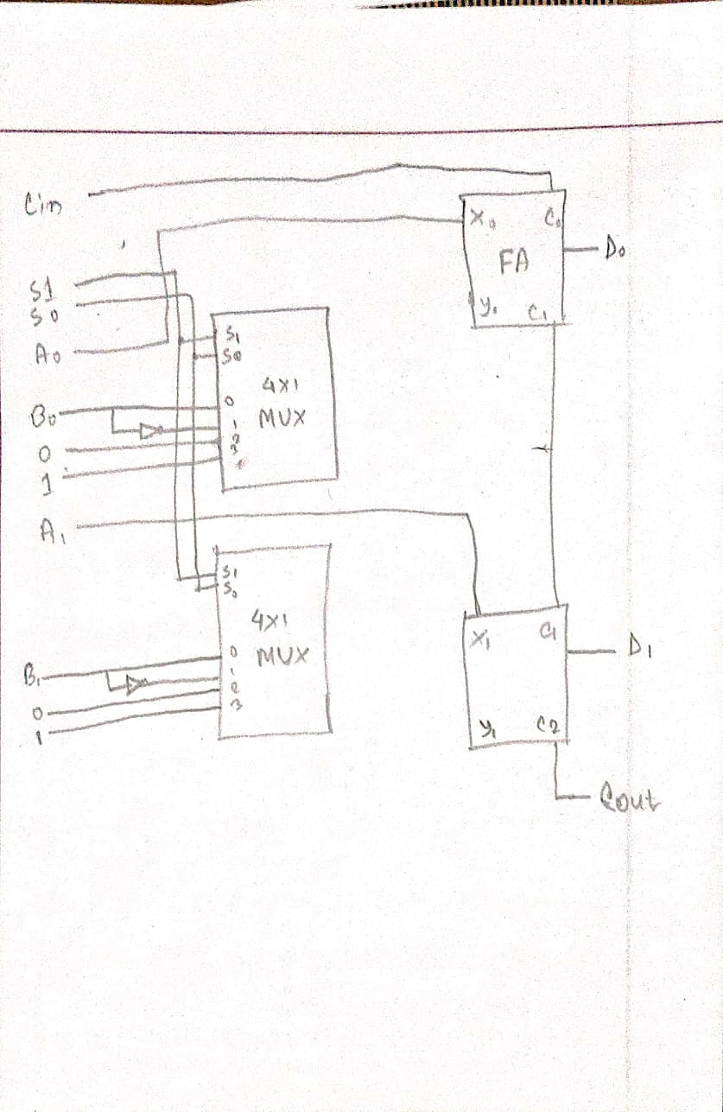

**Procedure:**

1. Place the ICs on the trainer board.
2. Connect Vcc and ground to the respective pins of IC.
3. Connect the inputs with the switches and the outputs with LEDs.
4. Apply various combinations of inputs and observe the outputs.
5. Verify the experimental outputs with the Function Table.

**Logisim works screenshot(s):**

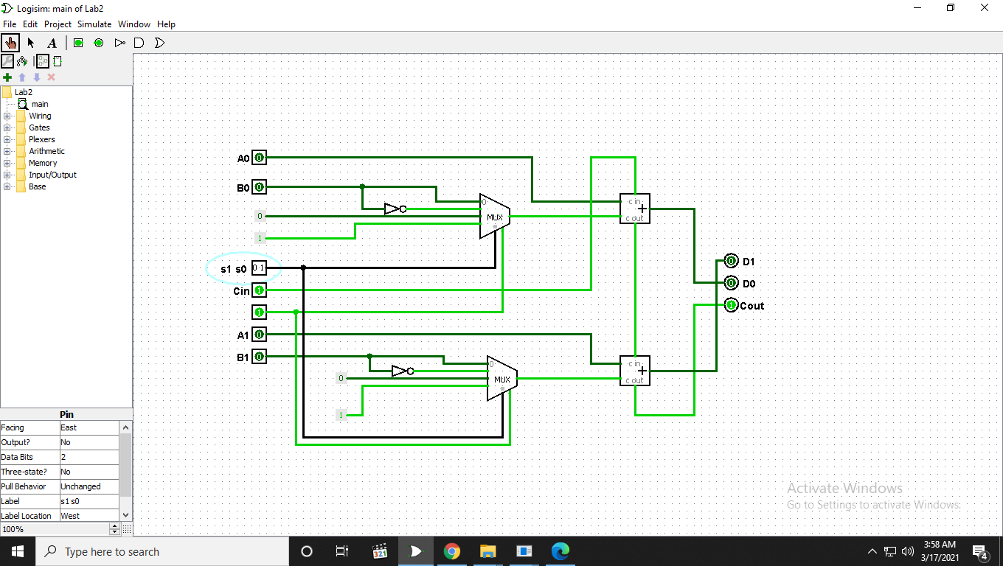

**Discussion:**

In lab 2, I construct a 2-bit arithmetic unit which is a part of an ALU. We had to run 8 different Arithmetic Operations in this experiment, Add, Add with carry, Subtract, Subtract with borrow, Increment, Decrement, Transfer. I had done mistake on Add with Carry but I solve that by following the equation. Every component in the circuit is 2 bit. But this lab was pretty simple. It took some time but finally I found out where the problem was and fix IC circuit and then solved it properly. By the help of our class lab instructor I fix that problem also.