|  |  |  |
| --- | --- | --- |
| G:\nsu-logo.png  **North South University**  Department of Electrical & Computer Engineering    **LAB REPORT**  Course Name:CSE332L  Experiment Number: **03**     |  | | --- | | Experiment Name: **Design of a 4-bit Universal Shift Register** |   Experiment Date: 22/03/2021  Report Submission Date: 17/03/2021  Faculty: SFM  Submitted to: Md Saidur Rahman  Section: 06 | |
| Student Name: **Koushik Banerjee** | Score |
| Student ID: **1812171642** |  |
| Remarks: |

**Title: Design of a 4-bit Universal Shift Register**

**Objectives:**

* Designing a Design of a 4-bit Universal Shift Register by using Logisim software.
* Learn how to work with Shift Register.

**Types of equipment:**

*Four D Flip Flops (Two 7474 ICs)

* Four 4X1 MUX (Two 74153 ICs)

* Trainer Board

* Wires

* Power Supply

**Function Table:**

|  |  |  |  |  |  |  |  |  |  |  |
| --- | --- | --- | --- | --- | --- | --- | --- | --- | --- | --- |
| S1 | S0 | Operation | I4 | I3 | I2 | I1 | A4 | A3 | A2 | A1 |
| 0 | 0 | No change | 0 | 1 | 1 | 0 | A4 | A3 | A2 | A1 |
| 0 | 1 | SHR | 1 | 1 | 0 | 0 | S1(R) | A4 | A3 | A2 |
| 1 | 0 | SHL | 1 | 1 | 0 | 0 | A3 | A2 | A1 | S1(L) |
| 1 | 1 | Parallel load | 1 | 1 | 0 | 0 | 1 | 1 | 0 | 0 |

**Logic Diagram:**

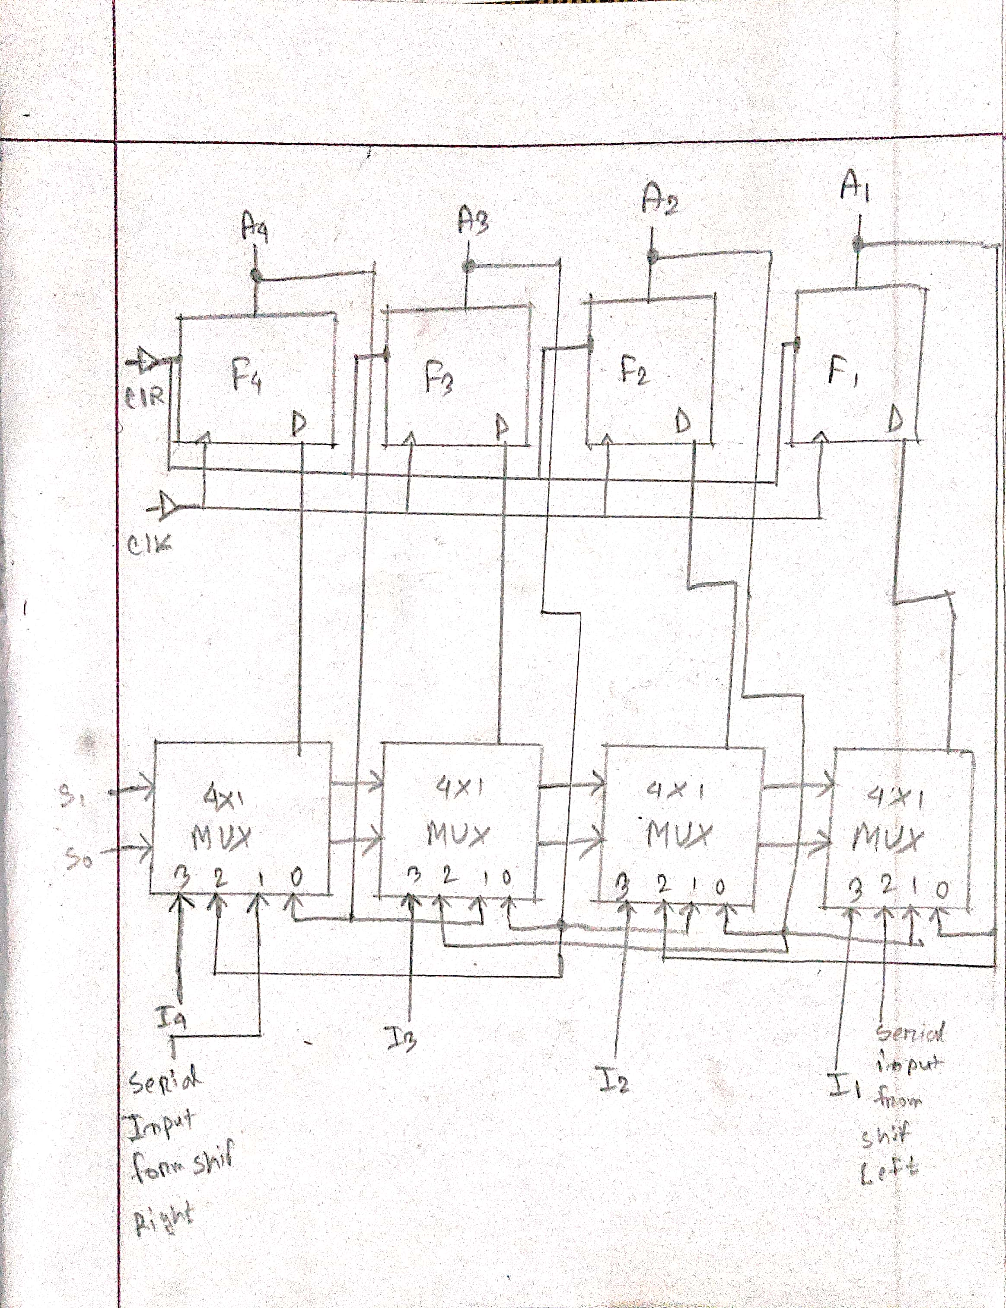

**Procedure:**

1) Place the ICs on the trainer board.

2) Connect Vcc and ground to the respective pins of IC.

3) Connect the inputs with the switches and the outputs (A1-A4) with LEDs.

4) Apply various combinations of inputs and observe the outputs.

5) Verify the experimental outputs with the Function Table.

**Logisim works screenshot(s):**

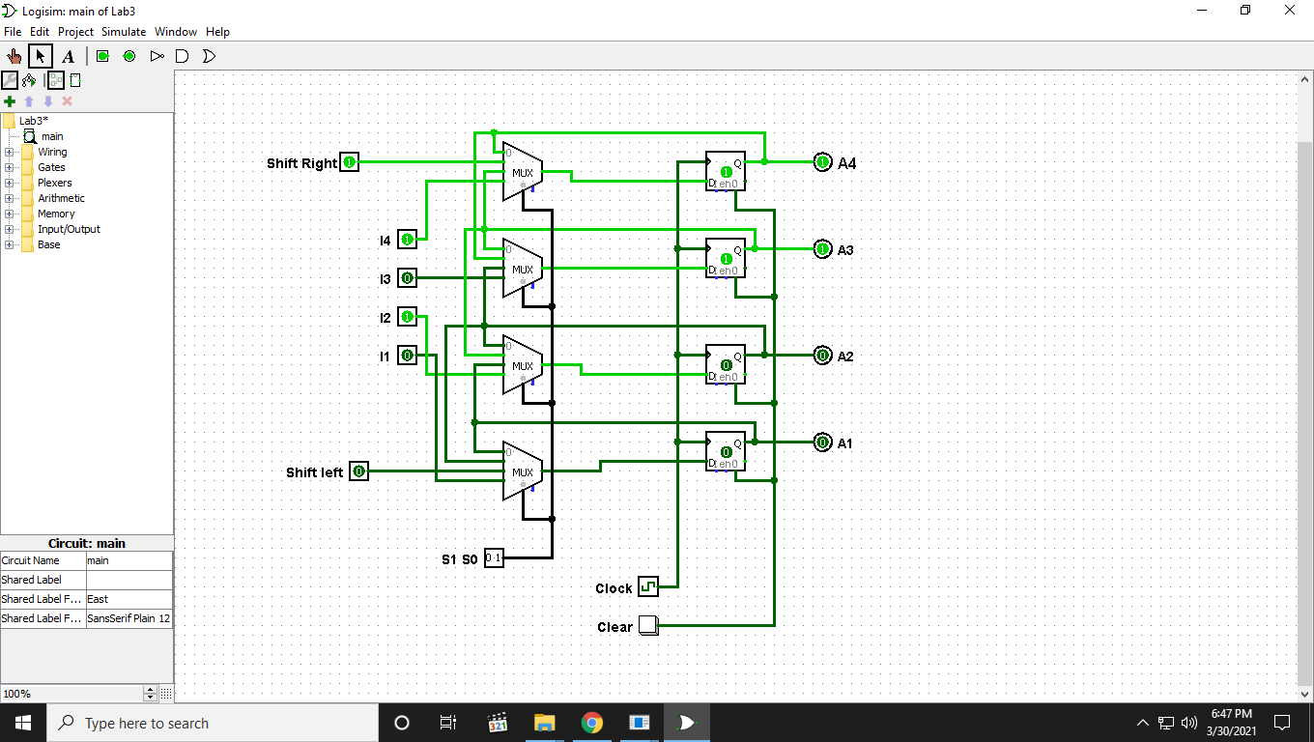

**Discussion:**

In lab 3, I construct a 4-bit Universal Shift Register. In Universal shift register there have an option to perform Shift Right when select bits are 01. When we do shift right it actually dividing by 2n. When we shift three times present bits are dividing by 23. For left shift the current bits are multiplying by 2n. If we shift left 3 times, it means current bits multiplying by 23. In this lab I face some theoretical problem. After understanding how this circuit works, I figure out how to do it. It took some time but finally I found out where the problem was fix the circuit and then solved it properly. By the help of our class lab instructor I fix that problem also.