**Install and Setup Metamask, Ganache, Nodejs, Visual Studio Build Tools, Truffle and Visual Studio Code in Windows Platform**

Table of Contents

**1)** **Download and install the “Metamask” Wallet as the extension of Chrome Browser** 3

a) Download the Metamask from the relevant website 3

b) Install the Metamask as an extension of Chrome Browser 3

c) Click on “GET CHROME EXTENSION” 4

d) Click on “Add to Chrome” 5

e) Click on “Add extension” 5

f) Click on “Get Started” 6

g) Click on “Create a Wallet” 6

h) Click on “No Thanks” 7

i) Enter the Password and store it safely for future use 7

j) Copy the “Secret Backup Phrase” and store it safely in a file 8

k) Confirm the “Secret Backup Phrase” 9

l) Click on “All Done” 10

m) Select the “Main Ethereum Network” option and verify the display of “Account 1” with “0 ETH” 10

**2)** **Download and install the latest version of “Ganache Ethereum Test Blockchain”** 11

a) Open the below “ganache” website and click on “DOWNLOAD (WINDOWS)” button 11

b) Install the Ganache Test Blockchain using down loaded .appx file 11

c) Launch the Ganache 12

**3)** **Create a network for “Ganache Test Blockchain” in the Metamask** 12

a) Open the Metamask and click on “Custom RPC” option 29

b) Enter the “New RPC URL” info and Click on “Save” button 29

c) Select the “http://127.0.0.1:7545 “as the network option 31

d) Click on the round symbol and select the “Import Account” option 32

e) Verify the display of the “Import Account” screen 33

f) Click on the key symbol of the first account of the Ganache Test Blockchain 33

g) Copy the “PRIVATE KEY” of the account 34

h) Paste the copied “PRIVATE KEY” on to the Metamask’s “Import Account” and click on the “Import” button 35

i) Verify that the 100 Ethers of the first account of Ganache is loaded into your “Metamask Wallet” 36

**4)** **Setting up of required Tools in the “c:/Users/Username/”directory in Windows Platform** 36

a) Download and install nodejs for Windows Platform 36

b) Verify the successful installation of “nodejs” and “npm” through Windows terminal (using “cmd” command) 37

c) Install Visual Studio Build Tools 38

d) Install Truffle through Windows terminal and verify its version after installation 39

e) Download and Install “Visual Studio code” editor and verify 39

# **Download and install the “Metamask” Wallet as the extension of Chrome Browser**

## Download the Metamask from the relevant website

<https://metamask.io/>

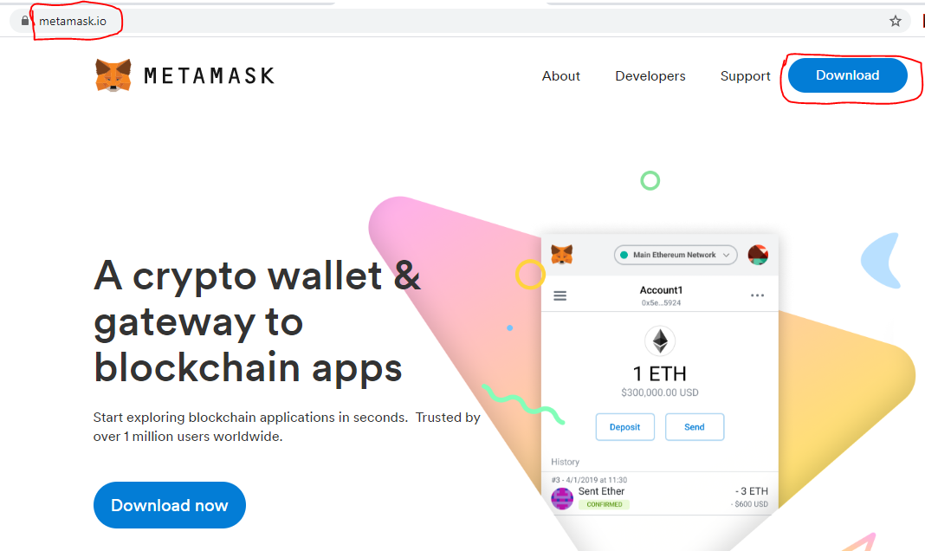

## Install the Metamask as an extension of Chrome Browser

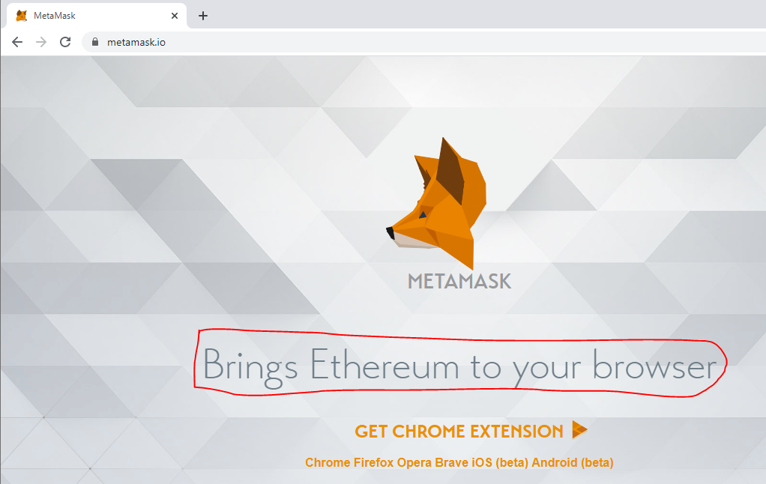

## Click on “GET CHROME EXTENSION”

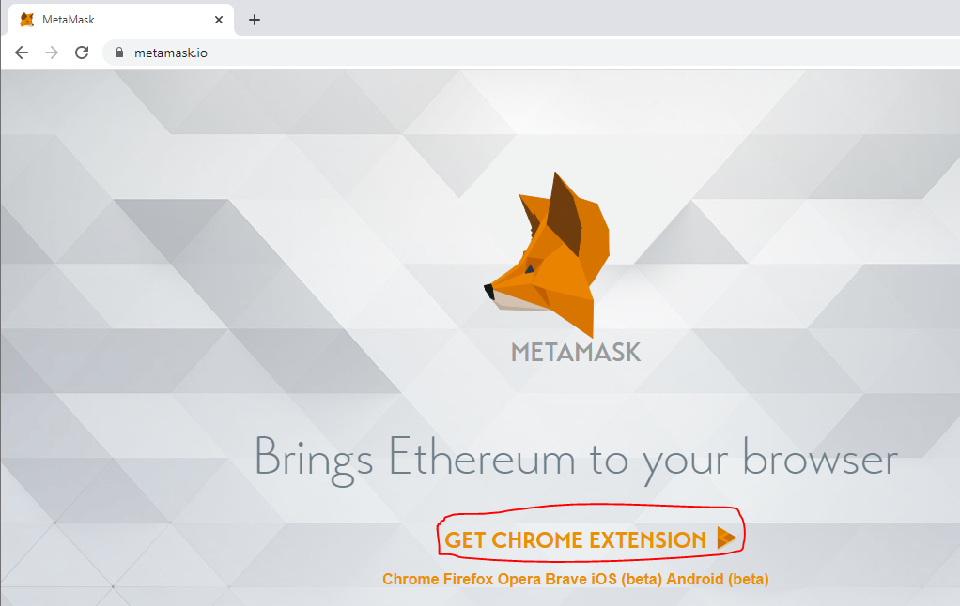

## Click on “Add to Chrome”

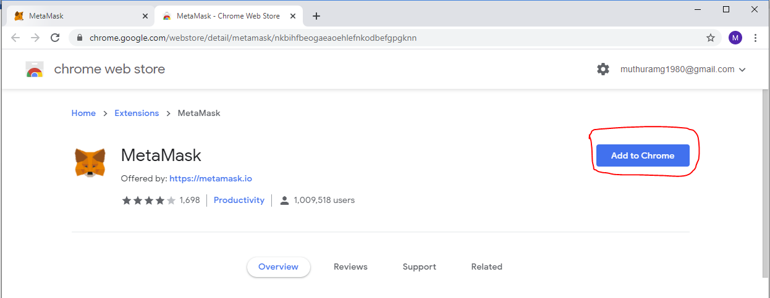

## Click on “Add extension”

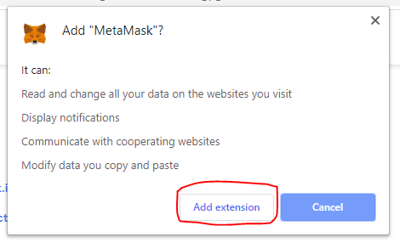

## Click on “Get Started”

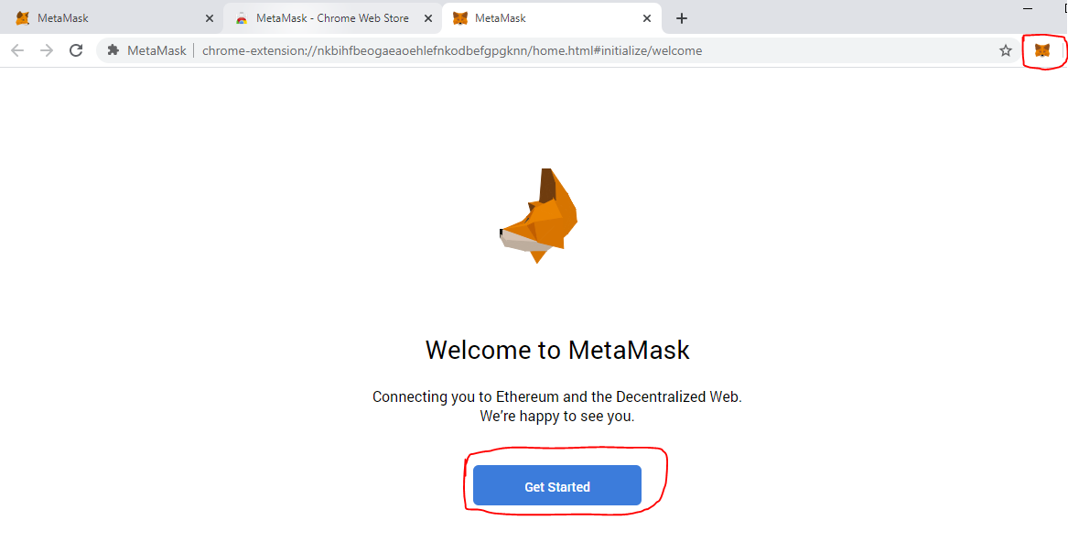

## Click on “Create a Wallet”

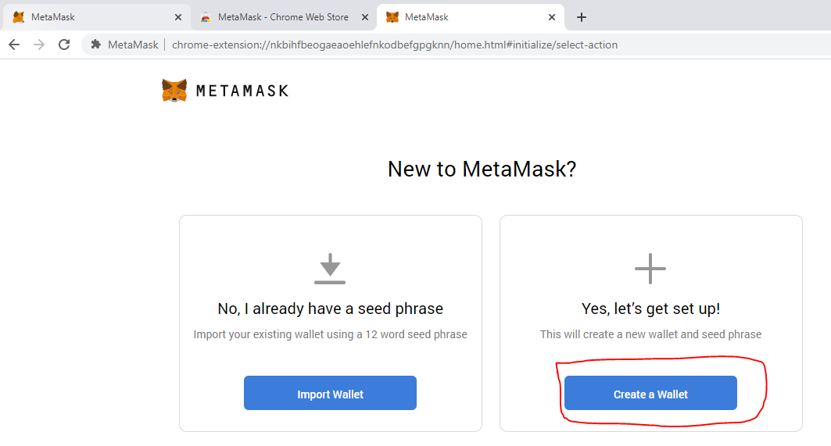

## Click on “No Thanks”

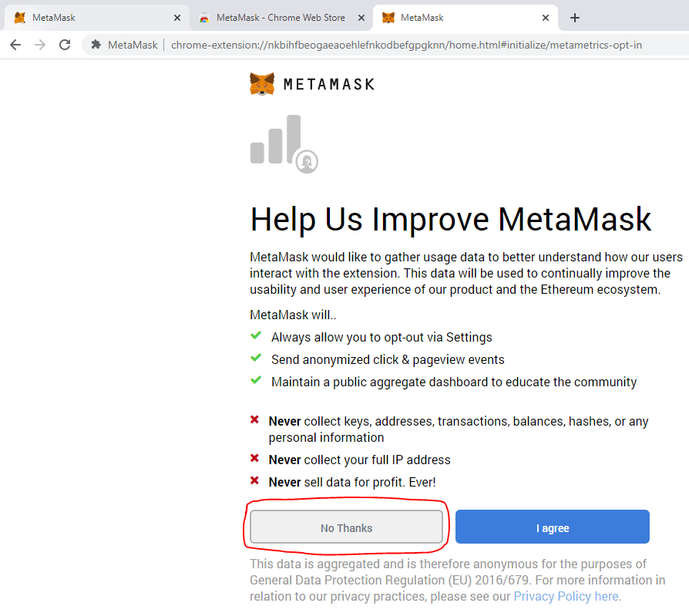

## Enter the Password and store it safely for future use

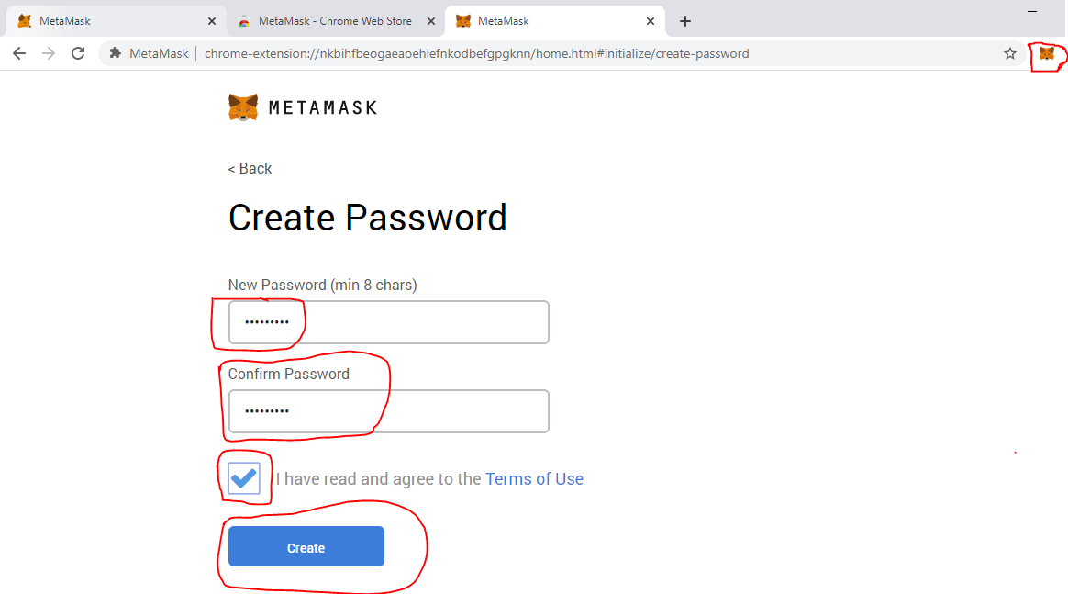

## Copy the “Secret Backup Phrase” and store it safely in a file

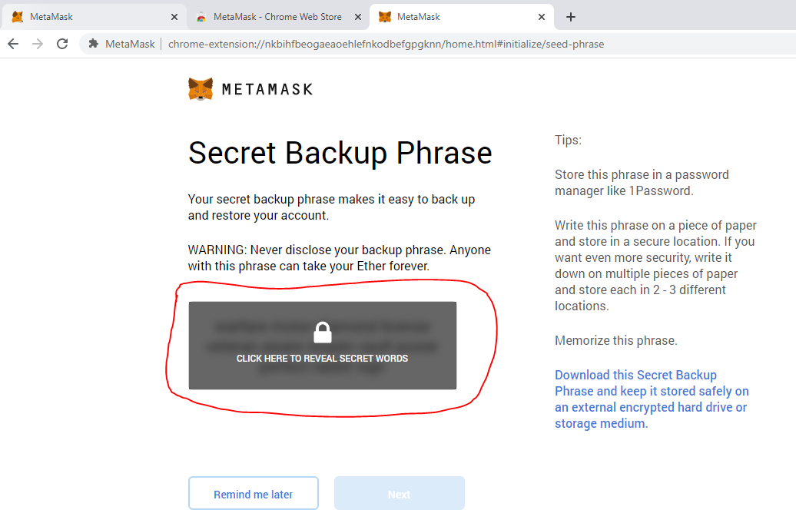

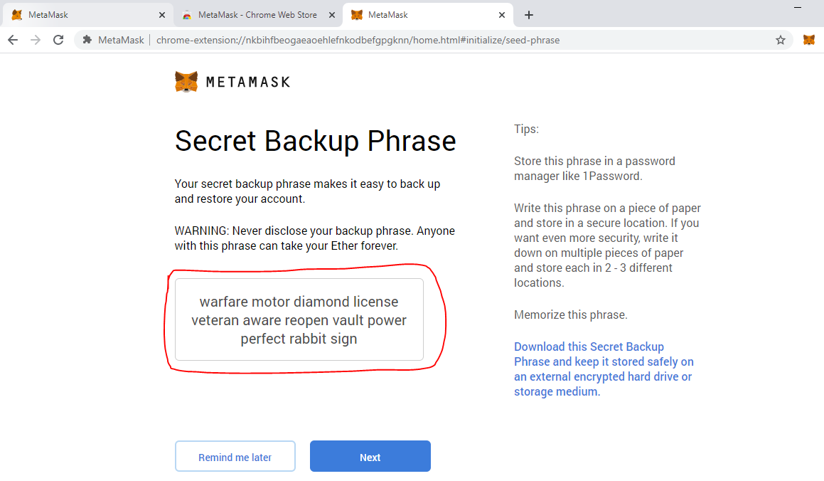

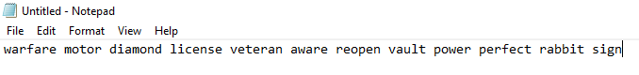

## Confirm the “Secret Backup Phrase”

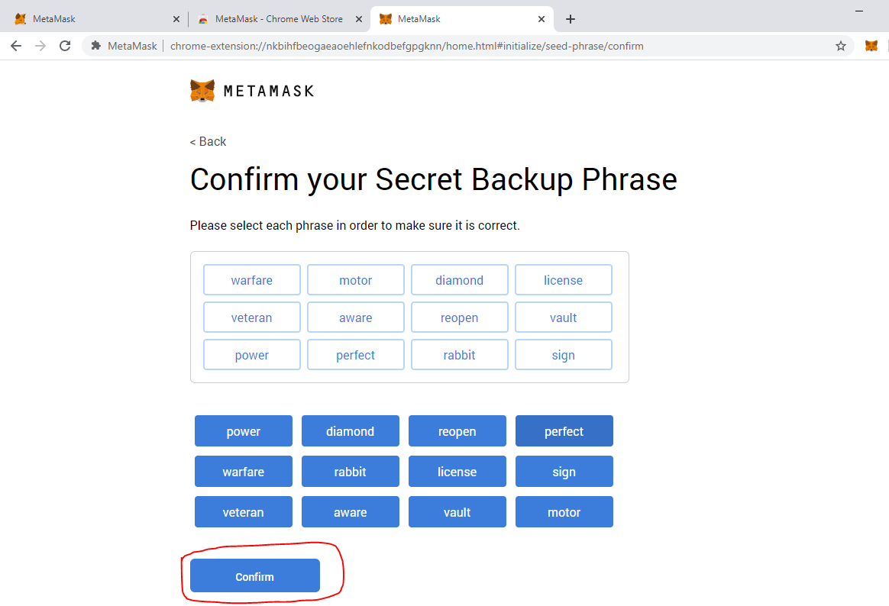

## Click on “All Done”

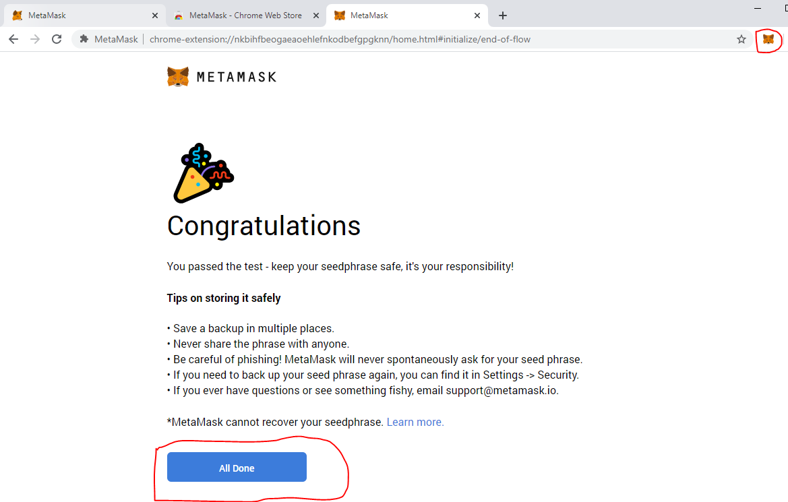

## Select the “Main Ethereum Network” option and verify the display of “Account 1” with “0 ETH”

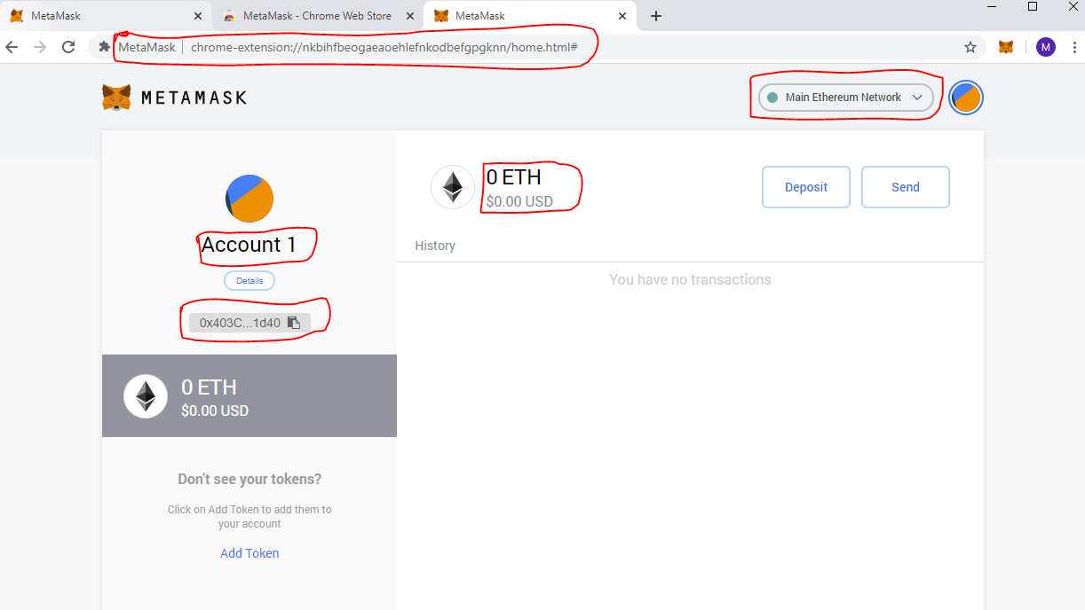

# **Download and install the latest version of “Ganache Ethereum Test Blockchain”**

## Open the below “ganache” website and click on “DOWNLOAD (WINDOWS)” button

<https://www.trufflesuite.com/ganache>

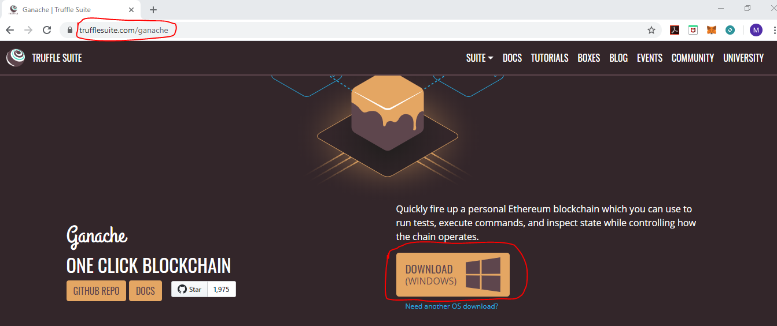

## Install the Ganache Test Blockchain using down loaded .appx file

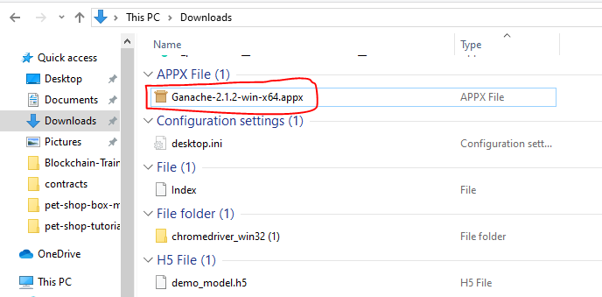

## Launch the Ganache

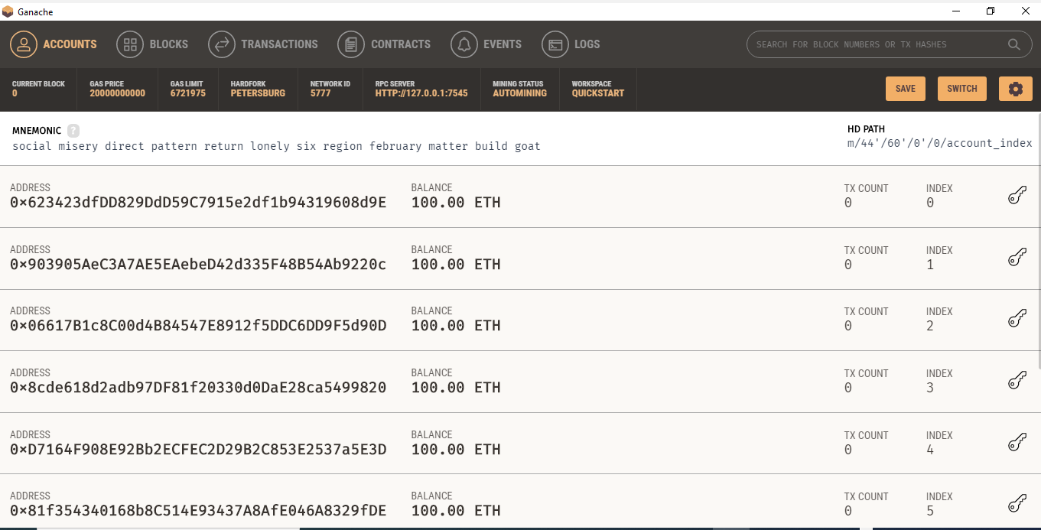

# **Create a network for “Ganache Test Blockchain” in the Metamask**

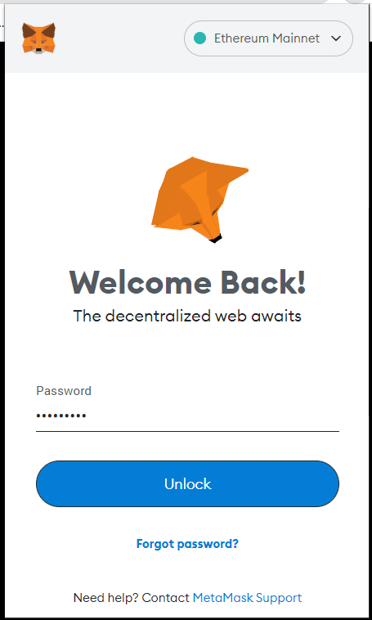

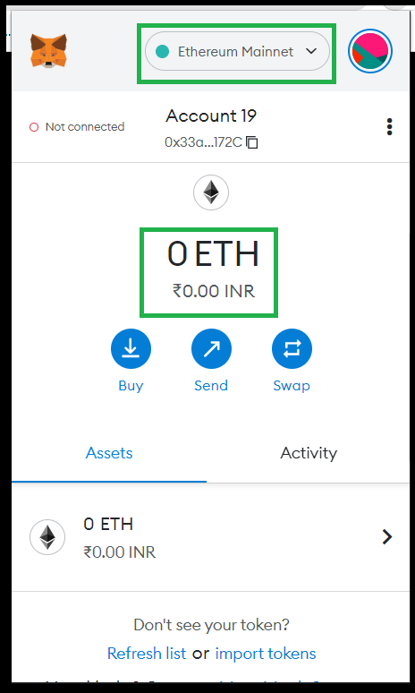

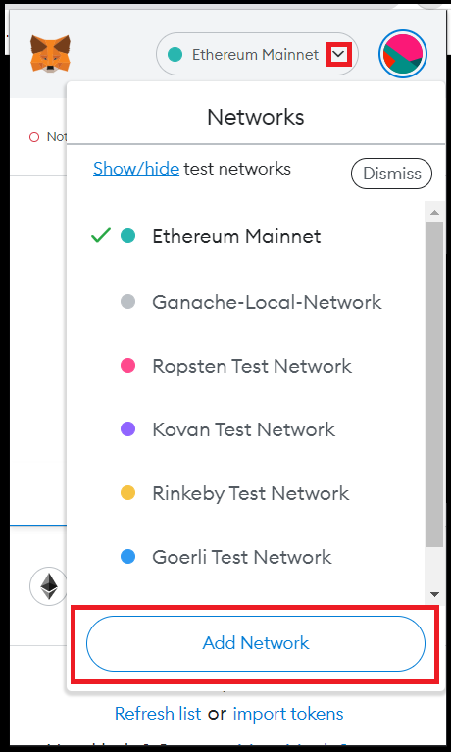

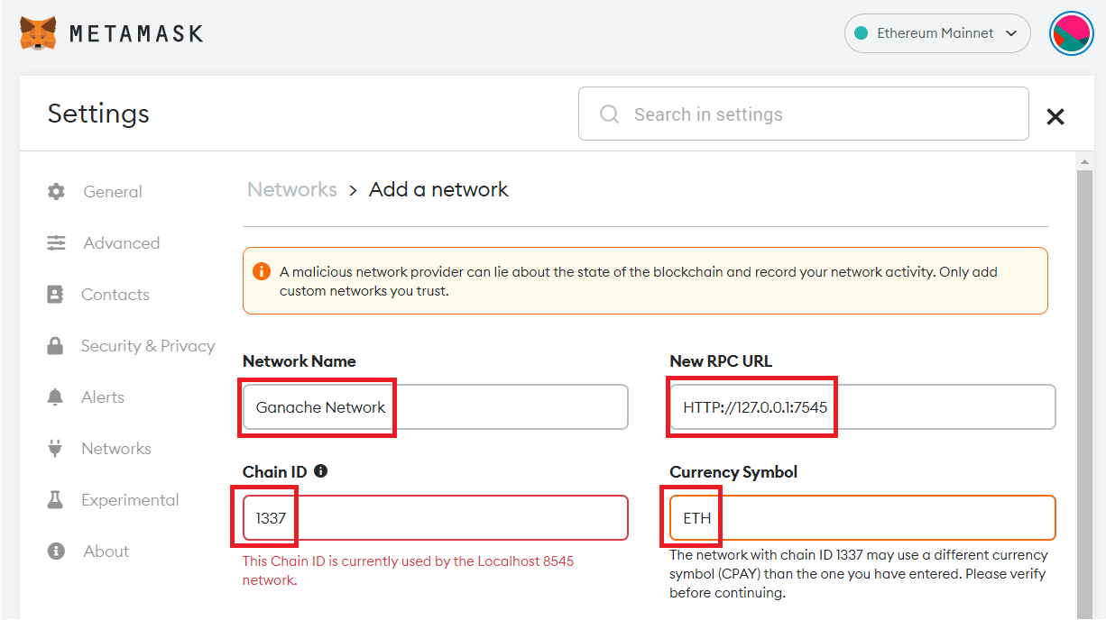

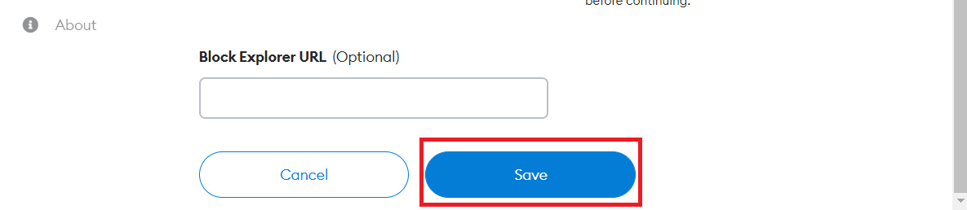

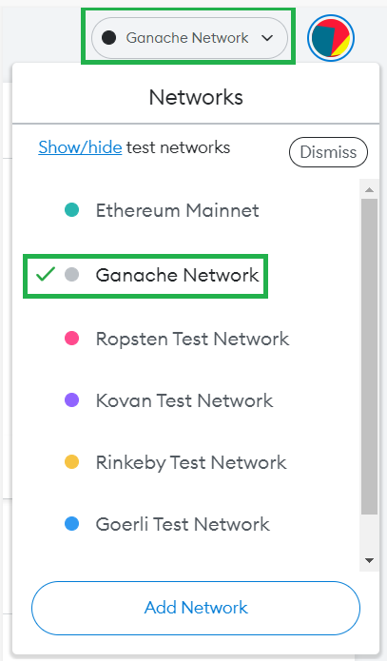

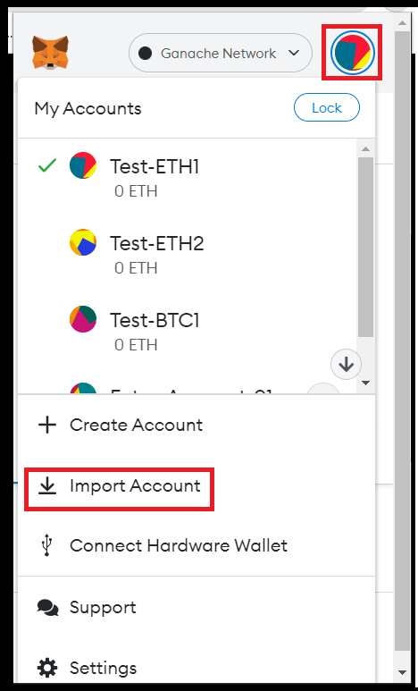

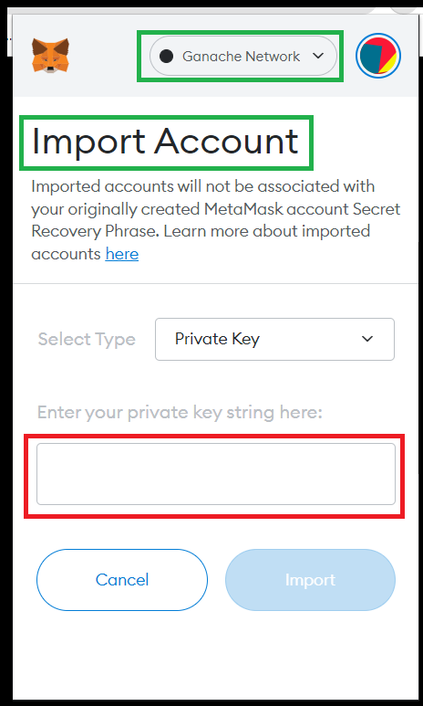

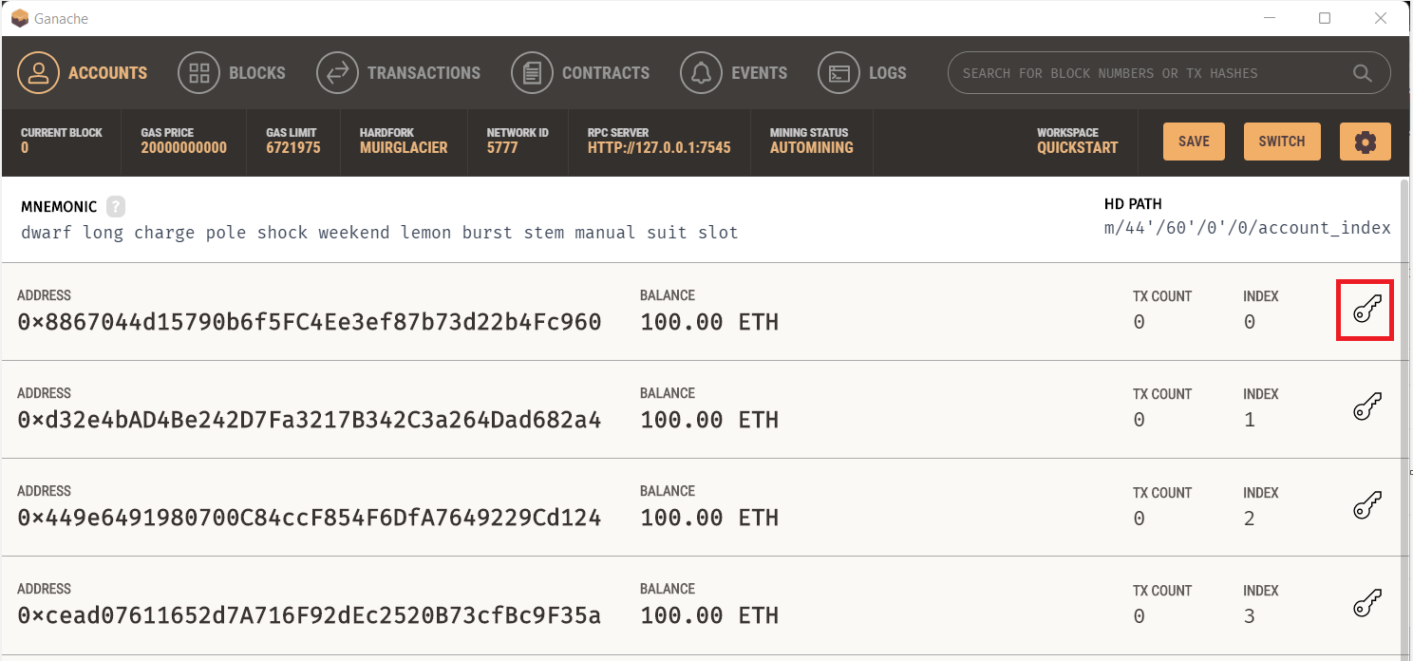

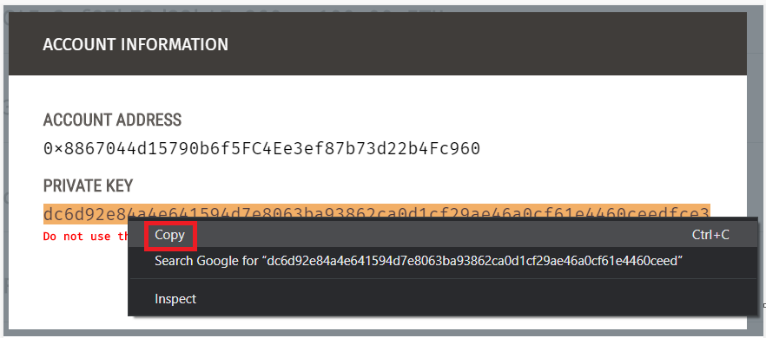

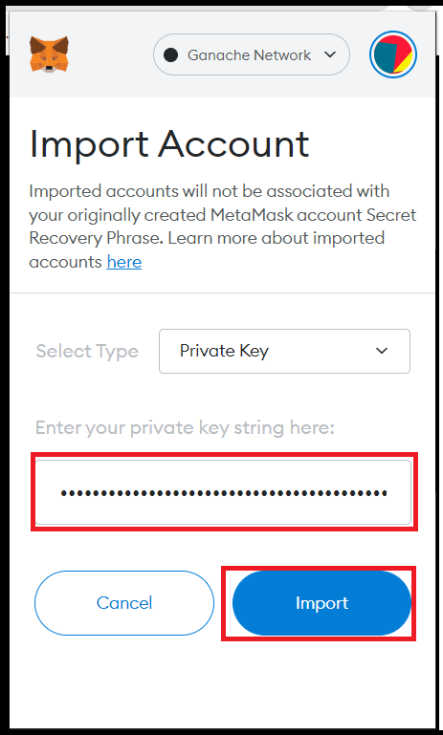

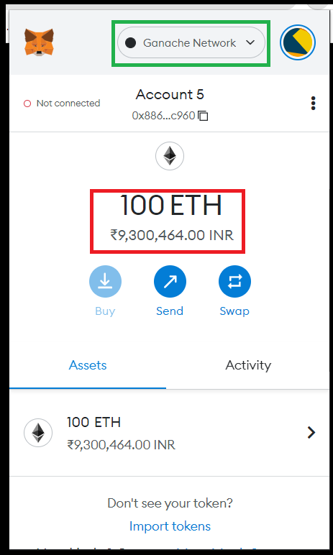

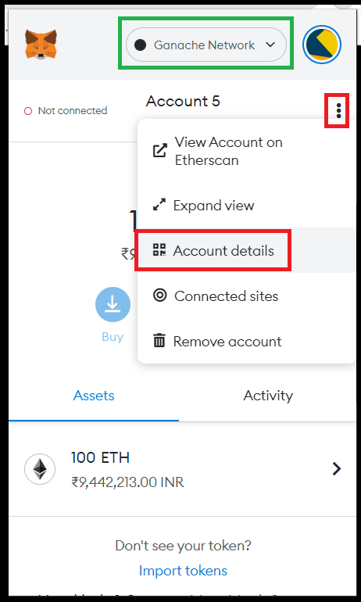

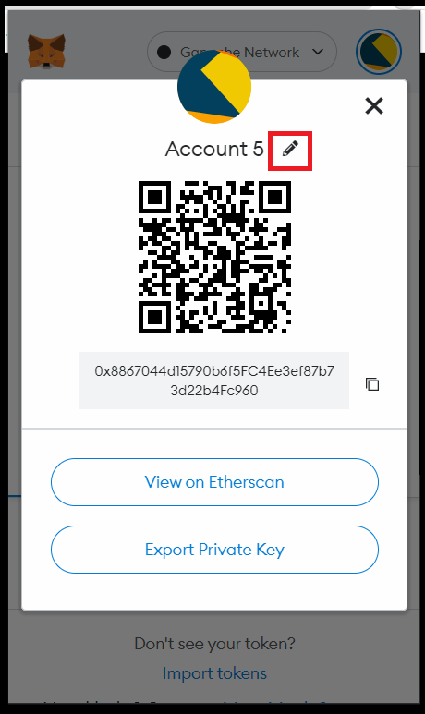

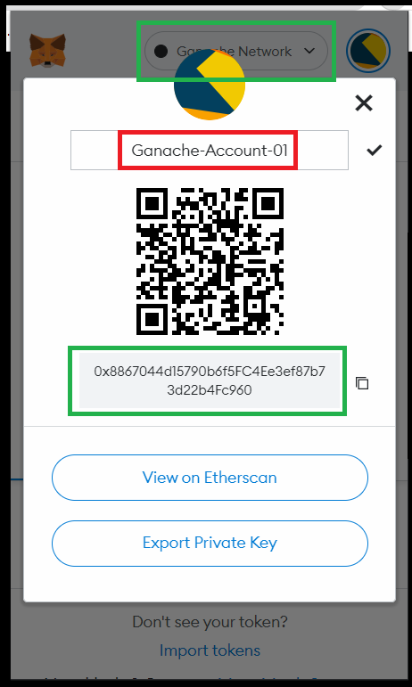

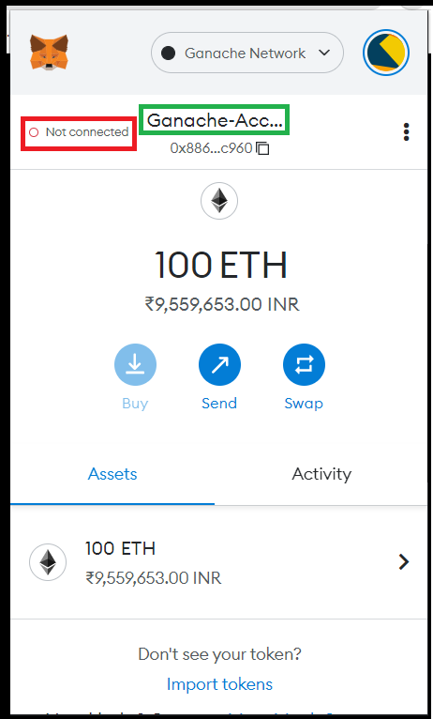

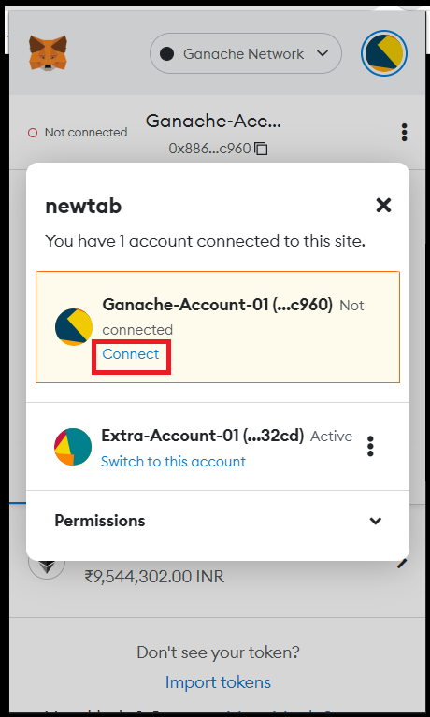

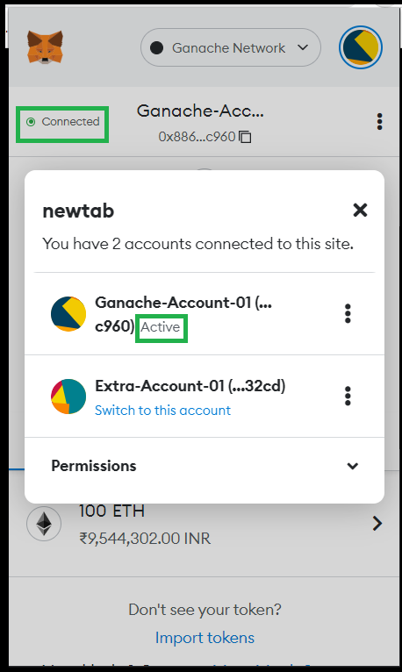

## Open the Metamask and click on “Custom RPC” option

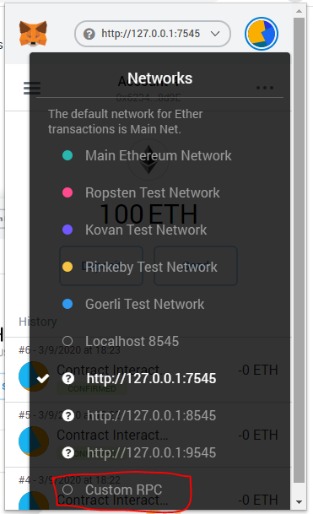

## Enter the “New RPC URL” info and Click on “Save” button

Here the New RPC URL will be “http://127.0.0.1:7545”

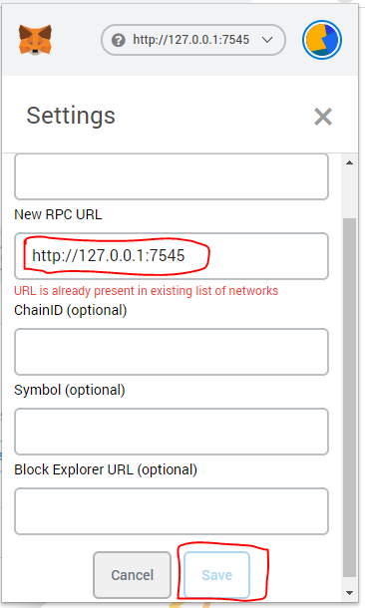

## Select the “<http://127.0.0.1:7545> “as the network option

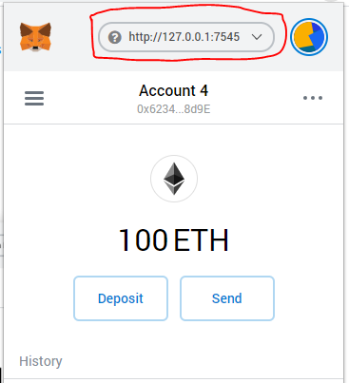

## Click on the round symbol and select the “Import Account” option

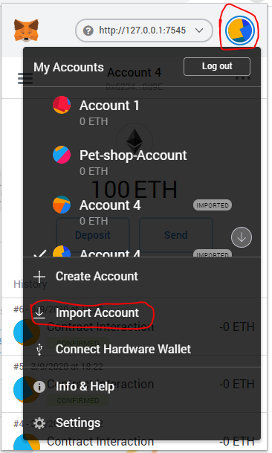

## Verify the display of the “Import Account” screen

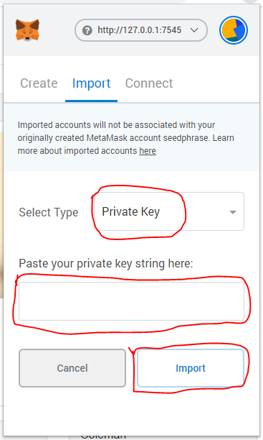

## Click on the key symbol of the first account of the Ganache Test Blockchain

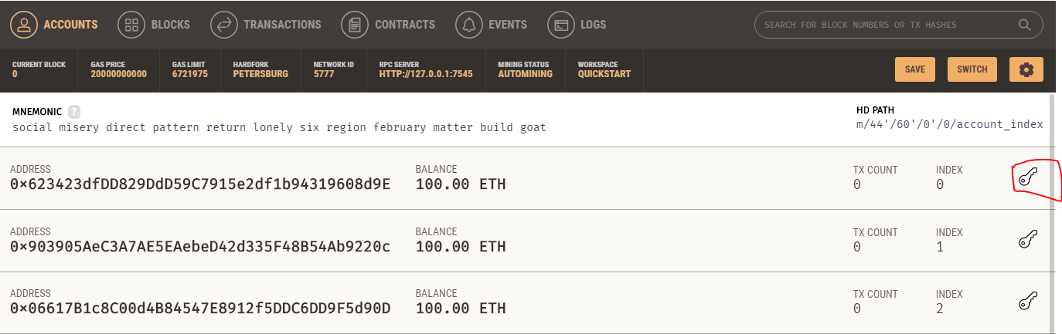

## Copy the “PRIVATE KEY” of the account

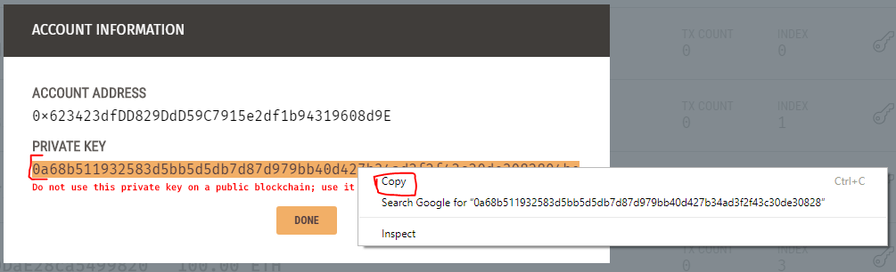

## Paste the copied “PRIVATE KEY” on to the Metamask’s “Import Account” and click on the “Import” button

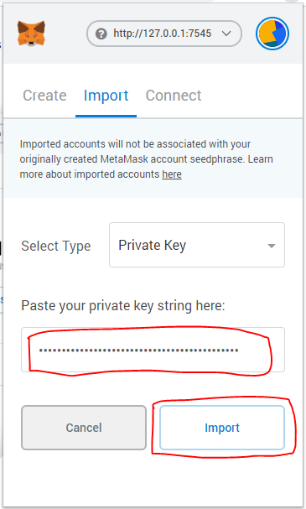

## Verify that the 100 Ethers of the first account of Ganache is loaded into your “Metamask Wallet”

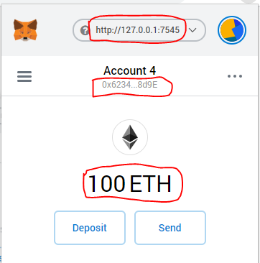

# **Setting up of required Tools in the “c:/Users/Username/”directory in Windows Platform**

## Download and install nodejs for Windows Platform

<https://nodejs.org/en/download/>

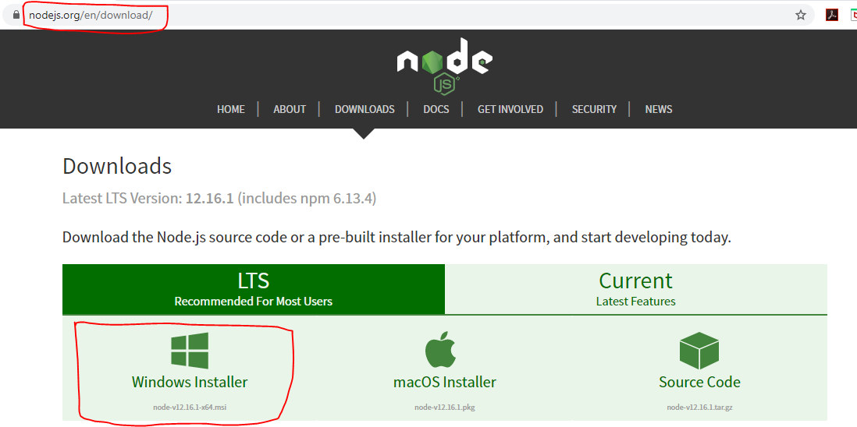

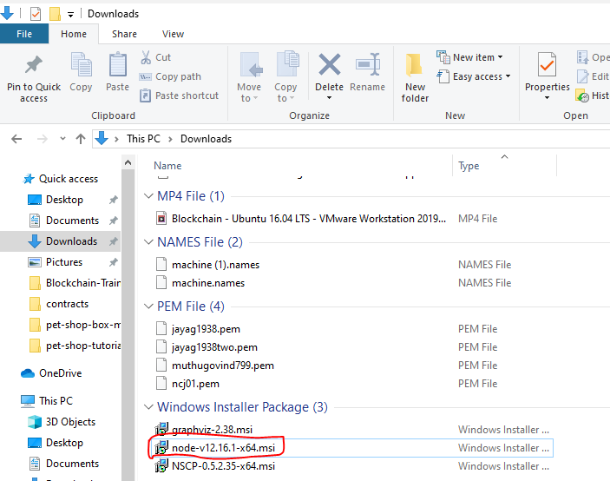

## Verify the successful installation of “nodejs” and “npm” through Windows terminal (using “cmd” command)

node -v

npm -v

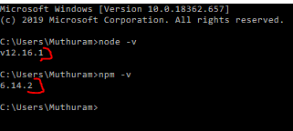

## Install Visual Studio Build Tools

<https://visualstudio.microsoft.com/downloads/?q=build+tools>

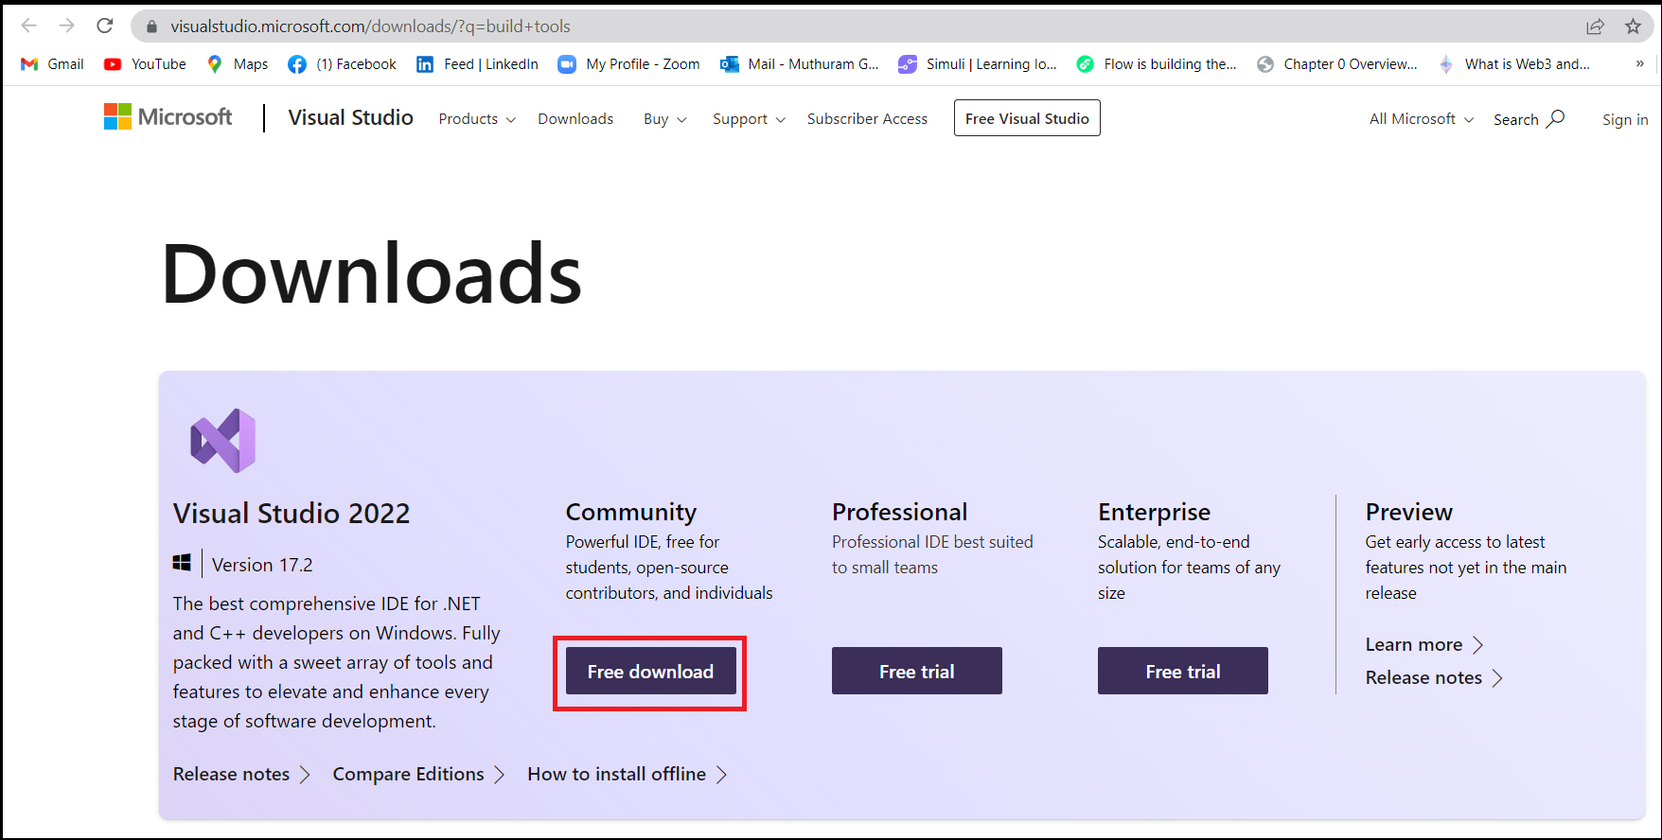

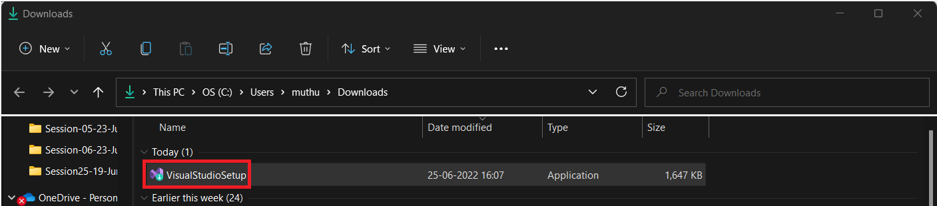

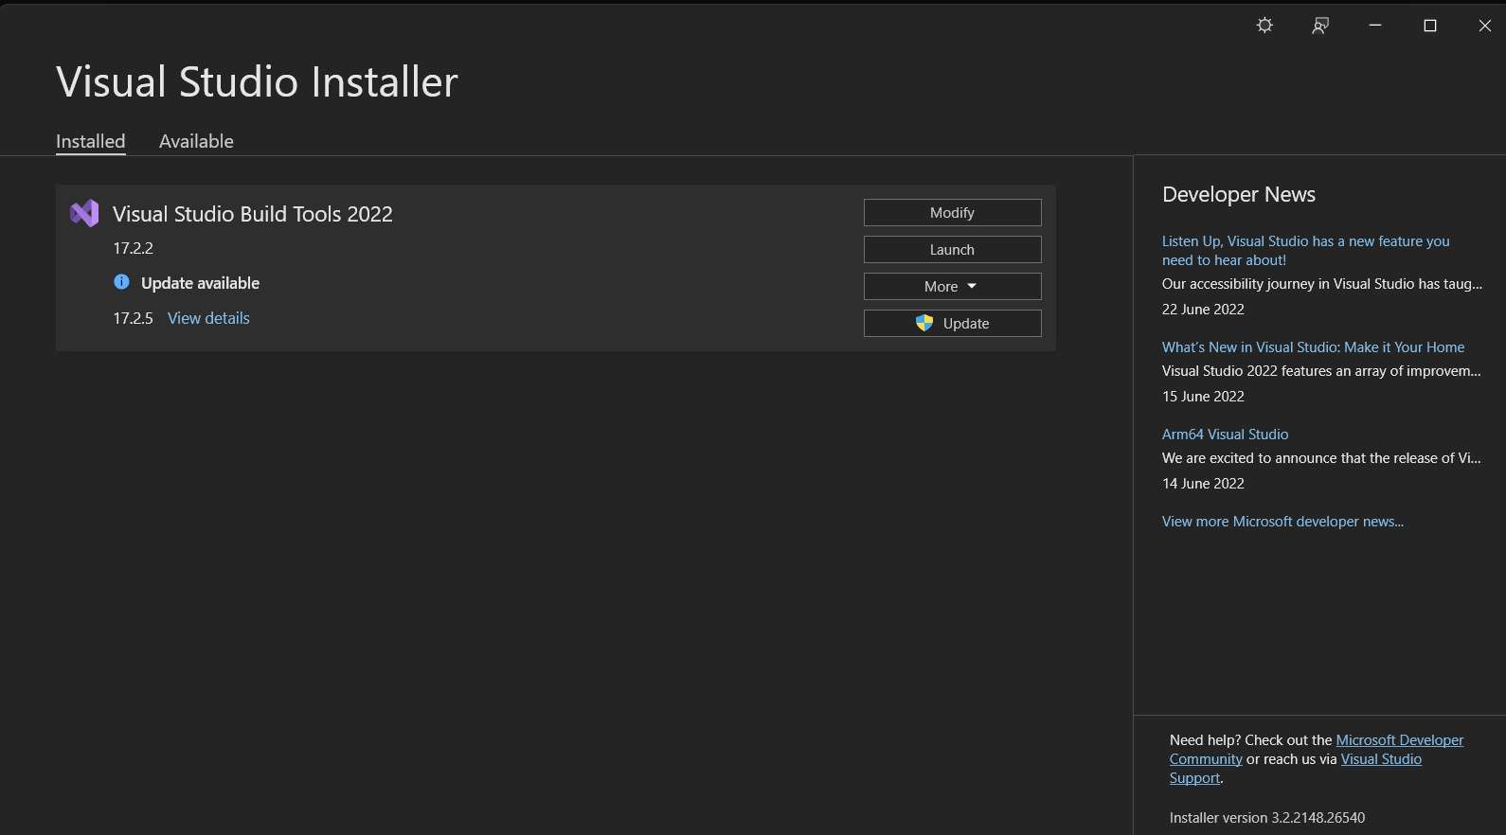

## Install Truffle through Windows terminal and verify its version after installation

Prerequisite: Visual Studio Builds Tool installation is a perquisite for installing Truffle in your system.

**Command to install Truffle:**

npm install -g truffle



**truffle version**

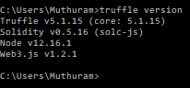

## Download and Install “Visual Studio code” editor and verify

<https://code.visualstudio.com/download>

