**Huffman Coding Algorithm of Variable Length Coding Scheme**

**Name : Koushik Mahanta**  **Roll : 002011001106**

Step 1: The input is read from a file “codingDataExample.txt” which is a text file. So, to run the code the text file and its path should be mentioned in the code file “Huffman.ipynb” at appropriate location.

Specify the input file here inside the open() method.



Step 2: All the cells of the file “Huffman.ipynb” are run sequentially and this generates a console output and three files. One output file is “CodingTree.json” which contains the coding tree in JSON format, another file is “Codes.csv”, which contains the symbols and their respective codes, counts and frequencies and the last file is “OutputText.txt” which contains the entropy of the message, average code length after compression and efficiency of the Huffman algorithm. The output files are also mentioned in the code, so the paths and names of the output files should also be appropriately mentioned in the code before running the code.

Specify the JSON output file here inside the open() method.

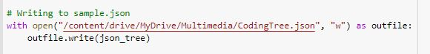

Specify the CSV output file here.



Specify the Text output file here inside the open() method.



Note : While mentioning the file names their path should be valid