**RESTAURANT TYPE RECOMMENDER**

1. **Introduction:**

**Problem background:**

Bangalore is the capital and largest city of the Indian state of Karnataka. With a population of over 15 million (as of January 2016), Bangalore is the third largest city in India and 27th largest city in the world.

The diversity of the cuisine available is reflective of the social and economic diversity of Bangalore. Roadside vendors, tea stalls, South Indian, North Indian, Muslim food, Chinese and Western fast food are all very popular in the city. Udupi restaurants are very popular and serve predominantly vegetarian cuisine. The Chinese food and the Thai food served in most of the restaurants are can be customized to cater to the tastes of the Indian population. Bangalore can also be called a foodie's paradise because of its vast variety of foods and edibles with a touch of Bangalore's uniqueness and tradition.

**2.Problem Statement**

In a huge city like Bangalore it is difficult to choose where to open the Restaurant and what kind of restaurant to open. In this project we will explore the different neighborhoods in Bangalore and find a place and kind of restaurant to open. This would help in solving one of the major problems in restaurant business

**3.Data for solving the problem**

1. We will fetch the details of the Neighborhoods of Bangalore from the Wikipedia page <https://en.wikipedia.org/wiki/List_of_neighbourhoods_in_Bangalore>
2. We will fetch the details of the Latitude and Longitude from the Google Maps API
3. We will fetch the details of the population from <https://indikosh.com/dist/655489/bangalore>
4. We will fetch the details of the restaurants from the Foursquare API

**4.Methodology:**

**Exploratory analysis:**

Scrapping the data from different sources and then combining it to form a single-ton dataset is a difficult task. To do so, we need to explore the current state of dataset and then list up all the features needed to be fetched.

Exploring the dataset is important because it gives you initial insights and may help you to get partial idea of the answers that you are looking to find out from the data.

While exploring the dataset, I found out that Indiranagar has most number of venues while Varthur has the least.

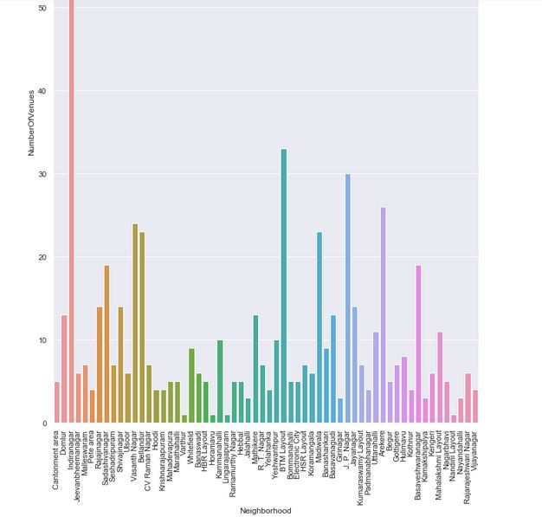

Also, while producing graph for number of cluster, I produced a graph to explore all the values for n_clusters and then finding the best by exploring the elbow graph.

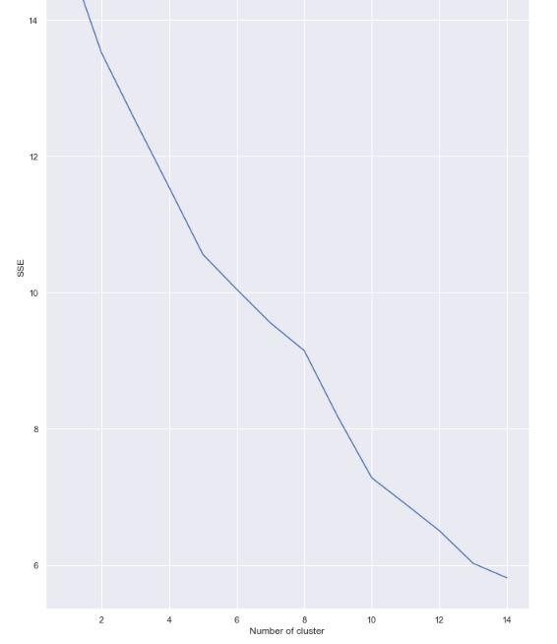

**Inferential analysis:**

Most important factors while building the recommender system were population and income. They are the most import factor because they have a nonlinear relationship according to our dataset.

It needed to make some inferential analysis to understand this nonlinear relationship. As the amount of population increases, it does not necessarily mean that average income of a neighborhood will also increase. It is true to most of the case but also many cases differ to follow this trend. Similarly, a neighborhood with a smaller number of people may not necessarily have less average income. It is possible to have a smaller number of people and more income and vice versa. This can be inferred from the following graph:

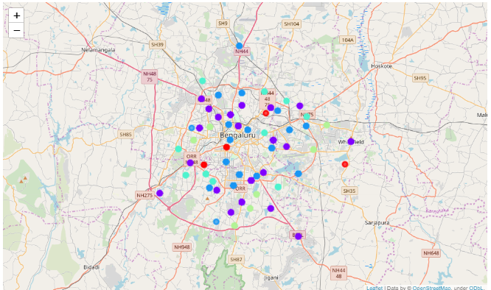

**5.Results**

We generated the statistics for different neighborhoods like what are the major venues in the neighborhoods and in what proportion they exist 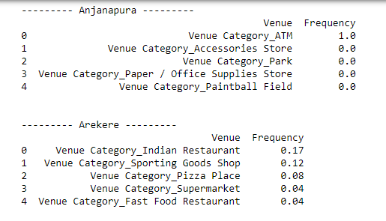

**6.Conclusion**

From the Results section we can see whether any restaurants are present are in the neighborhood or not and what are the kind of restaurants are present. For example, in Anjanapur there are no restaurants and in HSR Layout there is no Indian restaurant