COLLEGE ADMISSION AI CHATBOT
A Mini Project Report
Submitted by
KOUSHIK (Register No. __________)
in partial fulfilment of the requirements for the award of the degree
of
Bachelor of Technology
in
Computer Science & Engineering
(Artificial Intelligence & Data Science)
Under the Guidance of
Dr. Lakshmi, Associate Professor

SCHOOL OF TECHNOLOGY
DEPARTMENT OF COMPUTER SCIENCE & ENGINEERING
THE APOLLO UNIVERSITY, CHITTOOR
Murukambattu, Chittoor – 517 127, Andhra Pradesh
October, 2026

DECLARATION
We hereby declare that the mini project report entitled “College Admission AI Chatbot” submitted by us to The Apollo University, Chittoor, in partial fulfilment of the requirements for the award of the degree of Bachelor of Technology in Computer Science & Engineering (Artificial Intelligence & Data Science), School of Technology, is a record of bonafide work carried out by us during the ____ Semester of the academic year 2026–2027 under the supervision of Dr. Lakshmi, Associate Professor, Department of Computer Science & Engineering.
We further declare that the work reported in this report has not been submitted and will not be submitted, either in part or in full, for the award of any other degree or diploma in this institute or any other institute or university. Wherever the work of others has been used, it has been duly acknowledged and cited.
Signature of the Candidate(s) with names
1. KOUSHIK (Register No. __________) ______________________
Place : Chittoor
Date :
THE APOLLO UNIVERSITY, CHITTOOR
SCHOOL OF TECHNOLOGY
DEPARTMENT OF COMPUTER SCIENCE & ENGINEERING

BONAFIDE CERTIFICATE
This is to certify that the mini project report entitled “COLLEGE ADMISSION AI CHATBOT” is the bonafide work carried out by Koushik (Register No(s): __________), III Year B.Tech, ____ Semester, under my supervision and guidance, in partial fulfilment of the requirements for the award of the degree of Bachelor of Technology in Computer Science & Engineering (Artificial Intelligence & Data Science) by The Apollo University, Chittoor, during the academic year 2026–2027. This work was carried out as part of the course __________ – Mini Project.
The results embodied in this report have not been submitted to any other University or Institute for the award of any degree or diploma.
Signature of the Guide  Dr. Lakshmi  Associate Professor  Dept. of CSE | Programme Coordinator  __________  Dept. of CSE  School of Technology | Dean  School of Technology  The Apollo University
Submitted for the Mini Project (__________) Viva-Voce Examination held on ____________________
Internal Examiner | External Examiner

CERTIFICATE OF SIMILARITY CHECK
(As per UGC (Promotion of Academic Integrity and Prevention of Plagiarism in Higher Educational Institutions) Regulations, 2018)
This is to certify that the mini project report entitled “College Admission AI Chatbot” submitted by Koushik has been checked for similarity using [Turnitin / iThenticate / DrillBit / Ouriginal] and the details are as follows:
Particulars | Details
Software used
Date of similarity check
Overall similarity index (%)
Similarity excluding references, quotes and bibliography (%)
Similarity level (UGC) | Level 0 (≤ 10%) / Level 1 (> 10% to 40%)
Submission / Report ID
Attach the first page (summary) of the similarity report after this page. As per UGC Regulations 2018, similarity up to 10% (Level 0) is acceptable; core work should not exceed the permissible limit.
Signature of the Guide  Dr. Lakshmi | Signature of the Programme Coordinator  __________

ACKNOWLEDGEMENT
We express our sincere gratitude to our project guide Dr. Lakshmi, Associate Professor, Department of Computer Science & Engineering, School of Technology, The Apollo University, Chittoor, for the continuous guidance, valuable suggestions and constructive feedback throughout the course of this project. Their support has been instrumental in the successful completion of this work.
We thank __________, __________, Mini Project Coordinator, Department of Computer Science & Engineering, School of Technology, The Apollo University, for giving us the right direction at every stage of the work.
We extend our heartfelt thanks to __________, Programme Coordinator, __________, Department of Computer Science & Engineering, School of Technology, The Apollo University, for providing the necessary academic support and facilities to carry out this project effectively.
We also convey our sincere thanks to Prof. D. Jagadeesan, Dean, School of Technology, for his support and encouragement throughout the project work.
We express our profound gratitude to the Honourable Chancellor Emeritus Dr. Prathap C. Reddy, Chancellor Dr. Preetha Reddy, Pro Chancellor Dr. Ravi Raju Tatapudi, Vice-Chancellor Prof. (Dr.) Nitin M. Nagarkar, Pro Vice-Chancellor Dr. Alfred J. Augustine, and Registrar Mr. Anil Kumar S, The Apollo University, for their visionary leadership, constant encouragement and for fostering a supportive academic environment.
We acknowledge the support of all faculty members and technical staff of the department for their cooperation and valuable inputs during the project period. We thank our friends and classmates for their constant encouragement, and express our deepest gratitude to our parents and family members for their unwavering support, motivation and blessings.
1. KOUSHIK (Register No. __________)

ABSTRACT
Admission offices answer the same questions about fees, courses, scholarships, hostel and transport again and again, and a general-purpose chatbot may invent facts when it does not know the answer. This project builds a College Admission AI Chatbot for The Apollo University, Chittoor, that runs completely on a local computer. A web chat widget sends each question to an n8n workflow. The workflow detects the topic, retrieves only the relevant official facts, such as fees for 34 programmes and 3 postgraduate diplomas, syllabus, library, clubs, events, hostel and transport, and passes them to the Llama 3.2 1B model running on Ollama. Eleven suggested-prompt chips give instant answers without calling the model, and follow-up chips guide the conversation. The last six messages of every session are kept so short follow-up questions are understood. In testing, chip answers appeared in about 0.37 seconds, prompts were 76% to 95% smaller than sending the whole knowledge base, and all eight designed test cases passed. The system needs no cloud service and has no recurring cost, so it is a practical first line of response for admission enquiries.
Keywords: Chatbot, Llama 3.2, n8n, Ollama, Prompt grounding

TABLE OF CONTENTS
 | CONTENTS | Page No.
 | ABSTRACT | v
 | LIST OF FIGURES | viii
 | LIST OF TABLES | ix
 | LIST OF ABBREVIATIONS | x
1 | INTRODUCTION | 1
 | 1.1 Background | 1
 | 1.2 Problem Statement | 1
 | 1.3 Objectives | 2
 | 1.4 Scope of the Project | 2
 | 1.5 Organization of the Report | 2
2 | LITERATURE SURVEY | 4
 | 2.1 Existing Methods / Systems | 4
 | 2.2 Limitations of Existing Systems | 6
 | 2.3 Proposed System | 6
3 | SYSTEM DESIGN AND METHODOLOGY | 8
 | 3.1 Requirements | 8
 | 3.2 System Architecture | 9
 | 3.3 Workflow / Flowchart | 10
 | 3.4 Algorithm / Methodology | 11
4 | IMPLEMENTATION | 13
 | 4.1 Development Environment | 13
 | 4.2 Module Description | 13
 | 4.3 Code Description | 14
5 | RESULTS AND DISCUSSION | 16
 | 5.1 Output Screens | 16
 | 5.2 Testing | 17
 | 5.3 Performance Analysis | 18
6 | CONCLUSION AND FUTURE SCOPE | 20
 | 6.1 Conclusion | 20
 | 6.2 Future Enhancements | 20
 | REFERENCES | 22
 | MAPPING WITH PROGRAMME OUTCOMES | 24
 | APPENDICES | 26

LIST OF FIGURES
Figure No. | Title | Page No.
3.1 | Proposed System Architecture | 10
3.2 | Workflow of the Proposed System | 11
5.1 | Chat Widget Answering a Fee Question | 16
5.2 | n8n Workflow Canvas | 16
5.3 | Estimated Prompt Size per Question | 18
B.1 | Chat Widget Answering a Library Question | 28

LIST OF TABLES
Table No. | Title | Page No.
2.1 | Summary of Literature Survey | 4
3.1 | Hardware and Software Requirements | 8
4.1 | Model Settings Used in the Ollama Request | 13
5.1 | Test Cases and Results | 17
5.2 | Estimated Prompt Size per Question | 18
5.3 | Comparison with Existing Approaches | 19

LIST OF ABBREVIATIONS
Abbreviation | Expansion
AI | Artificial Intelligence
API | Application Programming Interface
CPU | Central Processing Unit
CSS | Cascading Style Sheets
FAQ | Frequently Asked Questions
GPU | Graphics Processing Unit
HTML | HyperText Markup Language
HTTP | HyperText Transfer Protocol
JS | JavaScript
JSON | JavaScript Object Notation
KB | Knowledge Base
LLM | Large Language Model
NLP | Natural Language Processing
RAG | Retrieval-Augmented Generation
UI | User Interface
WSL2 | Windows Subsystem for Linux 2

CHAPTER 1

INTRODUCTION

1.1 BACKGROUND
Universities receive a steady stream of questions from students and parents before and during the admission season. The questions are mostly the same: which programmes are offered, what the fee is, how much the hostel costs, whether scholarships exist, how the buses run and what the syllabus contains. Answering them by phone, e-mail and counter visits takes staff time, and the answers are not always consistent or available outside office hours. A chatbot on the university website can answer such questions at any hour [1].
Modern chatbots are built on large language models (LLMs). The Transformer architecture [2] made it possible to train models that understand free-form questions, and very large models such as GPT-3 [3] showed that a model can answer many kinds of questions from a short prompt without special training. However, an LLM does not know the facts of one particular university. If it is asked for a fee it does not know, it may still produce a confident but wrong number. A common remedy is retrieval-augmented generation (RAG), in which relevant text is retrieved first and given to the model together with the question [4], [5]. This false-fact behaviour is called hallucination and is studied in detail in [6]; the use of RAG against it is surveyed in [7].
Open-weight models such as the Llama 3 family [8] can be run on a personal computer with free tools, so a university can host its own chatbot without paying for a cloud service or sending student questions to an outside company. Recent studies show that RAG chatbots can answer university admission questions accurately [9], [10], [11]. This project applies these ideas to The Apollo University, Chittoor: a small Llama 3.2 1B model is run locally with Ollama, an n8n workflow retrieves only the facts that a question needs from official university data [12], and a custom web widget gives students a simple chat window with suggested-prompt chips.

1.2 PROBLEM STATEMENT
Admission enquiries to The Apollo University are answered slowly and not always consistently because they depend on staff availability, and the facts (fees for many programmes, syllabus, hostel, transport, timings) are spread across many pages of the website. A general AI chatbot can answer quickly but may invent fees or dates, which is unacceptable for admission information. The problem is to build a chatbot that gives quick, correct answers about the university, uses only verified facts, and runs on an ordinary laptop without any paid cloud service.

1.3 OBJECTIVES
1. To study chatbot, language-model and grounding techniques that reduce wrong answers from language models.
2. To design a web chat widget and an n8n workflow that retrieves official Apollo University facts for each question.
3. To implement the chatbot on a locally hosted Llama 3.2 1B model with session memory and suggested-prompt chips.
4. To evaluate the system using test cases, prompt size and response time.

1.4 SCOPE OF THE PROJECT
In scope: answering questions on programmes and fees (34 programmes and 3 postgraduate diplomas), syllabus by semester, eligibility, scholarships, placements, library, clubs, cultural events, transport, hostel and mess, and college working hours; a chat widget with eleven suggested prompts and follow-up chips; short-term session memory; local deployment with Docker, n8n and Ollama.
Out of scope: online application forms, fee payment, voice or telephone support, languages other than English, and information about other universities.
Assumptions: the official data was current when it was collected in October 2026 and must be updated by the university when it changes; the system runs on a CPU-only laptop; the person using the chatbot is an applicant, parent or student asking about the university.

1.5 ORGANIZATION OF THE REPORT
Chapter 1 introduces the background, problem statement, objectives and scope. Chapter 2 surveys eleven related works, lists the limitations of existing systems and introduces the proposed system. Chapter 3 gives the requirements, system architecture, workflow and algorithm. Chapter 4 describes the development environment, the modules and the key code. Chapter 5 presents the output screens, test cases and performance analysis. Chapter 6 concludes the report and suggests future enhancements. The references, the mapping with programme outcomes and the appendices follow.
CHAPTER 2

LITERATURE SURVEY

2.1 EXISTING METHODS / SYSTEMS
Eleven works were studied. They cover chatbot technology, the Transformer and large language models, retrieval for question answering, hallucination, open models that can run locally, and three recent studies (2024 and 2025) of RAG chatbots for universities. Table 2.1 summarises them.
Table 2.1: Summary of Literature Survey
S. No. | Author(s) & Year | Technique / Method | Dataset | Findings | Limitations
1 | Adamopoulou & Moussiades, 2020 [1] | Overview of chatbot types and design approaches | Literature review | Classifies rule-based, retrieval-based and generative chatbots | Survey only; no system is built
2 | Vaswani et al., 2017 [2] | Transformer (self-attention) | WMT 2014 English–German and English–French | Trains faster and translates better than recurrent models | Translation only; no fact grounding
3 | Brown et al., 2020 [3] | GPT-3 with few-shot prompting | Large web text corpus | Strong results from a prompt, without fine-tuning | Very large model; can state false facts
4 | Lewis et al., 2020 [4] | Retrieval-augmented generation | Wikipedia index; open-domain QA sets | Retrieved text makes answers more factual | Needs a vector index and heavy models
5 | Karpukhin et al., 2020 [5] | Dense passage retrieval | Natural Questions, TriviaQA and others | 9–19% better top-20 accuracy than BM25 | Needs training and a built index
6 | Ji et al., 2023 [6] | Survey of hallucination in language generation | Many language tasks | Defines and groups hallucination and its remedies | Survey; no admission-domain study
7 | Gao et al., 2023 [7] | Survey of RAG for large language models | Literature review | Retrieval grounds answers and reduces hallucination | General; not tuned for small CPU models
8 | Grattafiori et al., 2024 [8] | Open-weight Llama 3 models | Multilingual web data (about 15T tokens) | Open models can run locally and rival closed models | Paper covers 8B–405B; this project uses a 1B model
9 | Chen et al., 2024 [9] | Admission chatbot: ChatGPT 3.5 with RAG (LlamaIndex) | Admission data of 3 universities; 53 student users | Accuracy rose from 41.4% to 89.5% with RAG | Paid cloud model; small user sample
10 | Trienes et al., 2025 [10] | Marcel: FAQ retriever with BM25 / dense fallback and open models | 249 university web pages; 95 test questions | FAQ retriever roughly doubled MRR over the baseline (0.70 vs 0.40) | Needs curated FAQs; small, single-turn test
11 | Sarmiento & Lauría, 2025 [11] | Simple RAG vs Corrective RAG (LangChain, ChromaDB, GPT-4o-mini) | College website; 667 question–context pairs | Corrective RAG: higher precision; simple RAG: higher recall | Cloud model; small samples; one institution

Adamopoulou and Moussiades [1] give an overview of chatbot technology and group chatbots by how they are built: rule-based bots follow fixed patterns, retrieval-based bots pick an answer from stored ones, and generative bots write new text. Rule-based bots are dependable but fail when a question is worded in an unexpected way. The Transformer of Vaswani et al. [2] replaced recurrent networks with self-attention and is the base of all modern language models. Brown et al. [3] showed with GPT-3 that a very large Transformer can follow instructions given only in the prompt.
Lewis et al. [4] combine a language model with a retriever so that the model reads retrieved passages before answering, which makes answers more factual. Karpukhin et al. [5] show that dense retrieval finds relevant passages better than the traditional BM25 keyword method. Ji et al. [6] survey hallucination and explain why models state false facts, and Gao et al. [7] survey RAG methods. Finally, the Llama 3 report of Grattafiori et al. [8] describes open-weight models that can be downloaded and run locally, which makes a private, cost-free deployment possible.
Three recent studies apply RAG to university enquiries. Chen et al. [9] built an admission chatbot with ChatGPT 3.5 and RAG and tested it on admission data from three universities; its accuracy rose from 41.4% without retrieval to 89.5% with it. Trienes et al. [10] describe Marcel, an open-source student-support chatbot whose main part is an FAQ retriever that matches questions to curated FAQs; it roughly doubled retrieval quality (MRR 0.70 against 0.40) and was used by 27 people in a two-week trial. Sarmiento and Lauría [11] compared simple RAG with Corrective RAG on college web pages and found that each is better on different measures. These studies confirm that grounding with retrieved facts works for admission questions, but they use paid cloud models or larger models and vector stores.

2.2 LIMITATIONS OF EXISTING SYSTEMS
The works above show four gaps for a university admission chatbot.
1. Rule-based bots are brittle. They need every question and answer to be written in advance and fail on new wording [1].
2. Ungrounded language models hallucinate. A model that is not given the university’s facts can invent fees, dates and rules [3], [6].
3. Full RAG systems are heavy. Dense retrieval and vector indexes need training, extra software and usually a GPU [4], [5], [7], which is more than a small college team can run on a laptop.
4. Recent admission chatbots need paid or larger resources. The chatbots in [9] and [11] use the paid cloud models ChatGPT 3.5 and GPT-4o-mini, and [10] needs curated FAQs and was tested with 12B and 70B open models, so none of them targets a CPU-only laptop with a 1B model.

2.3 PROPOSED SYSTEM
The proposed system is a light, local chatbot that keeps the flexibility of a language model but takes the facts from official university data. A web chat widget sends each question to an n8n workflow. A short piece of code detects the topics in the question (for example fee, hostel or library) and the programme names it mentions, and copies only the matching facts, at most 2,600 characters, into the prompt of a Llama 3.2 1B model running on Ollama. The model is told to use only these facts and to say so when the answer is not available.
The main advantages over the existing approaches are:
1. Correct, current facts. Answers come from data collected from the official website and from details supplied by the college, such as bus routes, mess timings and working hours.
2. Speed on a small computer. Sending only the needed facts makes the prompt 76% to 95% smaller than sending the whole knowledge base, and eleven suggested-prompt chips are answered instantly in the browser without calling the model.
3. Privacy and zero running cost. Everything runs locally; no question leaves the machine and no paid API is used.
4. Easy conversation. Suggested prompts, follow-up chips and a six-message memory help users who do not know what to ask.
CHAPTER 3

SYSTEM DESIGN AND METHODOLOGY

3.1 REQUIREMENTS
Functional requirements
1. FR1: The system shall answer admission questions about programmes, fees, syllabus, library, clubs, events, hostel, mess, transport and timings in plain English.
2. FR2: The widget shall show suggested prompts at the start and follow-up chips after each answer.
3. FR3: The system shall remember recent messages of a session so that short follow-up questions such as “and hostel?” are understood.
4. FR4: The system shall answer only from the supplied facts and say so when it does not have the answer.
5. FR5: The widget shall ignore empty input.
Non-functional requirements: preset-chip answers in under one second; no cloud service or recurring cost; simple interface usable on a phone-sized screen; knowledge base that can be updated by editing text; answers kept short (two to five lines).
The hardware and software used are given in Table 3.1.
Table 3.1: Hardware and Software Requirements
Category | Specification
Processor | Intel laptop CPU, 8 logical cores
RAM | About 3.8 GiB available to Docker (WSL2 virtual machine)
Storage | A few GB free; the Llama 3.2 1B model file is about 1.3 GB
GPU (if any) | Intel UHD Graphics 620 (integrated, not used for inference)
Operating System | Windows with WSL2 and Docker Desktop
Programming Language | JavaScript, HTML, CSS
Frameworks / Libraries | n8n workflow automation; Ollama (Llama 3.2 1B model)
IDE / Tools | Web browser, n8n editor, Playwright (widget testing)
Database | Text knowledge base; n8n workflow static data for session memory

3.2 SYSTEM ARCHITECTURE
Figure 3.1 shows the architecture. The system has six components.
1. Student and chat widget. The student types a question or taps a chip in a custom HTML, CSS and JavaScript chat widget that carries the Apollo University logo. Chips with a stored local answer are answered in the browser at once; all other questions are sent to n8n.
2. n8n workflow. A Chat Trigger receives the question and session id. A Code node called Prepare Prompt performs retrieval and builds the model request, and a second Code node saves the reply to memory and returns it.
3. Knowledge base. Official Apollo University information (fees of 34 programmes and 3 postgraduate diplomas, syllabus, eligibility, scholarships, library, clubs, events, hostel, mess, transport, timings, contact) stored as text sections inside the Prepare Prompt node.
4. Session memory. The last six messages of each session are kept in n8n workflow static data; the last four are added to the next prompt.
5. Ollama and Llama 3.2 1B. Ollama serves the model on the laptop. Docker reaches it at host.docker.internal on port 11434.
6. Reply. The answer text is returned to the widget, which shows it and offers follow-up chips.
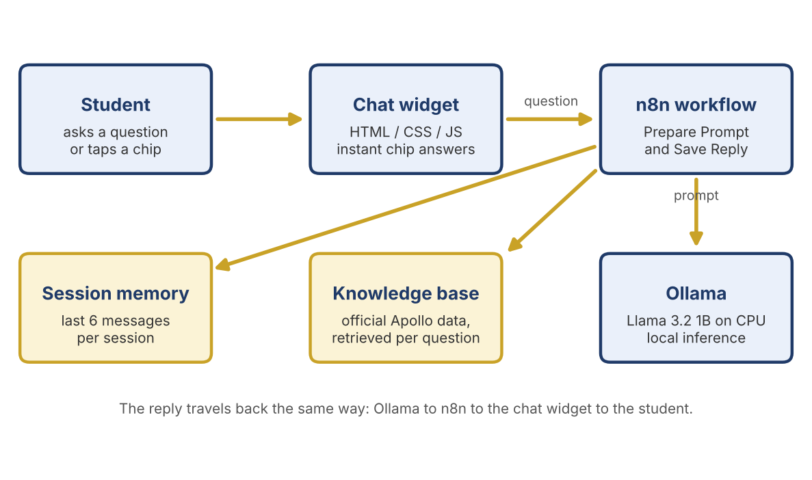
Figure 3.1: Proposed System Architecture

3.3 WORKFLOW / FLOWCHART
Figure 3.2 shows how a question moves through the system. If the student taps a chip that has a stored local answer, the widget shows the answer immediately. Otherwise the question goes to n8n, where the topics and programmes are detected, the matching facts are selected, the prompt is built and sent to Ollama, and the reply is saved to memory and returned to the widget.
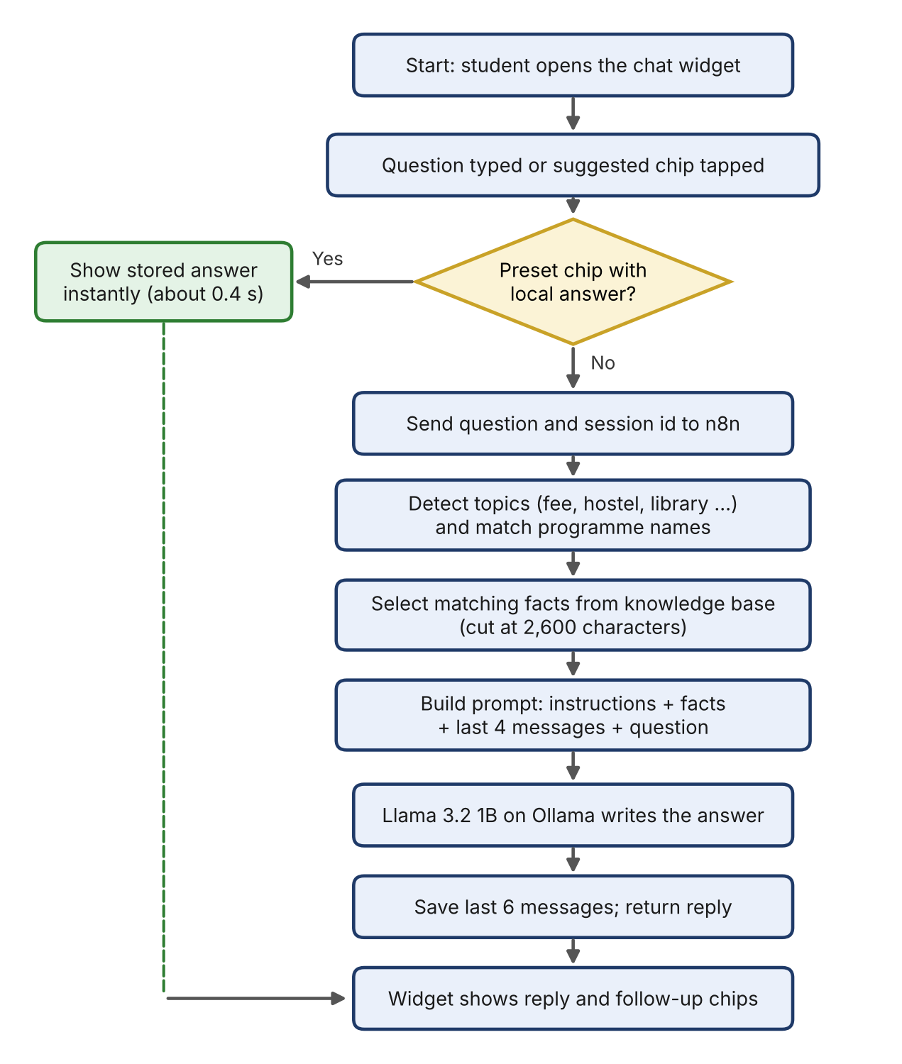
Figure 3.2: Workflow of the Proposed System

3.4 ALGORITHM / METHODOLOGY
The algorithm followed for each question is given below.
1. Read the question and the session id. Remove empty input in the widget.
2. Normalise the text: convert to lower case and write forms such as “B.Tech”, “M.Tech” and “&” in one standard way.
3. If the question has four words or fewer and a previous question exists, join it with the previous question so that “and hostel?” is understood.
4. Test the question against fourteen topic patterns (fee, syllabus, courses, eligibility, scholarship, hostel, mess, library, clubs, events, sports, timings, transport, placements, contact) and match programme names and levels (B.Tech, M.Tech, B.Sc, M.Sc and others).
5. Collect the facts for every matched topic and programme and stop when 2,600 characters are reached.
6. Build the request: a system instruction (“use only the facts below; answer in two to five short lines; say you do not have the detail if it is missing”), the last four messages and the question.
7. Send the request to the Llama 3.2 1B model with temperature 0.2, at most 200 generated tokens and a 2,048-token context window.
8. Save the question and reply (each cut to 300 characters) to the session memory, keep the last six messages and return the reply.
Dataset. The knowledge base is not a training dataset. It is a collection of text facts: official fee pages of The Apollo University for 34 programmes and 3 postgraduate diplomas, the syllabus pages, and sections on eligibility, scholarships, library, clubs, cultural events, hostel and mess, transport and contact. The details that are not on the website (college working hours, eleven bus routes, mess timings, hostel room types with one to five persons sharing) were supplied by the college. The knowledge base is about 12,000 characters (about 3,000 tokens) and the syllabus text adds about 8,000 tokens. The fee of B.Tech CSE, for example, is Rs 2,60,000 tuition per year (Rs 10,99,000 in total) and Rs 2,85,000 per year (Rs 11,99,000 in total) for the specialisations, with Rs 13,000 recurring and Rs 7,000 one-time admission fee included in the totals.
CHAPTER 4

IMPLEMENTATION

4.1 DEVELOPMENT ENVIRONMENT
The chatbot was built with free tools. Docker Desktop with WSL2 runs n8n in a container. Ollama runs on Windows and serves the Llama 3.2 1B model, which was downloaded with the command ollama pull llama3.2:1b. n8n reaches Ollama through http://host.docker.internal:11434/api/chat. The chat widget is a single HTML file with its own CSS and JavaScript, and it calls the n8n chat webhook. The workflow was built and tested in the n8n editor, and the widget was tested with Playwright.
Table 4.1 lists the settings sent to Ollama with every request.
Table 4.1: Model Settings Used in the Ollama Request
Setting | Value | Purpose
model | llama3.2:1b | Small model that runs on a CPU
num_ctx | 2048 | Context window kept small for speed
num_predict | 200 (1 for warm-up) | Maximum words generated
temperature | 0.2 | Low value for factual answers
top_p | 0.9 | Sampling limit
repeat_penalty | 1.1 | Avoids repeated sentences
keep_alive | 60m | Keeps the model in memory between questions
stream | false | Whole reply returned at once

4.2 MODULE DESCRIPTION
The system has five modules.

4.2.1 Module 1: Chat Widget
Purpose: the page the student sees. Input: typed question or tapped chip. Process: shows eleven suggested prompts (courses offered, B.Tech fee, scholarships, placements, cultural events, clubs, library, transport, hostel and mess food, semester subjects, college hours); answers chips from stored local answers in about 0.37 seconds; ignores empty or blank input; sends other questions to the n8n webhook; sends a silent warm-up message when the page loads so the model is already in memory. Output: answer bubble with follow-up chips.

4.2.2 Module 2: Prepare Prompt (Retrieval)
Purpose: choose the facts a question needs. Input: question, session id and last messages. Process: normalises the text, detects topics with regular expressions, matches programme names and semester numbers, and collects facts up to 2,600 characters. Output: the Ollama request with a short grounded prompt.

4.2.3 Module 3: Local Language Model
Purpose: write the answer in plain English. Input: system instruction, facts, recent messages and question. Process: Llama 3.2 1B on Ollama generates at most 200 tokens at temperature 0.2. Output: reply text.

4.2.4 Module 4: Session Memory and Reply
Purpose: remember the conversation and return the reply. Input: model response. Process: stores the last six messages of the session in n8n static data (each cut to 300 characters, at most 200 sessions), and replaces an empty reply with the admissions phone number. Output: the object {output: reply} for the widget.

4.2.5 Module 5: Knowledge Base
Purpose: hold verified facts. Input: official website pages and details supplied by the college. Process: converted to short text sections, one per topic or programme, so that each can be selected separately. Output: fact text for Module 2.

4.3 CODE DESCRIPTION
The key parts of the code are explained below; the listings are in Appendix A.
Retrieval size limit. The constant MAX_CHARS limits the facts added to a prompt, which keeps the prompt small and the answer fast:
const MAX_CHARS = 2600;
for (const p of pieces) {
const room = MAX_CHARS - out.length; if (room < 200) break;
out += (out ? '\n' : '') + (p.text.length > room ? p.text.slice(0, room - 3) + '...' : p.text);
}

Topic detection. Each topic has a regular expression, for example for fees:
fee: /\b(fee|fees|cost|tuition|price|charges|payment|pay|amount|expensive|cheap|how much|total)\b/

Follow-up questions. A very short question borrows the previous user question for matching:
const forMatching = (userText.split(/\s+/).length <= 4 && prevUser)
? prevUser.content + ' ' + userText : userText;

Model request. The request sent to Ollama uses the settings of Table 4.1:
ollamaBody: {
model: 'llama3.2:1b', messages, stream: false, keep_alive: '60m',
options: { num_ctx: 2048, num_predict: warm ? 1 : 200,
temperature: 0.2, top_p: 0.9, repeat_penalty: 1.1 }
}

Memory. After the answer, the Save Reply node keeps the last six messages of the session:
h.push({ role: 'user', content: prep.userText.slice(0, 300) },
{ role: 'assistant', content: reply.slice(0, 300) });
sd.fastHist[prep.sessionId] = h.slice(-6);

CHAPTER 5

RESULTS AND DISCUSSION

5.1 OUTPUT SCREENS
Figure 5.1 shows the chat widget after the student taps the B.Tech fee chip. The answer is shown at once with the fee of each B.Tech programme and follow-up chips (Hostel fees, Scholarships, Courses offered). Figure 5.2 shows the n8n workflow canvas with the chat trigger, the Prepare Prompt node, the request to Ollama and the Save Reply node.
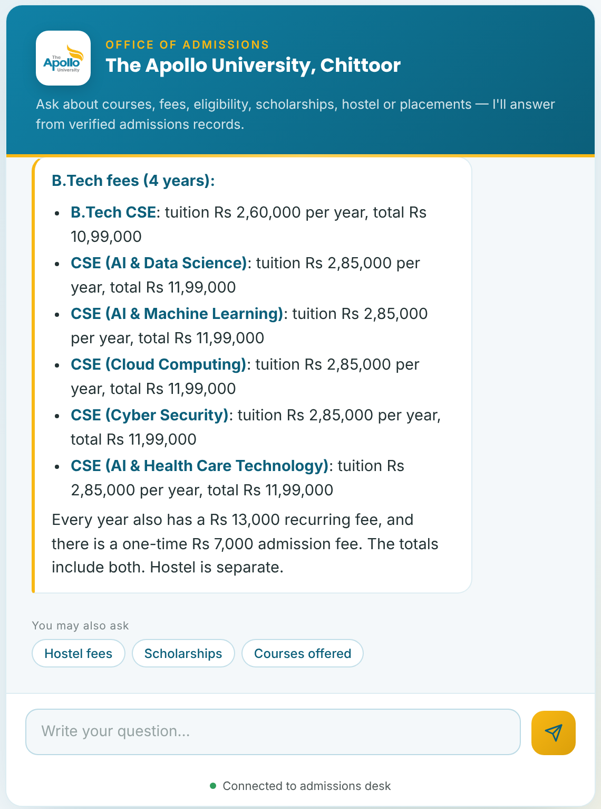
Figure 5.1: Chat widget answering the B.Tech fee question
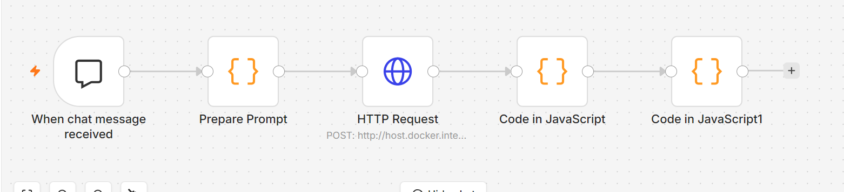
Figure 5.2: n8n Workflow Canvas

5.2 TESTING
Eight test cases were designed for the retrieval logic, the widget and the whole system. They were run with a script for the retrieval logic, with Playwright for the widget (the n8n webhook was replaced by a stub so that only the widget was tested) and with the live n8n workflow for the integration test. Table 5.1 shows the results.
Table 5.1: Test Cases and Results
TC ID | Test Description | Input | Expected Output | Actual Output | Status
TC01 | Valid question | “What is the fee for B.Tech?” | Fee lines for all six B.Tech programmes | Six fee lines with tuition and totals; 6 fee sections used | Pass
TC02 | Specific programme | “fee for btech cse ai and data science” | Only the AI & Data Science fee | One section used (fee_btech_aids) | Pass
TC03 | Invalid input | Empty input and spaces only | No message sent | No request sent, no bubble shown | Pass
TC04 | Syllabus request | “subjects for B.Tech CSE AI & DS semester 2” | Semester 2 subjects only | Syllabus section selected | Pass
TC05 | Question without a stored answer | “who is the founder” | Facts from schools, contact and topics | Three sections used; model told to answer only from them | Pass
TC06 | Boundary case | Eight topics in one question | Prompt within the 2,600-character limit | 2,462 characters (about 729 tokens) | Pass
TC07 | Module integration | Widget to n8n to Ollama and back | A grounded reply is shown in the widget | Reply shown; confirmed live in n8n | Pass
TC08 | Performance | Five preset chips | Answer in under one second | 367 to 381 ms | Pass
All eight test cases passed. TC03 and TC08 were measured with the webhook replaced by a stub, so they measure the widget only. The time of typed answers that need the model was not measured in these tests; it depends on the laptop and is longer than the time of chip answers.

5.3 PERFORMANCE ANALYSIS
Prompt size. The main speed-up comes from sending only the facts a question needs. The whole knowledge base is about 3,000 tokens (12,032 characters divided by four), and the syllabus text adds about 8,000 more. Table 5.2 and Figure 5.3 show the estimated size of the prompt for eight questions, measured as characters divided by four. The prompts are between 143 and 729 tokens, which is 76% to 95% smaller than sending the whole knowledge base.
Table 5.2: Estimated Prompt Size per Question
Question | Sections used | Prompt tokens | Smaller than 3,000
Fee for a specific programme | 1 | 143 | 95%
Semester subjects | 1 | 169 | 94%
Where is the university | 1 | 179 | 94%
Hostel fees | 1 | 202 | 93%
Who is the founder | 3 | 325 | 89%
MBA subjects | 1 | 354 | 88%
B.Tech fee (all six programmes) | 6 | 361 | 88%
Eight topics in one question | 6 | 729 | 76%

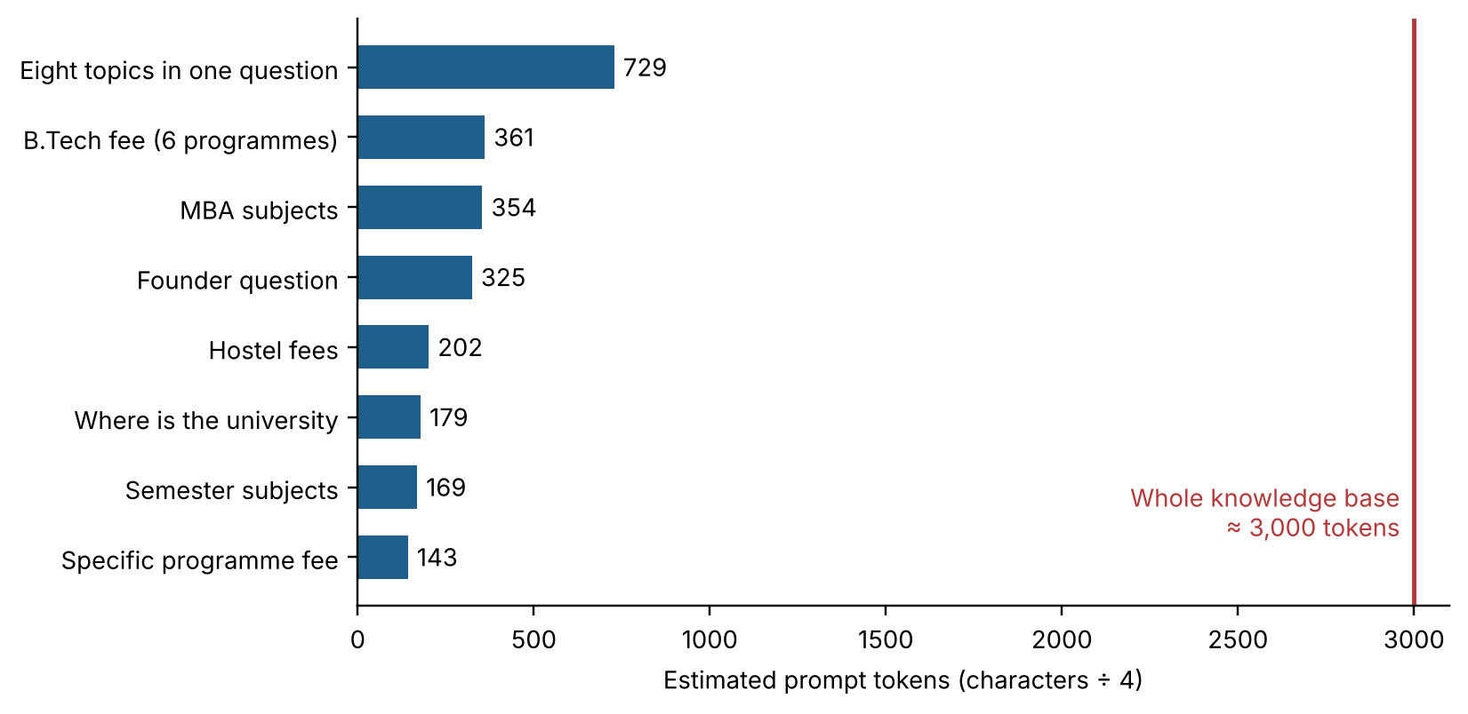
Figure 5.3: Estimated Prompt Size per Question
Response time. The first version, which sent the whole knowledge base with every question, took one to two minutes per answer on the test laptop (CPU only, Intel UHD Graphics 620). After the retrieval, the smaller prompt and the model warm-up were added, the system was clearly faster and the user confirmed that it worked “faster and better”. The preset chips are answered in the browser in 367 to 381 ms (mean 374 ms over five chips). A timing study of typed questions on the final system is left for future work.
Comparison with existing approaches. Table 5.3 compares the proposed system with the approaches in the literature survey. The comparison is qualitative, based on how each approach works and on the sources cited, not on a head-to-head experiment.
Table 5.3: Comparison with Existing Approaches
Approach | Free-text questions | Answers from verified data | Runs locally, no API cost
Rule-based FAQ bot [1] | Limited | Yes | Yes
General LLM without grounding [3], [6] | Yes | Not guaranteed | Usually no
Full RAG with vector index [4], [5], [7] | Yes | Yes | Needs heavy setup
Recent RAG admission chatbots [9], [10], [11] | Yes | Yes | Cloud API in [9] and [11]
Proposed system | Yes | Yes (retrieved facts) | Yes

CHAPTER 6

CONCLUSION AND FUTURE SCOPE

6.1 CONCLUSION
The project met its four objectives.
1. Study of techniques. Eleven works on chatbots, Transformers, large language models, retrieval, hallucination, open models and RAG chatbots for universities were studied (Chapter 2), and the gap of a light, local, grounded chatbot was identified.
2. Design. A chat widget and an n8n workflow were designed that retrieve only the needed official facts for each question; prompts became 76% to 95% smaller than sending the whole knowledge base.
3. Implementation. The chatbot runs on a local Llama 3.2 1B model on a CPU-only laptop, with session memory of six messages, eleven suggested prompts and follow-up chips; preset chips are answered in about 0.37 seconds.
4. Evaluation. All eight test cases passed (Chapter 5).
Limitations. The 1B model is small. Typed answers need the model and are slower than chip answers, and they can still miss details or be too short; their response time was not measured in this report. The knowledge base is a snapshot of October 2026 and must be updated by hand. The chatbot answers only in English and cannot handle applications or payments.

6.2 FUTURE ENHANCEMENTS
1. Replace the text knowledge base with a vector database (RAG) so that full brochures and policy documents can be searched.
2. Use a larger model, or a GPU server, for faster and more complete typed answers.
3. Add Telugu and Hindi support and voice input.
4. Connect the chatbot to live admission forms and to a staff hand-over when it cannot answer.
5. Final-year project: deploy on the university website with a persistent backend, usage analytics and an easy admin page for updating the facts.

REFERENCES
[1] Adamopoulou E & Moussiades L, An Overview of Chatbot Technology, Artificial Intelligence Applications and Innovations (AIAI 2020), IFIP Advances in Information and Communication Technology, vol. 584, Springer, 2020.
[2] Vaswani A, Shazeer N, Parmar N et al., Attention Is All You Need, Advances in Neural Information Processing Systems, 2017, vol. 30.
[3] Brown TB, Mann B, Ryder N et al., Language Models are Few-Shot Learners, Advances in Neural Information Processing Systems, 2020, vol. 33.
[4] Lewis P, Perez E, Piktus A et al., Retrieval-Augmented Generation for Knowledge-Intensive NLP Tasks, Advances in Neural Information Processing Systems, 2020, vol. 33.
[5] Karpukhin V, Oguz B, Min S et al., Dense Passage Retrieval for Open-Domain Question Answering, Proceedings of the 2020 Conference on Empirical Methods in Natural Language Processing (EMNLP), 2020.
[6] Ji Z, Lee N, Frieske R et al., Survey of Hallucination in Natural Language Generation, ACM Computing Surveys, 2023, vol. 55, no. 12.
[7] Gao Y, Xiong Y, Gao X et al., Retrieval-Augmented Generation for Large Language Models: A Survey, arXiv preprint, 2023, arXiv:2312.10997.
[8] Grattafiori A, Dubey A, Jauhri A et al., The Llama 3 Herd of Models, arXiv preprint, 2024, arXiv:2407.21783.
[9] Chen Z, Zou D, Xie H, Lou H & Pang Z, Facilitating university admission using a chatbot based on large language models with retrieval-augmented generation, Educational Technology & Society, 2024, vol. 27, no. 4, pp. 454–470.
[10] Trienes J, Derzhanskaia A, Schwarzkopf R, Mühling M, Schlötterer J & Seifert C, Marcel: A Lightweight and Open-Source Conversational Agent for University Student Support, arXiv preprint, 2025, arXiv:2507.13937.
[11] Sarmiento C & Lauría EJM, Investigating Flavors of RAG for Applications in College Chatbots, Proceedings of the 17th International Conference on Computer Supported Education (CSEDU), 2025, vol. 2, pp. 421–428.
[12] The Apollo University, Chittoor, Official website: admissions, fee structure and academics. Available from: <https://apollouniversity.edu.in/> [Accessed October 2026].

MAPPING OF PROJECT WITH PROGRAMME OUTCOMES
Project Title: College Admission AI Chatbot
Course: __________ – Mini Project, ____ Semester
Domain / Area: Natural Language Processing and Generative AI (conversational chatbot)
Sustainable Development Goal(s) addressed (if any): SDG 4 – Quality Education
 | PO1 | PO2 | PO3 | PO4 | PO5 | PO6 | PO7 | PO8 | PO9 | PO10 | PO11 | PO12 | PSO1 | PSO2
CO1 |  | 3 |  |  |  | 2 |  |  |  |  |  | 3
CO2 | 3 | 2 | 3 |  | 2
CO3 |  |  | 2 | 2 | 3
CO4 |  |  |  |  |  |  |  |  | 2 | 3 | 2
Enter correlation level: 3 – High, 2 – Medium, 1 – Low, leave blank if not mapped. Justify the high (3) mappings briefly below.
Justification:
• CO1 – PO2 (3), PO12 (3): the problem of repetitive, error-prone admission enquiries was analysed and eleven related works were studied (Chapter 2); the survey needed independent reading of new techniques such as RAG and hallucination.
• CO2 – PO1 (3), PO3 (3): engineering and language-model knowledge was used to design the retrieval-based prompt builder, the six-component architecture and the workflow (Chapter 3).
• CO3 – PO5 (3): modern tools (Docker, n8n, Ollama, Llama 3.2, Playwright) were selected and used to build and test the prototype (Chapters 4 and 5).
• CO4 – PO10 (3): the work was presented through this report, a slide deck and a live demonstration.
Course Outcomes (COs)
CO | Statement
CO1 | Identify a problem and survey existing solutions in the chosen domain.
CO2 | Design a solution using appropriate tools, algorithms and techniques.
CO3 | Implement and test a working prototype.
CO4 | Work as a team and present the work through a report and demonstration.

APPENDICES
Appendix A – Source Code
The complete files are n8n-node1-prepare-prompt.js (about 58,000 characters, mostly the knowledge-base text held in the DATA object) and n8n-node2-save-reply.js. Long lines are shortened below with “...”.
A.1 Prepare Prompt node (retrieval and request)
const MAX_CHARS = 2600;
function norm(q) {
let s = String(q).toLowerCase().replace(/&/g, ' and ');
s = s.replace(/artificial intelligence/g, 'ai').replace(/\bpharm\.?\s?d\b/g, 'pharmd')
.replace(/\bb\.?\s?tech\b/g, 'btech').replace(/\bm\.?\s?tech\b/g, 'mtech')
.replace(/\bb\.?\s?sc\b/g, 'bsc').replace(/\bm\.?\s?sc\b/g, 'msc')
.replace(/\bb\.?\s?pharm/g, 'bpharm');
return s.replace(/[^a-z0-9]+/g, ' ').replace(/\s+/g, ' ').trim();
}
const has = (nq, ph) => (' ' + nq + ' ').includes(' ' + ph + ' ');
const INTENTS = {
fee: /\b(fee|fees|cost|tuition|price|charges|payment|pay|amount|expensive|cheap|how much|t...
syllabus: /\b(subject|subjects|syllabus|semester|semesters|sem|paper|papers|curriculum|cou...
courses: /\b(course|courses|program|programme|programmes|branch|branches|offer|offered|sch...
eligibility: /\b(eligibility|eligible|admission|admissions|apply|application|process|quali...
scholarship: /\b(scholarship|scholarships|waiver|concession|financial|loan|aid)\b/,
hostel: /\b(hostel|hostels|room|rooms|sharing|accommodation|warden|deposit|laundry|electri...
mess: /\b(mess|canteen|cafeteria|food|breakfast|lunch|dinner|snacks|snack|menu|meal|meals|...
library: /\b(library|libraries|book|books|journal|journals|reading|delnet|ieee|ebooks)\b/,
clubs: /\b(club|clubs)\b/,
events: /\b(event|events|cultural|culture|fest|festival|celebration|celebrations|freshers|...
sports: /\b(sport|sports|cricket|football|volleyball|gym|ground|clinic|ambulance|hospital|...
timings: /\b(timing|timings|hours|working|time|saturday|sunday|holiday|holidays|schedule|c...
transport: /\b(transport|transportation|bus|buses|vehicle|travel|route|routes|pickup|tirup...
placements: /\b(placement|placements|job|jobs|recruit|recruiters|package|packages|company|...
contact: /\b(contact|phone|number|email|mail|call|helpline|toll free|address|where|located...
};
const SECTION_FOR = { courses: 'schools', eligibility: 'eligibility', scholarship: 'scholars...
clubs: 'clubs', events: 'events', sports: 'sports', timings: 'timings', transport: 'transp...
// ... programme matching and context building omitted here ...
function buildPrompt(query) {
const { context, used } = buildContext(query);
const system = 'You are the admissions assistant of The Apollo University, Chittoor. Use O...
return { system, used };
}
if (typeof module !== 'undefined') module.exports = { buildContext, buildPrompt, norm, DATA };

const item = $input.first().json;
const sessionId = item.sessionId || (item.body && item.body.sessionId) || 'default';
let userText = String(item.chatInput != null ? item.chatInput : (item.body && item.body.chat...
const sd = $getWorkflowStaticData('global');
sd.fastHist = sd.fastHist || {};
const hist = (sd.fastHist[sessionId] || []).slice(-4);
// very short follow-ups ("and hostel?") borrow the previous question for matching
const prevUser = [...hist].reverse().find(m => m.role === 'user');
const forMatching = (userText.split(/\s+/).length <= 4 && prevUser) ? prevUser.content + ' '...
const warm = userText === '__warmup__'; // sent by the widget on page load so the model is...
const { system, used } = buildPrompt(forMatching);
const messages = warm ? [{ role: 'user', content: 'hi' }] : [{ role: 'system', content: syst...
return [{ json: {
sessionId, userText, used, warm,
ollamaBody: {
model: 'llama3.2:1b', messages, stream: false, keep_alive: '60m',
options: { num_ctx: 2048, num_predict: warm ? 1 : 200, temperature: 0.2, top_p: 0.9, rep...
}
}}];

A.2 Save Reply node (memory and output)
// NODE 2 - put this Code node right AFTER the HTTP Request to Ollama (mode: Run Once for Al...
// Saves the exchange to memory and returns { output } for the chat widget.
const res = $input.first().json;
let reply = String((res.message && res.message.content) || res.response || res.output || '')...
if (!reply) reply = 'Sorry, I could not answer that. Please call admissions on 7995574332.';
const prep = $('Prepare Prompt').first().json;
if (prep.warm) return [{ json: { output: '' } }]; // warm-up call: don't store it
const sd = $getWorkflowStaticData('global');
sd.fastHist = sd.fastHist || {};
const h = sd.fastHist[prep.sessionId] || [];
h.push({ role: 'user', content: prep.userText.slice(0, 300) }, { role: 'assistant', content:...
delete sd.fastHist[prep.sessionId];
sd.fastHist[prep.sessionId] = h.slice(-6);
const ids = Object.keys(sd.fastHist);
if (ids.length > 200) ids.slice(0, ids.length - 200).forEach(i => delete sd.fastHist[i]);
return [{ json: { output: reply } }];

Appendix B – Output Screenshots
Figure B.1 shows the widget answering the Library chip. The answer is stored in the widget and appeared in about 0.37 seconds.
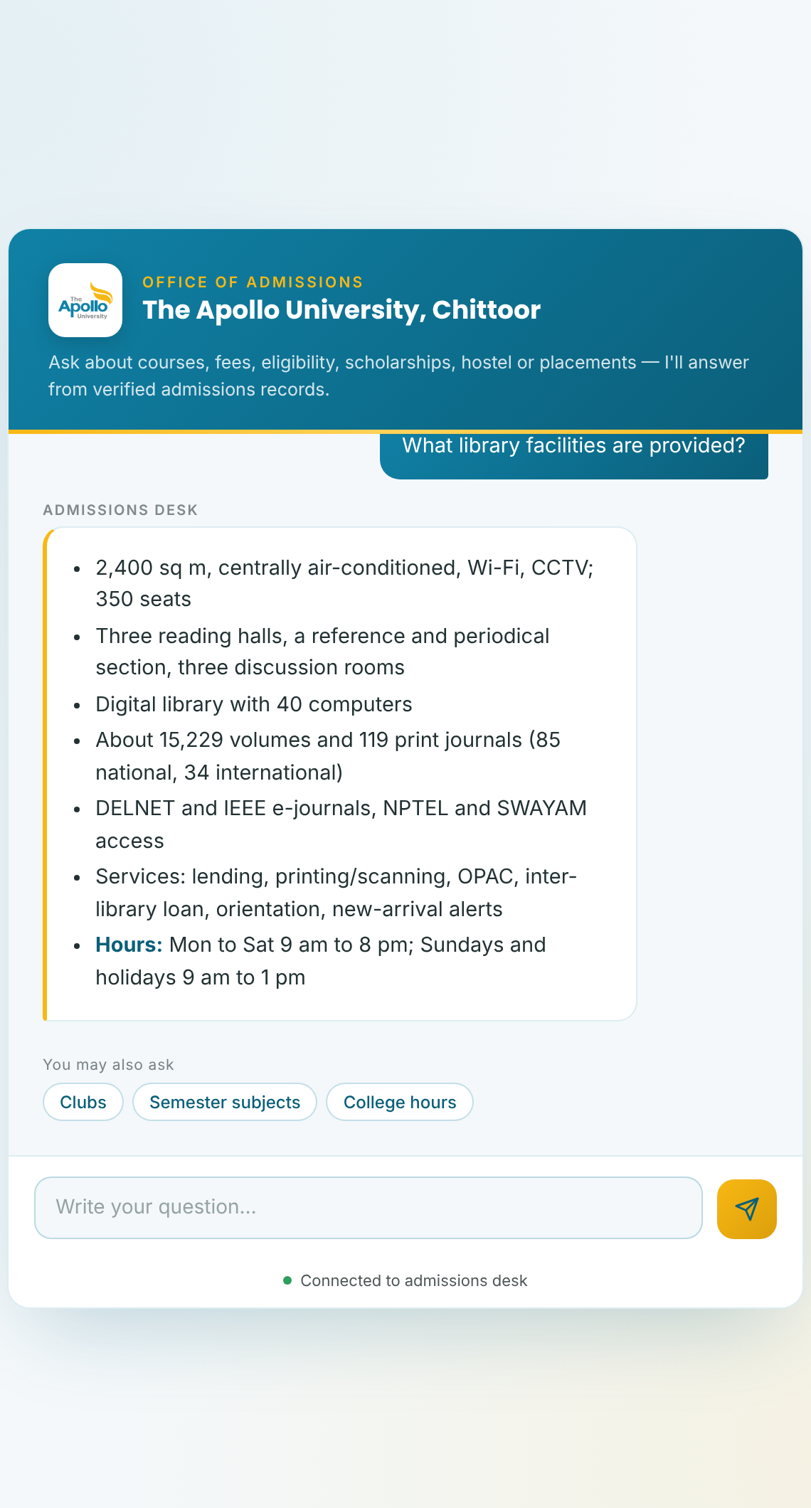
Figure B.1: Chat Widget Answering a Library Question
Appendix C – Similarity Report
Attach the first (summary) page of the similarity report here after the check is done.

