**AI BASED TRAIN RESERVATION SYSTEM**

A MINI PROJECT REPORT

submitted

*in the partial fulfilment of the requirements for the award of the degree*

**BACHELOR OF TECHNOLOGY**

in

**COMPUTER SCIENCE AND ENGINEERING**

by

**G.SAI KOUSHIK 17B81A05H7**

**M.PRASHANTH REDDY 17B81A05E7**

**P.SAI KRISHNA 17B81A05H8**

Under the guidance of

**Dr. K.MADHUSUDHANA**

Associate Professor , CSE



**DEPARTMENT OF COMPUTER SCIENCE AND ENGINEERING**

**CVR COLLEGE OF ENGINEERING**

**(*An Autonomous institution, NBA, NAAC Accredited and Affiliated to JNTUH, Hyderabad*)**

Vastunagar, Mangalpalli (V), Ibrahimpatnam (M),  
Rangareddy (D), Telangana- 501 510

June 2020

 **CVR COLLEGE OF ENGINEERING**

**(An Autonomous Institution)**

**ACCREDITED BY NBA, NAAC ‘A’ GRADE**(Approved by AICTE &

Government of Telangana and Affiliated to JNTU Hyderabad)

**DEPARTMENT OF COMPUTER SCIENCE AND**

**ENGINEERING**

**CERTIFICATE**

This is to certify that the project entitled “**AI BASED TRAIN RESERVATION SYSTEM**” that is being submitted by G.SAI KOUSHIK (17B81A05H7) , M.PRASHANTH REDDY (17B81A05E7) , P.SAI KRISHNA (17B81A05H8) in partial fulfilment for the award of Bachelor of Technology in Computer Science and Engineering to the CVR College of Engineering, is a record of bona fide work carried out by them under my guidance and supervision during the year 2019-2020.

The results embodied in this project work has not been submitted to any other University or Institute for the award of any degree or diploma.

Signature of the project guide, Signature of the HOD

**Dr K MADHUSUDHANA Dr K VENKATESWARARAO**

Associate Professor , CSE HOD , CSE

External Examiner

**ACKNOWLEDGEMENT**

We are greatly indebted to **Dr. K.Madhusudhana** (Associate Professor , CSE ) our revered guide for her valuable affectionate guidance in the preparation of this project work. He has been a source of great inspiration and encouragement to us. He has been kind enough to devote considerable amount of her valuable time in guiding us at every stage. Though this is our debut , perhaps we are sure that we will be able to do many more such studies, purely because of her lasting inspiration and guidance. We are highly grateful to her for helping us with necessary information and material. He has not only guided but also endowed us with capacity to guide us in future.

We would like to express heart full thanks to **Dr K Venkateswara Rao** , Professor and Head of the Department of Computer Science Engineering, who have always been grateful for us to complete our project.

We would like to express heart full thanks to **Dr S Nayanathara ,** Principal, who have always been grateful for us to complete our project “**AI BASED TRAIN RESERVATION SYSTEM**”.

We also thank all the teaching and non – teaching staff members of Department of Computer Science Engineering who have helped us directly or indirectly

**AI BASED TRAIN RESERVATION SYSTEM**

**ABSTRACT:**

* **This Documentation is based on the Project carried out in order to fulfil the requirements of the Mini Project of the Bachelor of Technology in Computer Science and Engineering. This is project documentation is about the development project, AI BASED TRAIN RESERVATION SYSTEM, In this Documentation the methods of analysis, designing, coding & testing are documented. This project has used the Unified Software Development Process & Object-Oriented techniques along with Unified Modeling Language. All the approaches and decisions made are documented. This project is about the AI BASED RESERVATION ,**In this Project we study the feasibility of making such predictions using the data from past railway travels. Empowered with this knowledge, users could be in a better position to make further decisions—either wait for the ticket to get confirmed, or make alternative travel arrangements. **One of the main intension of this project was to show user ‘the probability of confirmation of ticket’..**

|  |  |  |  |
| --- | --- | --- | --- |
| **Table of Contents** | | | |
|  | | | Page No. |
|  |  | List of Figures | 1 |
|  |  | Abbreviations | 2 |
| 1 |  | **Introduction** |  |
|  | 1.1 | Motivation | 3 |
|  | 1.2 | Problem statement | 3 |
| 2 |  | **Proposed Model** |  |
|  | 2.1 | Introduction to the characteristics of the Problem | 4 |
|  | 2.2 | Design challenges | 4 |
|  | 2.3 | Proposed Solution: (Developing Mobile Application) | 5 |
| 3 |  | **Requirements and Specifications** |  |
|  | 3.1 | Functional Requirements | 7 |
|  | 3.2 | Non-Functional Requirements | 8 |
|  | 3.3 | Software Specifications | 10 |
|  | 3.4 | Hardware Specifications | 10 |
| 4 |  | **Analysis and Design** |  |
|  | 4.1 | Use case Diagram | 11 |
|  | 4.2 | Class Diagrams | 13 |
|  | 4.3 | Activity Diagrams | 14 |
|  | 4.4 | Architecture Diagram | 15 |
|  | 4.5 | Technology Description | 16 |
|  | 4.5.1 | Front end | 16 |
|  | 4.5.2 | Back end | 16 |
| 5 |  | **Implementation & Testing** |  |
|  | 5.1 | Implementation | 17 |
|  | 5.2 | Screenshots | 17 |
| 6 |  | **Conclusion & Future scope** | 21 |
| 7 |  | **References** |  |

**LIST OF FIGURES**

Figure Title Page

4.1 Use case Diagram ............................................................................................11

4.2 Class Diagram..................................................................................................12

4.3 Activity Diagram..............................................................................................13

4.4 Architecture Diagram.......................................................................................14

**ABBREVIATIONS**

SRS Software Requirements Specifications

XML eXtensible Mark-up Language

MVC Model View Controller

IRCTC Indian Railway Catering and Tourism Corporation

ARIMA Auto Regressive Integrated Moving Averages

CSS Cascading Style Sheets

HTML Hyper Text Markup Language

**1.Introduction**

**1.1 Motivation:**

Currently there is a large movement in the transport system. To process and improve the current methods of booking a train ticket, this project will be helpful. The primary intention of this project is to show user the probability of ticket confirmation. User can know his ticket confirmation before logging in. Most importantly saves time. Thus, it would be helpful to create this feature.

**1.2 Problem Statement:**

The Indian Railway system supports 13 million passengers everyday, and yet millions do not avail confirmed tickets for their travel. Yet large number of people are unable to obtain confirmed ticket before their travel. While some travel (illegally) on wait-listed tickets , others cancel their tickets at the very last moment.

.

**2. Proposed Model**

* 1. **The characteristics of the problem:**

The problem includes a AI based Reservation System Software which helps in providing the following features

* Shows probability of ticket confirmation.
* User friendly
* Only authorized clients are allowed
* Well-ordered datasets
  1. **Design challenges**

Existing applications – Paytm

Today, there are many applications for booking train tickets and therefore there is an intensive challenge for everyone. Each application looks for the best way of providing their features.

**2.3 Proposed Solution**:

* In this Project we study the feasibility of making such predictions using the data from past railway travels. Empowered with this knowledge, users could be in a better position to make further decisions—either wait for the ticket to get confirmed, or make alternative travel arrangements.
* We obtain our data from a mobile application. Select the features that could affect confirmation of a wait-listed ticket, and design rules to improve the quality of our final data-set.
* We then train linear and nonlinear machine learning models and do inference on held-out test data.

## 3. Software Requirements Specifications

**3.1 Functional Requirements:**

* Enter Source
* Enter Destination
* Select Train
* Select Date
* Select Coach-Type
* Collect the Data
* Select Algorithm
* Run ML algorithms on Data

**3.2 Non-Functional Requirements:**

* Performance
* Reliability
* Scalability
* Confidentiality
* Integrity
* Security
* Maintainability
* Usability
* Portability

**3.3 Software Specifications:**

**NumPy**: NumPy is a numerical library that is used for accelerated tensor operations. This help is speeding up the computation by taking advantage of SIMD instructions on modern CPUs and GPUs. This library is useful for preprocessing data before classification.

**Matplotlib**: Matplotlib is a plotting library for python. This is useful for EDA and performing error analysis while training and testing the AI models.

**Colab**: Google Colab is a free cloud service which helps in developing deep learning applications using popular libraries such as Keras, TensorFlow, PyTorch. In runs on Google servers with GPU or TPU acceleration which helps in reducing the 6 training period for the AI model. Giving team, the ability to iterate and improve quickly.

**Flask** : Flask is a light-weight web framework for python. This can be used to run the inference server. Flask is ran inside a docker container.

**Jinja**: Jinja is a web template engine for the Python programming language. Jinja is similar to the Django template engine but provides Python-like expressions while ensuring that the templates are evaluated in a sandbox.

**Firebase**: Firebase is a BaaS (Backend as a Service) provided by Google. Firebase is scalable, distributed and secure by design. It is especially geared towards business apps, with the intention of helping businesses grow their user bases and increase their profits through their mobile apps. Firebase provides authentication(Auth), Database (Firestore), Cloud Storage (Storage), Analytics as a service.

**Pickle**: pickle module implements binary protocols for serializing and de-serializing a Python object structure. “Pickling” is the process whereby a Python object hierarchy is converted into a byte stream, and “unpickling” is the inverse operation, whereby a byte stream (from a binary file or bytes-like object) is converted back into an object hierarchy.

**3.4 Hardware Specifications:**

**User Device Requirements:**

Any Browser which has access to http/https protocol.

An internet connection.

**Minimum Server Requirements:**

Windows* Server / Linux* Server

Processor: Any x86 CPU with clock speed of 2.5GHz and above.

RAM: 2GB.

Storage: At-least 15 G.B.

Above mentioned server requirements are minimum and need to be automatically scaled depending on usage and traffic.

**4.Analysis and Design**

**4.1 Use Case Diagram**

A [UML](https://en.wikipedia.org/wiki/Unified_Modeling_Language) use case diagram is the primary form of system/software requirements for a new software program underdeveloped A key concept of use case modelling is that it helps us design a system from the end user's perspective. It is an effective technique for communicating system behavior in the user's terms by specifying all externally visible system behavior.

**Fig.4.2 Use Case Diagram**

**4.2 Class Diagram**

The **class diagram** is the main building block of object-oriented modelling. It is used for general conceptual modelling of the structure of the application, and for detailed modelling translating the models into programming code.

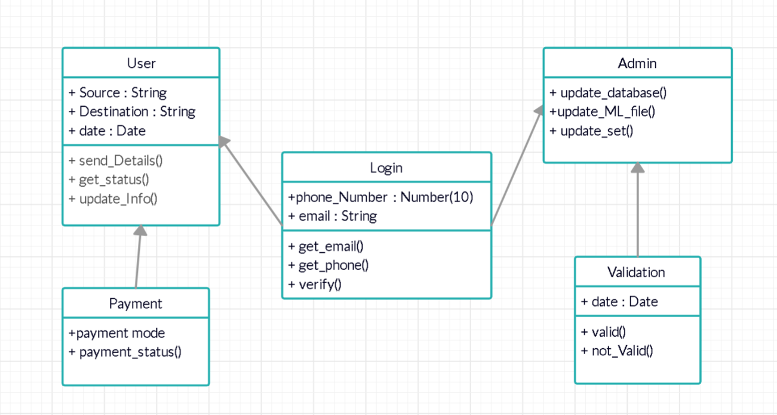

**Fig.4.2 Class Diagram**

**4.3 Activity Diagram**

**Activity Diagram** is basically a flowchart to represent the flow from one activity to another activity. The activity can be described as an operation of the system. The basic purpose of **activity** diagrams is to capture the dynamic behavior of the system. It is also called **object-oriented flowchart.**

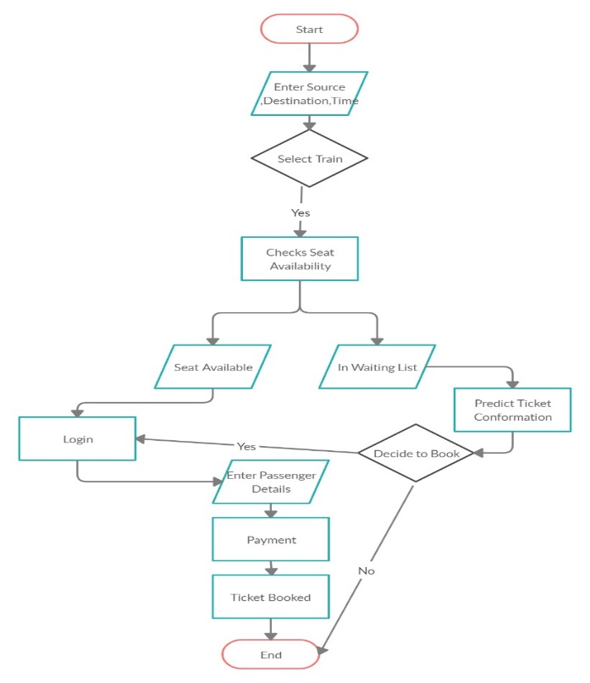

**Fig. 4.3.1 Activity Diagram for Client side**

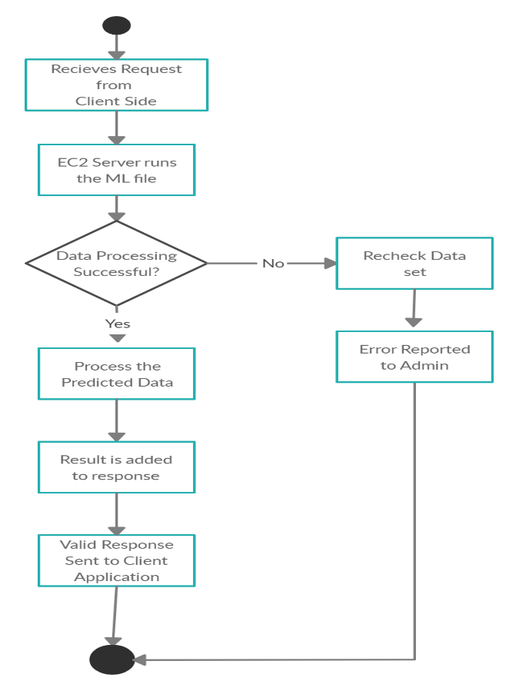

**Fig. 4.3.1 Activity Diagram for Server side**

**4.4 Architecture Diagram**

An architecture diagram is a graphical representation of a set of concepts, that are part of an architecture, including their principles, elements and components.

There are many kinds of architecture diagrams, like a software architecture diagram, system architecture diagram, application architecture diagram, security architecture diagram, etc.

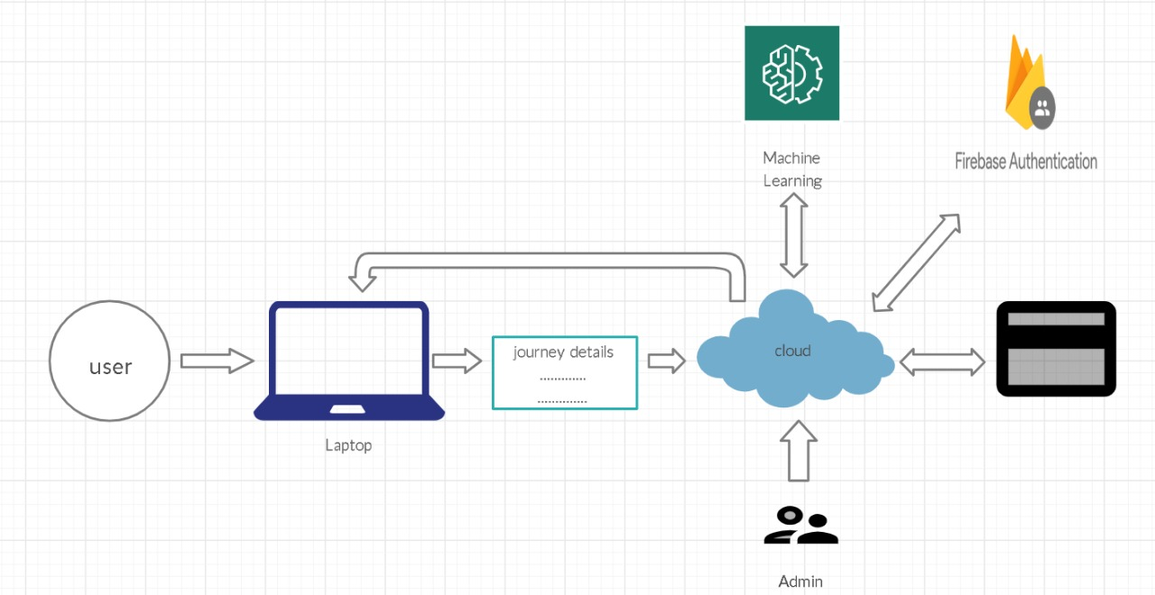

**Fig. 4.4 Architecture Diagram**

**4.5 Technology description**

**4.5.1 Front End**

Different web pages in this application are created and structured using HTML

CSS is used to present Web pages, including colors, layout, and fonts.

JavaScript is used to create responsive, interactive elements for web pages,

enhancing the user experience.

**4.5.2 Back End**

The back end is implemented using Flask which is a framework to link data and call appropriate function. ML – Time Forecasting Algorithm (ARIMAX), Google cloud for developing and deploying data. Google Firebase authentication is for generation of OTP, Payment gateway is for functioning of payment page.

**5. Implementation**

**5.1 front page screenshot**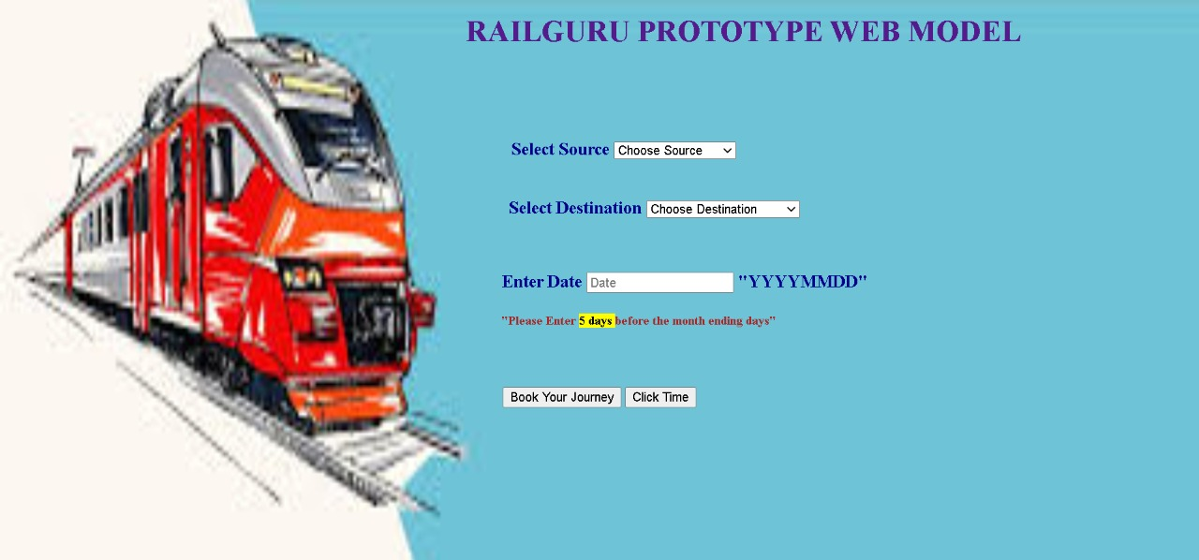

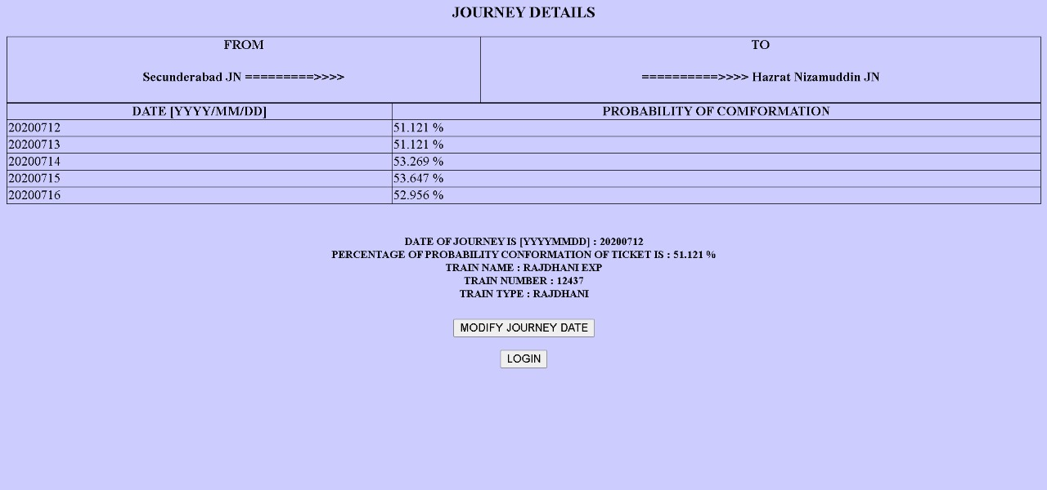

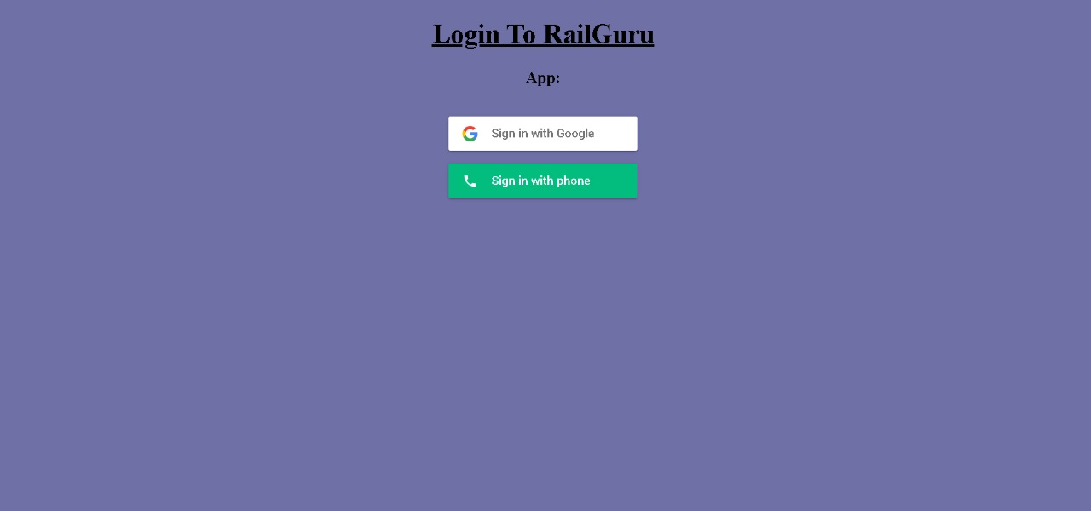

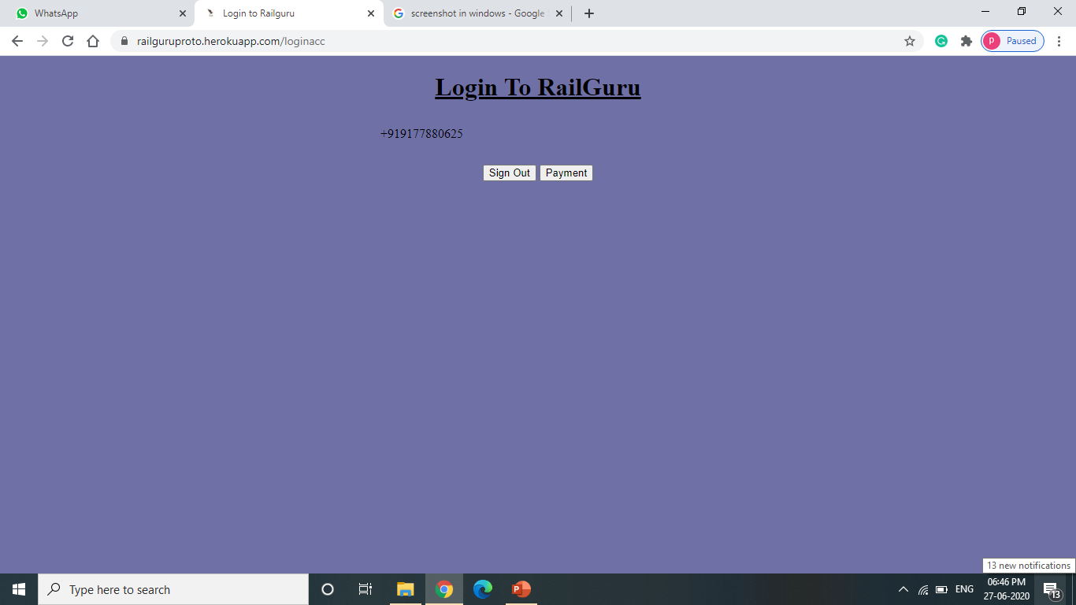

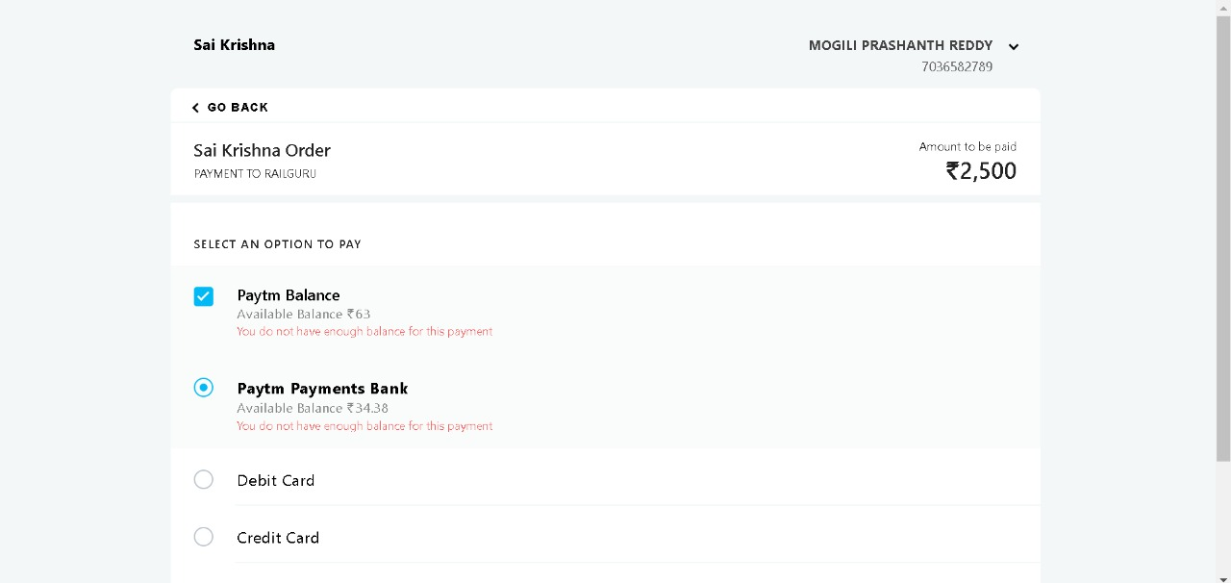

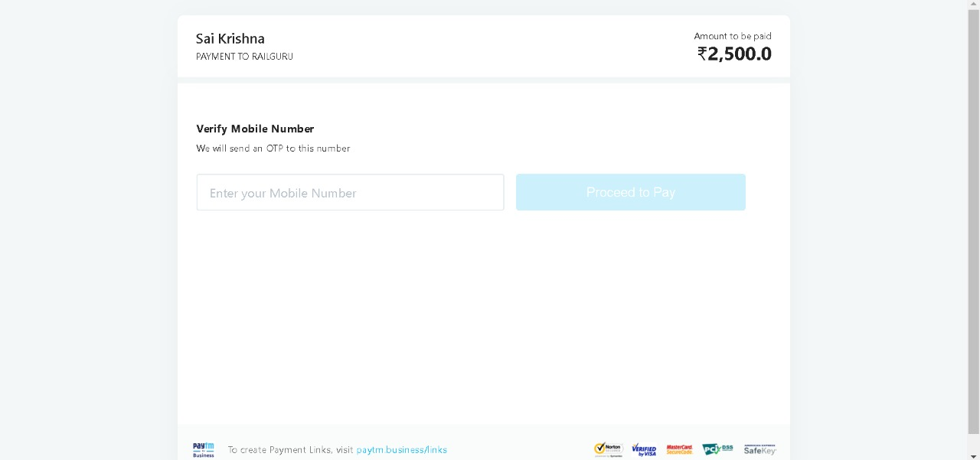

**6. CONCLUSION & FUTURE ENHANCEMENTS**

Application designing and modelling is a complex task to undertake. It requires many skills along with reasonable accuracy and user friendly. AI based Train Reservation System Software has been carried out using Machine learning algorithms and firebase Authentication. Various objects, functions, input and output methods of the computer software languages have been explored and utilized in this work. A good knowledge has been acquired. The various advantages, materials and applications of web technologies along with real-time applications of the project were studied in this project work.

With our proposed model a user can get Probability of his Ticket Conformation before Ticket Booking and such that he don’t face any issue regarding in his ticket conformation.

Updates we can expect in the following features:

* Security
* Flexibility
* Portability
* Search Options
* User Feed Back
* Privacy
* These features can be helpful for the proper conduction of the meetings with-out any disturbances. Perhaps we can expect many updates which make the app more user friendly with myriad of features from it.
* Features like User Graphical seating Selection can be implemented to our proposed model so he doesn’t be separated with his family in a couch and fell Comfortable.

**7.REFERENCES**

[1] Firebase <https://firebase.google.com/docs>

[2] Flask <https://flask.palletsprojects.com/en/1.1.x/>

[3] Google Colab <https://colab.research.google.com>

[4] Matplotlib <https://matplotlib.org/contents.html>

[5] NumPy <https://numpy.org/doc/stable/>

[6] Pandas <https://pandas.pydata.org/>

[7] Pickle <https://docs.python.org/2/library/pickle.html>

**Articles in Periodicals (journals, magazines, etc.)**

[8] <https://machinelearningmastery.com/make-predictions-time-series-forecasting-python/>

**Electronic sources**

[9] Coursera, <https://www.coursera.org/>

[10] Edx, <https://www.edx.org/>

**Project Site**

[11] <https://railguruproto.herokuapp.com/>