PROJECT REQUIREMENTS DOCUMENT
Azure File Sync with an On-Premises File Server
Team T175 | Project P073
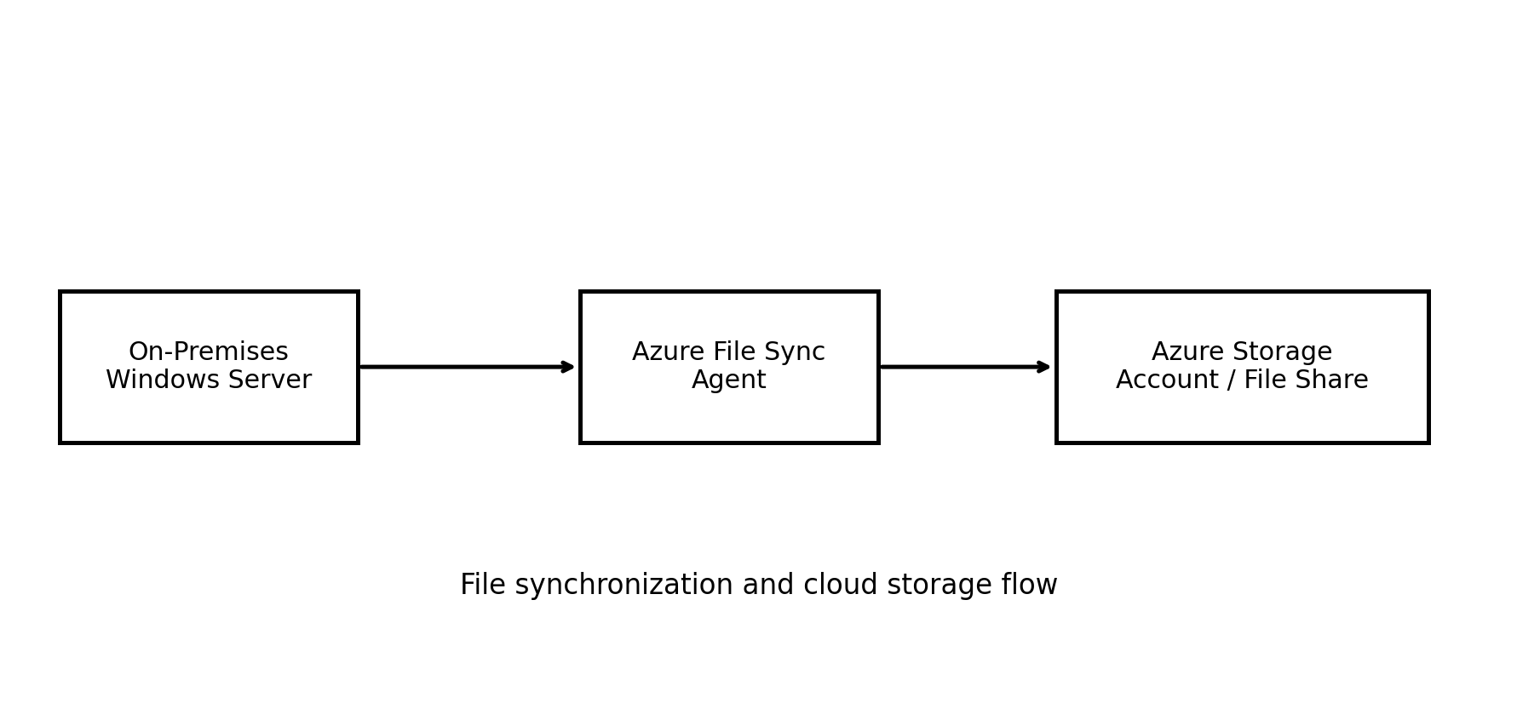

1. Introduction
This document defines the functional, technical, infrastructure, security, and validation requirements for the project “Azure File Sync with an On-Premises File Server.” The source abstract states that the solution connects a local file server with Microsoft Azure cloud storage to improve file management, storage, synchronization, tiering, and backup.

2. Problem Definition
Companies may store large amounts of data on local servers, making storage management, synchronization, and backup increasingly difficult. The proposed solution connects the on-premises file server to Azure storage so that files can be synchronized and additional copies can be maintained in the cloud.

3. Project Objectives
- Synchronize files between the local Windows Server and an Azure file share.
- Provide additional cloud storage for organizational files.
- Support cloud tiering so frequently used files can remain locally available while seldom-accessed files are stored in the cloud.
- Support synchronization of files for multiple offices or locations.
- Maintain an additional cloud copy of local files for backup purposes.

4. Functional Requirements
ID | Requirement | Description
FR-01 | Azure environment | The system shall use an Azure subscription to host the required cloud resources.
FR-02 | Storage account | The system shall use an Azure Storage Account for cloud-based file storage.
FR-03 | Azure file share | The system shall provide an Azure File Share as the remote cloud file location.
FR-04 | Storage Sync Service | The system shall use Azure Storage Sync Service to coordinate synchronization.
FR-05 | Sync agent | The Windows Server/VM shall have the Azure File Sync agent installed and configured.
FR-06 | File synchronization | The solution shall synchronize selected local files/folders with the Azure file share.
FR-07 | Cloud storage | The solution shall allow additional files to be stored in Azure.
FR-08 | Cloud tiering | The solution shall support keeping frequently accessed data locally while moving less frequently accessed data to cloud storage.
FR-09 | Multiple offices | The design shall support synchronization of file data across multiple office locations where additional server endpoints are configured.
FR-10 | Backup copy | The solution shall maintain an additional copy of local files in Azure as described in the project use cases.

5. Infrastructure Requirements
Component | Status | Requirement
Azure subscription | Required | Eligible Azure Free/Student subscription; use only within available credits/limits.
Windows Server / VM | Required | Use an existing/local Windows Server or VM where possible to avoid Azure VM charges.
Azure Storage Account | Required | Small Azure Storage Account for academic demonstration.
Azure File Share | Required | Small Azure File Share; keep storage and test data limited.
Storage Sync Service | Required | Required for Azure File Sync; use only for the limited project demonstration.
Azure File Sync Agent | Required | Install on the Windows Server/VM used for the demonstration.
Internet connection | Required | Existing Internet connection.

6. High-Level Architecture
The high-level solution consists of a Windows Server/VM at the local environment, the Azure File Sync agent on that server, and an Azure Storage Account containing the Azure File Share. The server connects to Azure through the available Internet connection.
Figure 1. High-level architecture for the proposed Azure File Sync solution.

7. Implementation Requirements
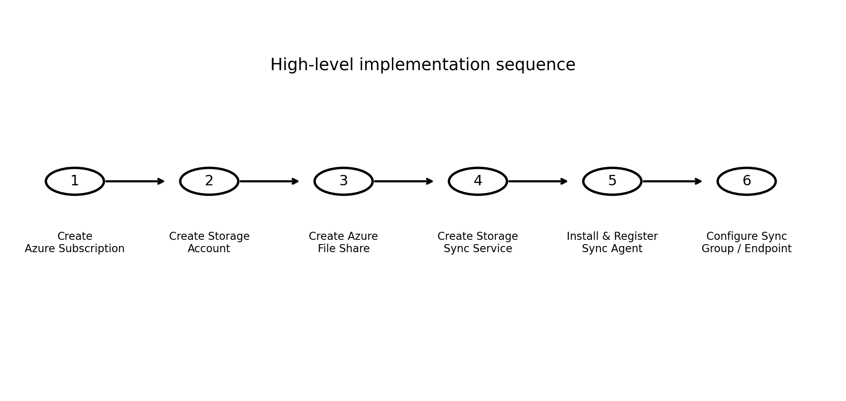
- Create or obtain an Azure subscription.
- Provision an Azure Storage Account.
- Create the required Azure File Share.
- Create a Storage Sync Service.
- Prepare the Windows Server/VM and install the Azure File Sync agent.
- Register the server with the Storage Sync Service.
- Configure the synchronization relationship and server endpoint.
- Test file creation/modification and synchronization between the local server and Azure.
- Validate cloud tiering and backup-related use cases described in the project.
Figure 2. Suggested high-level implementation sequence.

8. Non-Functional Requirements
Quality Attribute | Requirement
Availability | The synchronization solution should remain usable when the required Azure and local server resources are available.
Scalability | The design should allow additional file data and server endpoints to be accommodated as the organization grows.
Reliability | Synchronization should be tested under normal file creation, modification, and update scenarios.
Security | Access to Azure resources and file data should be controlled using appropriate Azure permissions and secure configuration.
Performance | File synchronization should be evaluated using representative file operations and network conditions.
Manageability | The resources and synchronization configuration should be organized so administrators can monitor and maintain them.
Recoverability | The cloud copy should support the stated backup use case and be available for recovery procedures defined during implementation.

9. Use-Case Requirements
File Sync: Users/administrators can synchronize local files with remote files in cloud storage.
Cloud Storage: Users can store additional files in Azure.
Cloud Tiering: Frequently used files remain locally accessible while seldom-accessed files can be stored in the cloud.
Multiple Offices: File data can be synchronized between different offices when corresponding endpoints are configured.
Backup: An additional cloud copy of local files can be maintained.
Free-Tier / Student Account Scope: This project is designed as a small-scale academic demonstration using an eligible Azure Free/Student subscription. Only the minimum Azure resources required for the demonstration will be used: Azure Storage Account, a small Azure File Share, Storage Sync Service, and Azure File Sync agent. Large-scale resources, additional paid services, and production-sized infrastructure are outside the project scope. Storage capacity and test data should be kept small to minimize consumption of available Azure credits. An existing/local Windows Server or VM will be used where possible instead of creating a continuously running Azure VM.

10. Team Members
- 2400032195 – S. MADHURI DEVI
- 2400032747 – B. LAKSHMI SRAVANTHI
- 2400032991 – BAPATHU YASWANTH OBUL REDDY
- 2400032964 – VISHNUBHOTLA H S S N S RAMA KOUSHIK

11. Source Basis
The project title, problem statement, abstract, use cases, and original listed requirements were taken from the supplied project document. The supplied document lists Azure subscription, Windows Server/VM, Azure Storage Account, Azure File Share, Storage Sync Service, Azure File Sync agent, and Internet connection as requirements.
For this academic implementation, the scope is intentionally limited to the minimum Azure services and small test data needed for demonstration under an eligible Free/Student account. Paid or production-scale Azure infrastructure is not included.

