PROJECT MODULES DOCUMENT
Azure File Sync with an On-Premises File Server
Team T175 | Project P073
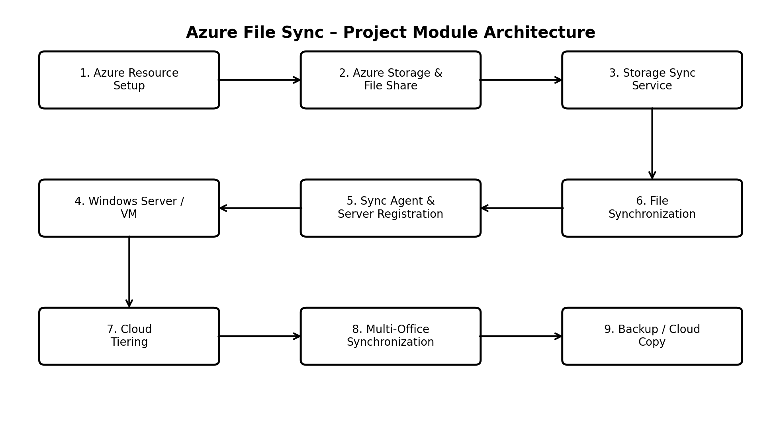
Figure 1. Overall project module architecture.

1. Module Overview
The project is divided into modules that collectively implement the Azure File Sync solution. The modules cover Azure resource preparation, cloud storage, synchronization services, the on-premises server, file synchronization, cloud tiering, multi-office synchronization, and backup.

2. Detailed Project Modules
Module | Purpose | Main Components | Main Activities | Output
Module 1 – Azure Resource Setup | Establishes the Azure environment required for the project. | Azure Subscription; Resource Group | Create and organize the Azure resources needed for the demonstration. | Azure environment ready for configuration.
Module 2 – Azure Storage & File Share | Provides the cloud location where synchronized files are stored. | Azure Storage Account; Azure File Share | Create the storage account and configure a small Azure File Share. | Cloud file storage endpoint.
Module 3 – Storage Sync Service | Coordinates Azure File Sync configuration and server endpoints. | Azure Storage Sync Service | Create the Storage Sync Service and configure the synchronization structure. | Sync service ready for server registration.
Module 4 – On-Premises Windows Server / VM | Provides the local file-server environment. | Windows Server / local VM | Prepare a Windows Server/VM and create the folders that will participate in synchronization. | Local file-server endpoint.
Module 5 – Azure File Sync Agent & Registration | Connects the Windows Server to Azure File Sync. | Azure File Sync Agent; Registered Server | Install the agent, register the server, and connect it to the Storage Sync Service. | Registered server ready for synchronization.
Module 6 – File Synchronization | Synchronizes selected local files with the Azure file share. | Sync Group; Server Endpoint; Azure File Share | Configure synchronization and verify file updates between local and cloud locations. | Synchronized file data.
Module 7 – Cloud Tiering | Allows frequently used data to remain locally available while less frequently accessed data can be tiered to Azure. | Azure File Sync Cloud Tiering | Configure and demonstrate tiering with suitable test files. | Local/cloud storage optimization.
Module 8 – Multi-Office Synchronization | Supports synchronization between multiple server endpoints when multiple offices are included. | Additional registered server endpoints; Sync Group | Configure additional endpoints and demonstrate synchronization between locations. | Shared synchronized data across endpoints.
Module 9 – Backup / Cloud Copy | Uses the Azure copy as an additional copy of local files for the stated backup use case. | Azure File Share / synchronized cloud copy | Maintain the synchronized cloud copy and demonstrate access to the stored files. | Additional cloud copy of data.
Module 10 – Subscription & Cost Management | Controls the project according to Free/Student or Pay-As-You-Go availability. | Azure Subscription; Cost Management | Use small test data under the Free/Student allowance; use PAYG only when additional capacity or longer-running resources are needed. | Controlled Azure usage and cost awareness.

3. Module Relationships
- Azure Resource Setup provides the base environment for the Azure components.
- Azure Storage & File Share provides the cloud file location.
- Storage Sync Service manages the synchronization configuration.
- The Windows Server/VM acts as the local file-server endpoint.
- The Azure File Sync Agent registers and connects the server to Azure.
- File Synchronization connects the local endpoint and Azure file share.
- Cloud Tiering extends synchronization by optimizing where files are stored.
- Multi-Office Synchronization can add more server endpoints when required.
- The synchronized Azure copy supports the project's backup/cloud-copy use case.
- Subscription & Cost Management controls whether the demonstration stays within Free/Student limits or is extended using PAYG.

4. Free-Tier / Student Implementation
For the academic demonstration, the project can be kept small by using an eligible Free/Student Azure subscription, a small Azure Storage Account and File Share, Storage Sync Service, and a local Windows Server/VM. Test files should be kept small and unnecessary Azure resources should not be left running.
- Use a local Windows Server/VM where possible instead of a continuously running Azure VM.
- Use only the Azure resources required for the synchronization demonstration.
- Keep the Azure File Share and test data small.
- Monitor available Azure credit/limits before extended testing.

5. Pay-As-You-Go Extension
If the project is extended beyond the Free/Student allowance, the core modules can continue under a Pay-As-You-Go subscription. PAYG is useful for larger storage, longer-running environments, additional server endpoints, or an Azure-hosted Windows Server. Optional extensions such as Azure Backup or Azure Monitor can be added if the project scope requires them.
Service | Project Usage | PAYG Benefit
Azure Storage / Azure Files | Stores synchronized cloud files. | Larger storage and continued use beyond available free allowance.
Storage Sync Service | Coordinates server endpoints and sync groups. | Supports extended and multi-server deployments.
Azure File Sync | Synchronizes local and cloud files; supports tiering. | Suitable for a larger or longer-running hybrid file environment.
Azure Windows VM (Optional) | Hosts the Windows Server endpoint in Azure. | Cloud-hosted server instead of a local VM.
Azure Backup (Optional) | Adds backup/recovery capability. | Extends the project into a more complete cloud backup scenario.
Azure Monitor / Log Analytics (Optional) | Monitors Azure resources and activity. | Improves administration, monitoring and troubleshooting.

6. Expected Project Outcome
After completing the modules, the project should demonstrate a working hybrid file-storage scenario in which a local Windows Server is connected to Azure, selected files are synchronized with an Azure File Share, and the cloud copy can support cloud storage, cloud tiering, multiple-office synchronization, and the additional-copy/backup use case described in the project requirements.

7. Team Members
- 2400032195 – S. MADHURI DEVI
- 2400032747 – B. LAKSHMI SRAVANTHI
- 2400032991 – BAPATHU YASWANTH OBUL REDDY
- 2400032964 – VISHNUBHOTLA H S S N S RAMA KOUSHIK

