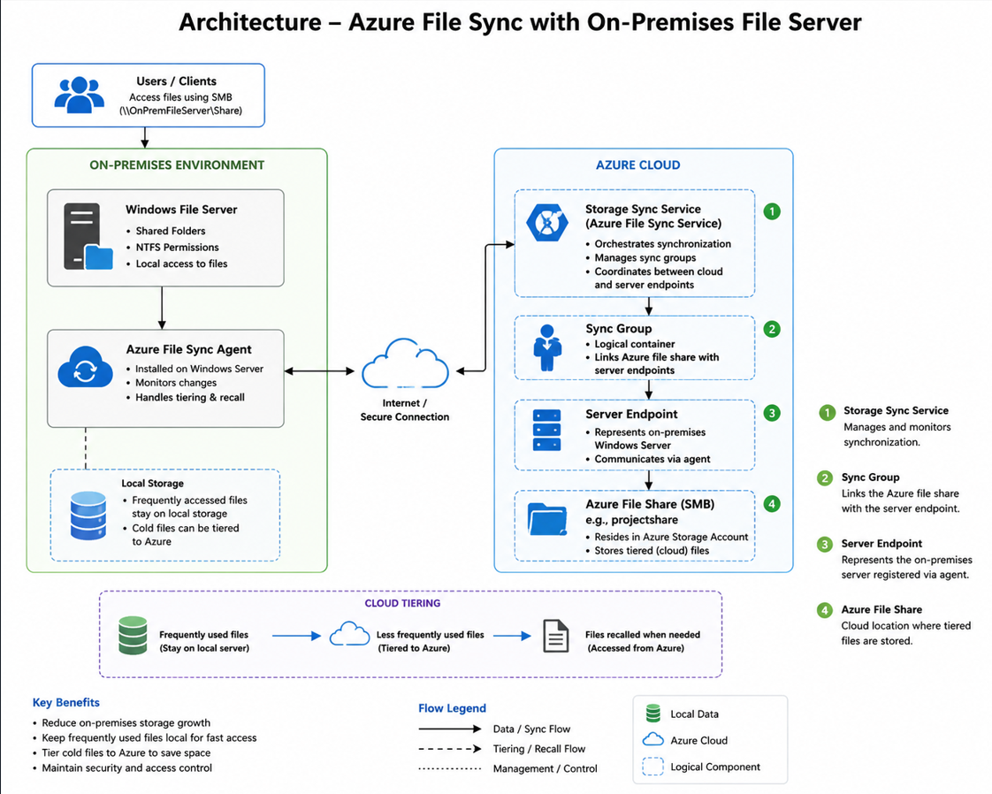
Architecture:

Description:
What this diagram is actually showing
This setup shows Azure File Sync working together with an on-prem file server. The main goal is to let a business keep running its file server the way it always has while Azure quietly takes care of storage and backups in the background.
Starting with the people who use it
Employees just open their shared folder the way they always have. By typing in the network path (\\OnPremFileServer\Share). They don’t see anything related to Azure. That’s the idea. To keep things simple and familiar.
On the office side
There’s a Windows File Server running on-premises. It holds folders and uses regular NTFS permissions to control who can access what. On that same server there's a small program called the Azure File Sync Agent. It doesn’t do anything it just watches for file changes and
syncs with Azure in the background. Frequently used files stay on the server so access stays fast.. Files that haven’t been used in a while get marked and eventually moved to the cloud to save space.

Getting to Azure
The agent connects to Azure using a secure internet connection. Nothing complicated. A safe encrypted link that keeps both sides talking.

Once it’s in Azure
A few different parts work together:
The Storage Sync Service acts like the manager of the system. It handles all the coordination. Then there’s the Sync Group. This is a rule that connects a specific cloud file share to a specific on-prem server. The Server Endpoint is Azure’s way of remembering that on-prem server. It gets registered through the agent.. Finally the Azure File Share is where the actual files go once they’ve been moved to the cloud.
The tiering part. This is the clever bit
Files that people use stay local. So no slowdowns for the user. Files that are rarely used get moved to Azure to save space back, at the office.. If someone suddenly needs an old file that’s already been moved it gets pulled back down automatically. The user opens it like normal. They have no idea it ever left the building.

Why bother doing all this

storage doesn’t fill up as quickly

Everyday files stay fast to access

Files that aren’t used often move to a cheaper place to store

Permissions and security stay the same the whole time

